Leetcode 2739
https://leetcode.com/problems/total-distance-traveled/
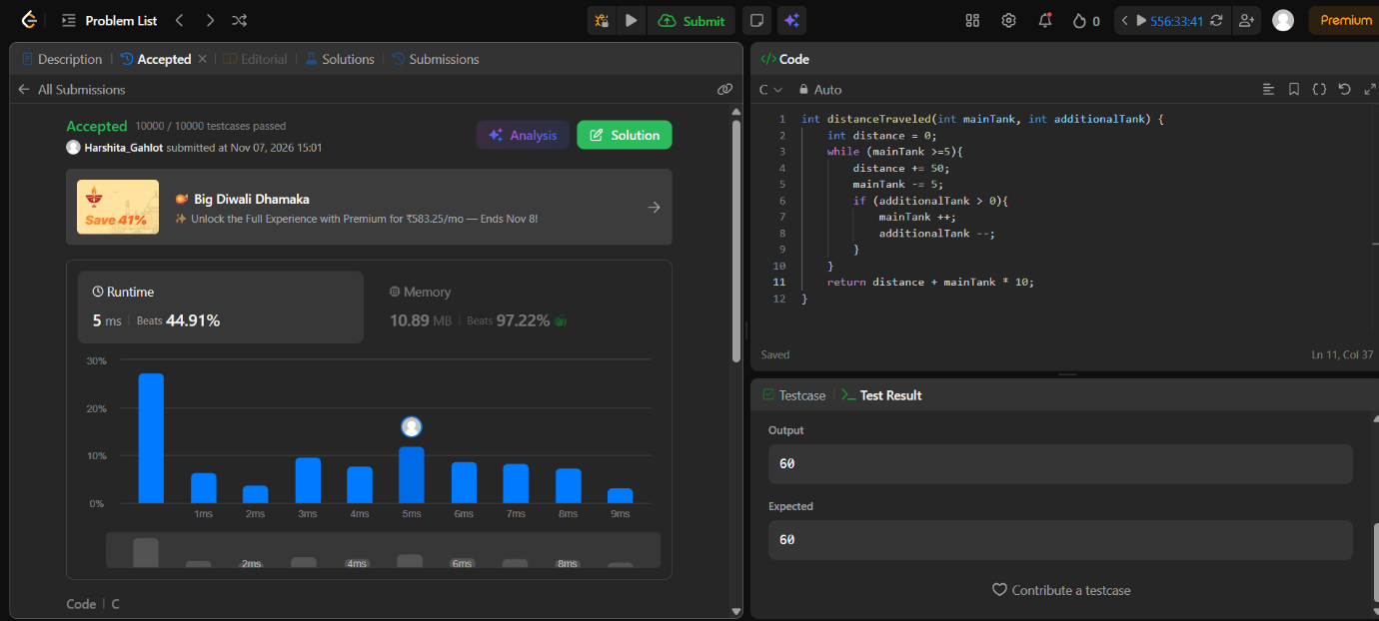

Code-
int distanceTraveled(int mainTank, int additionalTank) {
int distance = 0;
while (mainTank >=5){
distance += 50;
mainTank -= 5;
if (additionalTank > 0){
mainTank ++;
additionalTank --;
}
}
return distance + mainTank * 10;
}

