Leetcode 1281
https://leetcode.com/problems/subtract-the-product-and-sum-of-digits-of-an-integer/
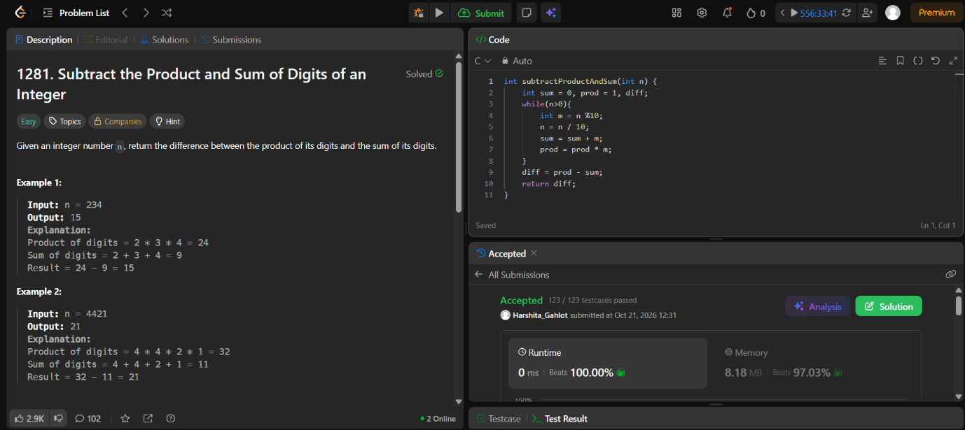

Code-
int subtractProductAndSum(int n) {
int sum = 0, prod = 1, diff;
while(n>0){
int m = n %10;
n = n / 10;
sum = sum + m;
prod = prod * m;
}
diff = prod - sum;
return diff;
}

