HackerRank – Printing Pattern Using Loops
https://www.hackerrank.com/challenges/printing-pattern-2/problem
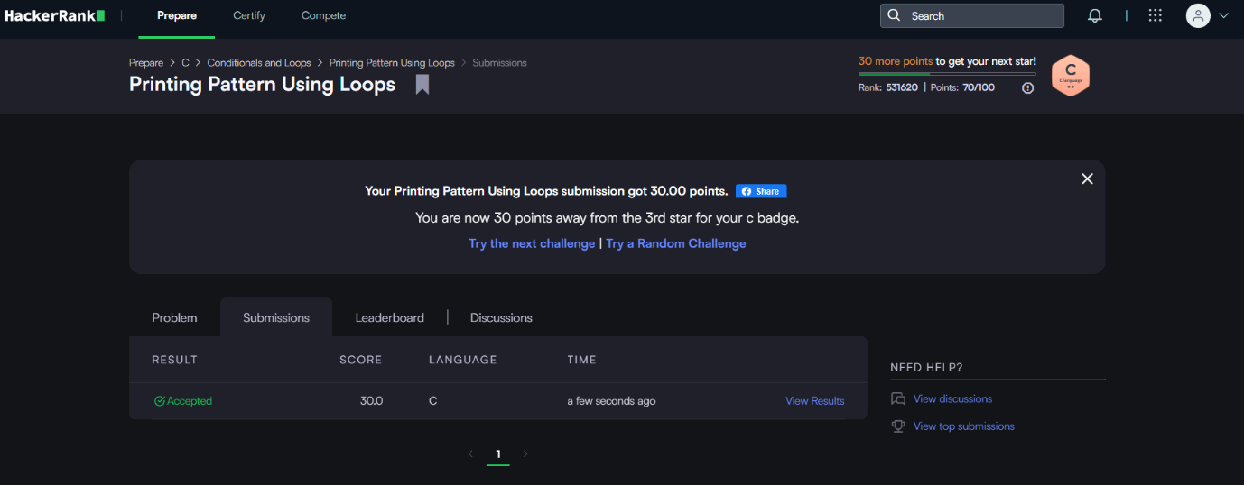

Code-
int main()
{
int n;
scanf("%d", &n);
for (int i = 0; i < 2 * n - 1; i++) {
for (int j = 0; j < 2 * n - 1; j++) {
int min = i;
if (j < min)
min = j;
if (2 * n - 2 - i < min)
min = 2 * n - 2 - i;
if (2 * n - 2 - j < min)
min = 2 * n - 2 - j;
printf("%d ", n - min);
}
printf("\n");
}
return 0;}

