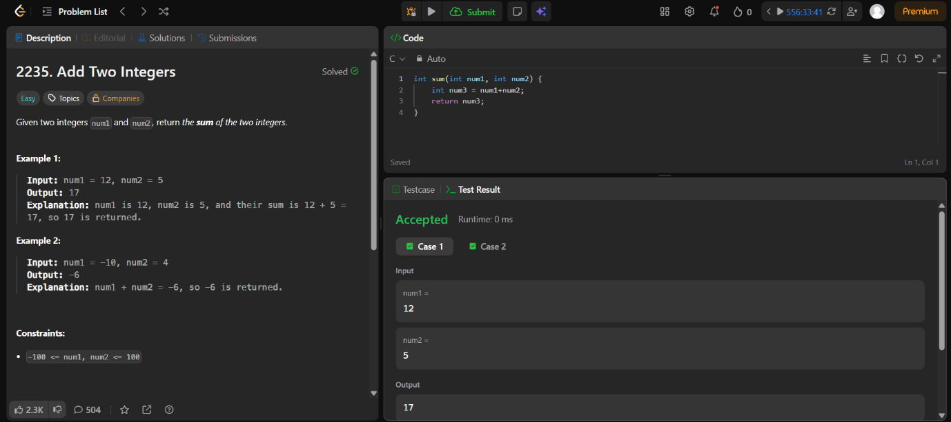
Leetcode 2235
https://leetcode.com/problems/add-two-integers/

Code-
int sum(int num1, int num2) {
int num3 = num1+num2;
return num3;
}

