Leetcode 2520
https://leetcode.com/problems/count-the-digits-that-divide-a-number/
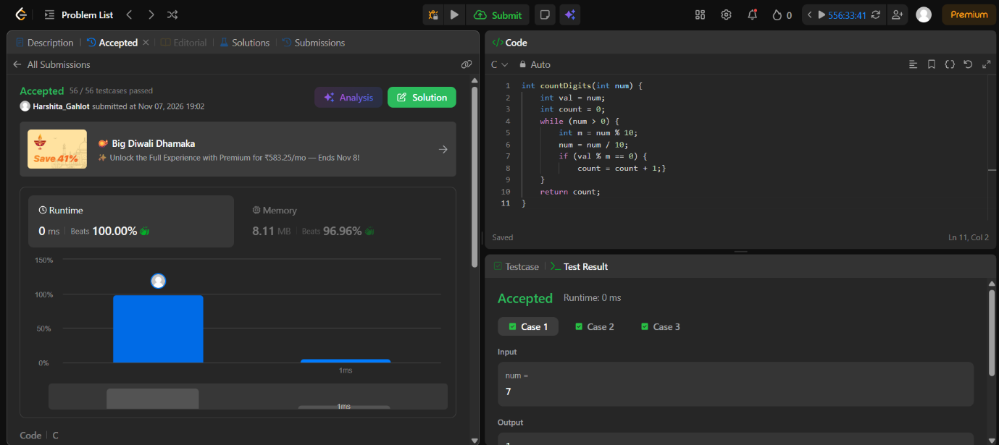

Code-
int countDigits(int num) {
int val = num;
int count = 0;
while (num > 0) {
int m = num % 10;
num = num / 10;
if (val % m == 0) {
count = count + 1;}
}
return count;
}

