HackerEarth – Read from STDIN, Write to STDOUT
https://www.hackerearth.com/practice/basic-programming/input-output/basics-of-input-output/practice-problems/algorithm/io-exercise/
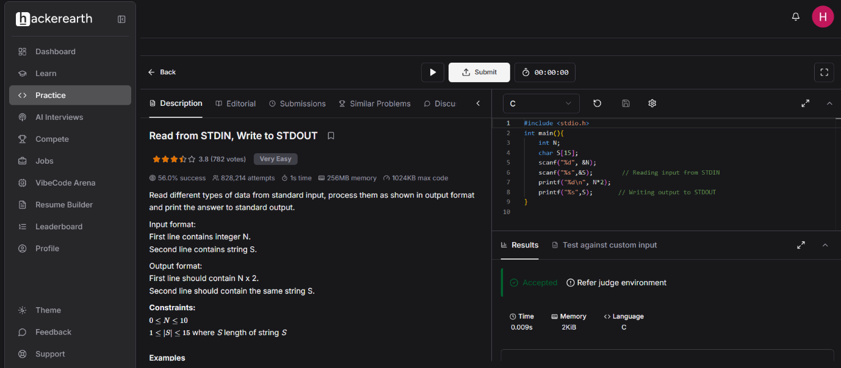

Code-
#include <stdio.h>
int main(){
int N;
char S[15];
scanf("%d", &N);
scanf("%s",&S); // Reading input from STDIN
printf("%d\n", N*2);
printf("%s",S); // Writing output to STDOUT
}

