Leetcode 231
https://leetcode.com/problems/power-of-two/
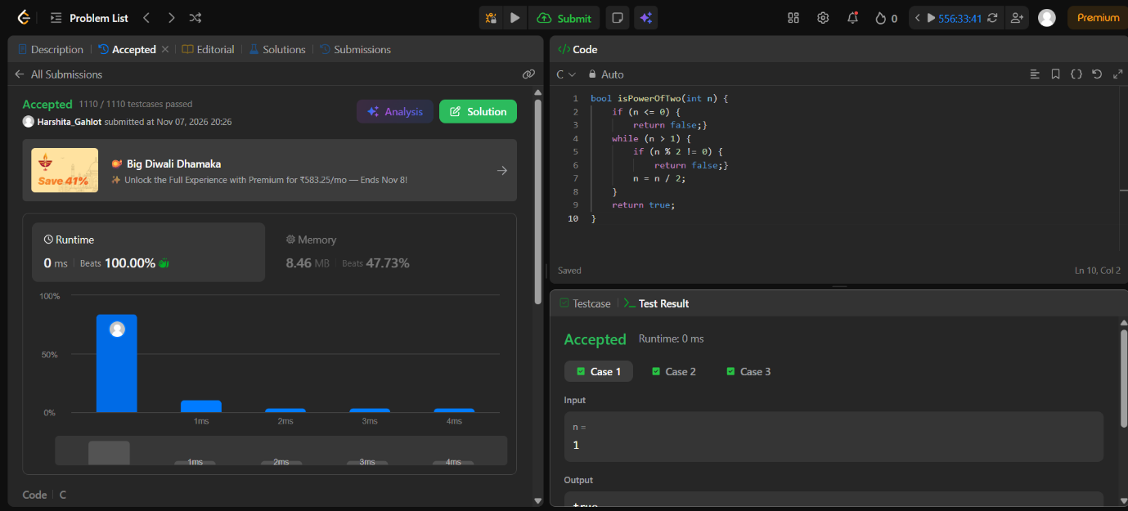

Code-
bool isPowerOfTwo(int n) {
if (n <= 0) {
return false;}
while (n > 1) {
if (n % 2 != 0) {
return false;}
n = n / 2;
}
return true;
}

