Leetcode 7
https://leetcode.com/problems/reverse-integer/
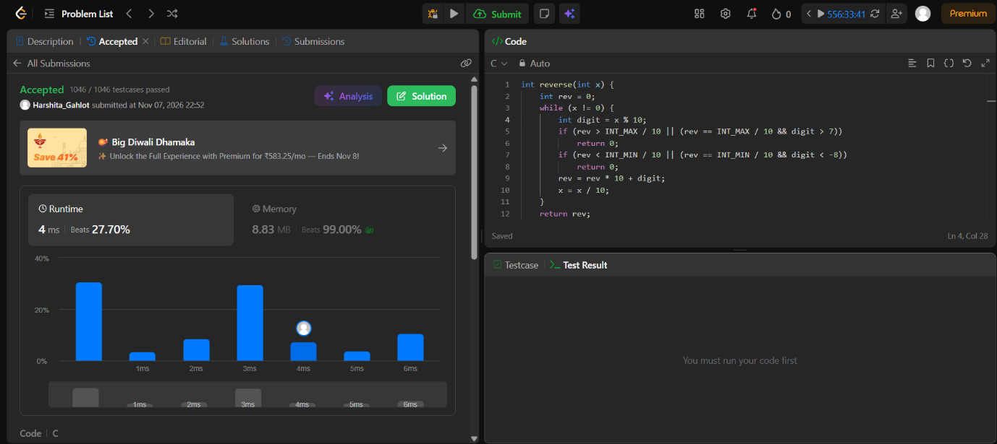

Code-
int reverse(int x) {
int rev = 0;
while (x != 0) {
int digit = x % 10;
if (rev > INT_MAX / 10 || (rev == INT_MAX / 10 && digit > 7))
return 0;
if (rev < INT_MIN / 10 || (rev == INT_MIN / 10 && digit < -8))
return 0;
rev = rev * 10 + digit;
x = x / 10;
}
return rev;
/ 10;
}

