HackerEarth – Prime Numbers
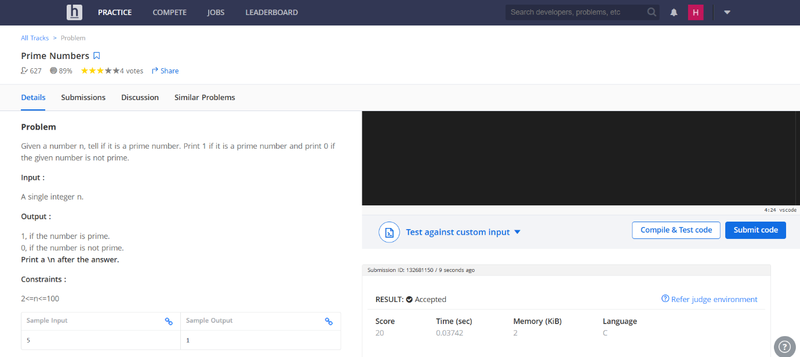
https://www.hackerearth.com/problem/algorithm/prime-numbers/

Code-
#include <stdio.h>
int main() {
int num, prime = 1;
scanf("%d", &num);
if (num <= 1) {
prime = 0;
}
else {
for (int i = 2; i * i <= num; i++) {
if (num % i == 0) {
prime = 0;
break;
}
}
}
printf("%d\n", prime);
return 0;
}

