Leetcode 2169
https://leetcode.com/problems/count-operations-to-obtain-zero/
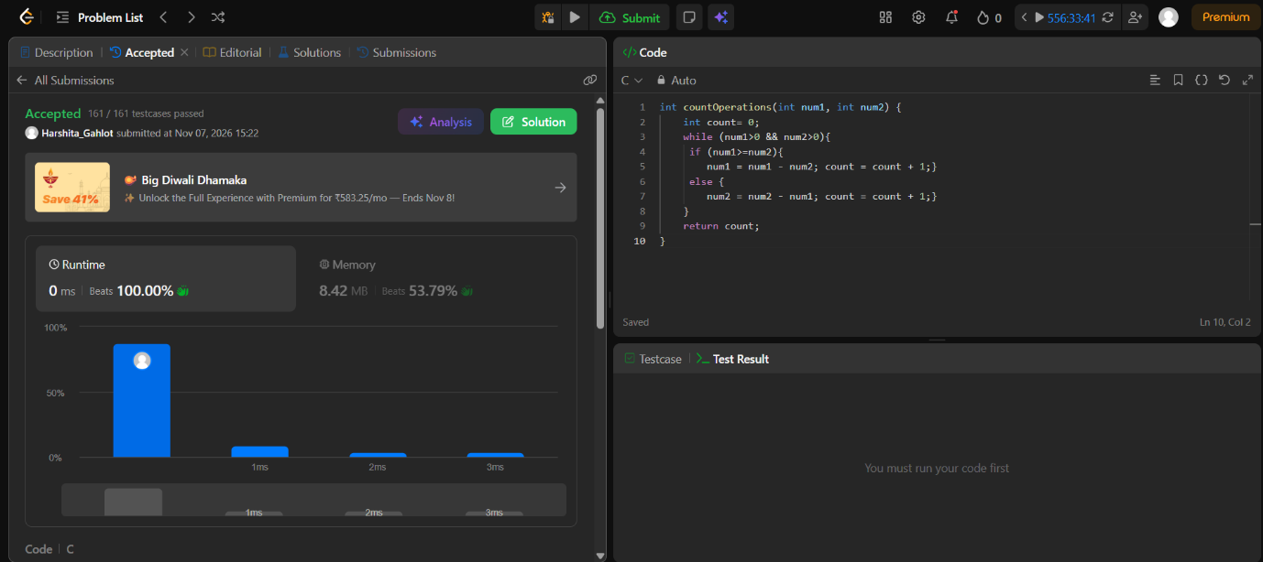

Code-
int countOperations(int num1, int num2) {
int count= 0;
while (num1>0 && num2>0){
if (num1>=num2){
num1 = num1 - num2; count = count + 1;}
else {
num2 = num2 - num1; count = count + 1;}
}
return count;
}

