Leetcode 507
https://leetcode.com/problems/perfect-number/
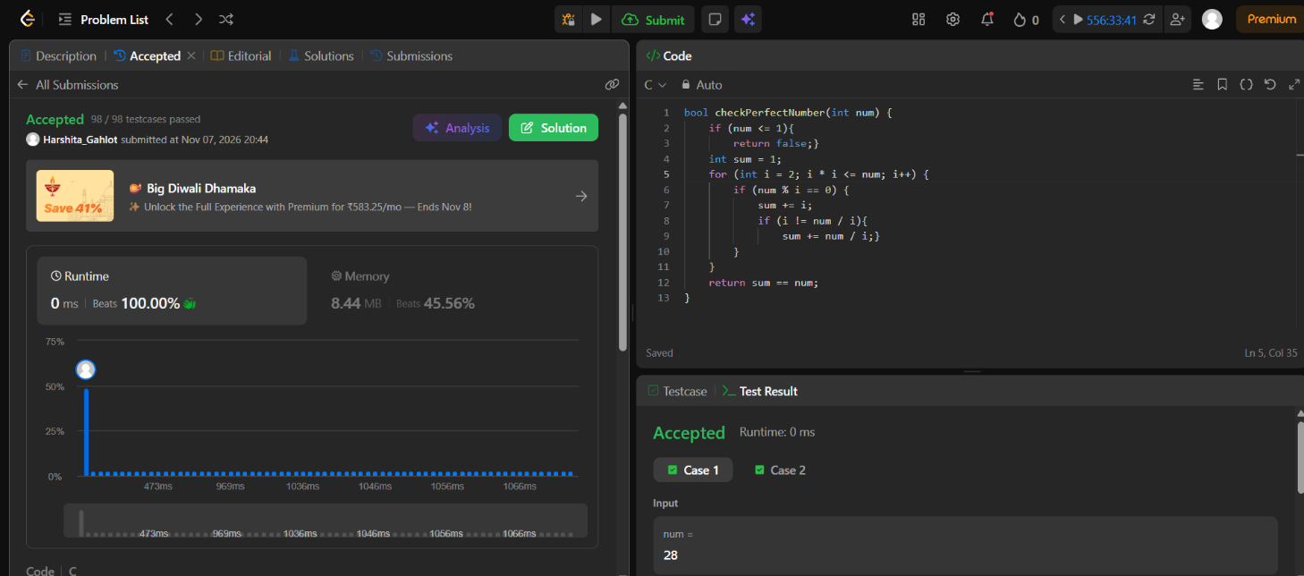

Code-
bool checkPerfectNumber(int num) {
if (num <= 1){
return false;}
int sum = 1;
for (int i = 2; i * i <= num; i++) {
if (num % i == 0) {
sum += i;
if (i != num / i){
sum += num / i;}
}
}
return sum == num;
}

