Leetcode 326
https://leetcode.com/problems/power-of-three/
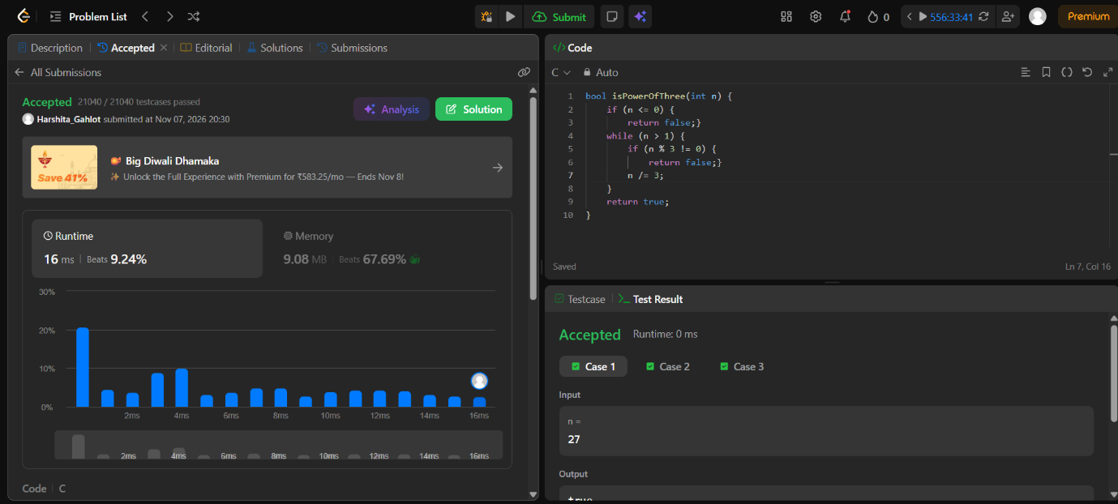

Code-
bool isPowerOfThree(int n) {
if (n <= 0) {
return false;}
while (n > 1) {
if (n % 3 != 0) {
return false;}
n /= 3;
}
return true;
}

