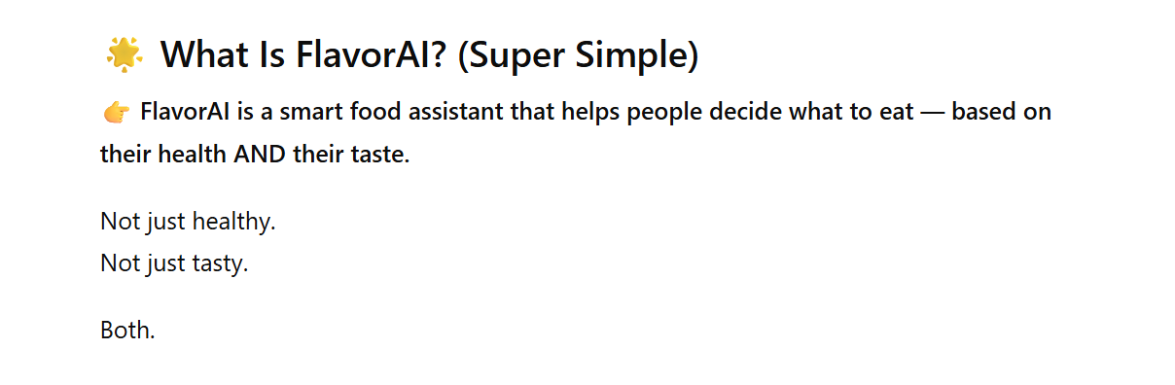
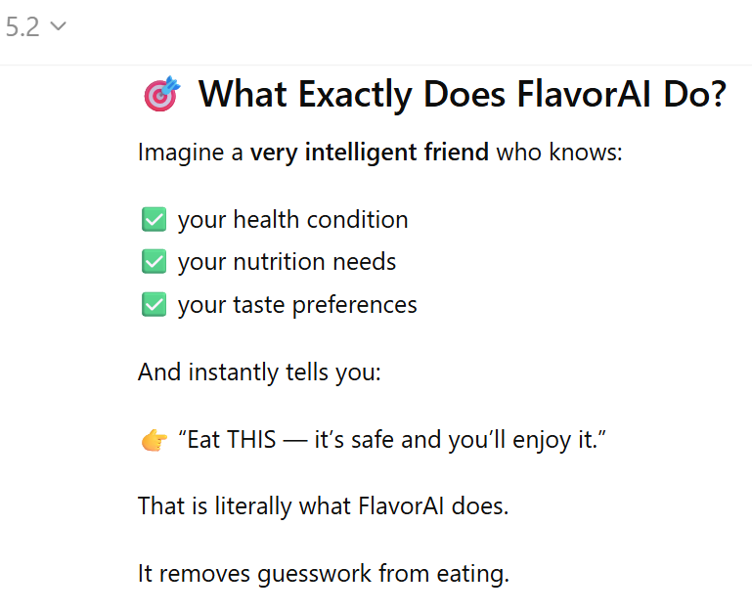
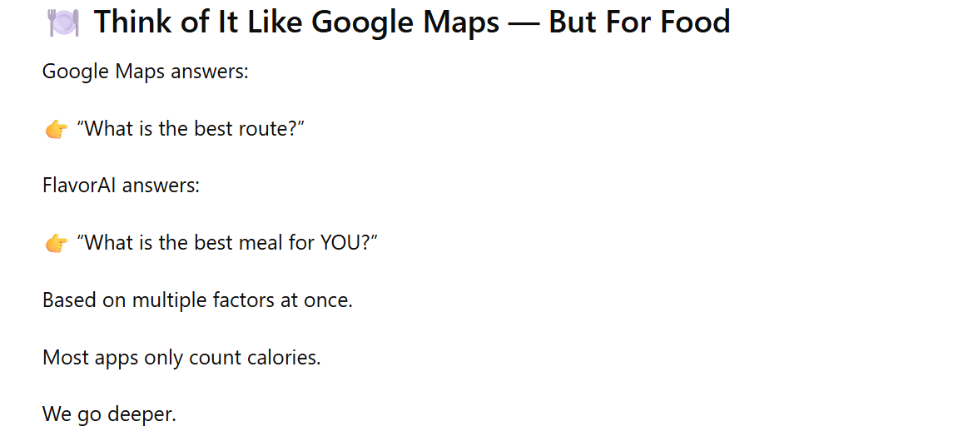
What Is Our Idea?
FlavorAI is an AI-powered meal recommendation system that helps people choose food that is both healthy and enjoyable.
Instead of giving generic diet plans, FlavorAI understands a user’s health condition, nutrition needs, and taste preferences — then recommends meals that are safe, personalized, and satisfying.
👉 Goal: Make healthy eating easier and sustainable so people don’t quit their diets.

⭐ How We Used the APIs
We combined two powerful food data APIs to build an intelligent decision system:
✅ RecipeDB — The Knowledge Layer
- Provides structured recipes, ingredients, and cooking details
- Gives macro and micronutrient information
- Helps filter meals based on medical and dietary restrictions
👉 Ensures every recommendation is nutritionally appropriate.

✅ FlavorDB — The Intelligence Layer
- Identifies ingredients that taste good together
- Suggests substitutions when certain foods must be avoided
- Helps maintain flavor even in restricted diets
👉 Ensures meals remain enjoyable, not boring.

⭐ One-Line Summary (VERY Useful)
👉 “RecipeDB helps us understand what is healthy, while FlavorDB helps us ensure it still tastes good — together enabling FlavorAI to recommend smarter meals.”

