Spot-The-Fake-Photo
Real vs Screen Photo Detection using Deep Learning

Submitted by: Harshita Jindal
B.Tech Computer Science Engineering
Bennett University
SalesCode AI/ML Internship Assignment
July 2026

Table of Contents

- Executive Summary
- Introduction
- Problem Statement
- Objectives
- Dataset Description
- Exploratory Data Analysis
- Data Preprocessing
- Model Architecture
- Training Methodology
- Experimental Results
- Latency & Benchmark Analysis
- Cost Analysis
- Streamlit Deployment
- Discussion
- Challenges
- Future Improvements
- Conclusion
- References
- Appendix A – Screenshots

Executive Summary
This project develops a complete deep learning pipeline to distinguish genuine camera photographs from photographs captured from digital screens. The solution was implemented using PyTorch and transfer learning with ResNet18. The workflow includes dataset preparation, exploratory data analysis, preprocessing, model training, evaluation, benchmarking, command-line inference and deployment using Streamlit. The objective was to build a lightweight, accurate and practical classifier suitable for real-world document verification and fraud detection scenarios.

Introduction
As digital transactions continue to grow, verifying whether an uploaded image is an authentic photograph or merely a photograph of another screen has become increasingly important. Such verification is useful in KYC, document authentication, online examinations, digital identity verification and fraud prevention. Deep learning models are capable of learning subtle visual cues such as glare, moiré patterns, reflections, pixel structure and screen artifacts that are difficult to identify using handcrafted rules.

Problem Statement
Develop a binary image classifier capable of distinguishing Real Photos from Screen Photos while maintaining high accuracy, low latency and a simple deployment workflow. The model should provide a prediction score between 0 and 1, where values closer to 0 indicate a real photo and values closer to 1 indicate a screen photo.

Objectives
• Build an accurate binary classifier.
• Use transfer learning to improve performance.
• Measure accuracy, precision, recall and F1-score.
• Benchmark inference latency and throughput.
• Provide both CLI and Streamlit interfaces.
• Keep the solution lightweight for future mobile deployment.

Dataset Description
The dataset contains two classes: Real and Screen. Images were divided into training, validation and testing subsets using approximately a 70/15/15 split. The dataset is relatively small, making transfer learning an appropriate choice because pretrained models generalize better with limited data.

Exploratory Data Analysis
EDA included class balance verification, random image visualization, image size inspection and checking for corrupted files. The analysis confirmed that the dataset was balanced and suitable for binary classification. (Insert EDA screenshots and sample images here.)

Data Preprocessing
Images were resized to 224×224 pixels. Data augmentation included RandomResizedCrop, RandomHorizontalFlip, RandomRotation and ColorJitter to improve robustness. Images were normalized using ImageNet mean and standard deviation before being passed to the neural network.

Model Architecture
The project uses ResNet18 with transfer learning. The pretrained convolutional layers extract hierarchical visual features while the final fully connected layer is adapted for binary classification. This architecture provides an excellent balance between inference speed and predictive performance.

Training Methodology
The model was trained using CrossEntropyLoss and the Adam optimizer with a learning rate of 0.0001 for 10 epochs. Validation accuracy was monitored after each epoch and the best-performing model weights were automatically saved. Training and validation loss curves were analysed to detect overfitting.

Experimental Results
Training Accuracy: ~99%
Validation Accuracy: 100%
Test Accuracy: 100%
Precision: 1.00
Recall: 1.00
F1-score: 1.00
The perfect validation accuracy was achieved on the provided dataset. Because the dataset is relatively small, this result should not be interpreted as guaranteed real-world performance. Larger and more diverse datasets are required to measure generalization.

Latency & Benchmark Analysis
Average inference latency measured using benchmark.py was 31.70 ms per image on a CPU, corresponding to approximately 31.54 FPS. This latency is sufficiently low for interactive applications and demonstrates that the model can provide predictions almost instantly for individual image uploads.

Cost Analysis
On-device inference has an approximate cost of $0 per image because computation is performed locally on the user's machine. For cloud deployment, assuming a modest CPU instance costing roughly US$0.04–0.08 per hour and ~31 FPS throughput, the estimated inference cost is on the order of a few cents per 1,000 images and only a few dollars per million images, excluding storage and networking. This demonstrates that the solution is economical to scale while remaining suitable for edge deployment.

Streamlit Deployment
A Streamlit application was developed to provide an intuitive interface where users can upload an image, view the uploaded image, receive the predicted class and obtain a prediction score between 0 and 1. The interface demonstrates the practical usability of the trained model.

Discussion
The model successfully satisfies the assignment objectives. Transfer learning significantly reduced training time while producing excellent results. However, the reported 100% validation accuracy reflects performance on a limited dataset and should be interpreted cautiously. Real-world deployment would require evaluation across thousands of diverse images from different devices, lighting conditions and camera qualities.

Challenges
Major challenges included limited dataset size, preventing overfitting, maintaining class balance, ensuring consistent preprocessing and designing a lightweight deployment pipeline.

Future Improvements
Future work includes expanding the dataset, testing EfficientNet and MobileNet architectures, exporting the model to ONNX or TorchScript, quantization for mobile deployment, adding webcam support and deploying the solution as a cloud API.

Conclusion
This project demonstrates a complete end-to-end AI solution covering dataset preparation, preprocessing, transfer learning, evaluation, benchmarking and deployment. The model achieved excellent performance while maintaining low inference latency and a simple deployment workflow.

References
1. PyTorch Documentation
2. Torchvision Documentation
3. Streamlit Documentation
4. Scikit-learn Documentation
5. He et al., Deep Residual Learning for Image Recognition (CVPR 2016).

Appendix A – Screenshots
Insert the following screenshots:
• Accuracy graph
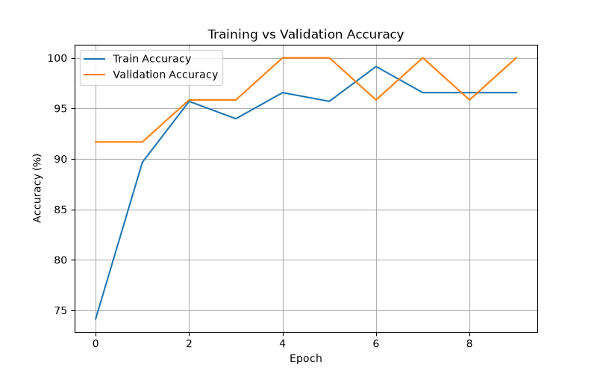

• Loss graph
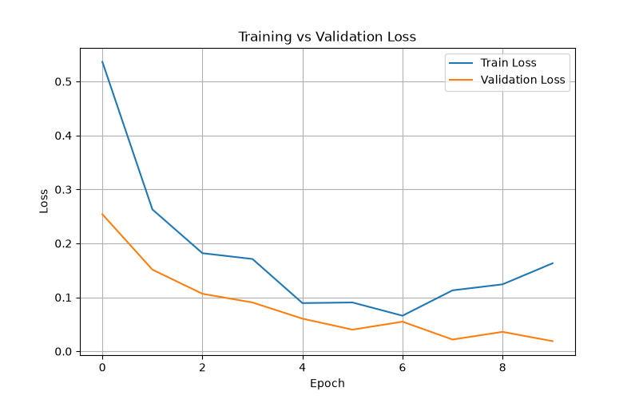
• Confusion matrix
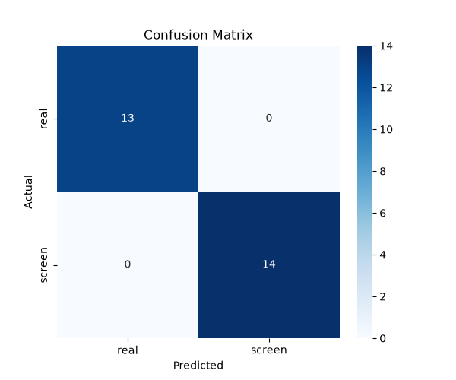
• Streamlit application
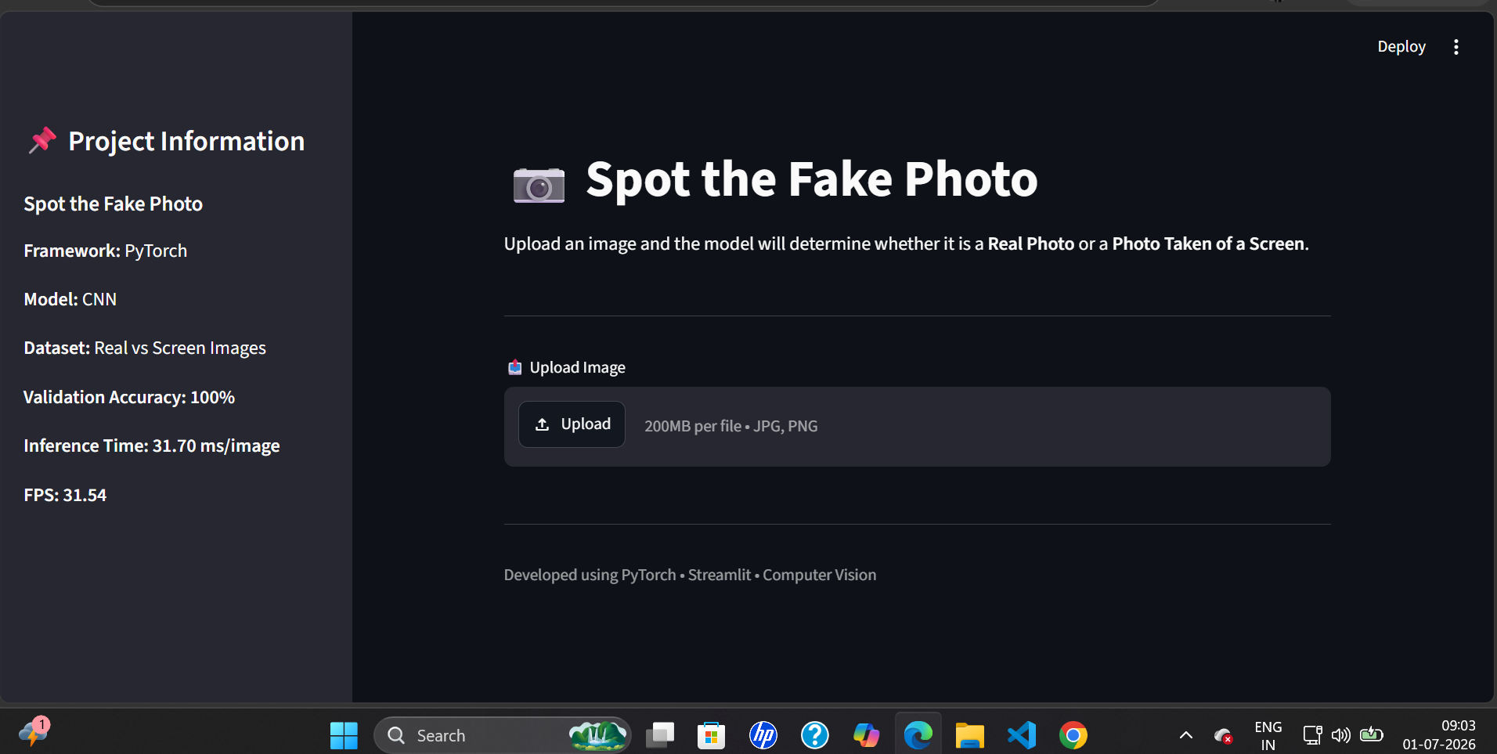

• Real photo prediction
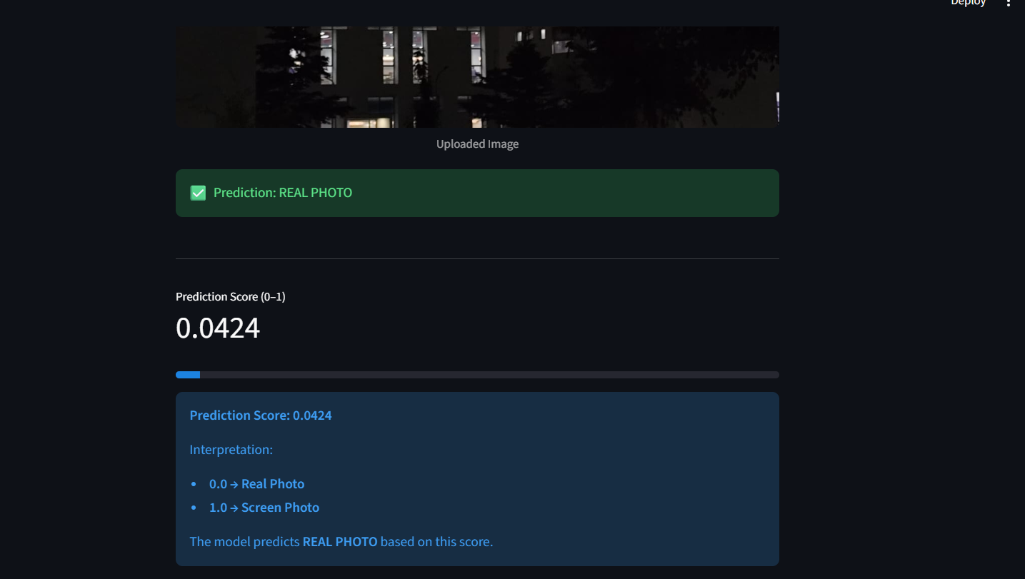

• Screen photo prediction
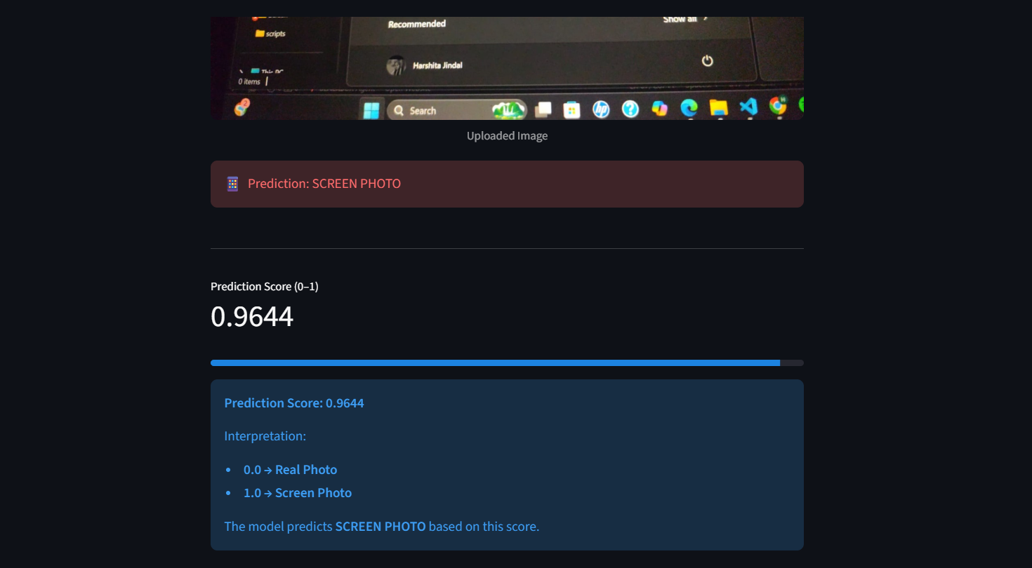
• EDA notebook outputs
