REQUIREMENT DOCUMENT

Development Environment Setup

1. Install VS Code.
2. Create Work-Space.
3. Create Index.html.

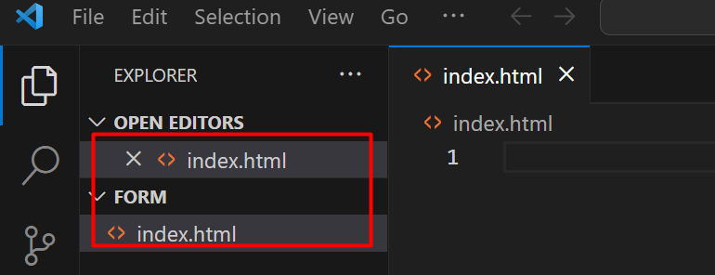

4.Add BootStrap Template.

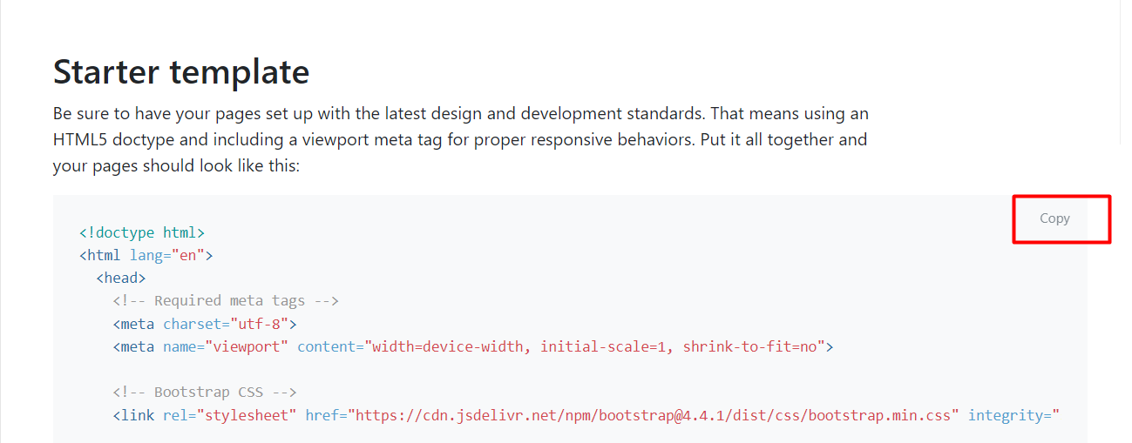

4.Verify your changes.

PHASE -I

1. After submit pop Up.
2. Can’t store duplicate email id and give pop up .
3. All fields are mandatory.
4. Show data at the right side of page.
5. Onclick on delete btn pop up will appear ask Boolean (yes or no).

PHASE - II

1.Create the form using html.

2. console the form data.

3. Convert form data into a JS Object.

4. Push the object into array .

5. Iterate array.

6. Create html string.

7. Inject into DOM.

8. check on delete btn.

a. popup- yes or no

b. y- get del btn id

ed.pop (a=> a.id =id)

9. Render the table.

PHASE – 3

1. All fields are mandatory.

2. Duplicate mails id . (warning)

3. encryption.

4. Email format. (with js).

OUTPUT

