**WEEK - 5**

**Microservices with Spring Boot 3 and Spring Cloud**

**Creating Microservices for account and loan**

**AccountController.java**

package com.cognizant.account;

import org.springframework.web.bind.annotation.*;

import java.util.Map;

@RestController

@RequestMapping("/accounts")

public class AccountController {

@GetMapping("/{number}")

public Map<String, Object> getAccount(@PathVariable String number) {

return Map.of(

"number", number,

"type", "savings",

"balance", 234343

);

}

}

**OUTPUT:**

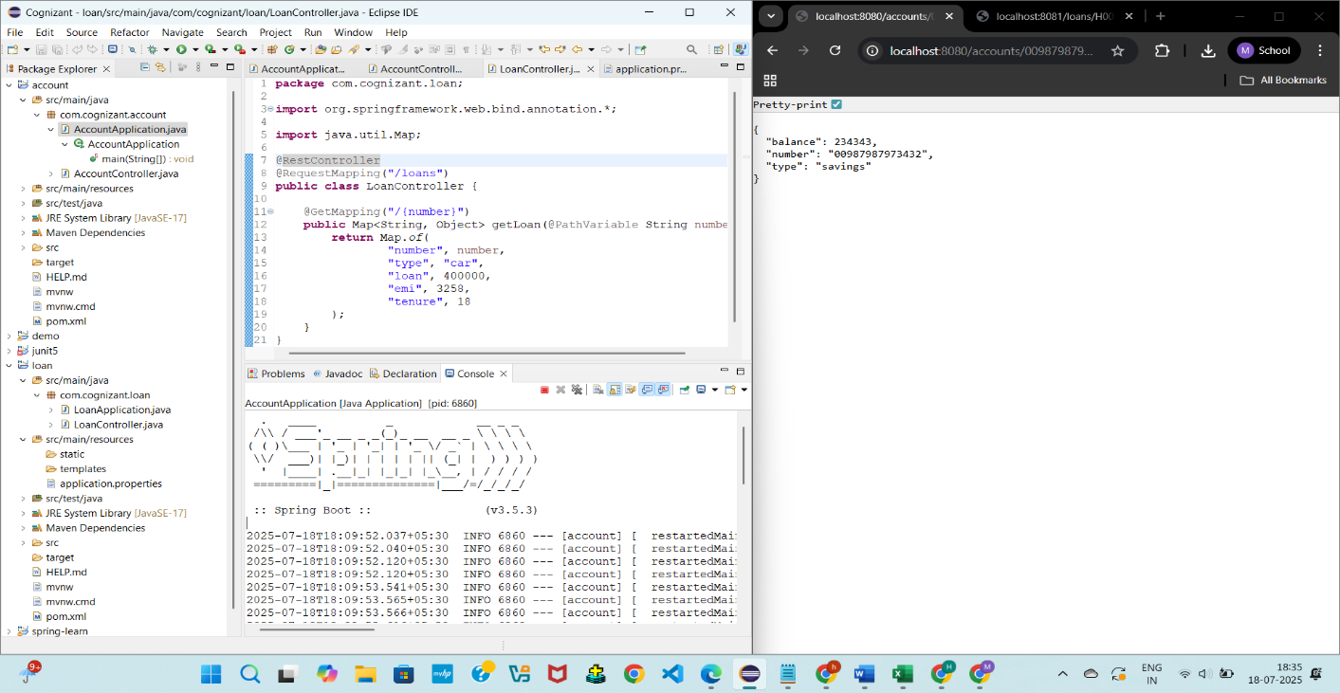

**LoanController.java**

package com.cognizant.loan;

import org.springframework.web.bind.annotation.*;

import java.util.Map;

@RestController

@RequestMapping("/loans")

public class LoanController {

@GetMapping("/{number}")

public Map<String, Object> getLoan(@PathVariable String number) {

return Map.of(

"number", number,

"type", "car",

"loan", 400000,

"emi", 3258,

"tenure", 18

);

}

}

**OUTPUT:**

