**WEEK - 6**

**React**

**1. ReactJS-HOL**

**App.js**

function App(){

  return (

    <h1>Welcome to the first session of React</h1>

  );

}

export default App;

**OUTPUT:**

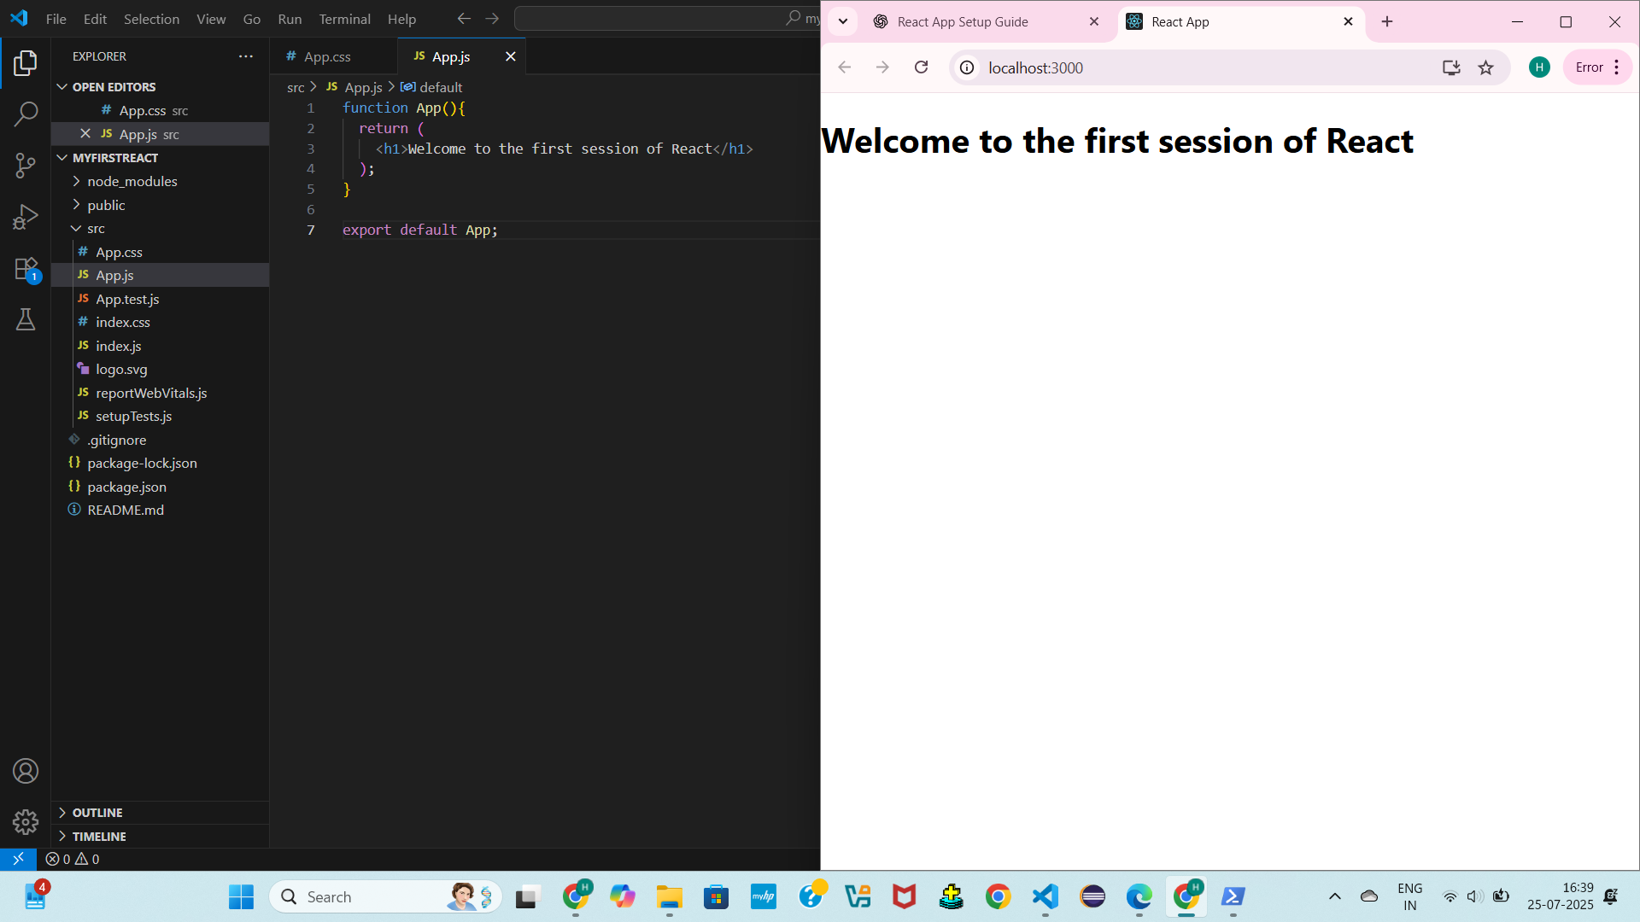

**2. ReactJS-HOL**

**Home.js**

import React from 'react';

function Home() {

  return (

    <div>

      <h2>Welcome to the Home page of Student Management Portal</h2>

    </div>

  );

}

export default Home;

**About.js**

import React from 'react';

function About() {

  return (

    <div>

      <h2>Welcome to the About page of Student Management Portal</h2>

    </div>

  );

}

export default Home;

**Contact.js**

import React from 'react';

function Contact() {

  return (

    <div>

      <h2>Welcome to the Contact page of Student Management Portal</h2>

    </div>

  );

}

export default Home;

**OUTPUT:**

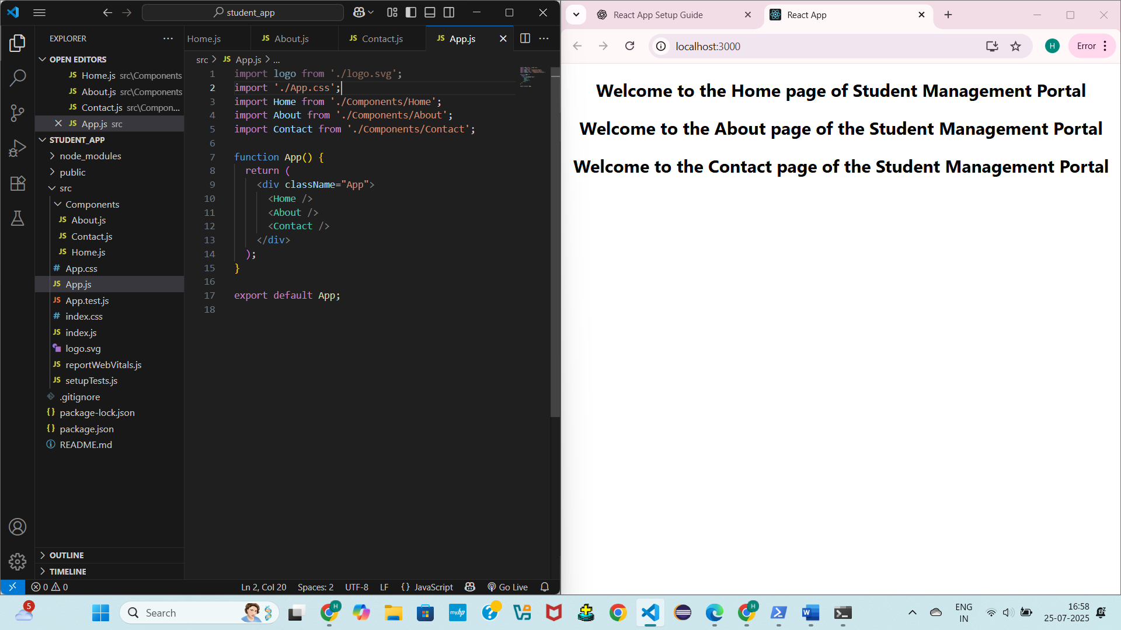

**3. ReactJS-HOL**

**CalculateScore.js**

import '../Stylesheets/mystyle.css';

const percentToDecimal = (decimal) => {

  return (decimal.toFixed(2) + '%');

};

const calcScore = (total, goal) => {

  return percentToDecimal(total / goal);

};

const CalculateScore = ({ Name, School, total, goal }) => {

  return (

    <div className="formatStyle">

      <h1><font color="brown">Student Details:</font></h1>

      <div className="Name">

        <b><span>Name: </span></b>

        <span>{Name}</span>

      </div>

      <div className="School">

        <b><span>School: </span></b>

        <span>{School}</span>

      </div>

      <div className="Total">

        <b><span>Total: </span></b>

        <span>{total}</span>

        <span> Marks</span>

      </div>

      <div className="Score">

        <b><span>Score: </span></b>

        <span>{calcScore(total, goal)}</span>

      </div>

    </div>

  );

};

export default CalculateScore;

**mystyle.css**

Name{

    font-weight: 300;

    color: blue;

}

.School{

    color: crimson;

}

.Total{

    color: darkmagenta;

}

.formatstyle{

    text-align: center;

    font-size: large;

}

.Score{

    color: forestgreen;

}

**OUTPUT:**

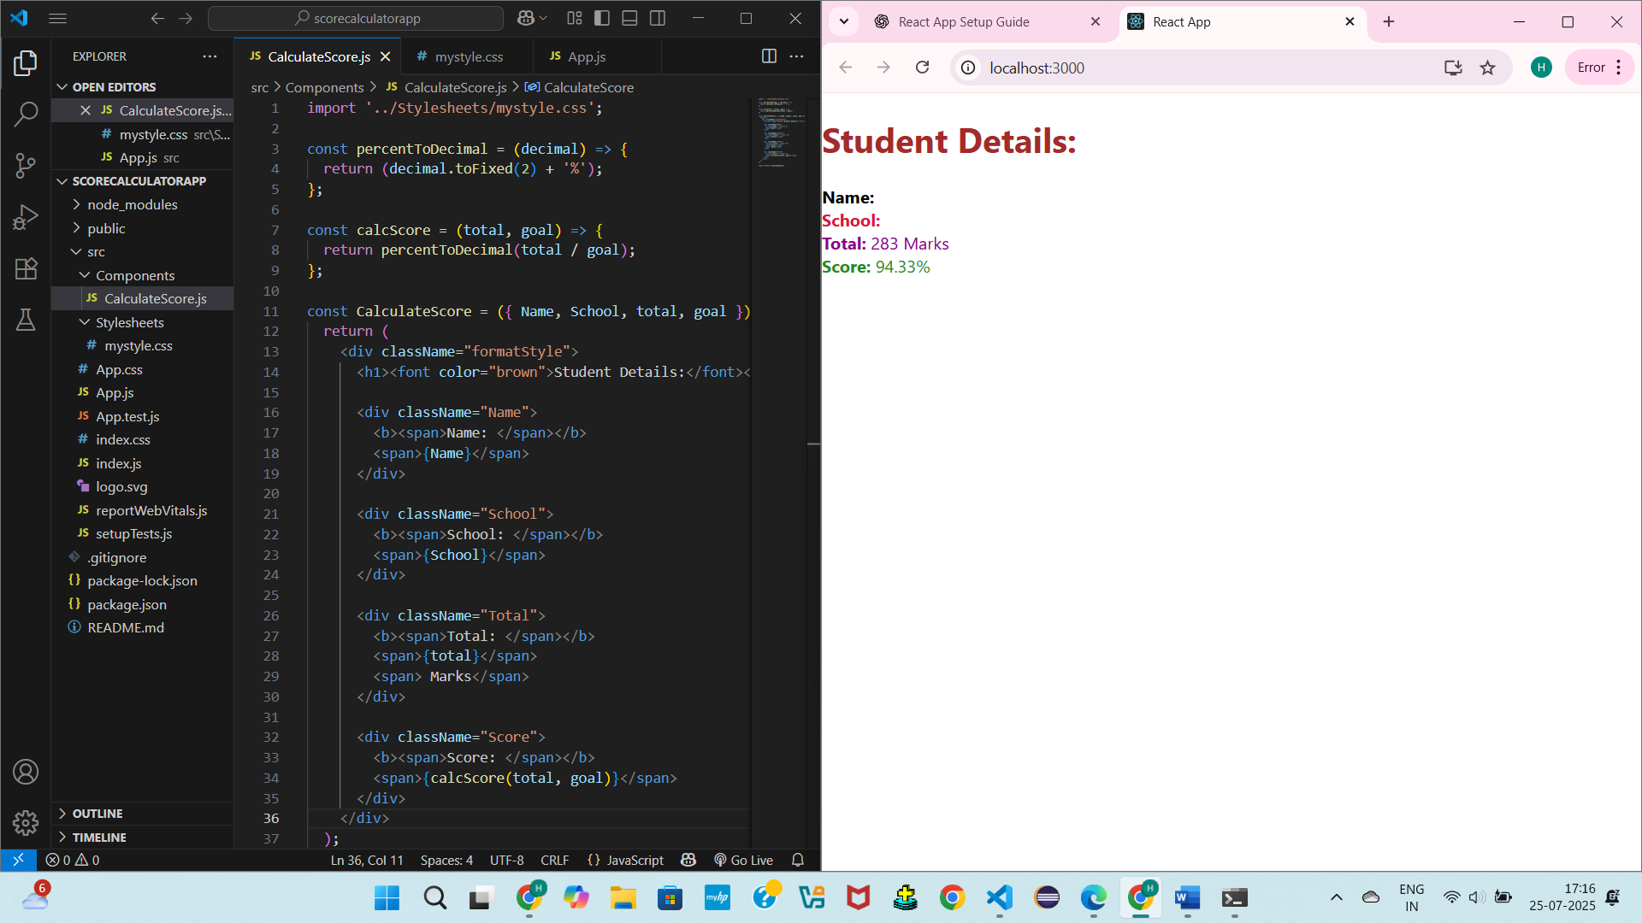

**4. ReactJS-HOL**

**Post.js**

import React from 'react';

function Post({ title, body }) {

  return (

    <div style={{ marginBottom: '20px' }}>

      <h3>{title}</h3>

      <p>{body}</p>

    </div>

  );

}

export default Post;

**Posts.js**

import React, { Component } from 'react';

import Post from './Post';

class Posts extends Component {

  constructor(props) {

    super(props);

    this.state = {

      posts: [],

      error: null

    };

  }

  loadPosts() {

    fetch('https://jsonplaceholder.typicode.com/posts')

      .then(response => response.json())

      .then(data => this.setState({ posts: data }))

      .catch(error => {

        this.setState({ error });

        alert('Error fetching posts: ' + error.message);

      });

  }

  componentDidMount() {

    this.loadPosts();

  }

  componentDidCatch(error, info) {

    alert('An unexpected error occurred: ' + error.toString());

  }

  render() {

    const { posts } = this.state;

    return (

      <div style={{ padding: '20px' }}>

        <h2>Blog Posts</h2>

        {posts.map(post => (

          <Post key={post.id} title={post.title} body={post.body} />

        ))}

      </div>

    );

  }

}

export default Posts;

**OUTPUT:**

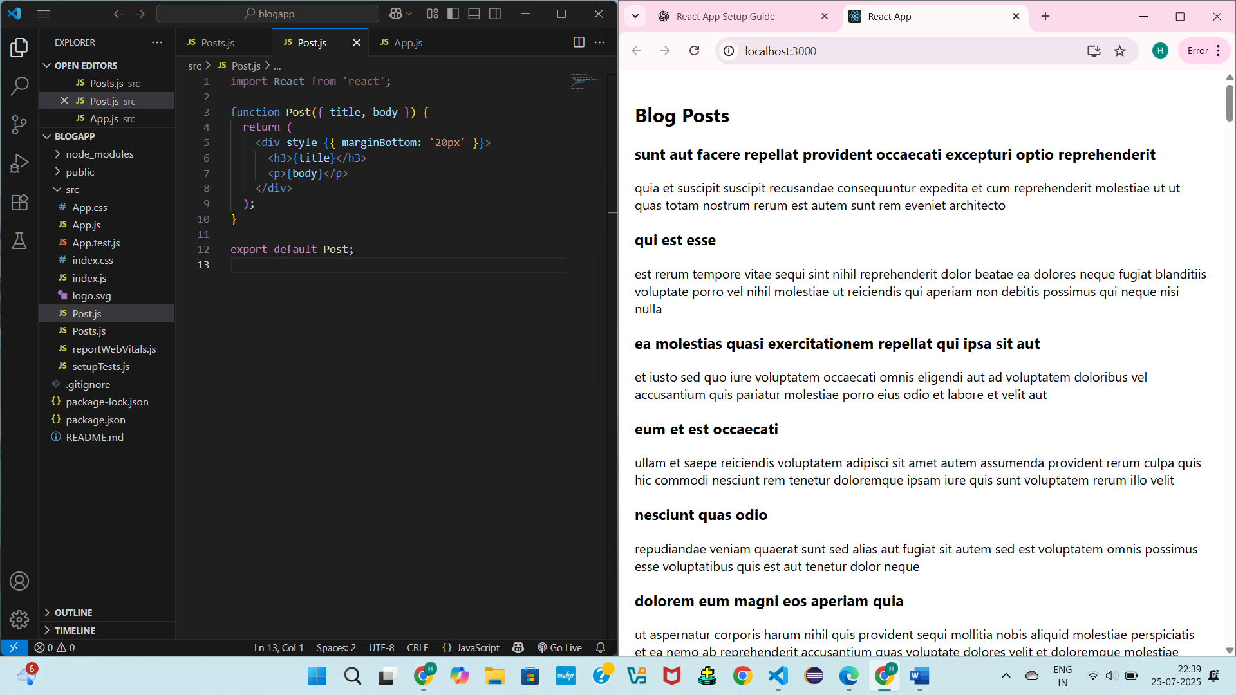

**5. ReactJS-HOL**

**CohortDetails.js**

import React from "react";

import styles from "../styles/CohortDetails.module.css";

const CohortDetails = () => {

  const cohorts = [

    {

      name: "INTADMDF10 -.NET FSD",

      startDate: "22-Feb-2022",

      status: "Scheduled",

      coach: "Aathma",

      trainer: "Jojo Jose",

    },

    {

      name: "ADM21JF014 - Java FSD",

      startDate: "10-Sep-2021",

      status: "Ongoing",

      coach: "Apoorv",

      trainer: "Elisa Smith",

    },

    {

      name: "CDBJF21025 - Java FSD",

      startDate: "24-Dec-2021",

      status: "Ongoing",

      coach: "Aathma",

      trainer: "John Doe",

    },

  ];

  return (

    <div>

      <h2><strong>Cohorts Details</strong></h2>

      {cohorts.map((cohort, index) => (

        <div key={index} className={styles.box}>

          <h3 className={cohort.status.toLowerCase() === "ongoing"

? styles.ongoing

                : styles.scheduled}>

            {cohort.name}

          </h3>

          <dl>

            <dt>Started On</dt>

            <dd>{cohort.startDate}</dd>

            <dt>Current Status</dt>

            <dd>{cohort.status}</dd>

            <dt>Coach</dt>

            <dd>{cohort.coach}</dd>

            <dt>Trainer</dt>

            <dd>{cohort.trainer}</dd>

          </dl>

        </div>

      ))}

    </div>

  );

};

export default CohortDetails;

**CohortDetails.module.css**

.box {

  width: 300px;

  display: inline-block;

  margin: 10px;

  padding: 10px 20px;

  border: 1px solid black;

  border-radius: 10px;

  vertical-align: top;

}

dt {

  font-weight: 500;

}

.ongoing {

  color: green;

}

.scheduled {

  color: blue;

}

**OUTPUT:**

