**WEEK - 7**

**React**

**9. ReactJS-HOL**

**ListOfPlayers.js**

import React from 'react';

const ListofPlayers = () => {

const players = [

{ name: 'Virat', score: 88 },

{ name: 'Rohit', score: 67 },

{ name: 'KL Rahul', score: 72 },

{ name: 'Shreyas', score: 45 },

{ name: 'Jadeja', score: 91 },

{ name: 'Hardik', score: 69 },

{ name: 'Bumrah', score: 32 },

{ name: 'Ashwin', score: 77 },

{ name: 'Gill', score: 84 },

{ name: 'Surya', score: 49 },

{ name: 'Ishan', score: 56 },

];

const lowScorers = players.filter(player => player.score < 70);

return (

<div>

<h2>All Players</h2>

{players.map((player, index) => (

<p key={index}>{player.name}: {player.score}</p>

))}

<h2>Players with Score Below 70</h2>

{lowScorers.map((player, index) => (

<p key={index}>{player.name}: {player.score}</p>

))}

</div>

);

};

export default ListofPlayers;

**IndianPlayers.js**

// src/components/IndianPlayers.js

import React from 'react';

const IndianPlayers = () => {

const team = ['Kohli', 'Rohit', 'Rahul', 'Jadeja', 'Bumrah', 'Ashwin'];

const oddPlayers = team.filter((_, index) => index % 2 === 1);

const evenPlayers = team.filter((_, index) => index % 2 === 0);

const [T20players, RanjiPlayers] = [

['Rohit', 'Surya', 'Bumrah'],

['Pujara', 'Rahane', 'Shaw'],

];

const allPlayers = [...T20players, ...RanjiPlayers];

return (

<div>

<h2>Odd Team Players</h2>

{oddPlayers.map((p, i) => <p key={i}>{p}</p>)}

<h2>Even Team Players</h2>

{evenPlayers.map((p, i) => <p key={i}>{p}</p>)}

<h2>Merged Players (T20 + Ranji)</h2>

{allPlayers.map((p, i) => <p key={i}>{p}</p>)}

</div>

);

};

export default IndianPlayers;

**App.js**

// src/App.js

import React from 'react';

import ListofPlayers from './components/ListofPlayers';

import IndianPlayers from './components/IndianPlayers';

function App() {

const flag = true; // change to false to show IndianPlayers

return (

<div className="App">

<h1>Welcome to Cricket App</h1>

{flag ? <ListofPlayers /> : <IndianPlayers />}

</div>

);

}

export default App;

**OUTPUT:**

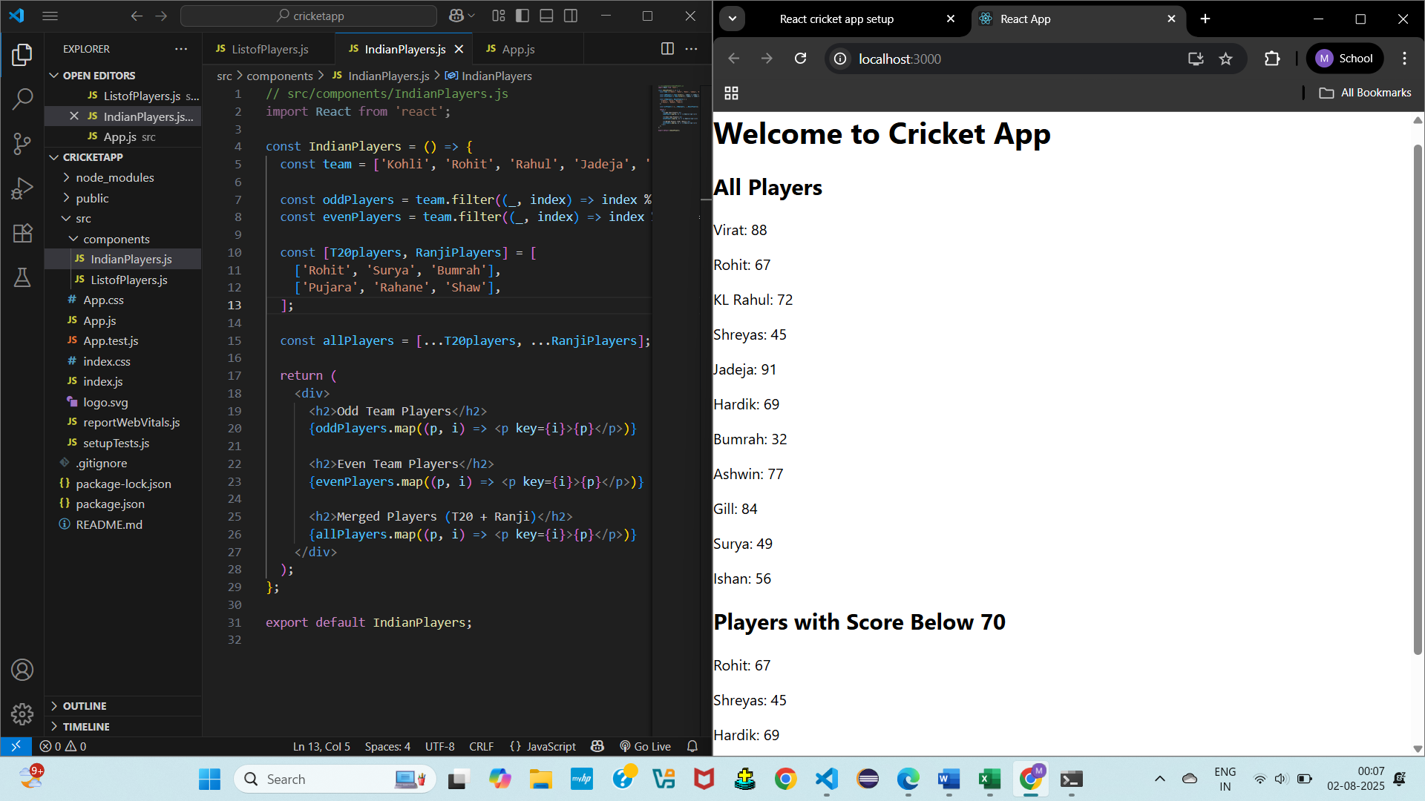

**10. ReactJS-HOL**

**App.js**

import React from 'react';

import './App.css';

function App() {

// Heading element

const heading = <h1>Office Space Rental App</h1>;

// Image attribute (URL or local image)

const officeImage = "https://via.placeholder.com/300x200?text=Office+Image";

// Office object

const office = {

name: "Elite Co-working Space",

rent: 55000,

address: "123 Tech Park, Bengaluru"

};

// List of office spaces

const officeList = [

{ name: "Tech Hub", rent: 45000, address: "MG Road, Bangalore" },

{ name: "StartUp Nest", rent: 60000, address: "Koramangala, Bangalore" },

{ name: "Enterprise Space", rent: 75000, address: "Indiranagar, Bangalore" },

{ name: "Remote Hub", rent: 50000, address: "HSR Layout, Bangalore" }

];

return (

<div className="App">

{heading}

<img src={officeImage} alt="Office Space" style={{ width: "300px", height: "200px" }} />

<h2>Featured Office</h2>

<p><strong>Name:</strong> {office.name}</p>

<p>

<strong>Rent:</strong> <span style={{ color: office.rent > 60000 ? 'green' : 'red' }}>

₹{office.rent}

</span>

</p>

<p><strong>Address:</strong> {office.address}</p>

<h2>Available Office Spaces</h2>

{officeList.map((item, index) => (

<div key={index} style={{ border: "1px solid #ccc", padding: "10px", margin: "10px" }}>

<p><strong>Name:</strong> {item.name}</p>

<p>

<strong>Rent:</strong> <span style={{ color: item.rent > 60000 ? 'green' : 'red' }}>

₹{item.rent}

</span>

</p>

<p><strong>Address:</strong> {item.address}</p>

</div>

))}

</div>

);

}

export default App;

**OUTPUT:**

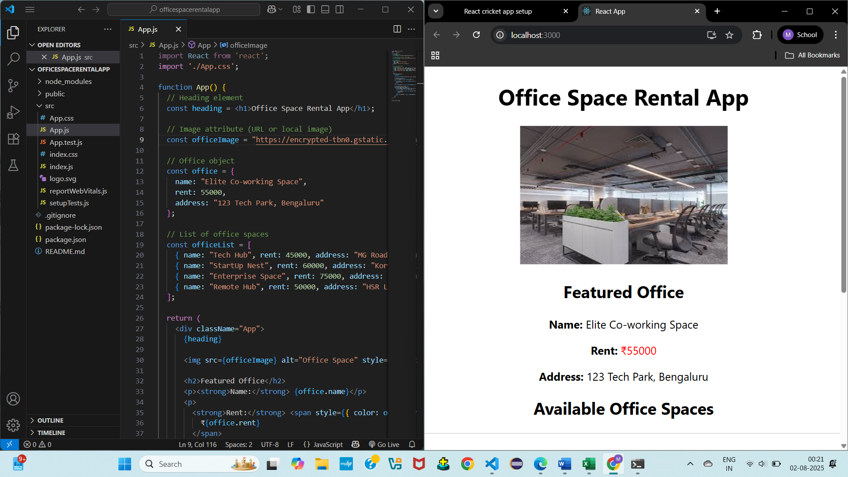

**11. ReactJS-HOL**

**App,js**

import React, { useState } from 'react';

import CurrencyConvertor from './CurrencyConvertor';

function App() {

const [count, setCount] = useState(0);

// 1a. Increment value

const increment = () => {

setCount(prev => prev + 1);

sayHello(); // calling second method too

};

// 1b. Say Hello method

const sayHello = () => {

console.log("Hello! You clicked increment.");

};

// Decrement method

const decrement = () => {

setCount(prev => prev - 1);

};

// 2. Say welcome with argument

const sayMessage = (msg) => {

alert(msg);

};

// 3. Synthetic event handler

const handleClick = () => {

alert("I was clicked");

};

return (

<div className="App" style={{ padding: 20 }}>

<h1>Event Examples App</h1>

<h2>Counter: {count}</h2>

<button onClick={increment}>Increment</button>

<button onClick={decrement}>Decrement</button>

<br /><br />

<button onClick={() => sayMessage("Welcome!")}>Say Welcome</button>

<br /><br />

<button onClick={handleClick}>Click Me</button>

<br /><br />

<CurrencyConvertor />

</div>

);

}

export default App;

**CurrencyConvertor.js**

import React, { useState } from 'react';

function CurrencyConvertor() {

const [rupees, setRupees] = useState('');

const [euro, setEuro] = useState('');

const handleSubmit = () => {

const rupeeValue = parseFloat(rupees);

if (!isNaN(rupeeValue)) {

const euroValue = (rupeeValue / 90).toFixed(2); // assume 1 euro = 90 INR

setEuro(euroValue);

}

};

return (

<div>

<h2>Currency Convertor</h2>

<input

type="text"

placeholder="Enter INR"

value={rupees}

onChange={(e) => setRupees(e.target.value)}

/>

<button onClick={handleSubmit}>Convert</button>

<p>In Euros: €{euro}</p>

</div>

);

}

export default CurrencyConvertor;

**OUTPUT:**

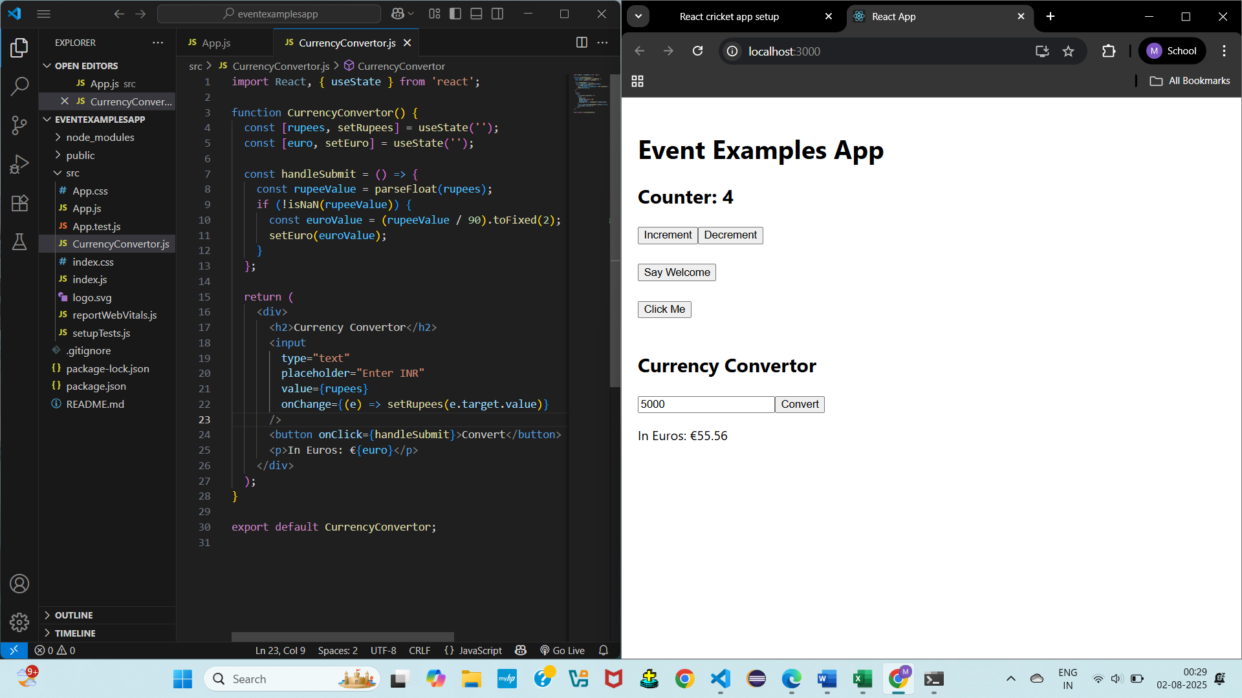

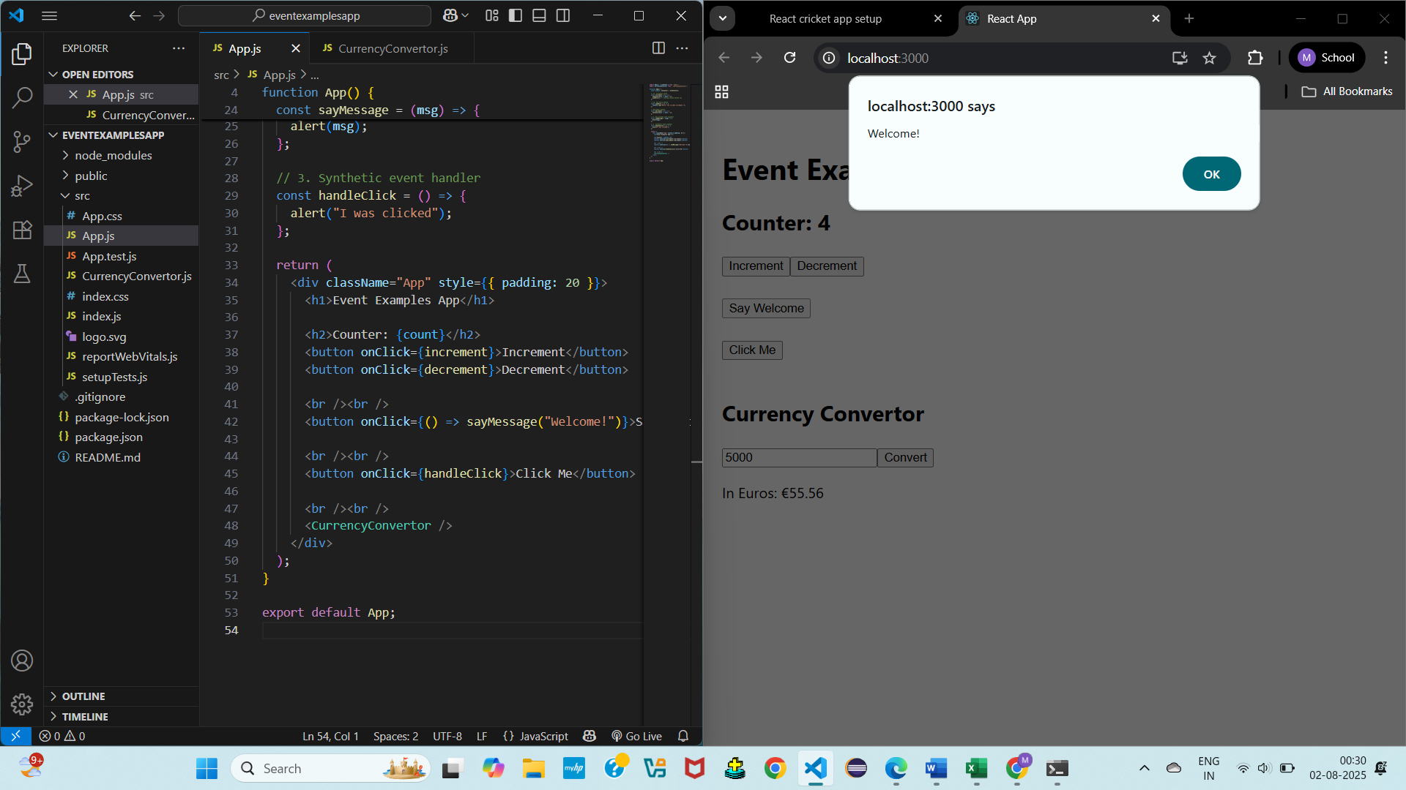

**12. ReactJS-HOL**

**App.js**

import React, { useState } from 'react';

import GuestPage from './GuestPage';

import UserPage from './UserPage';

function App() {

  const [isLoggedIn, setIsLoggedIn] = useState(false);

  const handleLogin = () => setIsLoggedIn(true);

  const handleLogout = () => setIsLoggedIn(false);

  return (

    <div className="App" style={{ padding: 20 }}>

      <h1>Ticket Booking App</h1>

      {isLoggedIn ? (

        <>

          <UserPage />

          <button onClick={handleLogout}>Logout</button>

        </>

      ) : (

        <>

          <GuestPage />

          <button onClick={handleLogin}>Login</button>

        </>

      )}

    </div>

  );

}

export default App;

**GuestPage.js**

import React from 'react';

function GuestPage() {

  return (

    <div>

      <h2>Guest View</h2>

      <p>You can browse flight details below:</p>

      <ul>

        <li> Delhi → Mumbai | Time: 10:00 AM</li>

        <li> Bengaluru → Chennai | Time: 2:00 PM</li>

        <li> Kolkata → Hyderabad | Time: 6:30 PM</li>

      </ul>

      <p><i>Login to book tickets.</i></p>

    </div>

  );

}

export default GuestPage;

**UserPage.js**

import React from 'react';

function UserPage() {

  return (

    <div>

      <h2>User View</h2>

      <p>Welcome! You can now book your tickets.</p>

      <button>Book Ticket</button>

    </div>

  );

}

export default UserPage;

**OUTPUT:**

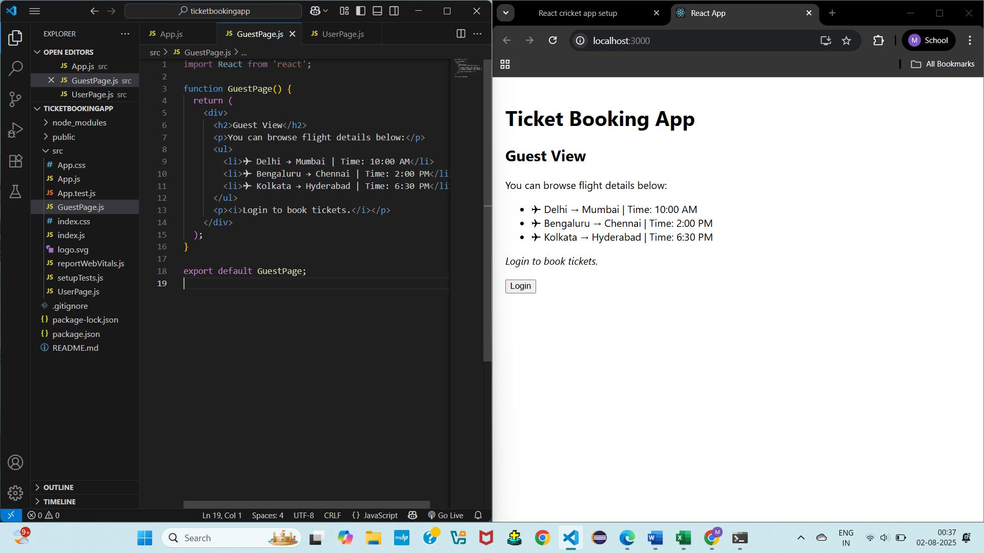

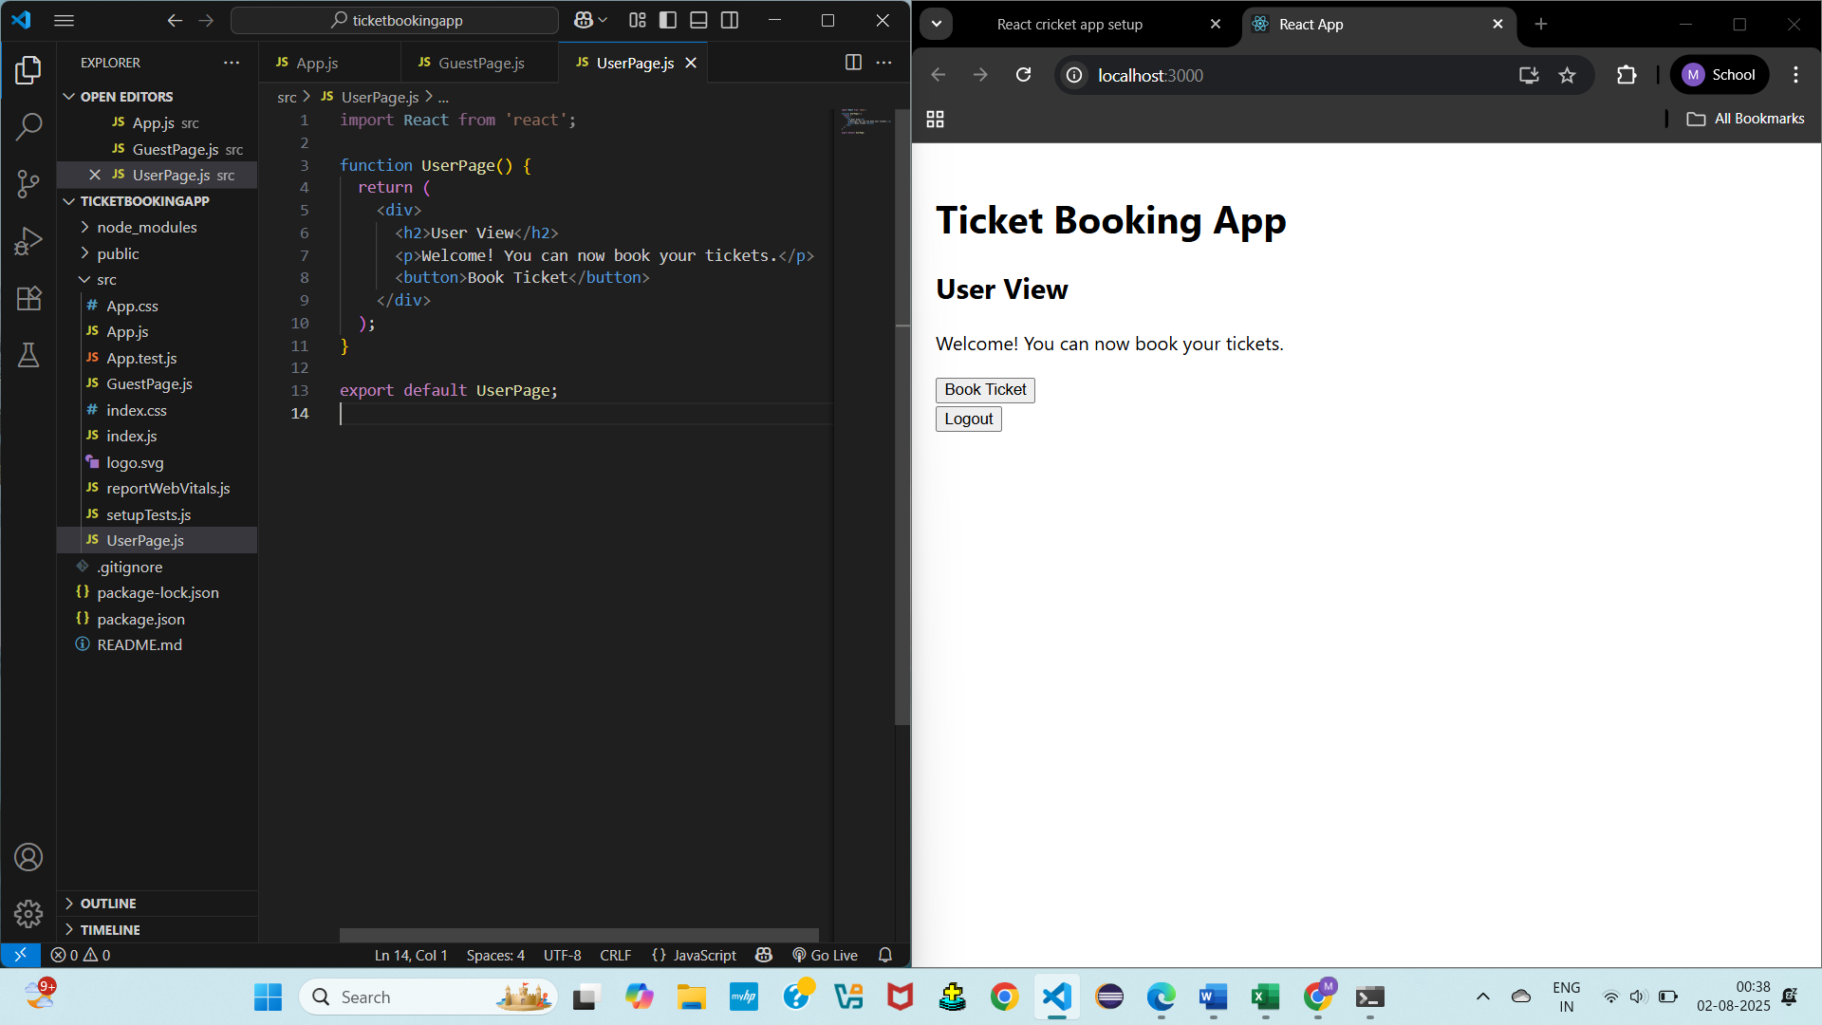

**13. ReactJS-HOL**

**BookDetails.js**

import React from 'react';

function BookDetails() {

return (

<div>

<h2> Book Details</h2>

<p>Title: React in Action</p>

<p>Author: Mark T.</p>

</div>

);

}

export default BookDetails;

**BlogDetails.js**

import React from 'react';

function BlogDetails() {

return (

<div>

<h2> Blog Details</h2>

<p>Topic: JavaScript Tips</p>

<p>Author: Sarah K.</p>

</div>

);

}

export default BlogDetails;

**CourseDetails.js**

import React from 'react';

function CourseDetails() {

return (

<div>

<h2>Course Details</h2>

<p>Course: Full Stack Web Development</p>

<p>Instructor: John D.</p>

</div>

);

}

export default CourseDetails;

**App.js**

import React, { useState } from 'react';

import BookDetails from './BookDetails';

import BlogDetails from './BlogDetails';

import CourseDetails from './CourseDetails';

function App() {

const [choice, setChoice] = useState('book');

// Option 1: If-else rendering

const renderContentIfElse = () => {

if (choice === 'book') {

return <BookDetails />;

} else if (choice === 'blog') {

return <BlogDetails />;

} else {

return <CourseDetails />;

}

};

// Option 2: Ternary operator

const renderContentTernary = () =>

choice === 'book' ? (

<BookDetails />

) : choice === 'blog' ? (

<BlogDetails />

) : (

<CourseDetails />

);

// Option 3: Logical && operator (not suitable for multiple but shown below)

const renderContentLogical = () => (

<div>

{choice === 'book' && <BookDetails />}

{choice === 'blog' && <BlogDetails />}

{choice === 'course' && <CourseDetails />}

</div>

);

return (

<div className="App" style={{ padding: 20 }}>

<h1>Blogger App</h1>

<div>

<button onClick={() => setChoice('book')}>Book</button>

<button onClick={() => setChoice('blog')}>Blog</button>

<button onClick={() => setChoice('course')}>Course</button>

</div>

<hr />

<h3>Using If-Else:</h3>

{renderContentIfElse()}

<hr />

<h3>Using Ternary Operator:</h3>

{renderContentTernary()}

<hr />

<h3>Using Logical && Operator:</h3>

{renderContentLogical()}

</div>

);

}

export default App;

**OUTPUT:**

