- Configure your user name and email.
- Clone repo of your name from GitHub to the local system.
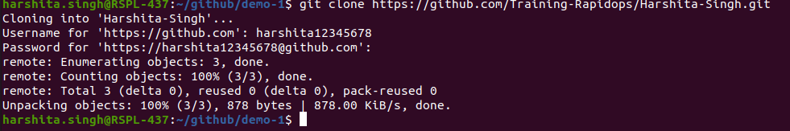
- Create a file inside the repo, and make your first commit "My First Commit".
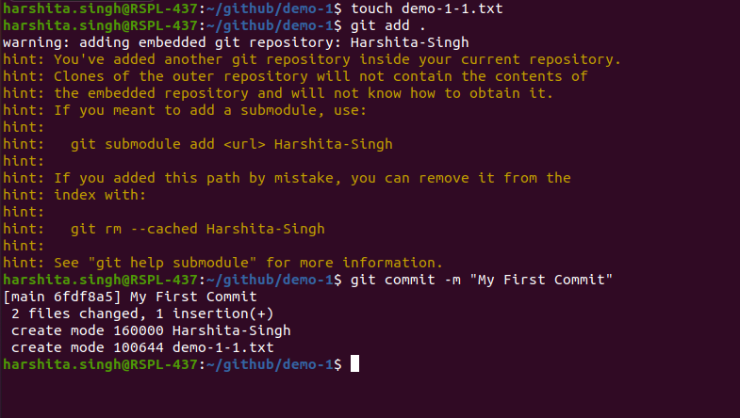
- Create and switch to the branch 'test/development' (create from the master branch and it should be from origin).
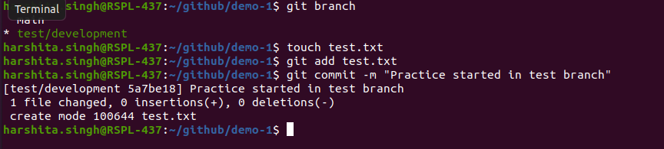
- Add a file in this branch and commit your changes with the message "Practice started in test branch".

- Now push your changes and this branch to the remote.
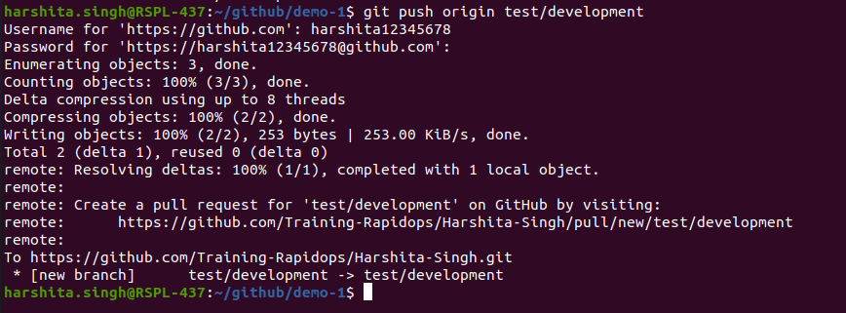
- Go to your GitHub repository and create a pull request to merge this branch in master. Also, add Ravindra & your mentor as reviewers.
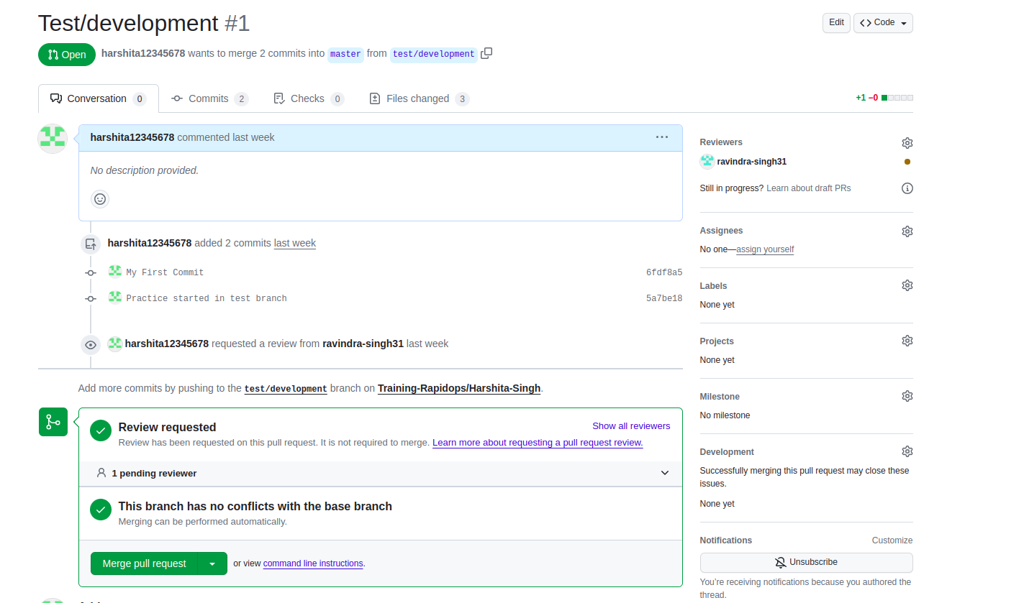
- Fork a public repository Test-Training
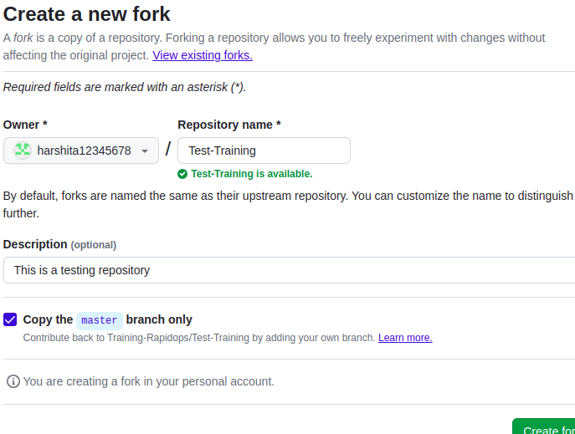
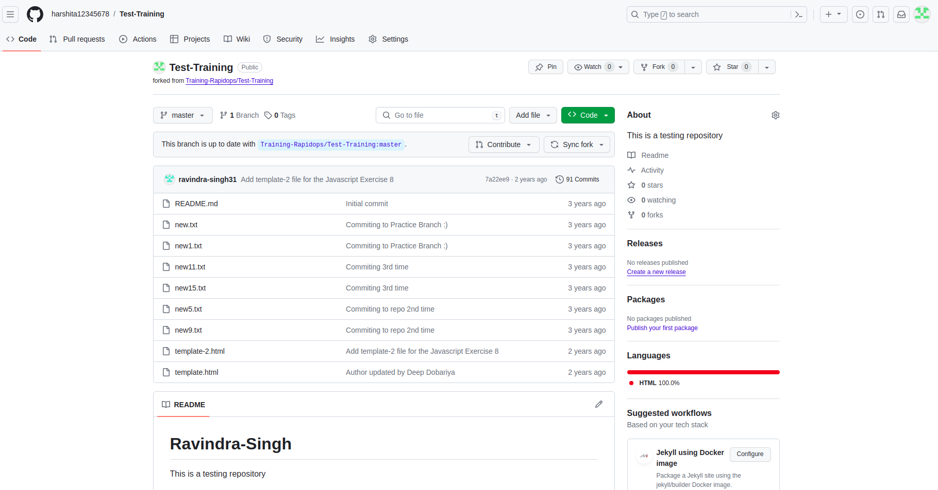

- Make a change in the template.html file by adding 'author: {your-name}' and add commit 'Author updated by {your-name}'.
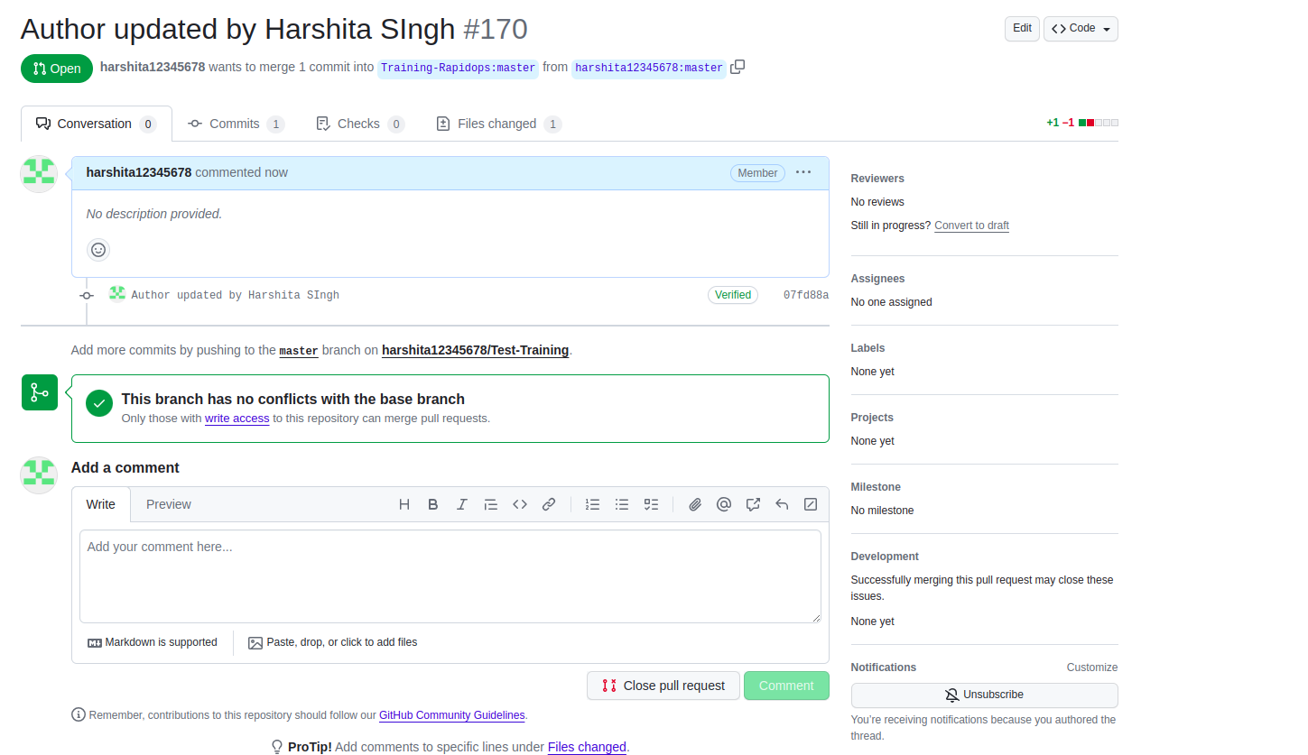
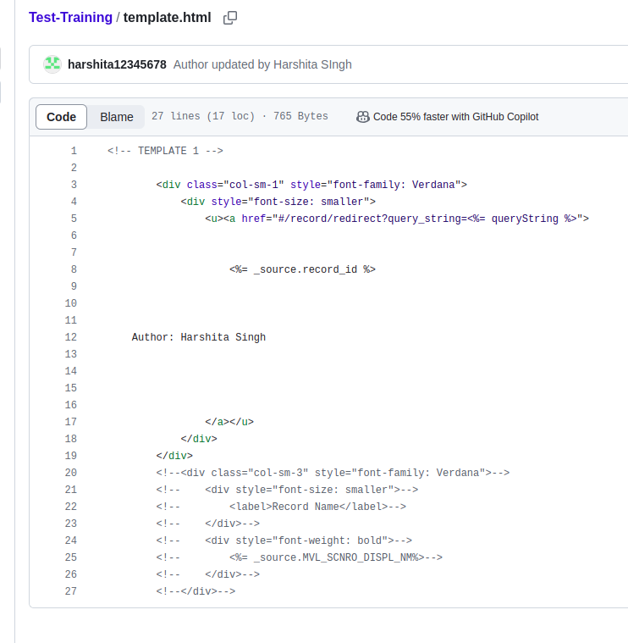
- Give PR to merge your forked repo in the Test-Training repo.

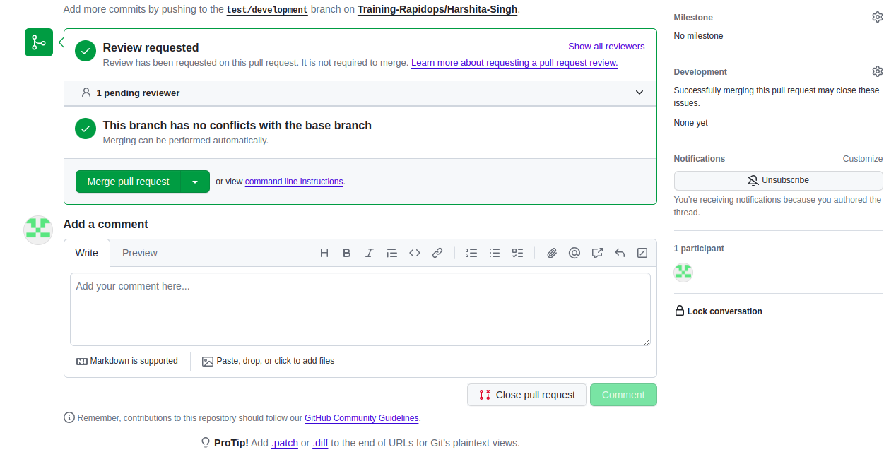
ans:- given pull request to merge your forked repo in test-training repo

