Assignment: Unit 2 Exercise 1 – Work with IBM SPSS Modeler
Student Name: HARSHITA GUPTA
Course: DATA ANALYTICS SEM 3
Date: January 18, 2026

Part 1: Initial Stream Creation and Modification
Objective: To practice using the IBM SPSS Modeler user interface and managing node connections.
Steps Taken:
- Task 2: Create a dry run stream. Placed various nodes including Statistics File, Select, Sort, Derive, Histogram, Derive, Distribution, and Excel onto the stream canvas. Connected them using the middle-mouse button/Alt-key method to create a data flow.
- Task 3: Modify the stream. Practiced non-destructive editing by deleting the second Derive node and the Distribution node. Reconnected the flow to an Excel export node and added a Statistics Export node downstream.
- Documentation: Added a freestanding comment with my name and date as indicated in class. Added a specific comment to the Derive node noting that a "new field is derived."

Part 2: Managing Multiple Streams and SuperNodes
Objective: To utilize stream management tools and encapsulate nodes for cleaner workflows.
Steps Taken:
- Task 4: Create a new stream. Created a second stream by copying and pasting the nodes from the first stream into a fresh canvas.
- Task 5: Work with SuperNodes. Selected the Select and Sort nodes and used the right-click menu to Create SuperNode. Renamed this SuperNode to "data preparation" via the Rename and Annotate dialog.
- Stream Insertion: Inserted a Sample node from the Record Ops palette between the Derive and Statistics Export nodes to finalize the modified layout.

Part 3: Data-Driven Selection and Refinement
Objective: To apply filtering logic using the Generate function on a live dataset.
Steps Taken:
- Task 6: Generate a Select node from Table output. Opened the file unit_02_exercise_1_start.str (manually mapped to exercise_data_working_with_modeler.xlsx) and opened the Table output window.
- Record Filtering: In the HAS_RECEIVED_TEST_MAILING column, selected the value "yes" and navigated to Generate > Select Node ("And"). Inserted the generated node into the stream and renamed it to "in test mailing."
- Task 7: Further record selections. Refined the data further by selecting both "female" and "male" in the GENDER column using the Ctrl key. Used Generate > Select Node ("Or") and renamed the new node "men, women."
- Verification: Confirmed that the final data flow produced exactly 9,980 records in the Table output.

Attachments
- 3 Screenshots
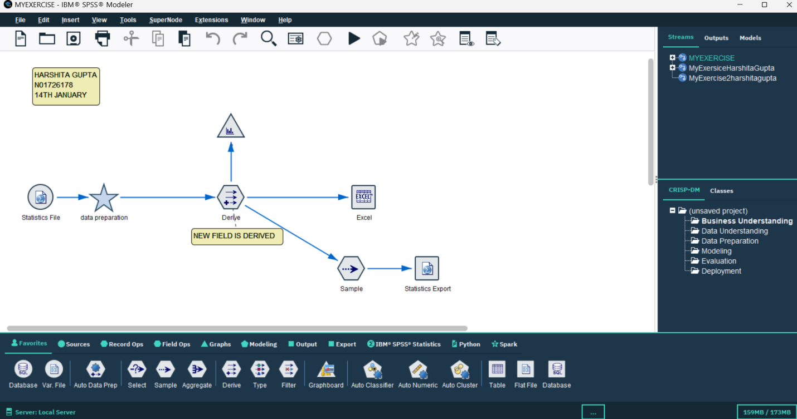
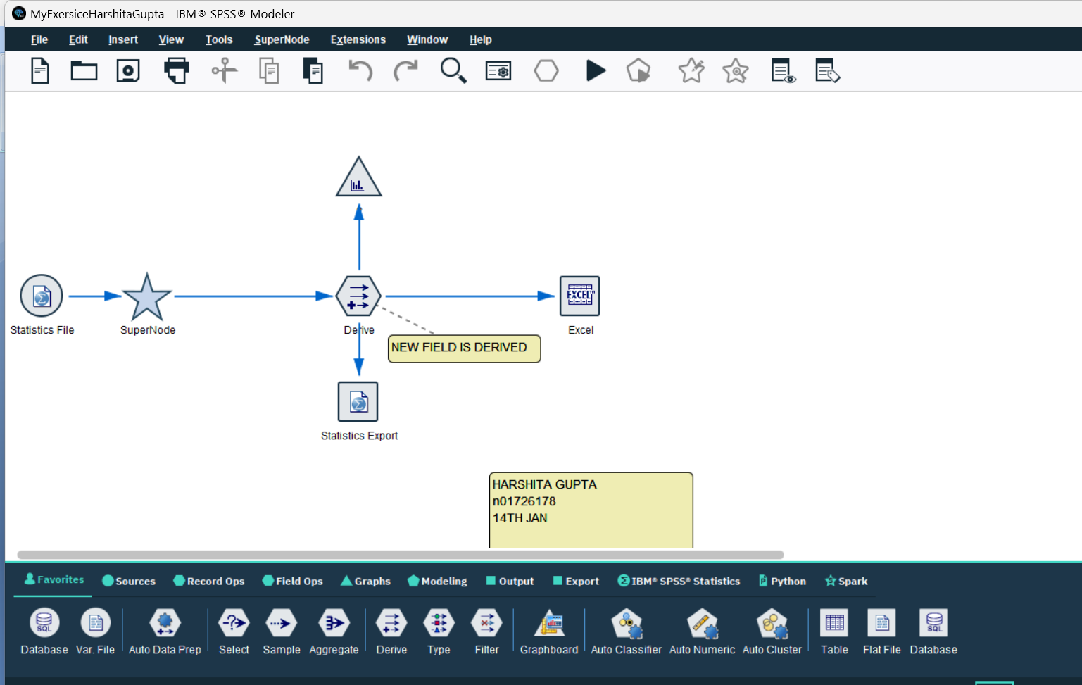

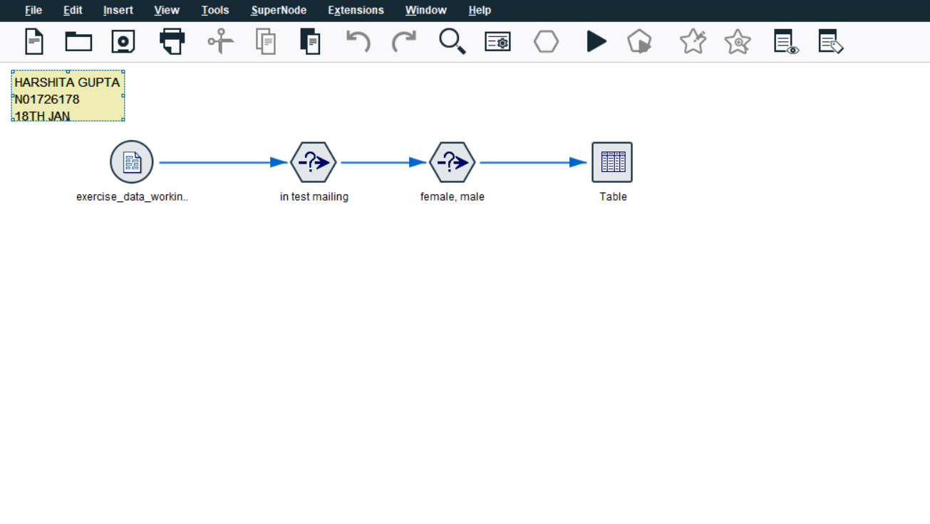
MYEXERCISE.str
MyExersiceHarshitaGupta.str
BIA5303\MOD 1..\..\Downloads\MyExercise2harshitagupta.str

