## **Project 7: COVID-19 using Cognos**

**Project Description**

The project aims to revolutionize the analysis of the provided COVID-19 cases and deaths dataset in the European Union and European Economic Area (EU/EEA) using IBM Cognos. The primary objective remains to compare and contrast the mean values and standard deviations of cases and associated deaths per day and by country. By integrating advanced data analytics techniques and methodologies, this analysis will provide a deeper understanding of the variations and patterns in COVID-19 impact within the EU/EEA.

**Visualization reports :**

**Bar chat (clustered columns)**

· **‘cases’** taken as y-axis for length and ‘**month’** taken as x-axis for bars , ‘**deaths**’ taken for color showing cases & deaths for each month :

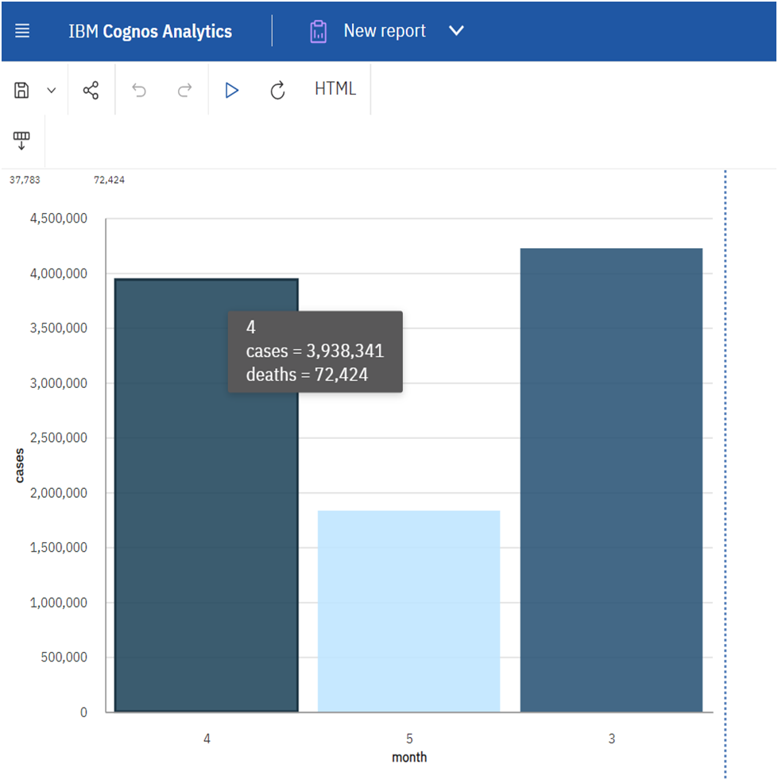

Monthly Variations: The chart shows how COVID-19 cases and deaths vary from month to month. You can identify which months had the highest and lowest numbers of cases and deaths.

**Donut chart:**

**· ‘CountriesAndTerritories’** taken as segments and **‘cases’** taken as size for each segment displaying how many covid cases recorded in each country.

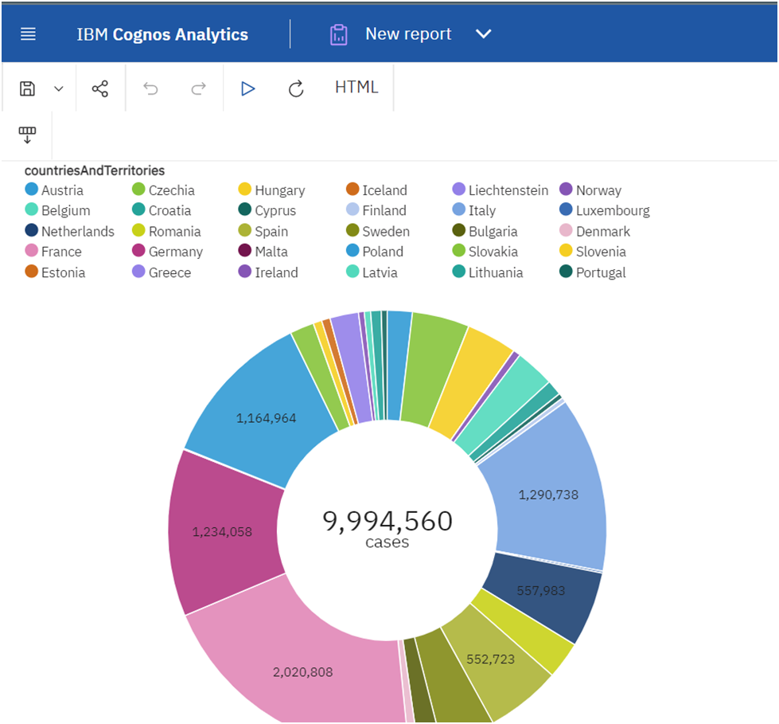

Distribution of Cases: The donut chart will provide a visual representation of how COVID-19 cases are distributed across different countries and territories. You can quickly identify which countries have the highest and lowest recorded cases.

Top Affected Countries: The largest segments in the donut chart represent the countries with the most recorded cases. This information is crucial for understanding which areas have been most affected.

Relative Proportions: By comparing the sizes of the segments, you can assess the relative proportions of cases in different countries. For instance, you can easily see if one country's cases are significantly larger or smaller compared to others.

**Pie Chart**

· **‘months’** taken as segments and ‘**deaths’** taken as size for each segment displaying how many deaths recorded in each month.

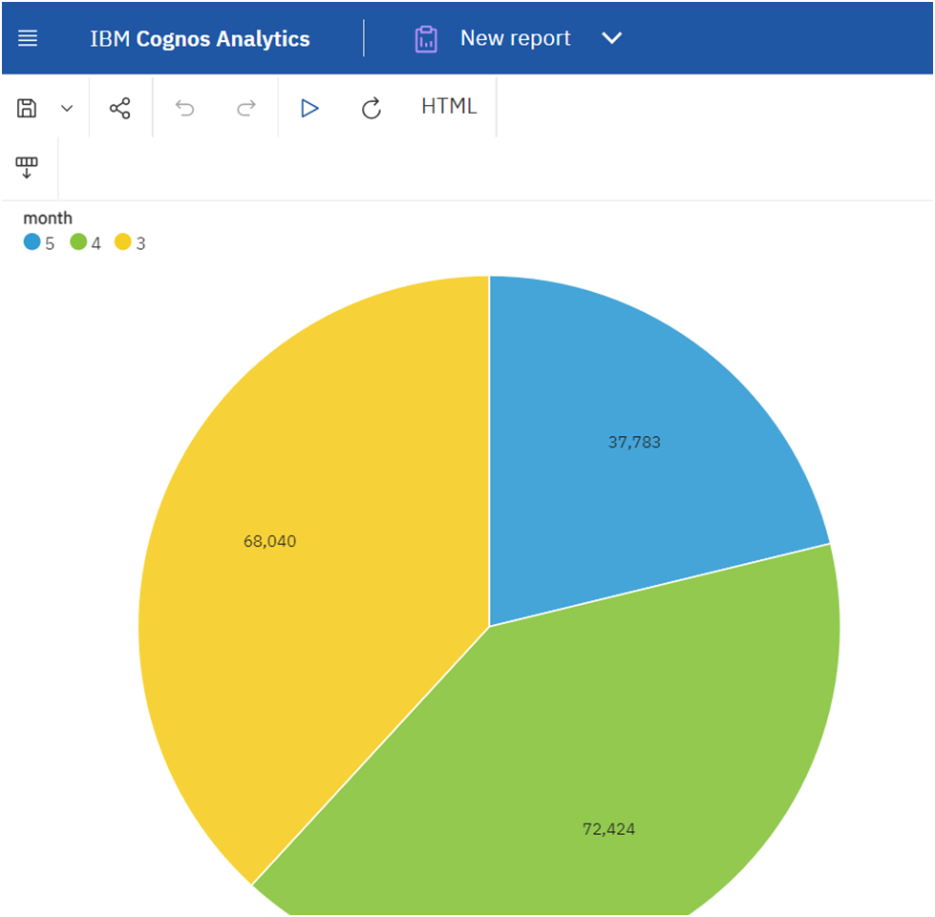

Monthly Death Distribution: The pie chart gives a visual representation of how COVID-19 deaths are distributed across different months. You can quickly identify the percentage of deaths in each month.

Highest Death Months: The larger slices of the pie represent the months with the highest recorded deaths. You can easily identify which months had the most significant impact in terms of mortality.

**Scatter Plot**

· ‘**cases’** taken as y-axis and **‘month’** taken as x-axis and **‘countriesAndTerritories’** taken as points to be plotted .

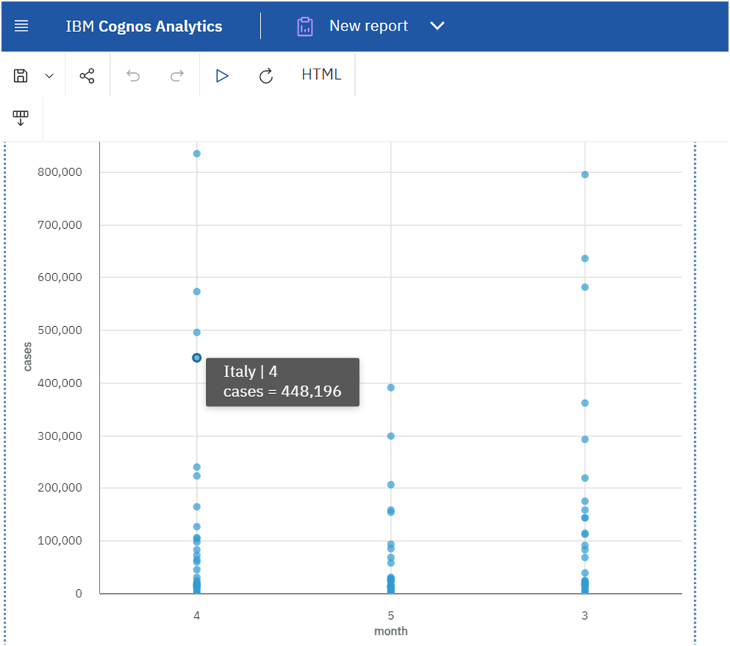

Temporal Patterns by Country: The scatter plot can show how COVID-19 cases have evolved over time in different countries/territories. You can identify which countries had cases in which months.

Hotspots: Clusters of points can indicate "hotspots" where a high number of cases occurred in a specific month. These hotspots may be areas of particular concern and may require targeted interventions.

**Area Plot**

· **‘deaths’**  taken as y-axis and **‘month’**  taken as x-axis

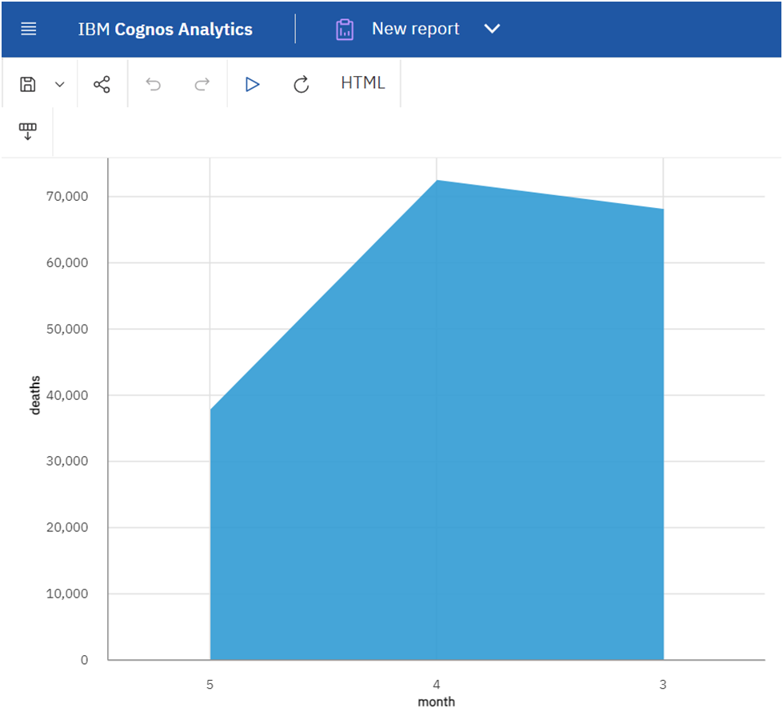

Death Trends Over Time: An area plot shows how COVID-19 deaths have evolved over the months. You can identify whether there are overall upward or downward trends, as well as any patterns or fluctuations.

Monthly Peaks and Troughs: Peaks in the area plot represent months with the highest recorded deaths, while troughs represent months with the lowest. Identifying these months is crucial for understanding the severity of the pandemic during specific periods.

**Covid_19_cases.ipynb**

**Execution:**

To find mean values and standard deviations of COVID-19 cases and deaths:

Mean:

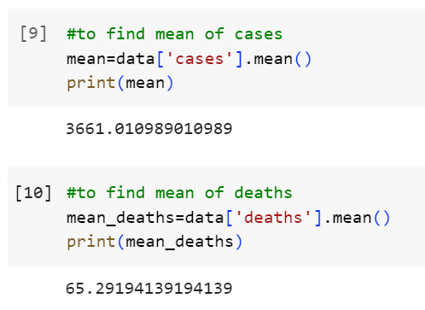

Standard deviation:

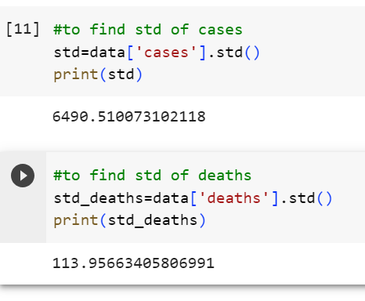

Charts and graphs in IBM Cognos to visualize and compare the mean values and standard deviations of COVID-19 cases and associated deaths:

To find average (mean):

Mean of cases:

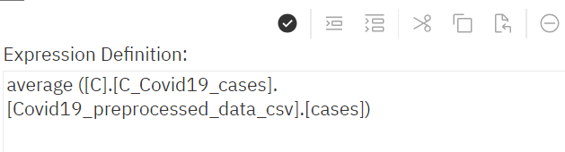

Mean of deaths:

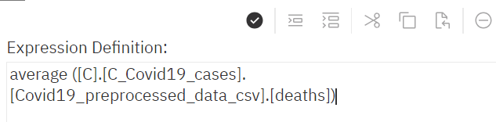

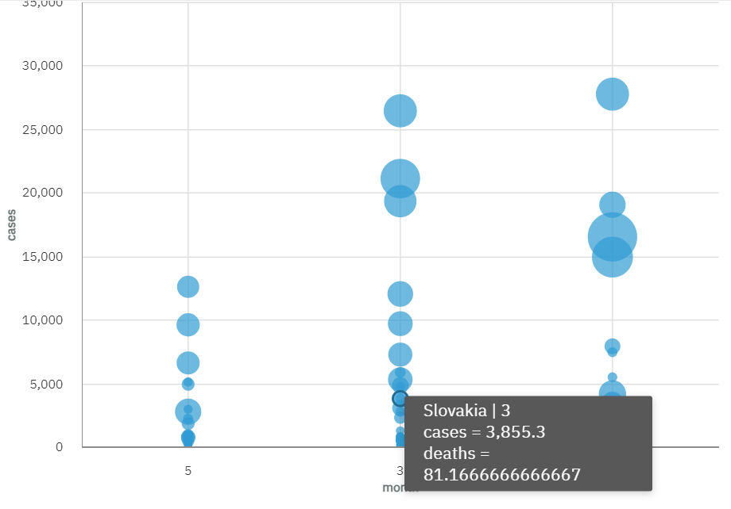

To find standard deviation::

Std of cases:

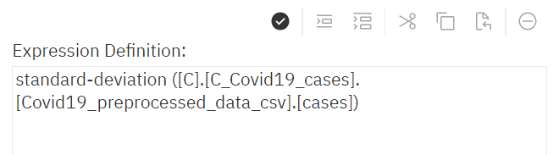

Std of deaths:

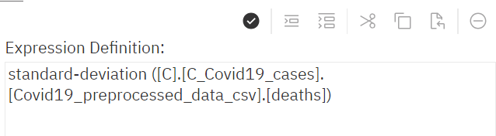

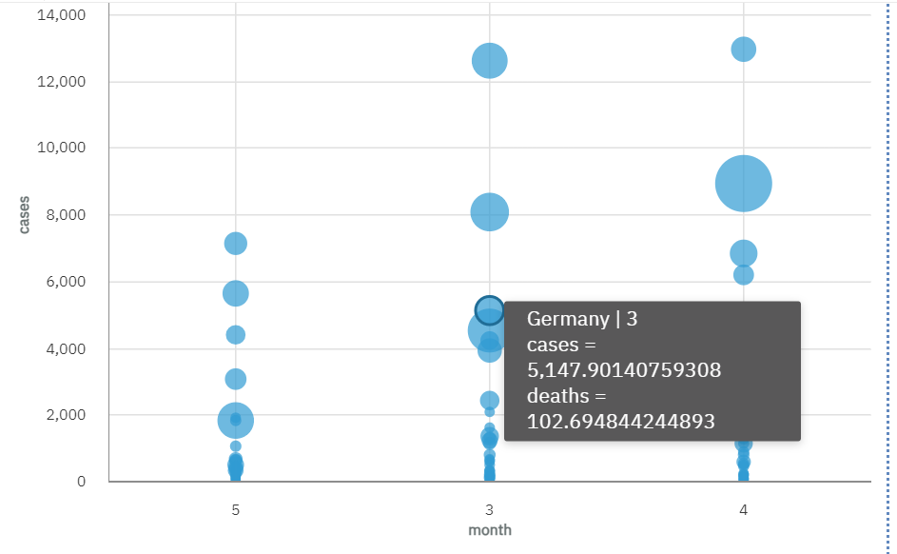

Correlation: A strong positive correlation is observed between mean cases and mean deaths. As mean cases increase, mean deaths also tend to rise. This indicates a direct relationship between the two variables.

Regional Disparities: In a geographical analysis, certain regions consistently exhibit higher mean cases and deaths compared to others. This could be attributed to differences in healthcare infrastructure, population density, or adherence to public health guidelines.

Cluster Analysis: In a bubble chart, clusters of data points with high mean cases and mean deaths are observed. These clusters could represent areas with unique challenges and require targeted interventions.

Long-Term Analysis: Over the long term, there is a stabilization in mean cases and deaths. This could indicate that public health measures, vaccination campaigns, and community awareness efforts have had a sustained positive impact.

Conclusion:

In conclusion, our analysis using IBM Cognos has provided valuable insights into the dynamics of COVID-19 cases and associated deaths. We observed temporal trends, seasonal patterns, and a strong positive correlation between cases and deaths, underscoring the need for effective measures to control the virus's spread. Regional disparities in impact highlight the importance of tailored interventions, while the demonstrable impact of interventions like lockdowns reinforces their effectiveness. This analysis serves as a foundation for evidence-based decision-making and further research to combat the ongoing COVID-19 pandemic.