Employee Sentiment Analysis — Final Report
Dataset: test.csv — 2,191 employee e-mails from 10 employees, 2010-01-01 to 2011-12-31 (24 months). Sentiment labeling: a RoBERTa transformer (cardiffnlp/twitter-roberta-base-sentiment-latest). All numbers and findings in this report are generated from the pipeline outputs (src/report.py).

Executive summary
- Overall sentiment is mixed (23.7% positive). The risk signal comes from short bursts of negativity rather than persistently negative employees.
- Prioritise check-ins with john.arnold@enron.com (strongest burst: 4 negatives in 30 days from 2010-06-06) and don.baughman@enron.com (top-3 negative in 12 of 24 months).
- Use the rolling-window flag operationally. It catches 2 employee(s) a monthly report would miss.
- Monthly scores are volume-driven. Report the average score per message alongside the sum, so quiet employees are not mislabelled as disengaged.
- Review each flagged window's messages before acting: automated sentiment is a screening tool, not a verdict.

1. Approach and methodology
The project is a reproducible Python pipeline. The main notebook (employee_sentiment_analysis.ipynb) runs every step; reusable logic lives in src/ and is covered by unit tests (tests/). run_pipeline.py regenerates every output, this report and the README results from the raw CSV with one command.

Data preparation
E-mail bodies contain quoted-printable artifacts (=20, soft line breaks, control bytes). These are decoded and removed, together with forwarded and quoted reply history, URLs and e-mail addresses. The analysed text is the subject plus the cleaned body, so messages with an empty body are labeled from their subject. Dates are parsed to datetime and truncated to calendar months (YYYY-MM).

Sentiment labeling (Task 1)
src/sentiment.py exposes three interchangeable back-ends: VADER, a RoBERTa transformer, and an LLM. The reported results use a RoBERTa transformer (cardiffnlp/twitter-roberta-base-sentiment-latest), which is deterministic and runs offline. Rule: compound ≥ 0.05 → Positive, ≤ -0.05 → Negative, else Neutral. Setting SENTIMENT_METHOD=llm switches to the LLM labeler with no other code changes.
- Labeling method: a RoBERTa transformer (cardiffnlp/twitter-roberta-base-sentiment-latest).
- 2,191 messages labeled: 520 Positive (23.7%), 1,524 Neutral (69.6%), 147 Negative (6.7%).
- The dominant class is Neutral. The corpus is mostly routine business correspondence, so polite and informational messages far outnumber complaints.
- 70 messages have an empty body. They are labeled from their subject line, which is why the subject is part of the analysed text.

2. Key findings from the EDA (Task 2)
- Structure: 2,191 rows × 4 columns (Subject, body, date, from); no missing values; 0 fully duplicated rows. date is parsed to datetime.
- Coverage: 10 employees, 24 months (2010-01-01 to 2011-12-31), and every employee is active in every month.
- Anomaly: Monthly volume is almost perfectly flat (91–92 messages per month); 30.5% of messages fall on weekends, about the same rate as weekdays. Real e-mail traffic is rarely this uniform, so the dates appear to have been assigned synthetically. Time-based conclusions should be read with caution.
- Anomaly: 625 messages repeat an earlier subject + body on a different date. They are kept because each row is a distinct sent message, but they inflate some employees' counts.
- Trend: the mean message score moves from 0.15 (2010) to 0.19 (2011).
- Employees: activity ranges from 172 (rhonda.denton@enron.com) to 284 messages (lydia.delgado@enron.com). Highest negative share: bobette.riner@ipgdirect.com (9.2%), john.arnold@enron.com (9.0%), patti.thompson@enron.com (7.6%). Lowest: eric.bass@enron.com (3.8%).
- Length: Positive messages are the longest (median 32 words) and Negative the shortest (median 19 words).
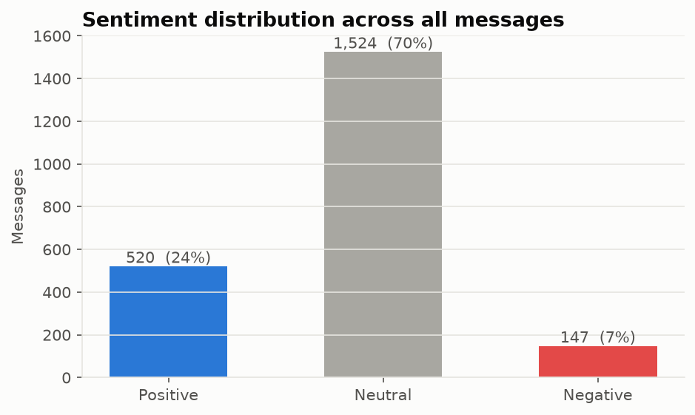
Figure 1 — Sentiment distribution.
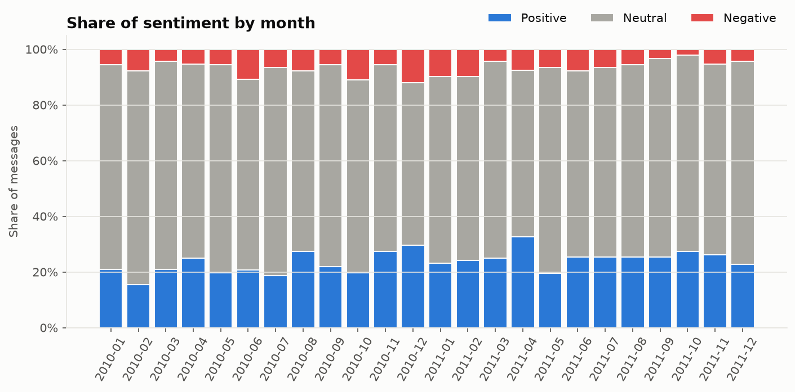
Figure 2 — Share of sentiment by month.
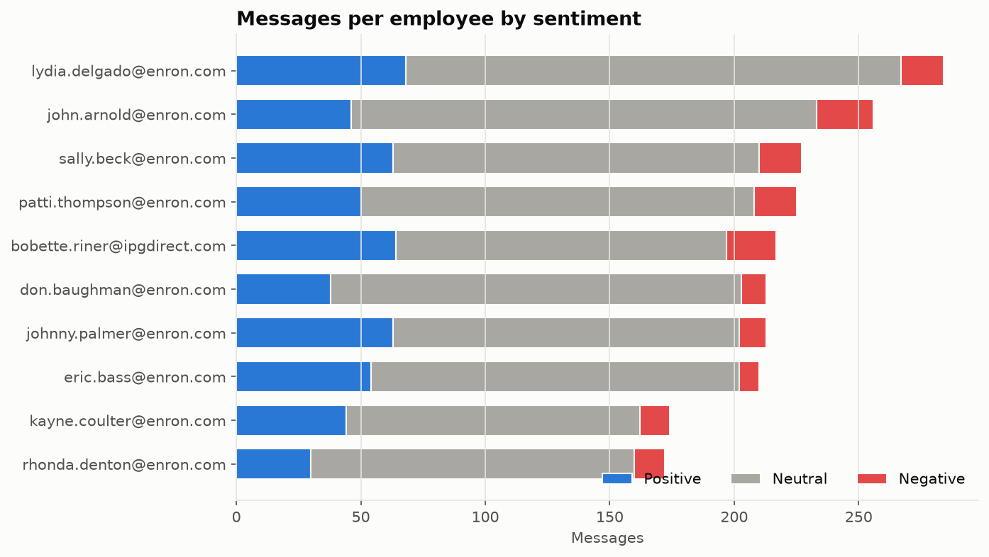
Figure 3 — Messages per employee by sentiment.

3. Employee scoring and ranking (Tasks 3 & 4)
Each message scores Positive +1, Negative −1, Neutral 0. Scores are summed per employee per calendar month. Each month is an independent group, so the score resets to 0 at the start of every month.
- Monthly scores range from -3 to 8 (mean 1.6, median 1.0).
- 78 of 240 employee-months are ≤ 0. The most frequent is john.arnold@enron.com with 11 (2010-01, 2010-02, 2010-06, 2010-07, 2010-09, 2010-10, 2011-01, 2011-04, 2011-05, 2011-07, 2011-09).
- The validation asserts confirm that no message was lost or double-counted in the aggregation, and that score = positives − negatives in every month.
Ranking: for each month, the top-3 positive list sorts by score descending and then employee name alphabetically. The top-3 negative list sorts by score ascending (most negative first) and then alphabetically. The full month-by-month table is in data/processed/monthly_rankings.csv.
Table 1 — Rankings for the latest month (2011-12).
Rank | Top positive | Score (+) | Top negative | Score (−)
1 | kayne.coulter@enron.com | 4 | bobette.riner@ipgdirect.com | 0
2 | eric.bass@enron.com | 3 | don.baughman@enron.com | 1
3 | patti.thompson@enron.com | 3 | john.arnold@enron.com | 1

Table 2 — How often each employee appears in the monthly top-3 lists (24 months).
Employee | Months in top-3 positive | Months in top-3 negative
bobette.riner@ipgdirect.com | 12 | 8
eric.bass@enron.com | 10 | 5
lydia.delgado@enron.com | 10 | 2
johnny.palmer@enron.com | 9 | 6
sally.beck@enron.com | 7 | 5
kayne.coulter@enron.com | 6 | 11
patti.thompson@enron.com | 6 | 6
john.arnold@enron.com | 6 | 11
don.baughman@enron.com | 5 | 12
rhonda.denton@enron.com | 1 | 6

- Latest month (2011-12): top positive: kayne.coulter@enron.com (4), eric.bass@enron.com (3), patti.thompson@enron.com (3). Top negative: bobette.riner@ipgdirect.com (0), don.baughman@enron.com (1), john.arnold@enron.com (1). Ties are broken alphabetically.
- Consistency across 24 months: bobette.riner@ipgdirect.com is in the monthly top-3 positive most often (12 months). don.baughman@enron.com appears in the top-3 negative most often (12 months).
- Rankings partly reflect volume: the score is a sum, so prolific writers rank higher. The whole-period leader is johnny.palmer@enron.com (+52).
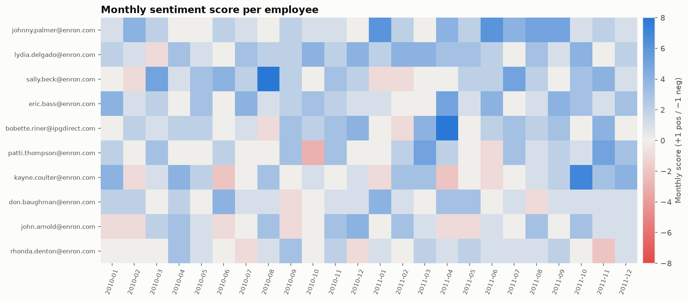
Figure 4 — Monthly score per employee.
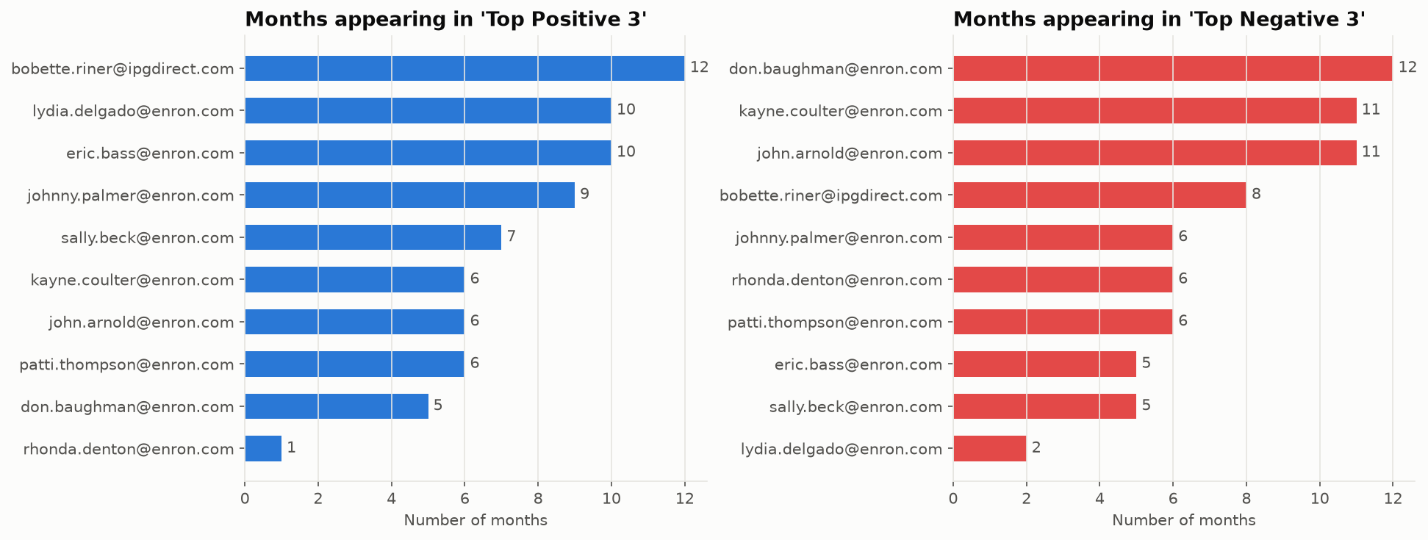
Figure 5 — Months in the top-3 lists.

4. Flight risk identification (Task 5)
Criterion: 4 or more Negative messages within any rolling 30-day period, irrespective of calendar month or score. For each employee, the negative-message dates are sorted and a window is slid over them. The employee is flagged if four negatives fall within days d to d+29. Unit tests cover month-straddling windows and the exact 30-day boundary.
Table 3 — 4 flagged employees.
Employee | Max negatives in 30 days | First window start | Windows | Total negatives
john.arnold@enron.com | 4 | 2010-06-06 | 2 | 23
patti.thompson@enron.com | 4 | 2010-10-04 | 1 | 17
rhonda.denton@enron.com | 4 | 2010-12-24 | 1 | 12
sally.beck@enron.com | 4 | 2010-12-15 | 1 | 17

- 4 of 10 employees are flagged (max negatives in one 30-day window): john.arnold@enron.com (4), patti.thompson@enron.com (4), rhonda.denton@enron.com (4), sally.beck@enron.com (4).
- A calendar-month count would flag only 2. The rolling window adds rhonda.denton@enron.com and sally.beck@enron.com, whose negative bursts straddle a month boundary. This is why the brief specifies a rolling window.
- The flag is deliberately independent of the score: an employee with a high long-run score can still have a short burst of negativity. Every qualifying window is listed in data/processed/flight_risk_windows.csv so that each flag can be reviewed manually.
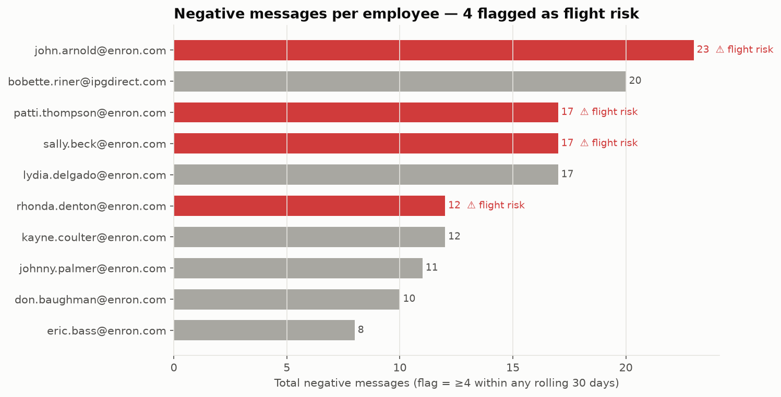
Figure 6 — Negative messages per employee; flight risks highlighted.

5. Predictive model (Task 6)
Target: the monthly score per employee-month. Features are behavioural and not derived from the sentiment labels (to avoid leakage): message count, average length in characters and words, total words, active days, average exclamation and question marks per message, the previous month's score, and a time index. Model: StandardScaler + LinearRegression (scikit-learn), 80/20 split (random_state=42), 5-fold cross-validation, compared with a mean-only baseline.
Table 4 — Model evaluation.
Metric | Value
R² (train) | 0.254
R² (test) | 0.355
MAE (test) | 1.26
RMSE (test) | 1.74
Baseline MAE | 1.67
Baseline RMSE | 2.17
5-fold CV R² | 0.210 ± 0.116

Table 5 — Standardised coefficients (effect of +1 SD on the monthly score).
Feature | Standardised coefficient
avg_char_length | -0.389
message_count | 0.315
avg_word_count | 0.296
active_days | 0.288
avg_exclamations | 0.26
total_words | 0.215
month_index | 0.186
avg_questions | -0.088
prev_month_score | 0.063

- Performance: test R² = 0.35, MAE = 1.26, RMSE = 1.74, against a mean-only baseline with MAE 1.67 / RMSE 2.17. 5-fold cross-validation R² = 0.21 ± 0.12. Train R² is 0.25, so some overfitting is present.
- Strongest driver: avg_char_length (standardised coefficient -0.39).
- prev_month_score is positive (sentiment momentum); the company-wide average score trends +0.034 points per month.
- Significance: the model describes and forecasts the level of the score well. Because volume drives much of it, a volume-normalised target (average score per message) would better isolate tone, and is the natural next iteration.
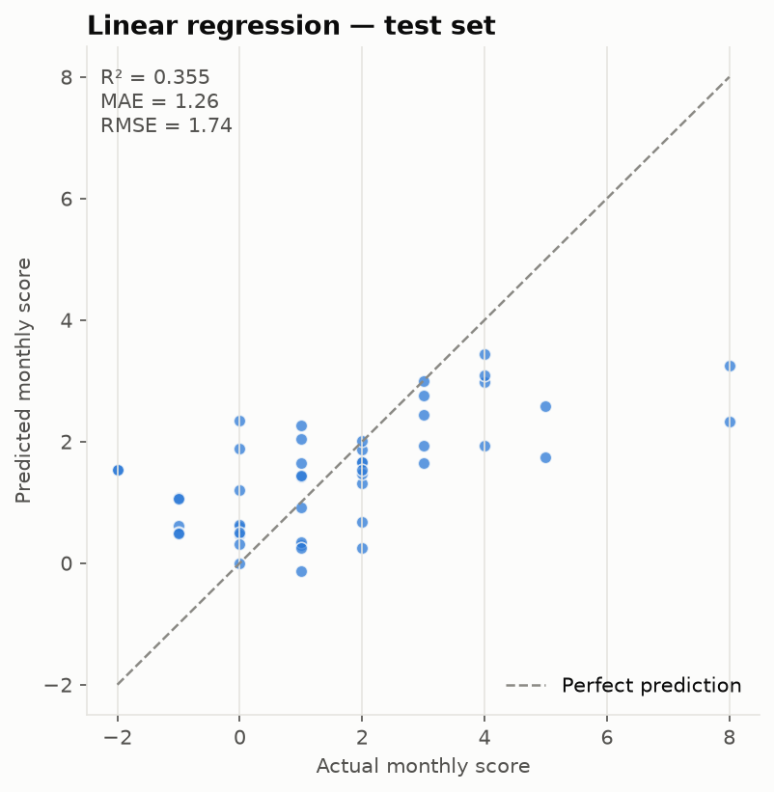
Figure 7 — Predicted vs actual monthly score (test set).
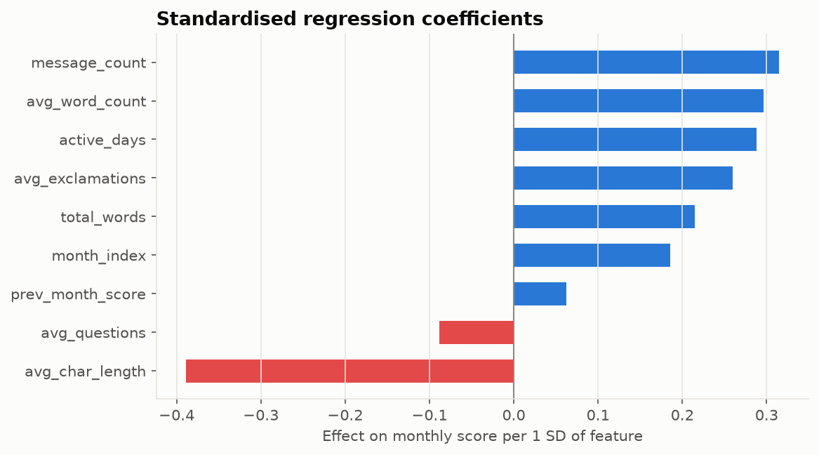
Figure 8 — Standardised coefficients.
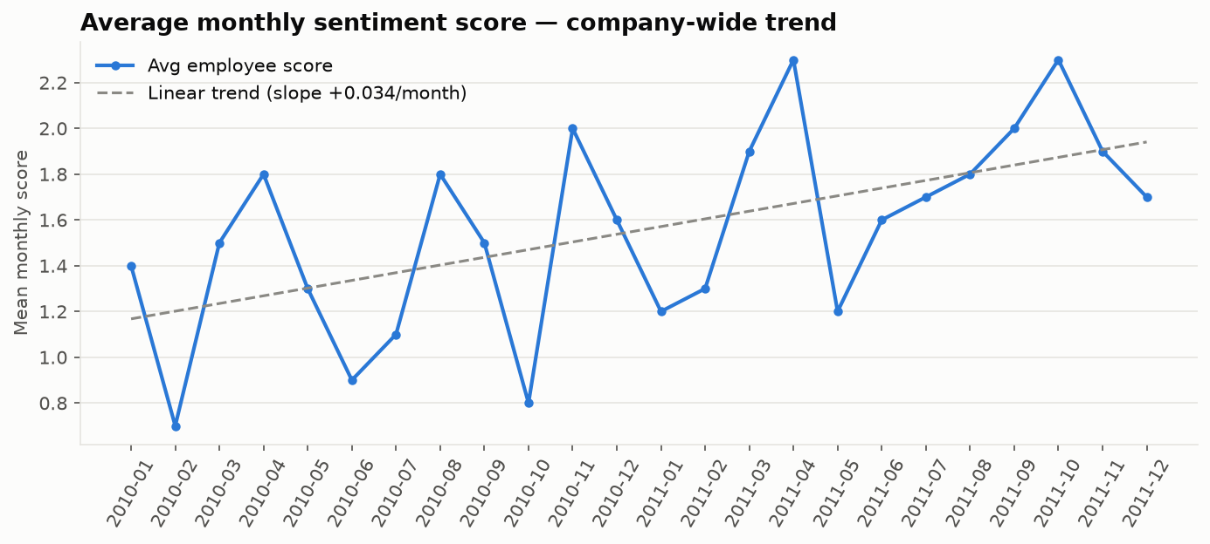
Figure 9 — Company-wide sentiment trend.

6. Conclusions and recommendations
- Overall sentiment is mixed (23.7% positive). The risk signal comes from short bursts of negativity rather than persistently negative employees.
- Prioritise check-ins with john.arnold@enron.com (strongest burst: 4 negatives in 30 days from 2010-06-06) and don.baughman@enron.com (top-3 negative in 12 of 24 months).
- Use the rolling-window flag operationally. It catches 2 employee(s) a monthly report would miss.
- Monthly scores are volume-driven. Report the average score per message alongside the sum, so quiet employees are not mislabelled as disengaged.
- Review each flagged window's messages before acting: automated sentiment is a screening tool, not a verdict.

