DAY-3 TASK-AEM

-20/3/25

1. Create A new component which have news title(should print as h2), news detail(<p>), published date, source create this component using sling model.

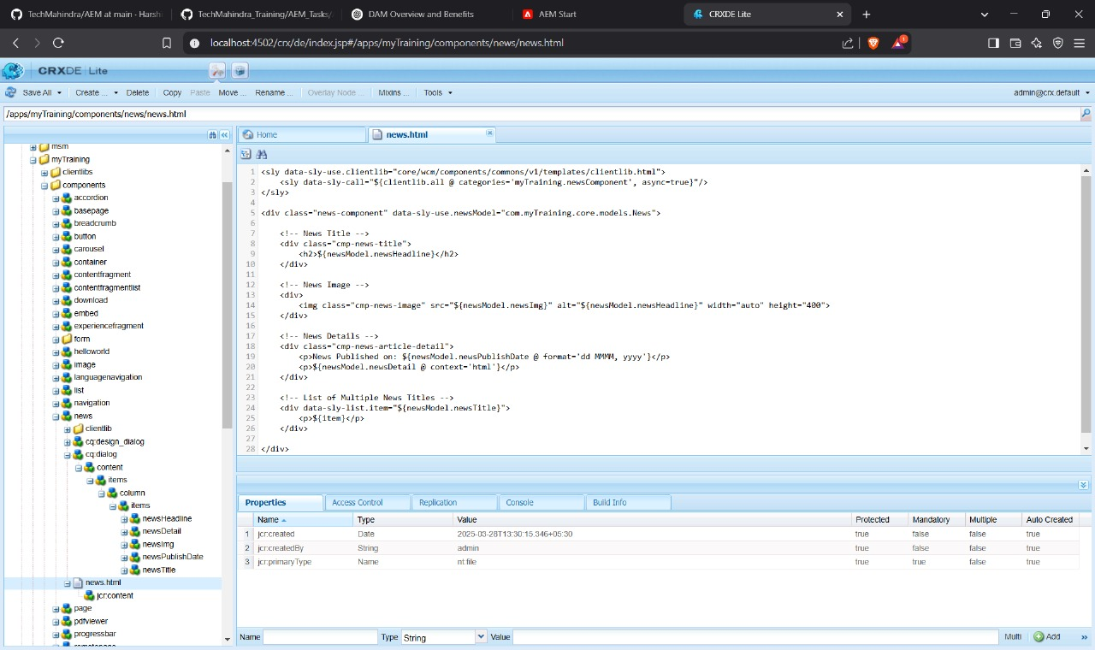

1. Create multi field component(multiple news) using sling model fields: title of new and source of news  
   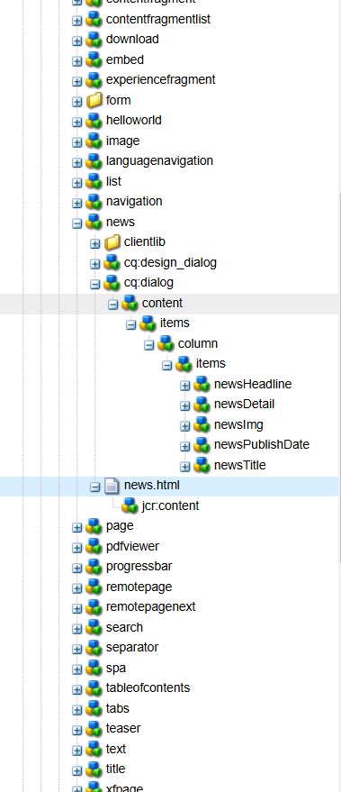
2. Create clientlibs for news component and Apply Green colour to the heading(h2) and yellow colour to news detail(<p) and date should be black in colour.

4.

5.Add Component style to add custom style name (cop-news-component)in news component

Code snippet:

6.Create a base page component and add new file as metadata so that it can print og:title, og:description and og:image link that file in base page.html;

7. Create custom page properties saying Global properties and 3 fields should be there as og:title, og :description and og:image path;

8. What is extraclientlib add it this multi field component  
• extraClientLibs is used to add additional **client libraries (CSS/JS)** to a component dynamically.

• In cq:dialog for multi-news, add

🡪<extraClientLibs

jcr:primaryType="nt:unstructured"

sling:resourceType="granite/ui/components/coral/foundation/includeclientlib"

categories="newsComponent"/>

Screen shot:

