**23CSE111**

**LAB MANUAL**



Department of CSE

Amrita School of Engineering

Amrita Vishwa Vidyapeetham, Amaravati Campus

**Verified By :- Name:** Karthi Tanikonda

**Roll No:** AV.SC.U4CSE24332.

|  |  |  |  |  |
| --- | --- | --- | --- | --- |
| S.NO | PROGRAMS | DATE | PG:NO | SIGNATURE |
| 1. | 1. Download and install java software. 2. Write a java program to print message “ welcome to java programming” 3. Write a java program that prints name,roll number,section of a student. |  |  |  |
| 2. | 1. Factorial of a given number. 2. Simple interest by taking user given values. 3. Fibonacci sequence. 4. Area of triangle using Heron’s formula 5. Area of rectangle. 6. Converting temperature from Fahrenheit to Celsius and vice-versa. |  |  |  |
|  |  |  |  |  |
|  |  |  |  |  |
|  |  |  |  |  |

**Week-1**

**Program-1:-**

**Aim:-** Download and install the java software

**Procedure:-**

Step-1:- Type java download in the google search

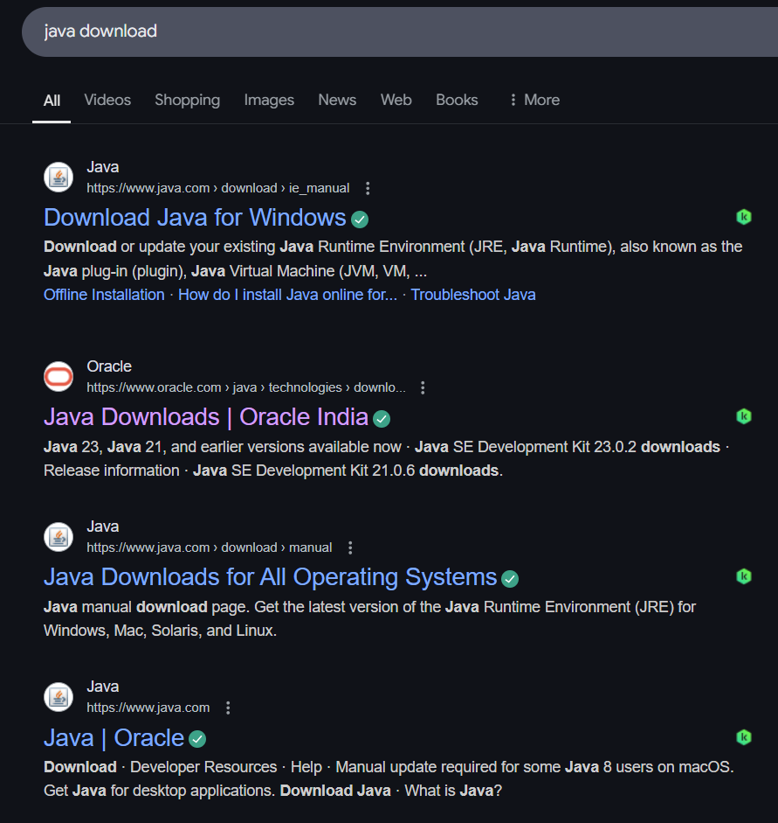

Step2:-click on oracle and into oracle website to download java

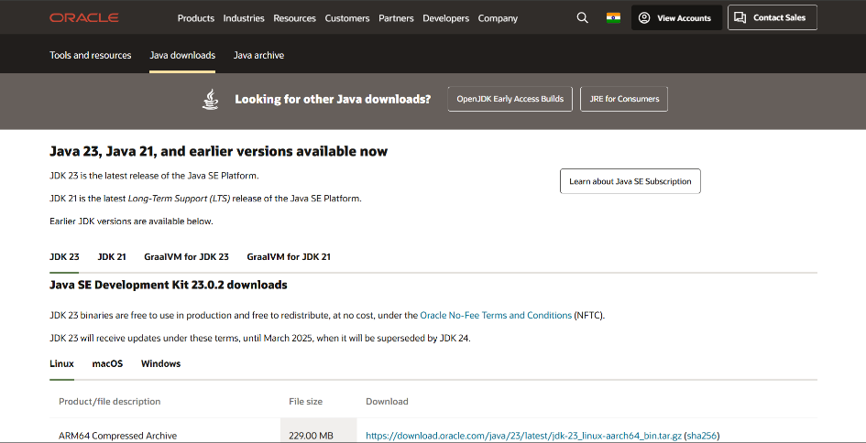

Step-3:- click on JDK21 because JDK21 is the latest Long-Term support(LTS) and click on windows and later on X64 installer link to download

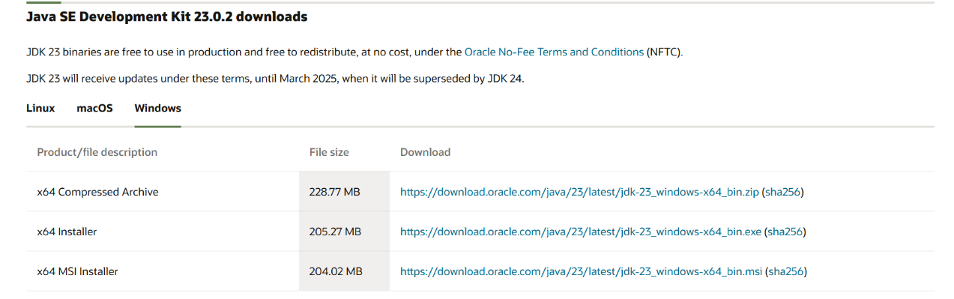

Step-4:- After completing download click on its file and then give permission to install

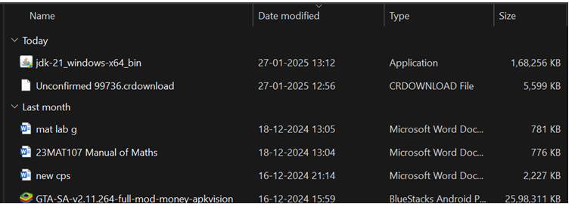

Step-5:- then go to the c drive and double click on program files in that click java and double click on jdk21 in the bin

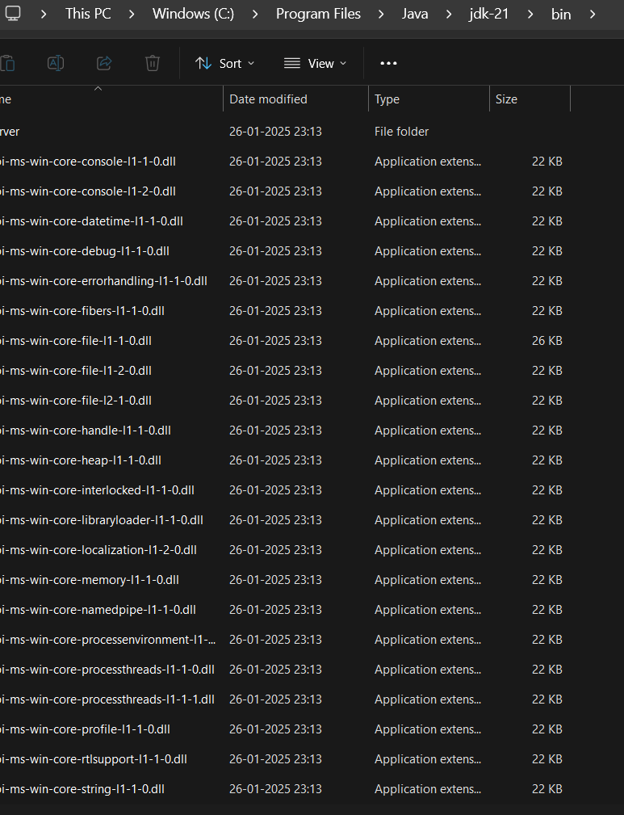

Step6:- Select and copy path of the file and then open windows and search for system environmental .

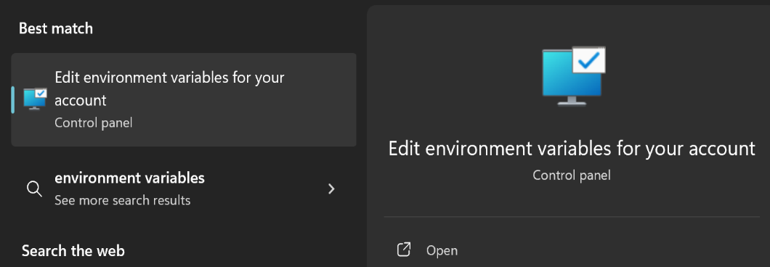

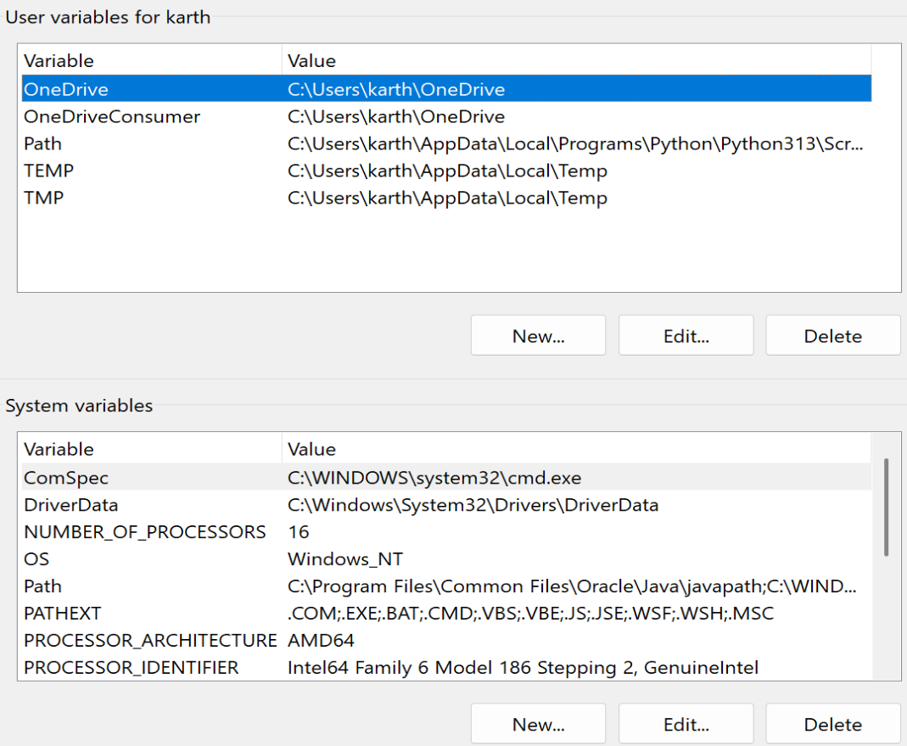

Step-7:- To verify version open CMD and type java—version

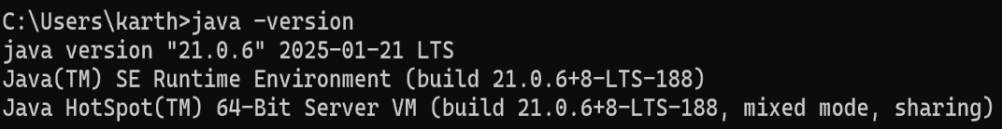

**Program-2:-**

**Aim:** write a java program to print [welcome to java programming]

**Input:-**

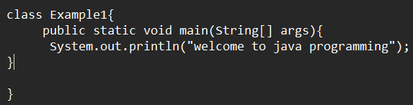

**Output:-**

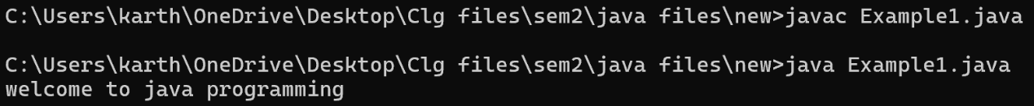

**Program-3:-**

**Aim:-** write a java program that prints name ,roll no ,section of the student

**Input:-**

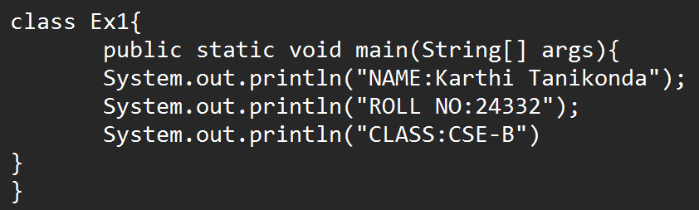

**Output:**

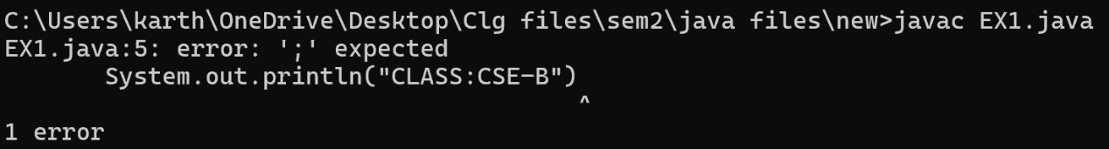

So we are getting an error which is in the class string. Go to notepad and correct the mistake in the class string.

|  |  |  |
| --- | --- | --- |
| SI.No: | Error name | Error rectification |
| 1. | Syntax error | Absence of semicolon |

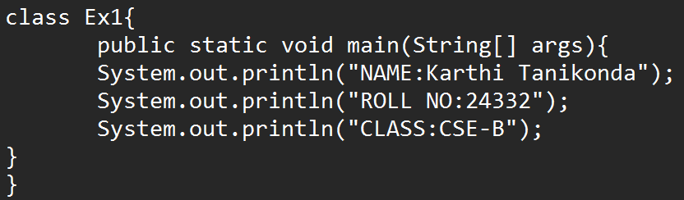

**Output:**

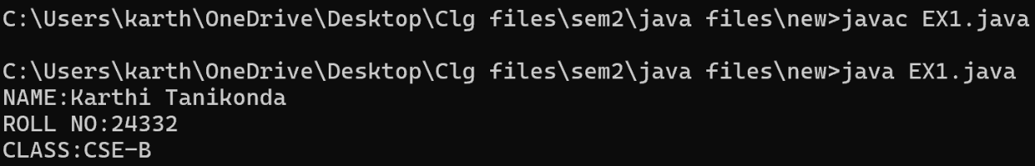

**Week-2**

**Program-1:-**

**Aim:-** write a program to find the factorial of a number.

**Input:**

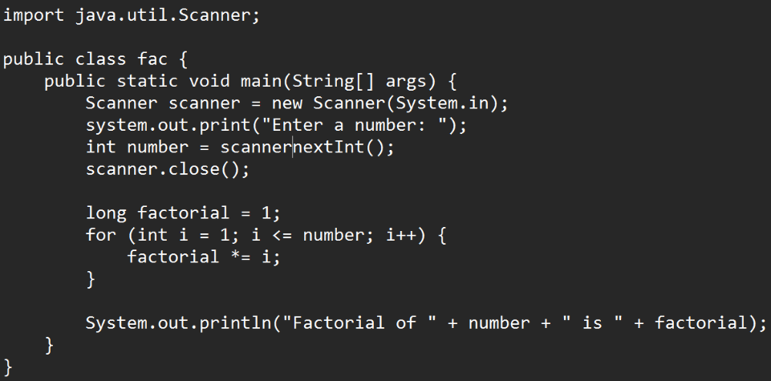

**Output:-**

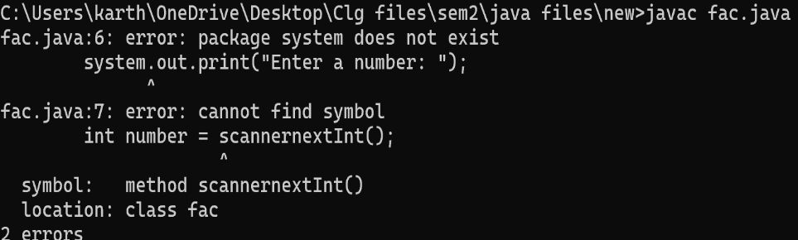

So we are getting an error which is in the class string. Go to notepad and correct the mistake in the class string.

|  |  |  |
| --- | --- | --- |
| Sl.No | Error name | Error rectification |
| 1 | Syntax error | S in system should be capital. |
| 2 | Syntax error | Dot(.) should be between scanner and nextInt(). |

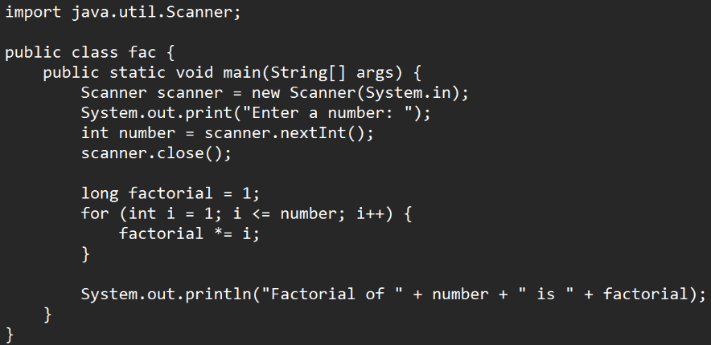

**Output:-**

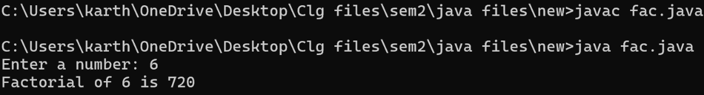

**Program:2:-**

**Aim:-** write a java program to find the simple interest .

**Input:-**

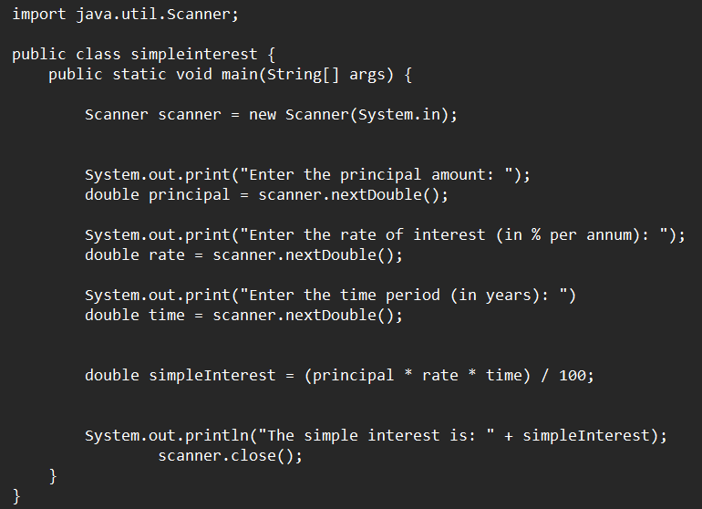

**Output:-**

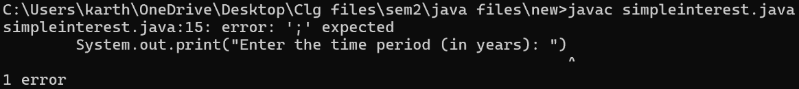

So we are getting an error which is in the class string. Go to notepad and correct the mistake in the class string.

|  |  |  |
| --- | --- | --- |
| S.i no: | Error name | rectification |
| 1 | Syntax error | Semicolon is expected |

**Input:-**

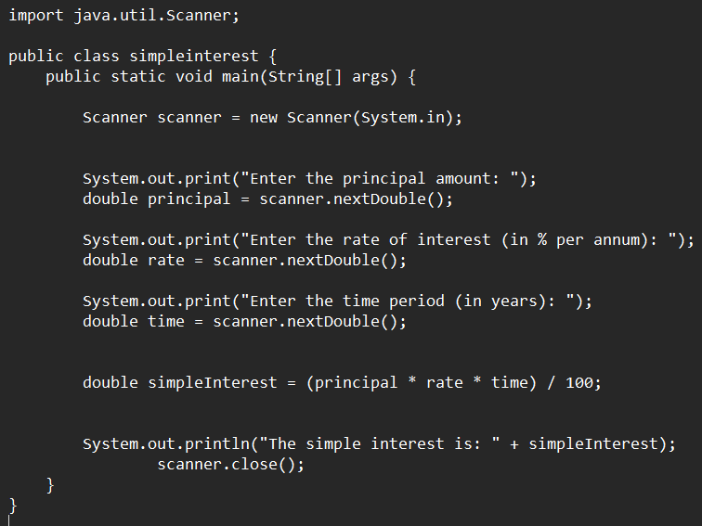

**Output:-**

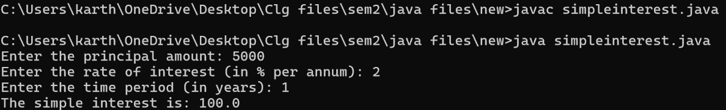

**Program-3:-**

**Aim:-** Write a program to to calculate the fibonacci sequence and take the input from user.

**Input:-**

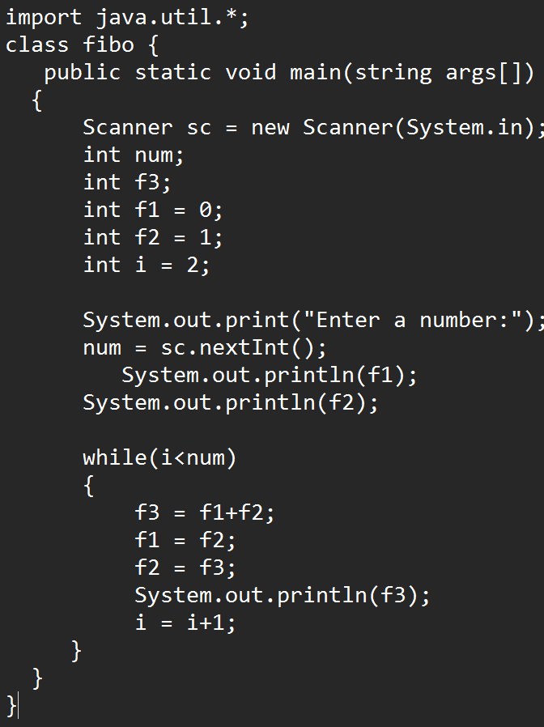

**Output:-**

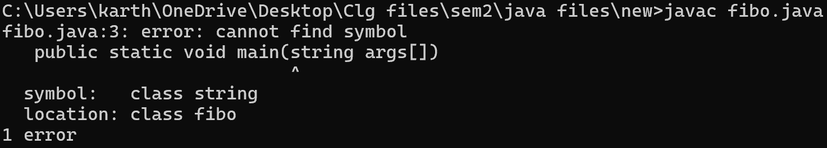

So we are getting an error which is in the class string. Go to notepad and correct the mistake in the class string.

|  |  |  |
| --- | --- | --- |
| Sl.No | Error | Rectification |
| 1. | Syntax error | Capital “S” in place of “s”. |

**Input:-**

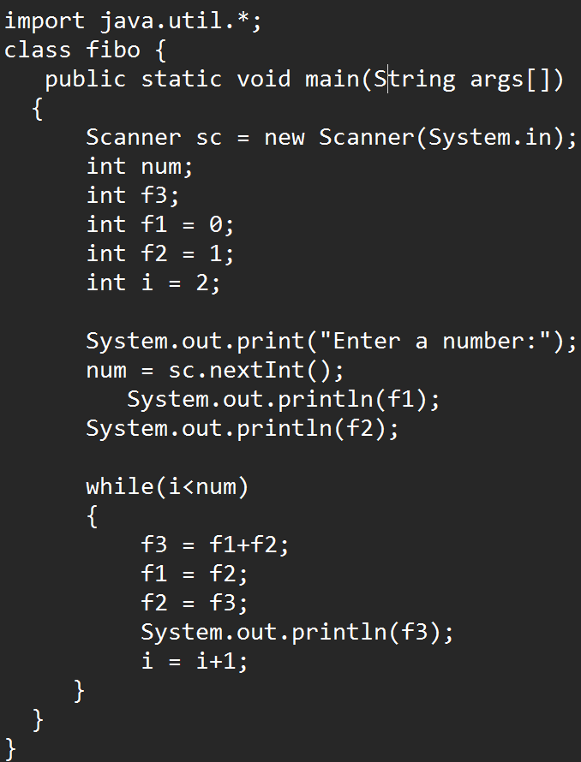

**Output:-**

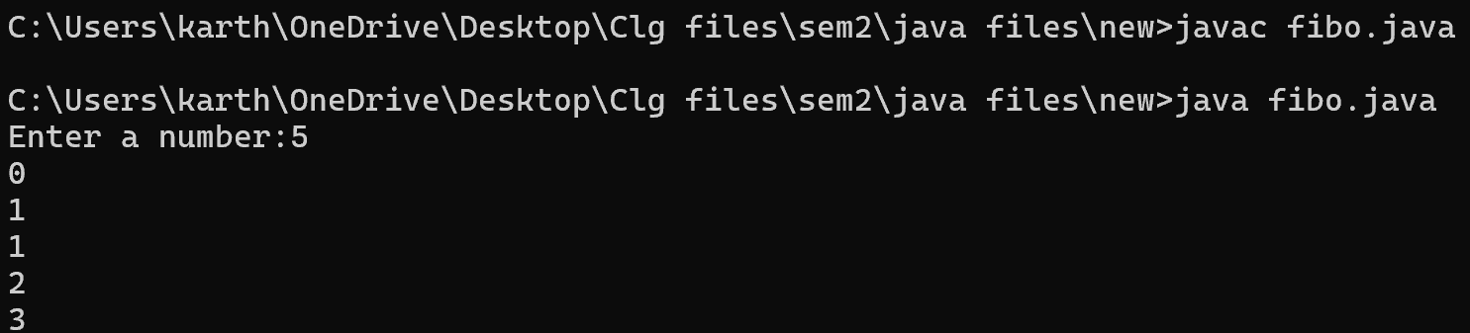

**Program-4:-**

**Aim:-** Write a program to find the area of triangle by using heron’s formula take the input from the user.

**Input:-**

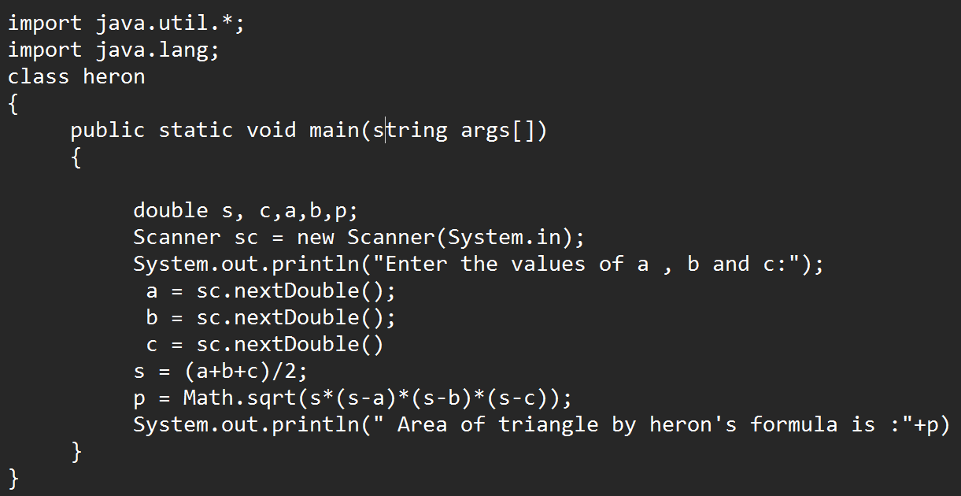

**Output:-**

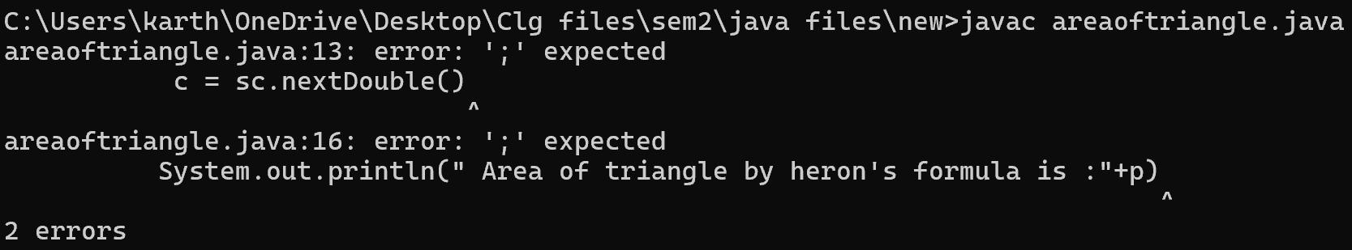

So we are getting an error which is in the class string. Go to notepad and correct the mistake in the class string.

|  |  |  |
| --- | --- | --- |
| **Sl.No** | Error | Rectification |
| 1. | Syntax Error | Semicolon is expected |

**Input:-**

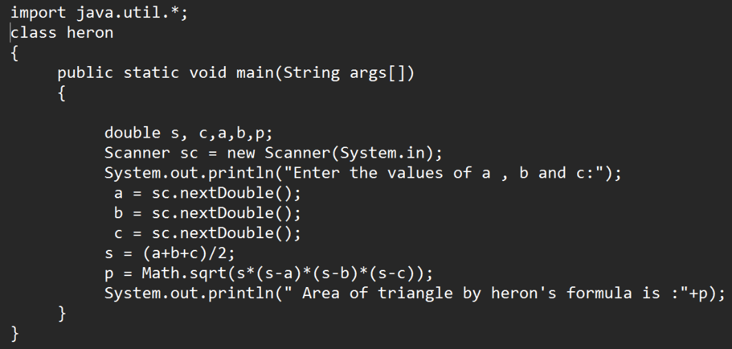

**Output:-**

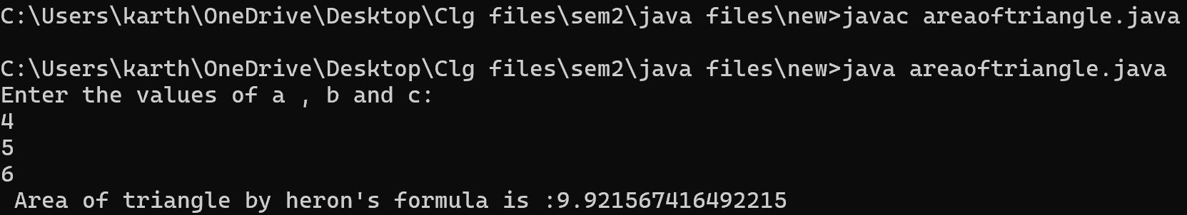

**Program-5:-**

**Aim:-**To calculate the area of the rectangle.

**Input:-**

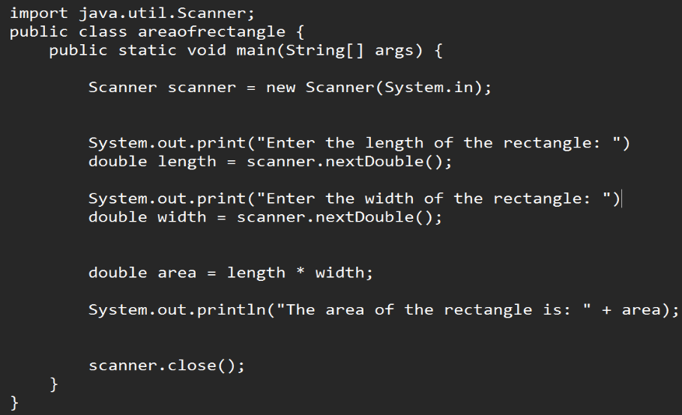

**Output:**

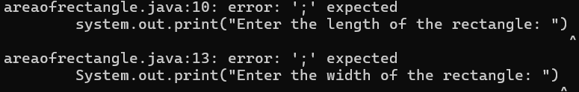

So we are getting an error which is in the class string. Go to notepad and correct the mistake in the class string.

|  |  |  |
| --- | --- | --- |
| Sl.No | Error name | rectification |
| 1. | Syntax error | Absence of semicolon |

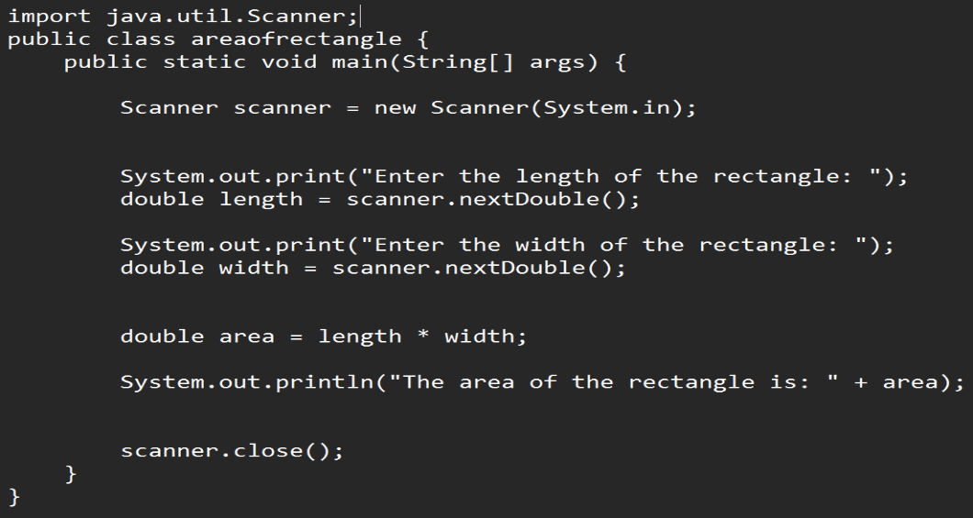

**Output:**

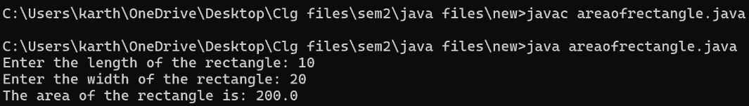

**Program-6:-**

**Aim:-**Write a java program to convert temperature from Celsius to Fahrenheit and Fahrenheit to Celsius.

**Input:-**

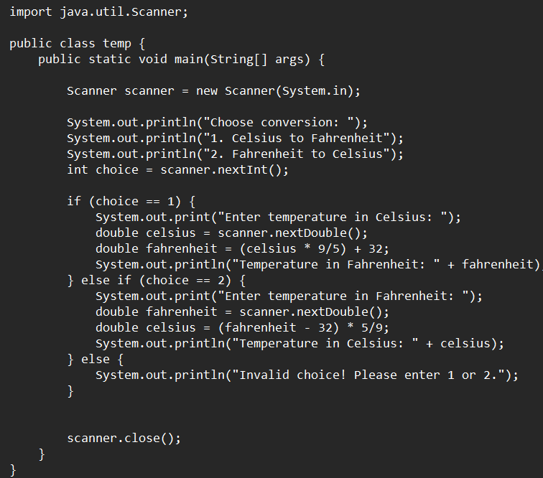

**Output:-**

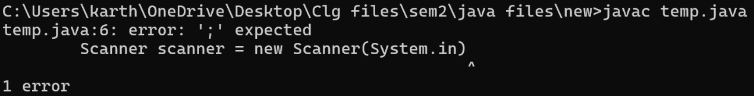

So we are getting an error which is in the class string. Go to notepad and correct the mistake in the class string.

|  |  |  |
| --- | --- | --- |
| Sl.No | Error Type | Rectification |
| 1. | Syntax Error | Absence of semicolon |

**Input:-**

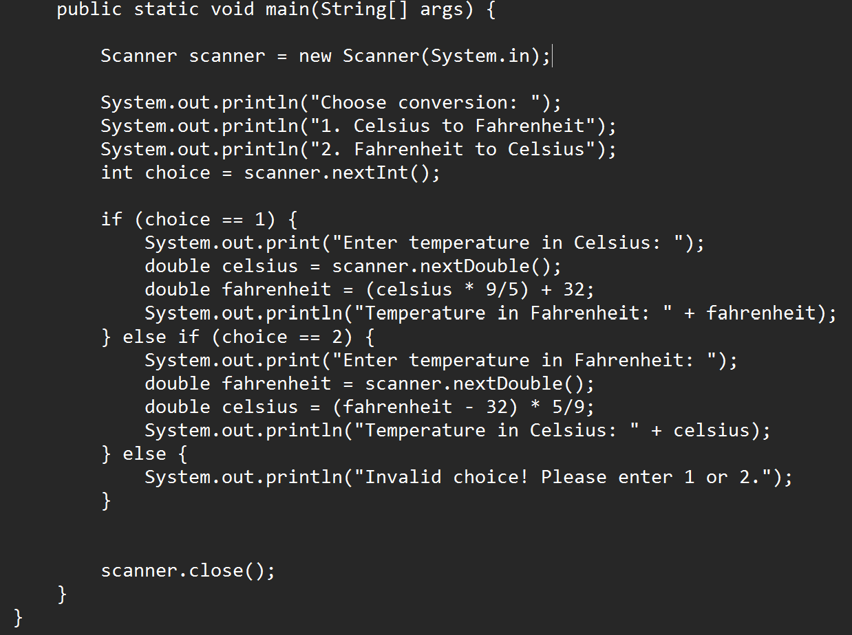

**Output:-**

