How to Use the App
This guide walks you through everything, step by step, with a picture for every step. Wherever you see an orange circle, box, or arrow in a picture, that is the exact spot to tap or click.

1. Signing In
When you open the app, you will see a sign-in page first. This keeps the app private so only people who have been given an email and password can get in.
Type the email into the first box, and the password into the second box. Then tap or click the blue "Log In" button.
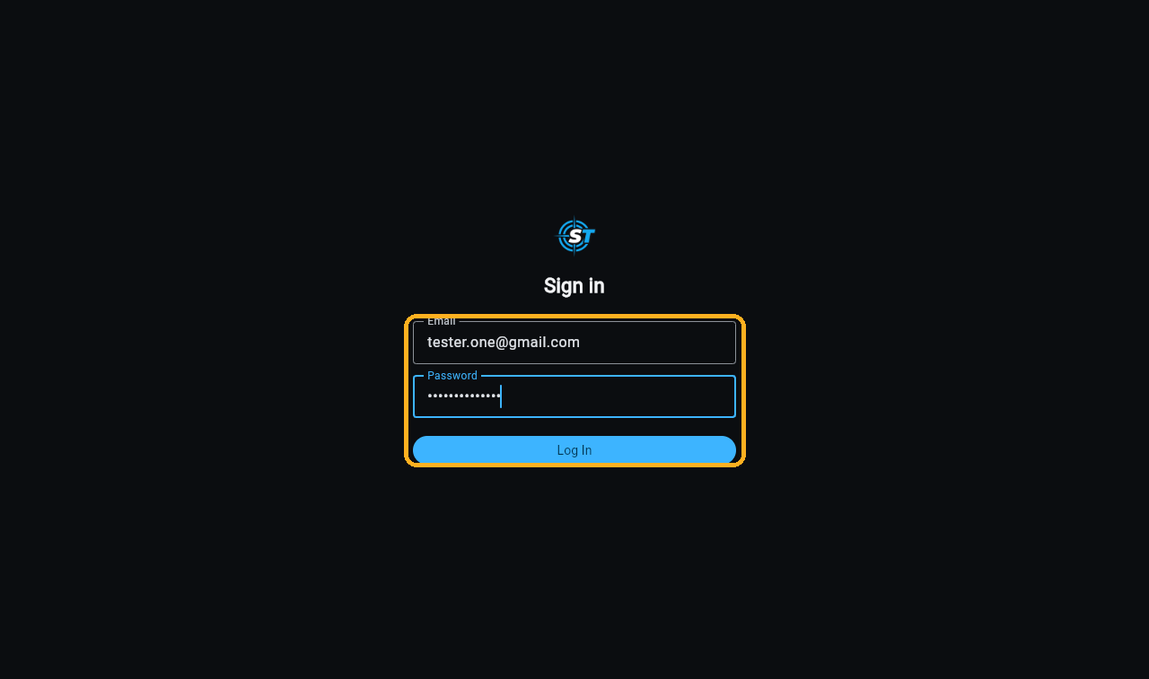
The orange box shows the two boxes to fill in, and the button to tap after.

2. Starting a New Recording
Once you are signed in, you will land on the main page. This is where every recording you have made before will show up under "Recent Transcripts".
To begin a brand new recording, tap or click the blue "Start New Session" bar at the top.
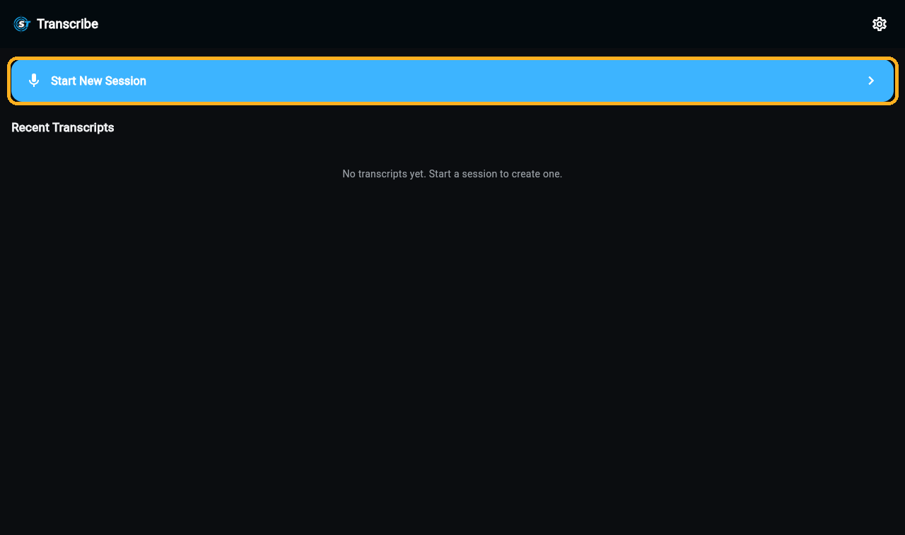
The orange box marks the bar that starts a new recording.

3. What the Settings Screen Lets You Change
Tap or click the small gear icon in the top-left corner of the recording page to open Settings. From here you can change a few simple things:
• Text size — make the words on screen smaller or bigger (S, M, or L).
• Theme — choose a light look, a dark look, or let it match your device.
• Microphone — pick which microphone to use for recording, if your device has more than one.
• Log out — sign out of the app. The next person to open it will need to sign in again.
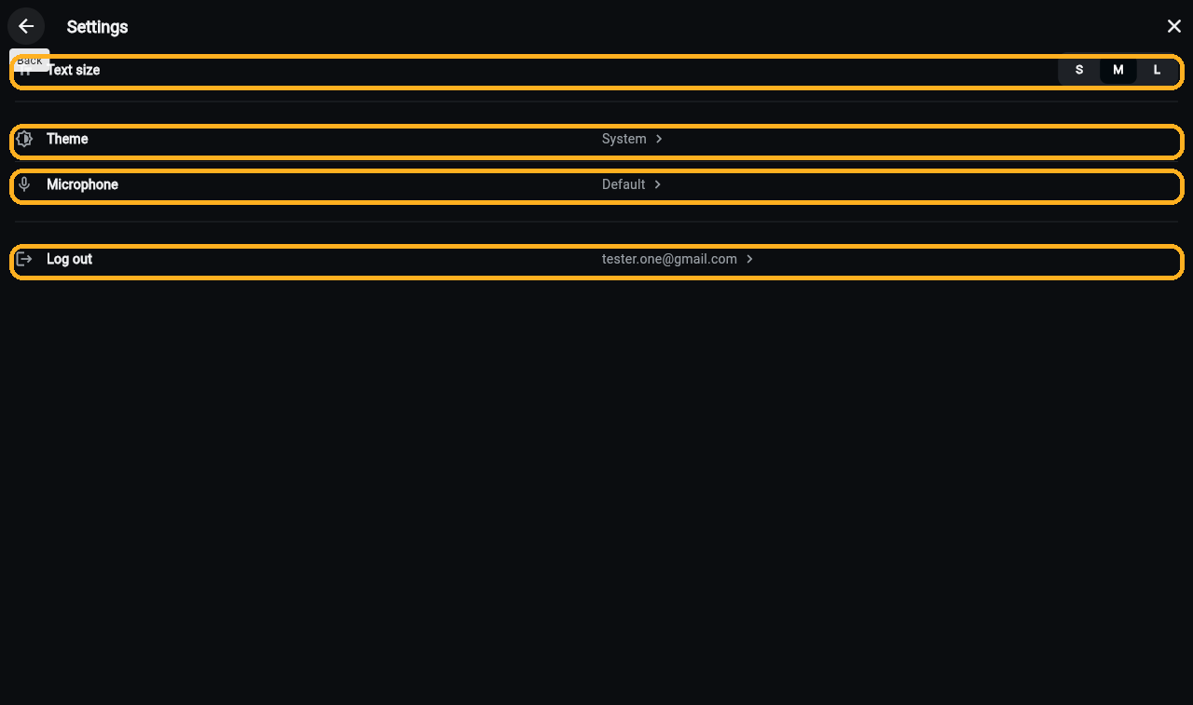
Each orange box marks one of the four things you can change.

4. Adding a Secret Code to Your Recording (Optional)
Before you start recording, you can turn on "Require access code". This adds a secret code to the link you will share later, so you have one extra layer of control over who can watch.
You do not have to turn this on — the app works perfectly fine without it. It is simply there if you want it.
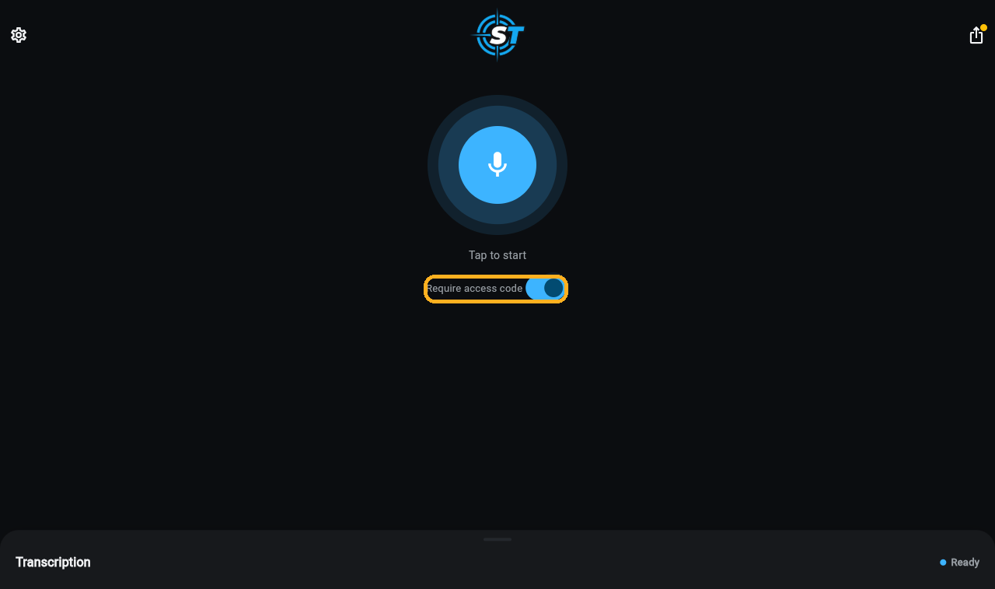
The orange box marks the switch. Blue means it is turned on.

5. Recording and Watching Your Words Appear
Tap or click the big round microphone button to start. The button turns red and the words you say will start appearing on the screen, live, as you speak.
To stop recording, tap or click the same button again.
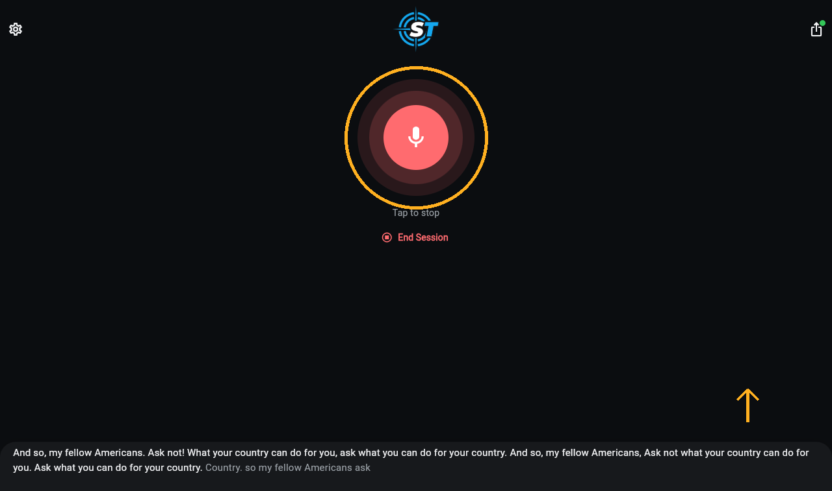
The orange circle marks the microphone button, which turns red while recording.

6. Seeing Everything You Have Said So Far
While you are recording, only a small strip at the very bottom of the screen shows the latest words. To see everything said from the beginning, place your finger (or your mouse) on that strip and drag it upward.
This opens up a larger panel that scrolls on its own as you keep talking, so the newest words are always in view.
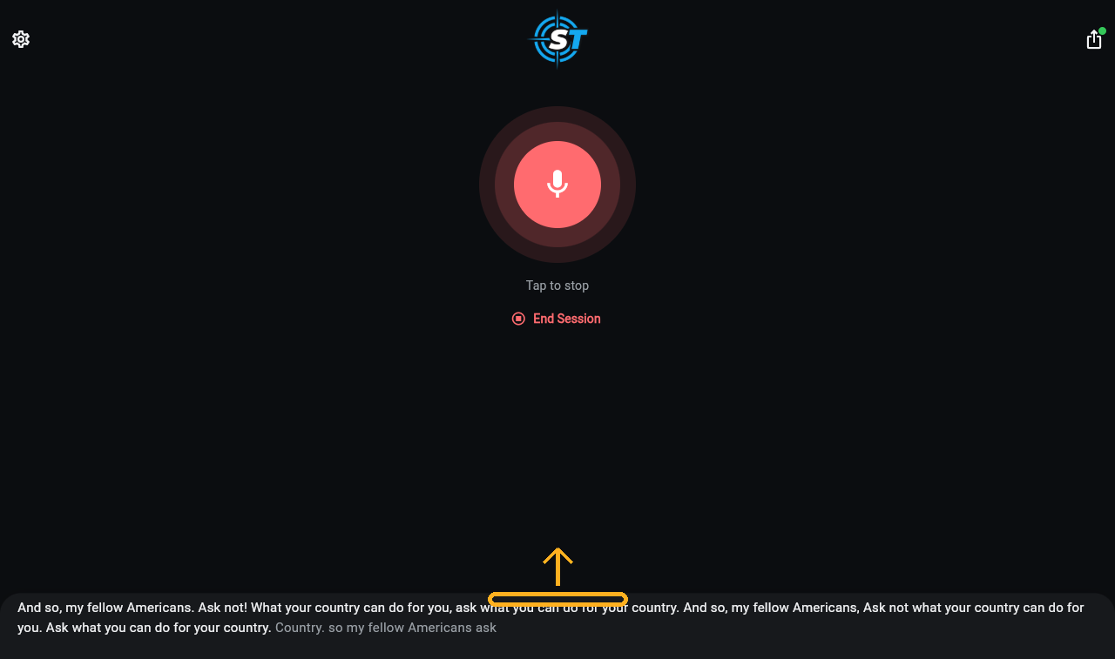
The orange arrow shows the strip to drag upward.

7. Getting a Link So Someone Else Can Watch Live
While recording, tap or click the share icon in the top-right corner. This opens a box with a link.
Anyone you send this link to can open it on their own phone or computer and watch your words appear live, without needing to sign in themselves. They cannot speak or change anything — they can only watch and read.
Tap or click the copy icon to copy the link, or tap or click "Share Link" to send it directly through your device's own sharing options (for example, Messages or Email). If you turned on the secret code in step 4, it is already included in this link, so you do not need to send it separately.
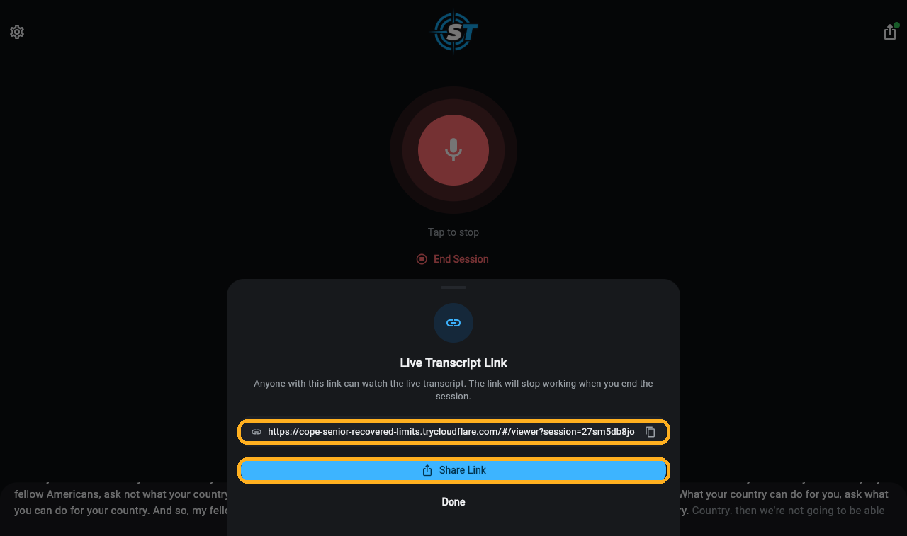
The top orange box is the link itself. The bottom orange box is the Share Link button.

8. Ending Your Recording
When you are finished speaking, tap or click "End Session", just below the microphone button. This stops the recording and finishes everything for anyone who was watching live.
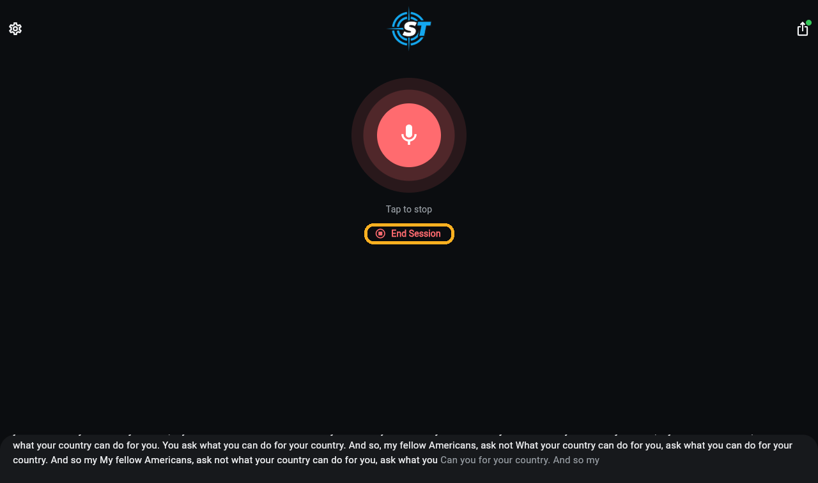
The orange box marks the End Session button.

9. Your Recording Is Saved Automatically
As soon as you end the recording, it is saved by itself — there is nothing extra you need to do. You will be taken back to the main page, and your new recording will appear at the top of "Recent Transcripts", with the date and a short preview of what was said.
Tap or click it at any time afterward to read the full text again.
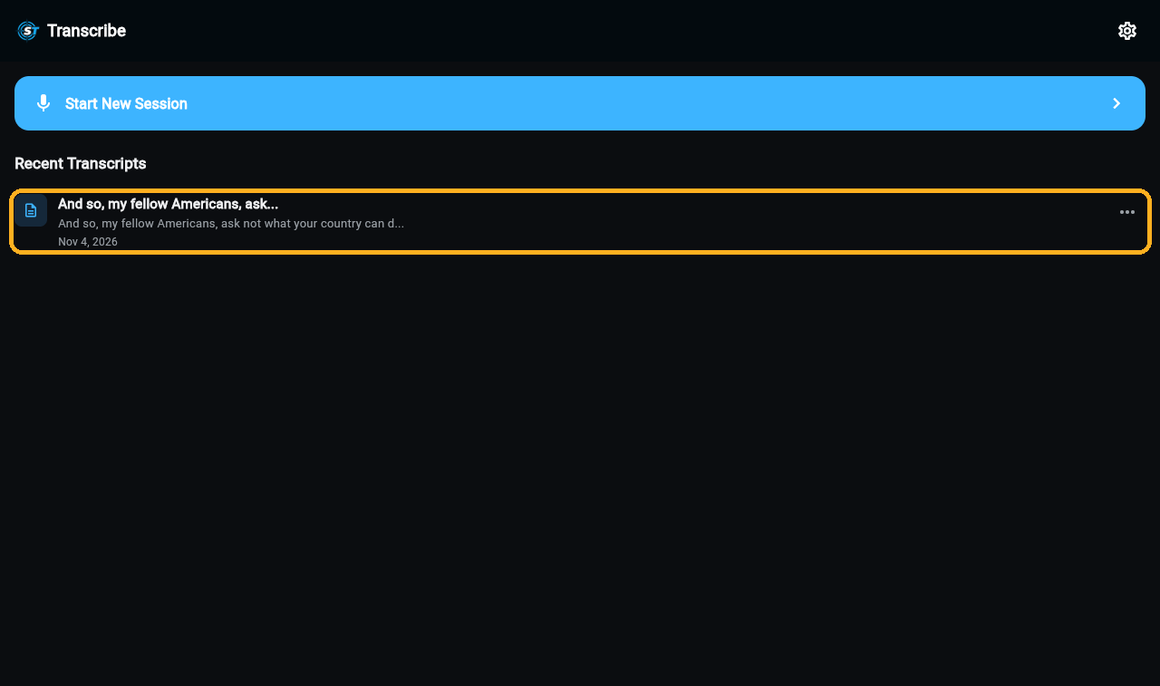
The orange box marks the newly saved recording on the main page.

10. What Happens to the Link After You End the Recording
The link you shared in step 7 keeps working even after you end the recording — it does not break or disappear.
If someone opens it after you have stopped, they will see a note saying the speaker has ended the session, followed by the complete text of everything that was said from start to finish. They are simply reading it now, instead of watching it appear live.
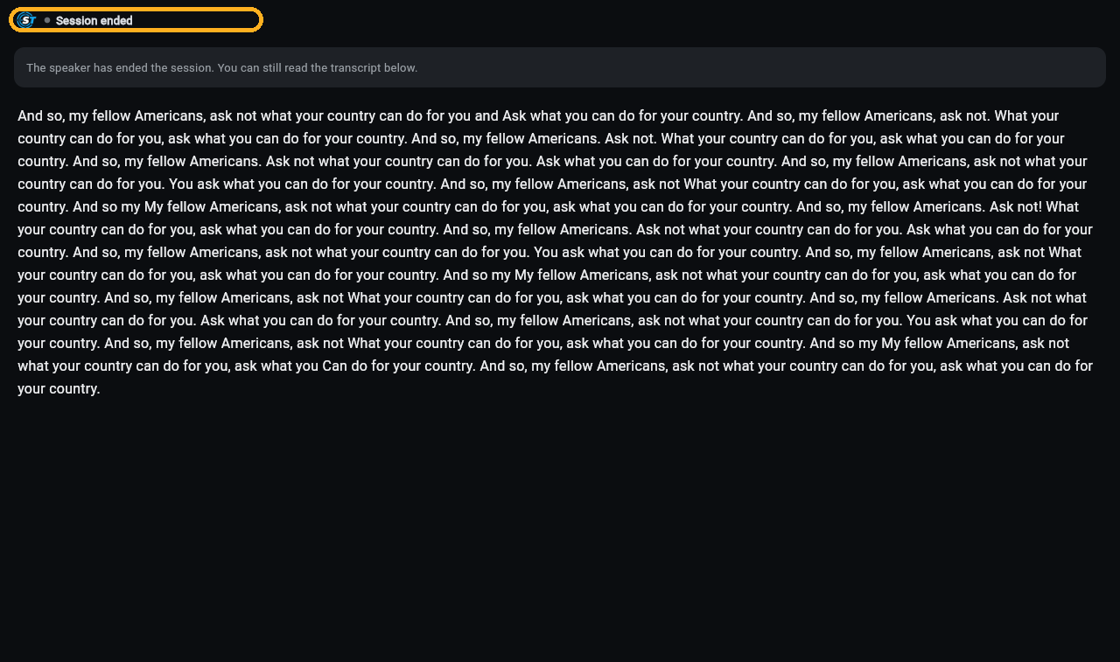
The orange box marks the "Session ended" note a viewer sees after you stop.

