ScriptLiv
Real-time speech to text

Technical & Business Document
Real-time speech-to-text platform: web, Android app, API and speech engine

Document type | Technical and business proposal
Version | 1.0
Date | 11 November 2026
Prepared by | Snypar Tech
Product status | Staging release candidate. Not approved for production.
Contact | info@scriptliv.com

Document Control
Field | Detail
Document title | ScriptLiv Technical & Business Document
Version | 1.0
Date | 11 November 2026
Owner | Snypar Tech
Audience | Customers, partners, evaluators, acquirers
Basis | Build documents and test results in the repository (SCRIPTLIV_COMPLETE_BUILD, PLATFORM, BACKEND, RELEASE_READINESS)
Honesty rule | Only verified facts are stated. Anything not tested or not decided is marked TBD or Not tested.

Contents
1. Executive Summary and Key Highlights
2. Technology Stack
3. System Architecture
4. Modules and Features
5. Roles and Dashboards
6. Plans, Usage and Licensing
7. Implementation Timeline
8. Deployment and Integration
9. Training and Adoption
10. Support Model
11. Scalability and Performance
12. Security and Compliance
13. Warranty and Service Levels
14. Commercial Breakup
15. Conclusion

1. Executive Summary and Key Highlights
ScriptLiv is a real-time speech-to-text platform. A speaker talks into a browser or an Android phone; the audio is streamed to a speech engine and the text comes back within moments. Transcripts are stored, searchable and exportable, and can be shared as a read-only live link that costs the viewer nothing.
Status: Release position: staging release candidate YES. Production approved NO. See section 12 and the Technical Due Diligence and Handover document for the open items.

Area | Key highlight
Product | Live transcription, continuous sessions, history, search, text export, live share links. English only for now.
Clients | Next.js web app, Flutter Android app (iOS shares code, untested).
Speech engine | Local streaming ASR (Parakeet EOU 120M) with an optional second-pass refine (Nemotron 0.6B).
Backend | FastAPI platform API with MongoDB Atlas; separate WebSocket relay that meters audio.
Plans | Basic free 300 min/month (30 min per session). Pro 2,500 min/month, $20. Add-on 1,000 min, $10. Purchases not switched on yet.
Fair metering | Only the speaker uses minutes. Viewers are free. Limits are exact to the audio sample.
Quality evidence | API 113 tests passed. Relay 187 passed, 1 skipped. Web type-check and lint clean, 10 tests, build OK. App 59 tests passed.
Open items | Payments disabled, iOS untested, no pen test or dependency CVE scan, legal pages are an unreviewed draft, no retention policy.

2. Technology Stack
Layer | Technology | Notes
Web client | Next.js, React, TypeScript, Tailwind CSS | Production build served by `next start`. The `/sl/*` path is rewritten server-side to the API.
Mobile client | Flutter (Dart) | Android tested. Deep link `scriptliv://s/<token>`.
Platform API | Python, FastAPI | JWT auth (HS256, 7 days), plans, usage ledger, reservations, billing, sessions, sharing, settings.
Relay | Python WebSocket service | Speaker and viewer roles, audio metering, strict limit, capacity cap, transcript mirroring.
Speech engine | Streaming ASR EOU 120M (Parakeet) and Nemotron 0.6B refine worker | Local workers on ports 8780 and 8781. About 3 live streams per worker on tested hardware.
Database | MongoDB Atlas | Database `scriptliv_staging`. Indexes audited (index scans).
Email | Resend, Gmail API, SMTP adapters | Chosen by recipient domain. Adapters are mock-tested; real delivery is not documented as verified.
Payments | Stripe adapter | Code exists; never run against Stripe. Payments disabled.
Demo edge | ngrok tunnels | Demo only. Not part of the production design.

3. System Architecture
Clients reach the Next.js server for pages and API calls, and the relay for live audio. The relay never decides who may speak: it asks the API to authorize each session and reports cumulative usage about every 10 seconds. The API is the only component that writes plans, usage and billing state.
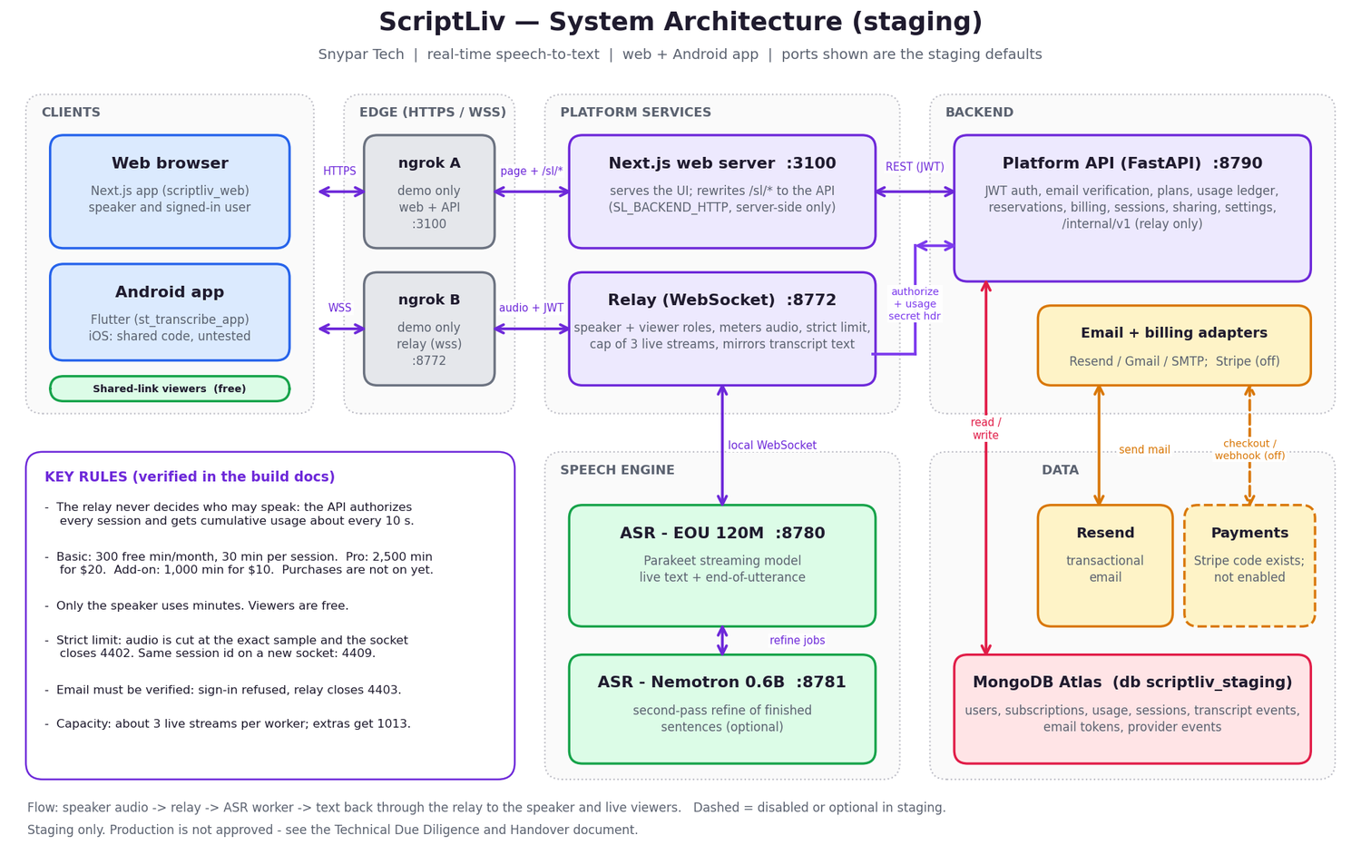
Figure 1. ScriptLiv system architecture (staging).

Live transcription flow
- The speaker's browser or app opens a WebSocket to the relay with a JWT.
- The relay calls the API (`/internal/v1/sessions/start`, with the relay secret header). The API checks the account, email verification, plan, minutes and reservation.
- Audio frames go to an ASR worker. Partial and final text return through the relay to the speaker and any live viewers.
- About every 10 s the relay reports cumulative seconds (`/internal/v1/usage`). When the allowance is reached, audio is cut at the exact sample and the socket closes with code 4402.
- At the end the session and transcript events are stored in MongoDB.
Relay close code | Meaning
4401 | Invalid token
4402 | Out of minutes, personal limit, allowance reserved, or payment required
4403 | Email not verified
4409 | Superseded: same account started a newer session
1011 | ASR connection lost
1013 | Server busy (capacity cap reached)

4. Modules and Features
Module | What it does
Accounts and auth | Register, verify email (24 h token), sign in, forgot/reset password (1 h token), change email, change password. Password change invalidates older tokens.
Live recording | Microphone capture, live partial and final text, session timer, screen-awake option.
Transcripts | History list, search, rename, delete, text export, transcript detail.
Sharing | Read-only share link, live or after the session, optional access code in the app, stop sharing.
Plans and usage | Plan catalogue, usage meter, add-on balance, warnings at 50/80/100 %, personal monthly limit.
Billing (disabled) | Provider adapter, payment states (active, past due, restricted, canceled), webhook with HMAC-SHA256 and 300 s tolerance.
Email | Verification, reset and change-email messages through the configured provider.
Legal and errors | Terms, Privacy (draft), friendly error pages written in plain language.
Android app | Splash, onboarding, sign in, home, record, transcripts, detail, settings, viewer join and shared view.

5. Roles and Dashboards
Role | Can do | Dashboard
Visitor | See the landing page, terms and privacy, register, sign in. | Landing page
Registered user (speaker) | Record, manage own transcripts, share, view plans and usage, change settings. | Home, Transcribe, Transcripts, Plans, Settings
Viewer | Read a shared transcript by link. No account, no minutes used. | Shared view `/s/<token>`
Relay (service) | Report usage and request authorization using a shared secret. | None (service to service)
Operator | Run, monitor and configure the services. | TBD (no admin console exists yet)

6. Plans, Usage and Licensing
Plan | Included minutes | Price | Session cap | Status
Basic | 300 per month | Free | 30 minutes | Live
Pro | 2,500 per month | $20 | TBD | Not purchasable yet
Add-on | 1,000 minutes | $10 | n/a | Valid to the end of the billing period bought in. Not purchasable yet.

- Included minutes are spent before add-on minutes. No rollover.
- Usage is recorded per second in a ledger. Overshoot beyond the limit is recorded as unbilled.
- One reservation per user at a time. Capacity cap `STT_MAX_ACTIVE_STREAMS` (default 3).
- Payment states: active, past due, restricted, canceled. A retry never activates a plan without provider confirmation.
Software licence terms for an acquirer or white-label customer: TBD.

7. Implementation Timeline
The platform is built and running in staging. Remaining work to reach production is listed below. Durations are not committed here and are marked TBD until a plan is agreed.
Phase | Activities | Duration
1. Production readiness | Move `/internal/*` off the public port, persistent login throttle, secrets rotation, dependency CVE scan, penetration test. | TBD
2. Payments go-live | Run Stripe adapter against Stripe test then live mode, webhooks, receipts, tax decisions. | TBD
3. Legal and policy | Legal review of Terms and Privacy, retention policy, support contact process. | TBD
4. Infrastructure | Production hosting, TLS, backups, monitoring, alerting, high availability design. | TBD
5. Mobile release | Play Store release, iOS testing and release. | TBD
6. Launch and hypercare | Go-live checklist, staged rollout, support rota. | TBD

8. Deployment and Integration
Component | Port | Run command / note
Web (Next.js) | 3100 | Production build, `next start -p 3100`. Needs `SL_BACKEND_HTTP` pointing to the API (server-side only).
Platform API | 8790 | `run_staging.py` (FastAPI).
Relay | 8772 | Platform relay script. Needs the shared relay secret and API URL.
ASR EOU worker | 8780 | Local worker, WebSocket.
ASR Nemotron worker | 8781 | Optional refine worker.
MongoDB | Atlas | Connection string kept in environment, never in the repo.

- Integrations in place: MongoDB Atlas; Resend, Gmail API and SMTP; Stripe adapter (off).
- Configuration: by environment variables. `SCRIPTLIV_DEV_RETURN_TOKENS=1` is a development switch and must be off in production.
- Demo exposure: ngrok tunnels for the web/API and for the relay. Addresses change on restart, so the web build and the app build must be redone.

9. Training and Adoption
- End users: the Web User Manual and the Android App User Manual (docs/manual).
- Operators and engineers: Knowledge Transfer document and the build documents in `docs/`.
- Formal training sessions, recordings and certification: TBD.

10. Support Model
Support contact: info@scriptliv.com. A staffed support desk, hours and response commitments are not yet decided. The table is a proposed structure, not a commitment.
Priority | Definition | Target response | Target resolution
P1 | Service down for everyone, or data loss/security incident | TBD | TBD
P2 | Major feature broken (cannot record or sign in) for many users | TBD | TBD
P3 | Feature degraded, workaround exists | TBD | TBD
P4 | Question, cosmetic issue, improvement request | TBD | TBD

11. Scalability and Performance
- Measured on the test hardware: about 3 live streams per ASR worker. With a cap of 3, five simultaneous streams served 3 and refused 2 with close code 1013.
- Scale-out path: more ASR workers behind the relay, more relay instances. Multi-worker routing and load balancing: TBD (not built).
- Database: indexes audited; query plans use index scans.
- Latency, word error rate and long-run soak figures: see the benchmark results in the repository. Production-scale numbers: TBD.

12. Security and Compliance
Control | State
Passwords | Hashed. Minimum 8 characters. Password version (`pwv`) invalidates old tokens.
Tokens | JWT HS256, 7 days. Email verify/change 24 h, reset 1 h. Random 32-byte tokens, SHA-256 stored, single use.
Email verification | Required to sign in and to record.
Relay trust | Shared secret header between relay and API.
Payments webhook | HMAC-SHA256, 300 s tolerance (adapter not live).
Account isolation | Each user's data scoped by account id (verified by tests).

Open security items
- `/internal/*` endpoints are on the public API port.
- Login throttle is in memory (resets on restart, not shared between instances).
- No penetration test and no dependency CVE scan.
- Staging secrets are dummy values and must be replaced for production.
- No data retention policy yet.
- Legal pages are a draft without legal review.
- Compliance certifications (SOC 2, ISO 27001, GDPR assessment): none claimed. TBD.

13. Warranty and Service Levels
No warranty period and no uptime SLA are offered yet. Terms to be agreed with the customer: TBD.
Item | Proposal
Defect warranty | TBD
Uptime target | TBD
Maintenance window | TBD
Backup and recovery objectives (RPO/RTO) | TBD

14. Commercial Breakup
Item | Description | Amount
Platform licence or transfer | Source, documentation, handover | [TBD]
Implementation and hardening | Phases 1 to 4 in section 7 | [TBD]
Hosting and infrastructure | Production environment, GPU for speech engine | [TBD]
Support and maintenance | Per section 10 and 13 | [TBD]
Taxes | As applicable | [TBD]

End-user pricing is in section 6.

15. Conclusion
ScriptLiv is a working, tested staging platform: accounts, live transcription, fair minute metering, history, sharing, a web app and an Android app. It is not yet approved for production. The path to production is short and well defined: secure the internal endpoints, run a security scan and penetration test, turn on and verify payments and real email delivery, finish legal review and retention policy, and set up hosting, monitoring and support. Questions: info@scriptliv.com.

