ScriptLiv
Real-time speech to text

Technical Due Diligence and Handover Checklist
Audit of the ScriptLiv platform for acquisition, hosting or handover

Document type | Technical due diligence audit and handover
Version | 1.0
Date | 11 November 2026
Prepared by | Snypar Tech
Product status | Staging release candidate. Not approved for production.
Contact | info@scriptliv.com

1. Purpose and verdict
This document lets a technical reviewer decide whether ScriptLiv can be taken over and run in production. It lists the stack, the four risk pillars with Level 1 to 3 questions, the answers known today, the handover interview questions, the acceptance criteria and a handover checklist.
Verdict: Verdict today: staging release candidate YES, production NOT ready. Blockers are listed in section 8.

2. Stack overview
Layer | Technology | Port
Web | Next.js (production build) | 3100
API | FastAPI | 8790
Relay | WebSocket service | 8772
ASR | Parakeet EOU 120M, Nemotron 0.6B refine | 8780, 8781
Data | MongoDB Atlas, db scriptliv_staging | n/a
Email | Resend / Gmail API / SMTP | n/a
Payments | Stripe adapter (disabled) | n/a
Mobile | Flutter (Android tested) | n/a

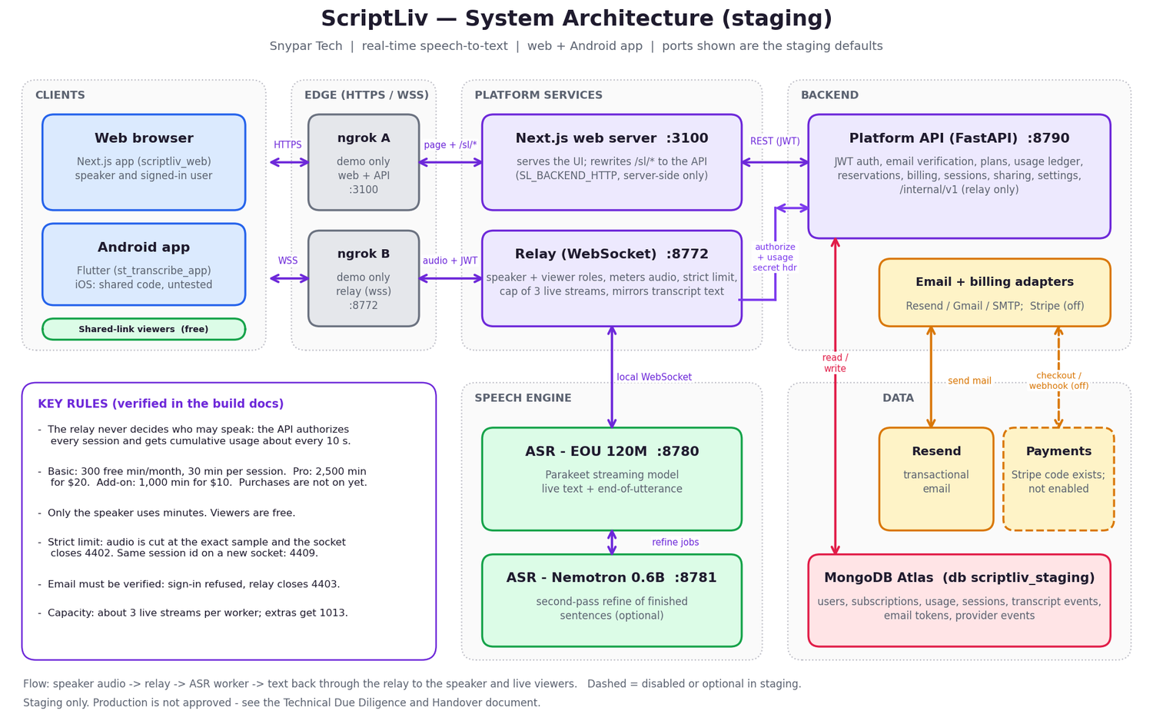
Figure 1. Architecture (staging).

3. Evidence of quality
Suite | Result
API | 113 passed
Relay | 187 passed, 1 skipped
Web | tsc and eslint clean, 10 vitest passed, build OK
Flutter app | 59 passed, 4 analyzer infos
Capacity | 5 streams with cap 3: 3 served, 2 refused 1013
MongoDB | Indexes audited, index scans

4. Pillar 1: Concurrency and load
Can the platform serve many speakers at once, and fail safely when full?

Level 1: awareness
- How many simultaneous live streams are supported?
- What happens at the limit?
- Is there a queue?

Level 2: design
- How is the capacity cap configured?
- How do relay and ASR workers scale?
- How are usage reports kept correct under load?

Level 3: proof
- Show a load test with results.
- Show behaviour when a worker dies mid-session.
- Show a soak test of long sessions.

Audit table
Check | Finding today | Status
Streams per worker | About 3 on tested hardware | Measured
Cap behaviour | STT_MAX_ACTIVE_STREAMS default 3; extras closed with 1013 | Pass
One session per user | Reservation per user; newer session gets 4409 on the old one | Pass
Multi-worker routing | Not built | Gap
Large-scale load test (100+ users) | Not run | Gap
Soak test | See benchmark results; production-scale: TBD | Partial

5. Pillar 2: Tenant and account isolation
Can one user see or spend another user's data or minutes?

Level 1: awareness
- How is each user's data scoped?
- Who can read a transcript?
- What does a share link expose?

Level 2: design
- How are tokens bound to a user and a password version?
- How is the relay prevented from trusting clients?
- How are viewers kept from minutes and from speaking?

Level 3: proof
- Show tests that user A cannot read user B.
- Show a revoked share link stops working.
- Show internal endpoints reject missing secrets.

Audit table
Check | Finding today | Status
Per-account data scoping | Enforced in the API; tests pass | Pass
Share link | Read-only, revocable with Stop sharing, optional access code (app) | Pass
Viewers use minutes? | Never | Pass
Token revocation | Password change bumps `pwv`, old JWTs rejected | Pass
`/internal/*` exposure | On the public port, protected by secret header only | Gap
Pen test | Not done | Gap

6. Pillar 3: Pipeline, configuration and portability
Can a new team build, configure and move the system without the original developers?

Level 1: awareness
- Is everything in the repository?
- Is configuration in the environment?
- Can it run on another machine?

Level 2: design
- Is there CI/CD?
- Which cloud-specific services are used?
- What is tied to the original machine (GPU, paths, models)?

Level 3: proof
- Build every component from a clean checkout.
- Deploy to a fresh server from the docs.
- Rotate a secret and restart without code changes.

Audit table
Check | Finding today | Status
Source in Git | Yes, branch `reliability-refactor`, remote on GitHub | Pass
Config via environment | Yes; values never committed | Pass
Docs | Build, platform, backend, release readiness docs, manuals, KT | Pass
CI/CD pipeline | None documented | Gap
Infrastructure as code / containers | Not documented | Gap
ASR model and GPU requirements | Needs exact versions written down | Gap
Demo tunnels | ngrok only for demo; URLs change | Note

7. Pillar 4: High availability and disaster recovery
What happens when something fails, and how fast can service and data be restored?

Level 1: awareness
- What are RPO and RTO targets?
- Are there backups?
- Who is on call?

Level 2: design
- Is any component redundant?
- How are database failures handled?
- How are ASR failures shown to users?

Level 3: proof
- Show a restore from backup.
- Show a failover drill.
- Show alerting firing on a stopped service.

Audit table
Check | Finding today | Status
Database backup and restore | Atlas feature available; restore not tested | Gap
Service redundancy | Single instance of each service | Gap
ASR failure handling | Close 1011; user can restart | Pass
Monitoring and alerts | Not set up | Gap
RPO / RTO | TBD | Gap
Data retention | No policy | Gap

8. Production blockers
# | Blocker | Why it matters
1 | `/internal/*` on public port | Remove public exposure or add network-level restriction.
2 | In-memory login throttle | Resets on restart, not shared across instances.
3 | No penetration test, no dependency CVE scan | Unknown vulnerabilities.
4 | Dummy staging secrets | Must be replaced and managed properly.
5 | Payments never run against Stripe | Cannot sell plans.
6 | Real email delivery not verified in docs | Users cannot verify or reset if it fails.
7 | Legal pages are a draft | Needs legal review before launch.
8 | No retention policy | Compliance and storage risk.
9 | No HA, monitoring, backups tested | Outages and data loss risk.
10 | iOS untested | No iPhone release.

9. Handover interview questions
Topic | Question | Answer
Origin | Who built each part and who remains available after handover?
Decisions | Why a separate relay and API? Why these ASR models?
Incidents | What has broken in staging and how was it fixed?
Secrets | Where are all secrets stored and who can rotate them?
Accounts | Which third-party accounts and domains are involved and who owns them?
Data | Is any real user data present? How is it removed?
Roadmap | What was planned next and why was it deferred?
Support | What support promises have been made to anyone?

10. Acceptance criteria and sign-off
Criterion | Required | Met?
All test suites run from a clean checkout and pass | Yes
Manuals and architecture diagram reviewed | Yes
Blockers 1 to 4 and 9 closed or accepted in writing | Yes
Payments verified end to end (if selling) | If in scope
Real email delivery verified | Yes
Secrets rotated and transferred | Yes
Backups restored in a test | Yes
Legal review of Terms and Privacy | Yes

Role | Name | Signature | Date
Seller / Snypar Tech
Buyer / receiving team
Independent reviewer

11. Handover checklist

Code and documents
[ ] Repository access transferred (GitHub org/owner).
[ ] All branches and tags reviewed; `reliability-refactor` merged or documented.
[ ] Docs folder complete (build, platform, backend, release readiness, manuals, KT, this audit).
[ ] Architecture diagram accepted.

Accounts and credentials
[ ] MongoDB Atlas project and users transferred.
[ ] Resend, Gmail/SMTP and Stripe accounts transferred or recreated.
[ ] Domain and DNS (scriptliv.com) transferred.
[ ] App signing keys and Play Console access transferred.
[ ] ngrok account no longer required for production.
[ ] All secrets rotated by the new owner.

Environments
[ ] New team built web, API, relay, ASR workers from clean checkout.
[ ] ASR model files and GPU requirements documented and reproduced.
[ ] Production environment, TLS and backups set up.
[ ] Monitoring and alerting configured.
[ ] `SCRIPTLIV_DEV_RETURN_TOKENS` confirmed off.

Quality and security
[ ] All test suites pass.
[ ] Dependency CVE scan done and findings handled.
[ ] Penetration test done.
[ ] `/internal/*` protected from public access.
[ ] Persistent login throttle in place.

Business and legal
[ ] Terms and Privacy reviewed by counsel.
[ ] Retention policy written.
[ ] Support process and contact (info@scriptliv.com) running.
[ ] Pricing and plan terms confirmed.
[ ] Commercial terms signed.

