ScriptLiv
Real-time speech to text

Android App User Manual
How to use the ScriptLiv app on your phone

Document type | User manual (Android app)
Version | 1.0
Date | 11 November 2026
Prepared by | Snypar Tech
Product status | Staging release candidate. Not approved for production.
Contact | info@scriptliv.com

Contents
1. About the app
2. Install the app
3. First launch and sign in
4. Home
5. Record a live transcript
6. Share while recording
7. Transcripts
8. Open a shared link
9. Settings
10. Plans and minutes
11. Messages and what to do
12. FAQ
13. Getting help

About the screenshots: Screens 1 to 5 are real captures from an Android device (emulator) using a test account. Screens 6 to 11 are illustrative renders of the same screens (onboarding, login, text view and viewer pages) and may differ slightly in spacing.

1. About the app
The ScriptLiv app does what the website does, on your phone: record, see live text, keep transcripts, search them, and share a link. It uses the same account as the website.
- Android is tested. iOS shares the same code but has not been tested yet.
- Language: English only for now.
- Only the speaker uses minutes. People who open your shared link never do.

2. Install the app
- Get the file app-release.apk from Snypar Tech (it is a test build, not on the Play Store).
- Copy it to the phone (USB, drive or download link).
- Open the file. If Android asks, allow Install unknown apps for the app you opened it from.
- Tap Install, then Open.
For developers: `adb install -r app-release.apk`, package name `com.snypar.st_transcribe`.
Note: Test builds point at a temporary demo address. If the app cannot connect, ask Snypar Tech for a newer build.

3. First launch and sign in
- The splash screen appears, then a short onboarding (two screens). Swipe or tap Next.
- On the sign-in screen enter your email and password and tap Sign in. New users register first (on the website or in the app), then verify the email.
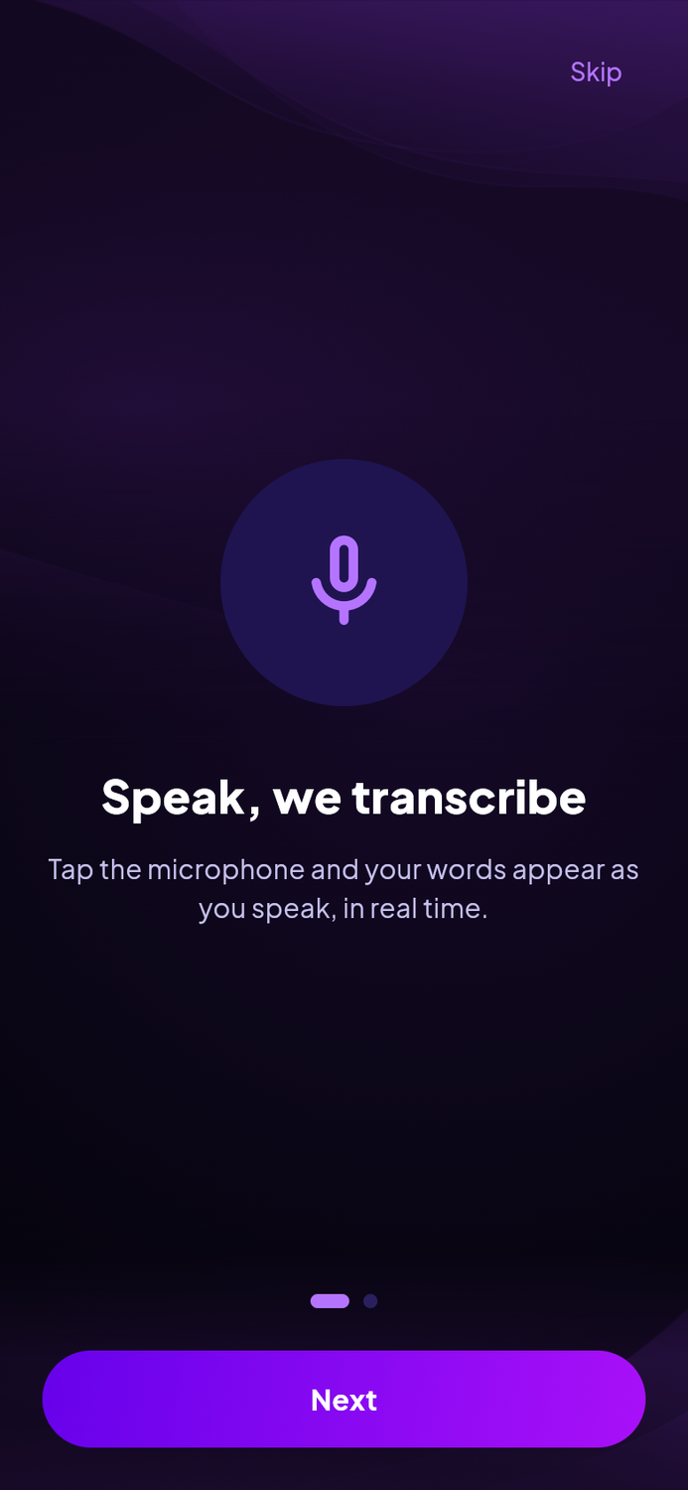
Figure 1. Onboarding, step 1 (illustrative).
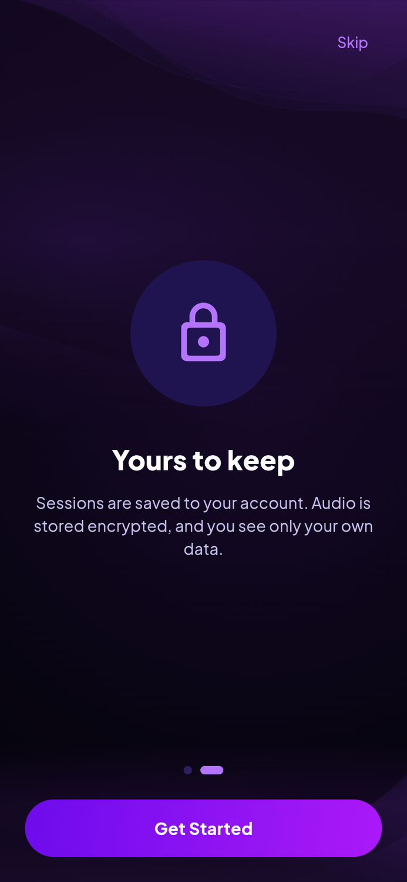
Figure 2. Onboarding, step 2 (illustrative).
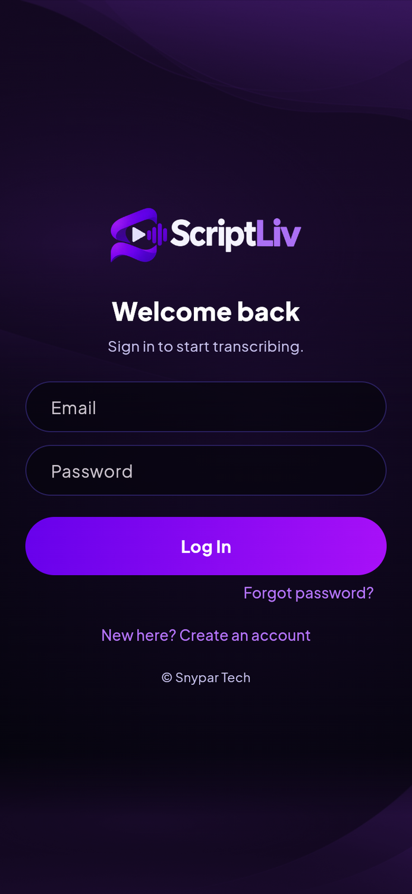
Figure 3. Sign in (illustrative).
Note: If your email is not verified, sign-in is refused. Open the verification email (valid 24 hours) and tap the link, then sign in again.

4. Home
- Start recording button.
- Plan usage card: your plan and how many minutes you have used this month.
- Recent transcripts, newest first.
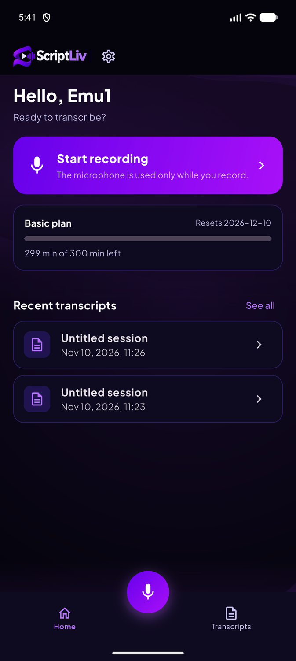
Figure 4. Home.
The bottom bar moves between Home, Transcripts and Settings.

5. Record a live transcript
- Tap Start recording (or the microphone button). Allow microphone access the first time.
- Speak. The text appears as you talk. Open the Transcription sheet to read it in full.
- Tap the microphone again to stop. The transcript is saved to Transcripts.
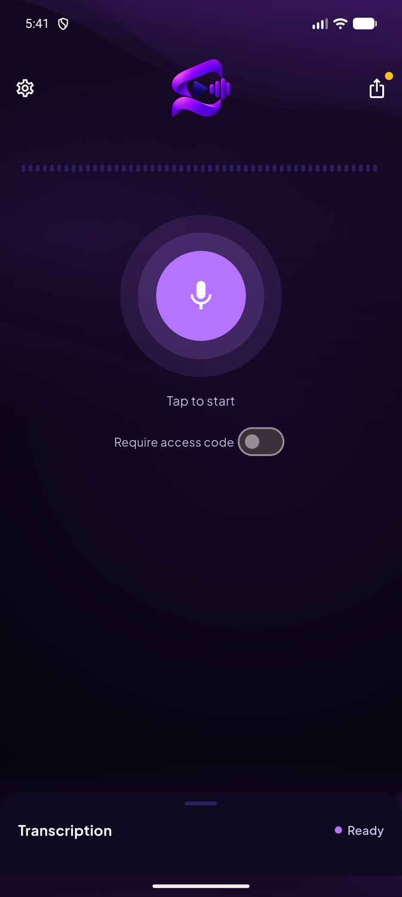
Figure 5. Record screen.
- Basic plan sessions stop at 30 minutes. Recording stops at the exact moment your minutes run out.
- Prevent auto-lock while live (Settings) keeps the screen on during recording.
- One speaking session per account at a time.

6. Share while recording
- Tap the share button on the record screen to get a viewer link.
- Turn on Require access code if you want viewers to enter a code before reading.
- Send the link. Viewers see the text live and it never uses your minutes.
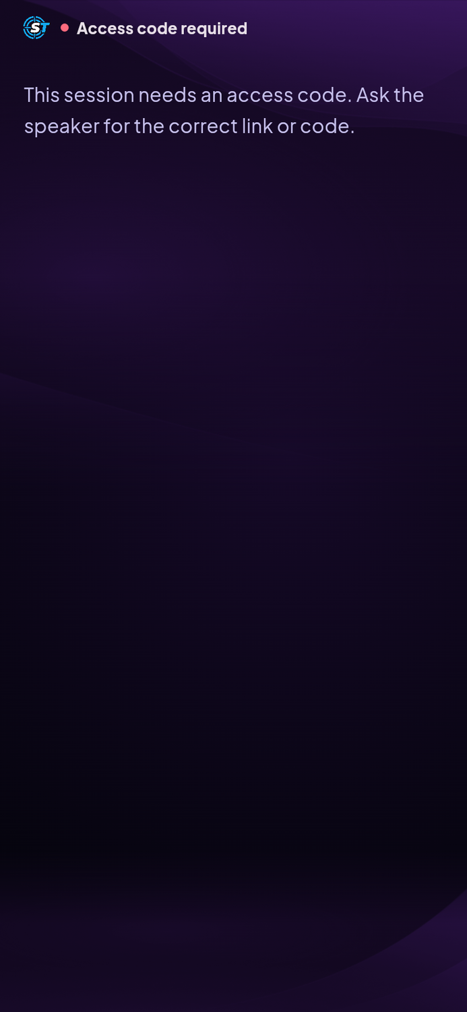
Figure 6. A viewer joins with a code (illustrative).

7. Transcripts
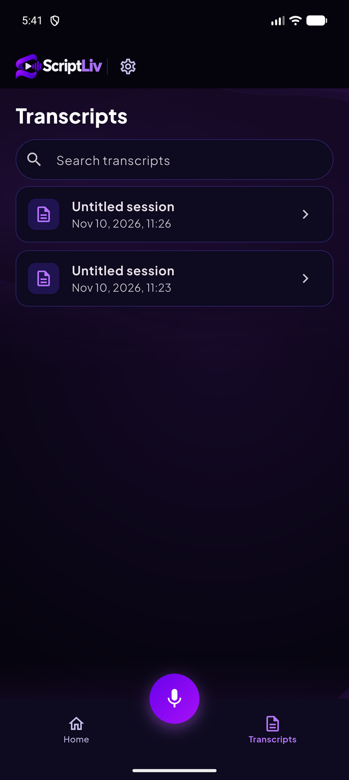
Figure 7. Transcripts with search.
Use the search box to find a transcript. Tap a transcript to open it.
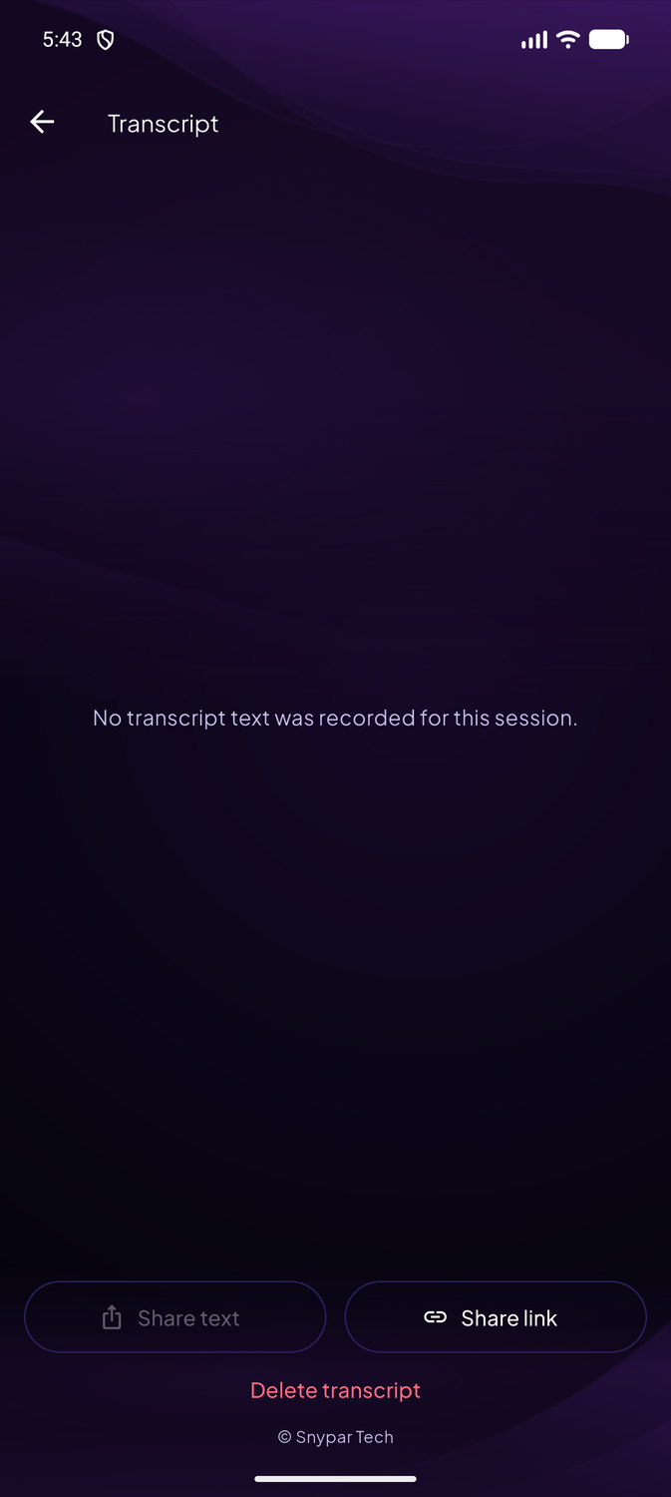
Figure 8. Transcript detail: **Share text**, **Share link**, **Delete**.
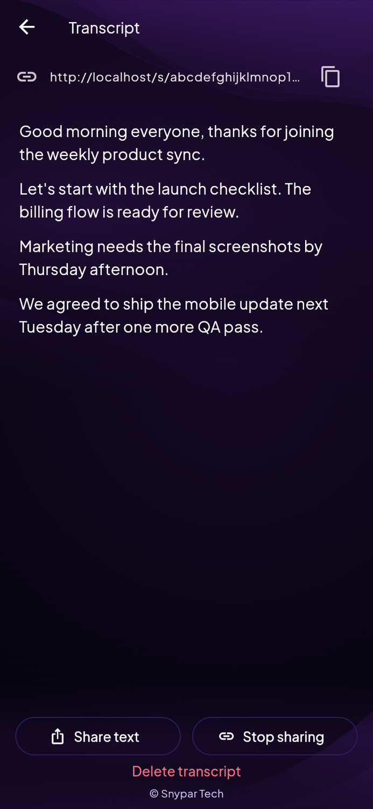
Figure 9. A transcript with text (illustrative).
Action | What it does
Share text | Sends the full text through any app on your phone (mail, chat, notes).
Share link | Creates or copies the read-only viewer link.
Delete | Removes the transcript after you confirm. This cannot be undone.

8. Open a shared link
Tap a ScriptLiv link (`https://.../s/<code>`) on the phone. If the app is installed it opens straight to the viewer; the app also understands `scriptliv://s/<code>`. Enter the access code if asked.
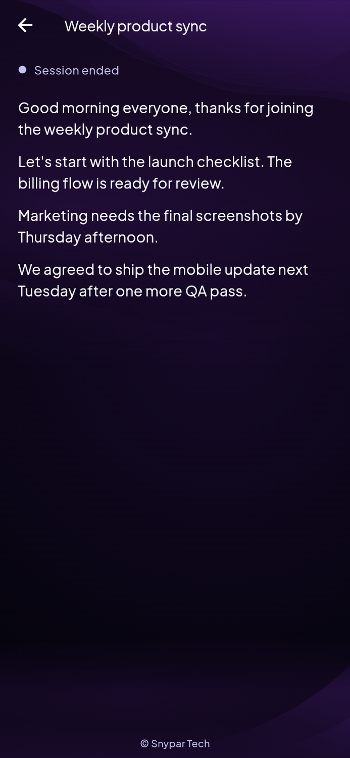
Figure 10. Shared view (illustrative).

9. Settings
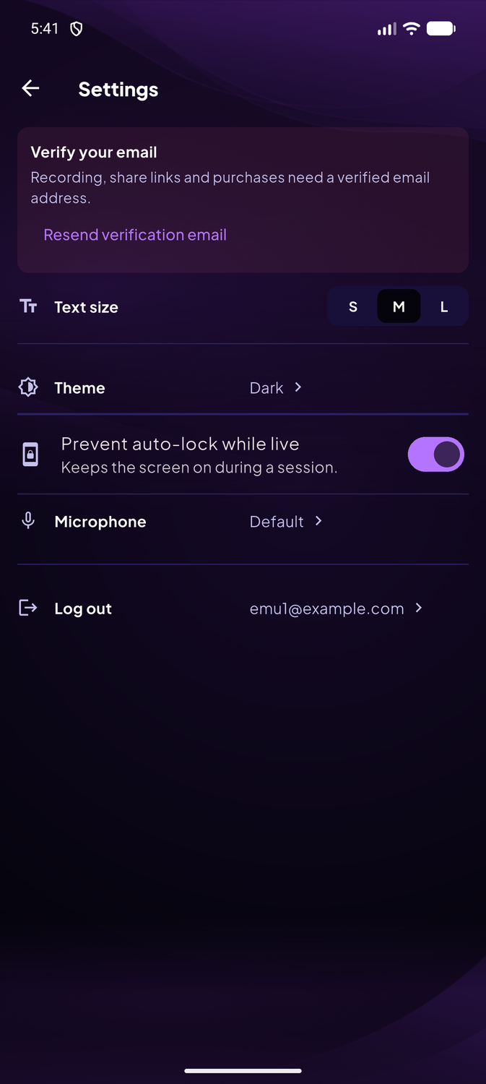
Figure 11. Settings.
Setting | What it does
Verify email banner | Shown if your email is not verified yet.
Text size (S / M / L) | Changes the transcript text size.
Theme | Light, dark or follow the phone.
Prevent auto-lock while live | Keeps the screen awake while recording.
Microphone | Choose the input device.
Log out | Signs you out of the app on this phone.

10. Plans and minutes
Plan | Minutes | Price | Notes
Basic | 300 per month | Free | 30 minutes per session. No rollover.
Pro | 2,500 per month | $20 | Not purchasable yet.
Add-on | 1,000 minutes | $10 | Not purchasable yet.

Current status: Purchases are not switched on yet. Everyone is on Basic for now.

11. Messages and what to do
What you see (in plain words) | What it means | What to do
Sign-in refused: email not verified | You have not clicked the link in the verification email yet. | Open the email from ScriptLiv, click the link (valid 24 hours). If it expired, ask Snypar Tech support to send a new one.
Out of minutes | Your included minutes and any add-on minutes are used up for this billing period. | Wait for the monthly reset (date shown in Settings) or open Plans.
Personal monthly limit reached | You set your own monthly cap in Settings and reached it. | Raise or clear the cap in Settings > Usage limits.
Another session is already running | One account can speak in one session at a time. A newer connection replaced the older one. | Close the other tab or device, then start again.
Server busy, try again | The speech engine is at its live-stream capacity. | Wait a few seconds and press the microphone again.
Connection lost | The speech engine or your network dropped. | Press the microphone to start again. Text already received is kept.
Session ended at 30 minutes (Basic) | Basic plan sessions are capped at 30 minutes each. | Start a new session. Your monthly minutes are unchanged by the cap.
Link not found / link stopped | The owner stopped sharing or the link was typed wrongly. | Ask the owner for a fresh link.
Page not found (404) | The address does not exist. | Use the button on the page to go home.

12. FAQ
Does the app need internet? Yes. Audio is sent live to ScriptLiv. Recording without a connection is not supported.
Can I use the app and the website with one account? Yes. Same account and same minutes. Only one speaking session at a time.
Is there an iPhone version? The code is shared but iOS has not been tested yet.
Will the screen turn off while I record? Turn on Prevent auto-lock while live in Settings.

13. Getting help
Email info@scriptliv.com with your account email, what you tapped, and the message you saw. Never send your password.

