ScriptLiv
Real-time speech to text

Web User Manual
How to use ScriptLiv in your browser

Document type | User manual (web)
Version | 1.0
Date | 11 November 2026
Prepared by | Snypar Tech
Product status | Staging release candidate. Not approved for production.
Contact | info@scriptliv.com

Contents
1. About ScriptLiv
2. Before you start
3. Create your account and verify your email
4. Sign in, sign out and reset a password
5. Dashboard (Home)
6. Record a live transcript
7. Share a live transcript
8. Transcripts: search, open, rename, export, delete
9. Plans and minutes
10. Settings
11. Viewing a shared transcript
12. Light and dark theme, phone browser
13. Legal pages and error pages
14. Messages and what to do
15. Frequently asked questions
16. Getting help

1. About ScriptLiv
ScriptLiv turns speech into text while you speak. You press one button, talk, and the words appear on screen within moments. You can keep the transcript, search it later, export it as text, and share a read-only link so other people can watch the text appear live.
- Live transcription: see text as you speak, with low delay.
- Continuous sessions: record as long as your plan allows. If the connection drops, you can start again without losing the text already received.
- Web and mobile: the same account works in the browser and in the Android app.
- Export: download a transcript as text.
- Share: anyone with the link can read the transcript, live or later. They never use your minutes.
- Language: English only for now.
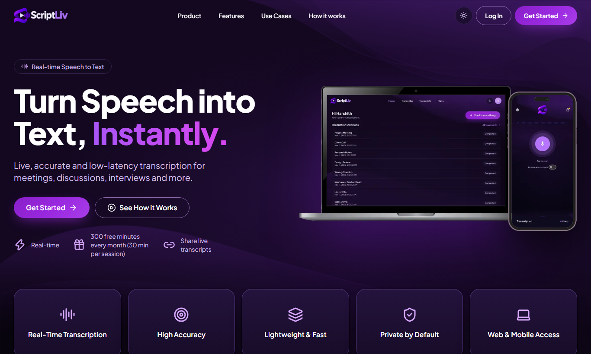
Figure 1. The ScriptLiv landing page.

2. Before you start
Item | Requirement
Browser | A current version of Chrome, Edge, Firefox or Safari on a laptop or desktop. Phone browsers also work.
Microphone | Any microphone. The browser asks permission the first time. Choose Allow.
Internet | A stable connection. Audio is streamed to ScriptLiv while you speak.
Email address | Needed to create the account and verify it.

3. Create your account and verify your email
- Open the ScriptLiv site and click Get Started (or Sign up in the top bar).
- Enter your Name, Email and Password (at least 8 characters).
- Read the Terms & Conditions and Privacy Policy links, then click Create account. Creating an account means you agree to them.
- Check your inbox for the verification email and click its link. The link works for 24 hours and only once.
- Return to ScriptLiv and sign in.
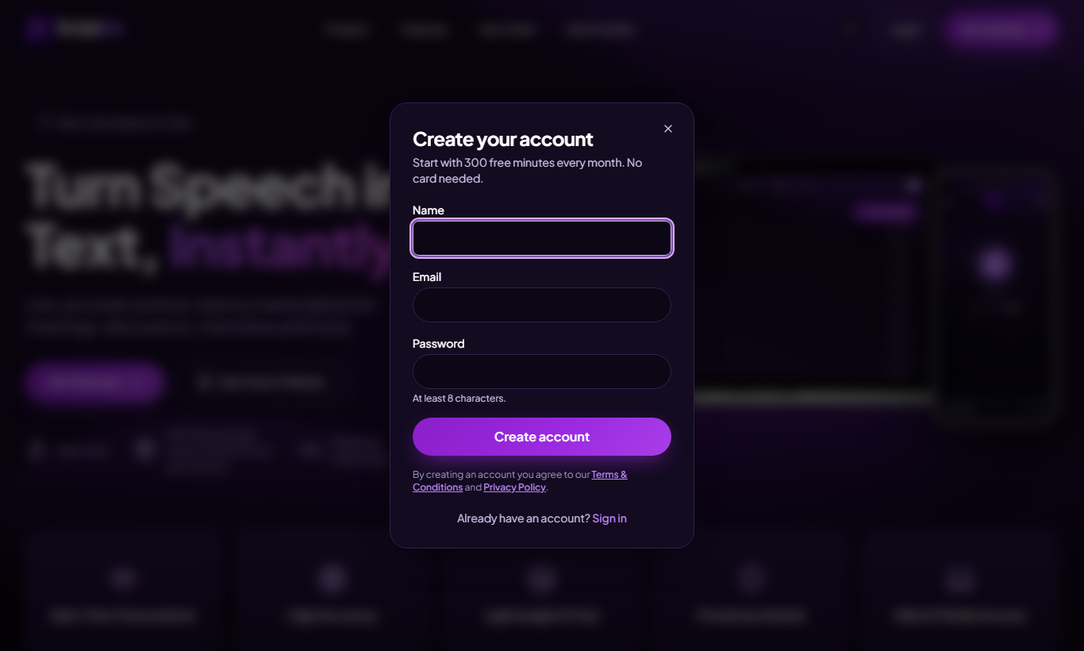
Figure 2. Create your account. Basic plan starts with 300 free minutes every month, no card needed.
Note: Registering does not sign you in. Until the email is verified, sign-in is refused with an "email not verified" message.

4. Sign in, sign out and reset a password

Sign in
Click Login, enter your email and password, and click sign in. Too many wrong attempts in a short time may make you wait before trying again.
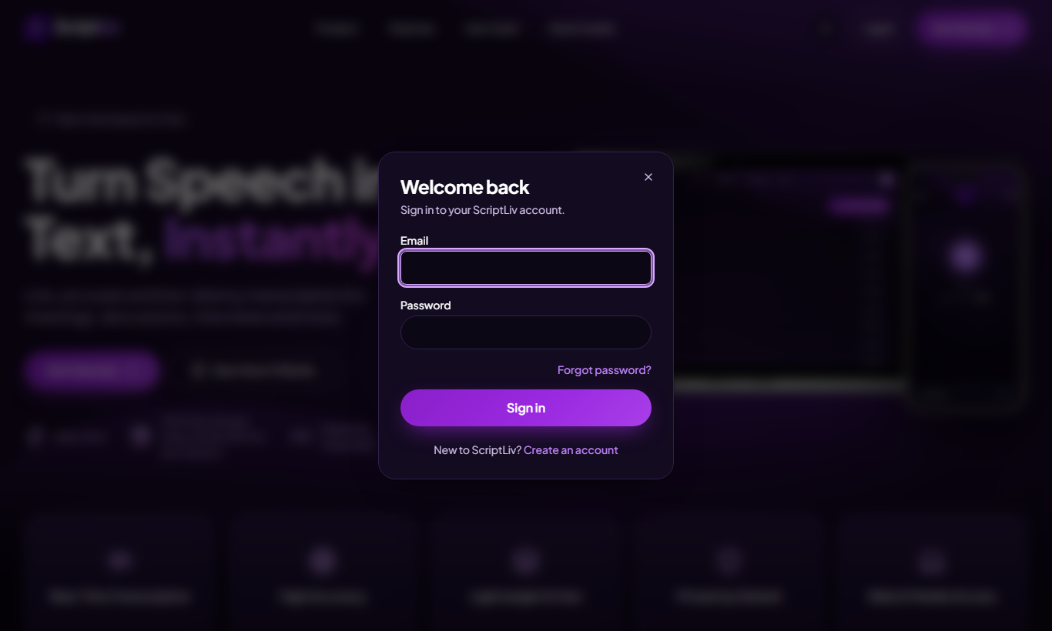
Figure 3. Sign in.

Forgot your password
- On the sign-in form choose Forgot password.
- Enter your email. If an account exists you receive a reset link (valid 1 hour, single use).
- Open the link, type a new password (at least 8 characters) and save. Every older sign-in on other devices is signed out.
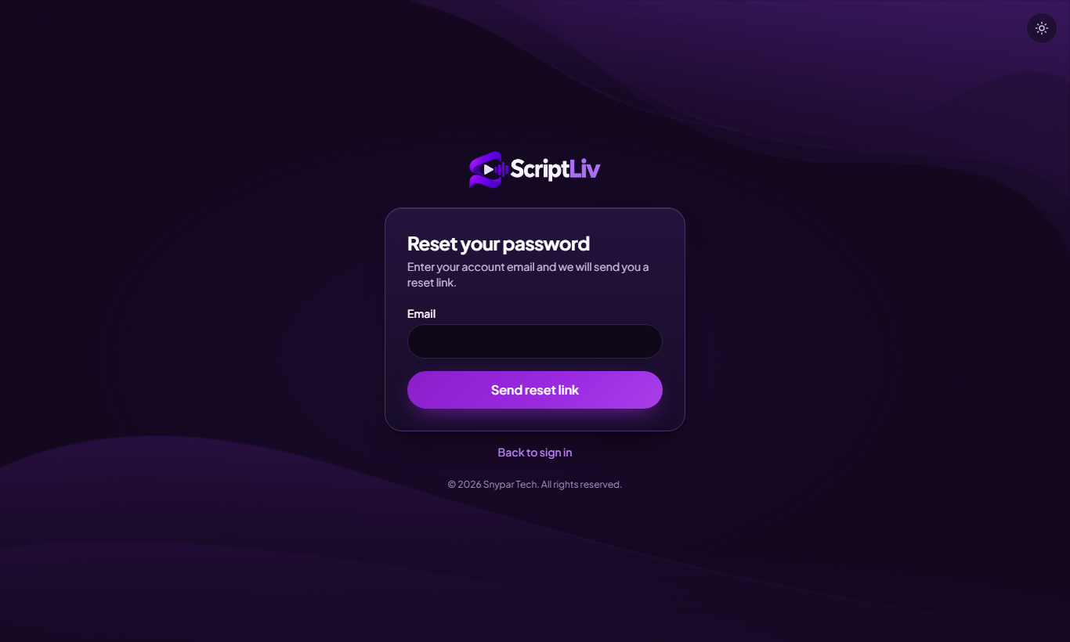
Figure 4. Forgot password.

Sign out
Click your round profile picture at the top right, then choose Log out.

5. Dashboard (Home)
After sign-in you land on Home. The top bar has four places: Home, Transcribe, Transcripts and Plans. At the right are the theme button (sun/moon) and your profile menu.
- Start transcribing takes you to the recording page.
- Recent transcriptions lists your latest sessions with a status such as Completed. All transcripts opens the full list.
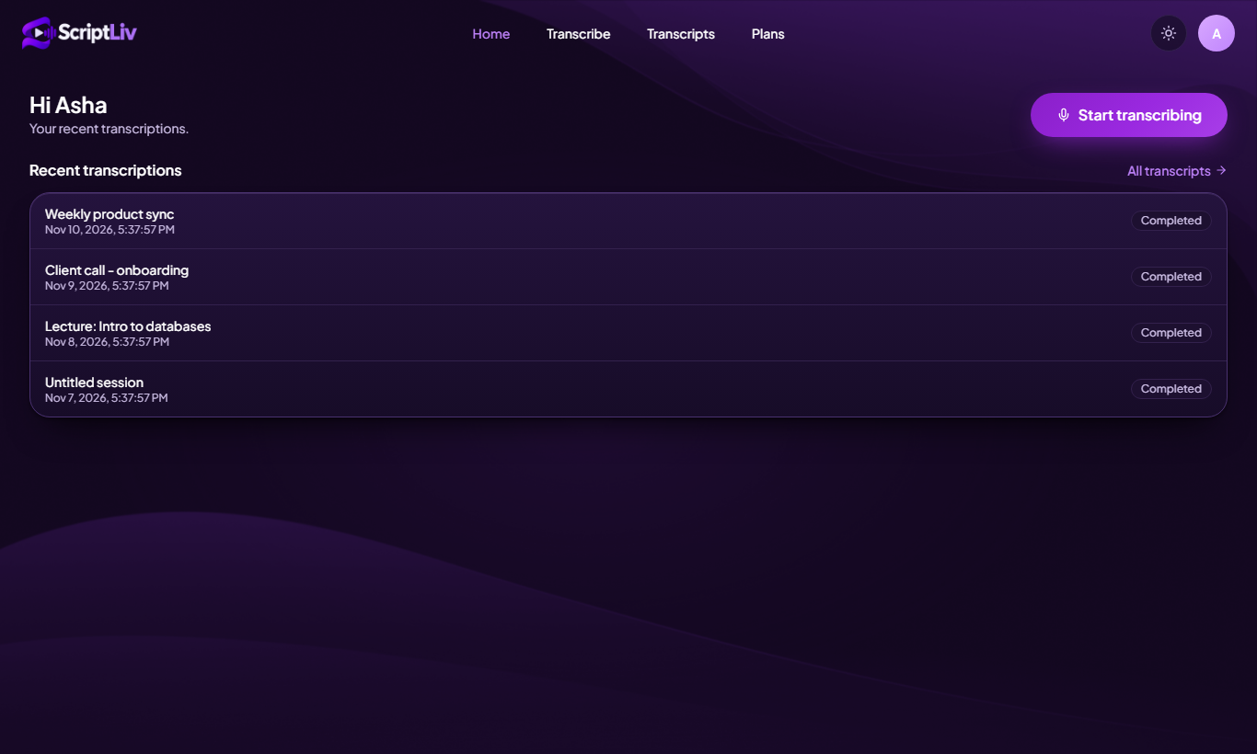
Figure 5. Home. Sample account and data shown for illustration.

6. Record a live transcript
- Open Transcribe. The status at the top right says Ready.
- Press the large round microphone button ("Press to start"). Allow microphone access if the browser asks.
- Speak normally. Words appear in Live transcript. Lighter text is still being decided; it firms up when you pause.
- The Session info card shows your account, duration, number of segments and screen lock state.
- Press the button again to stop. The transcript is saved to Transcripts.
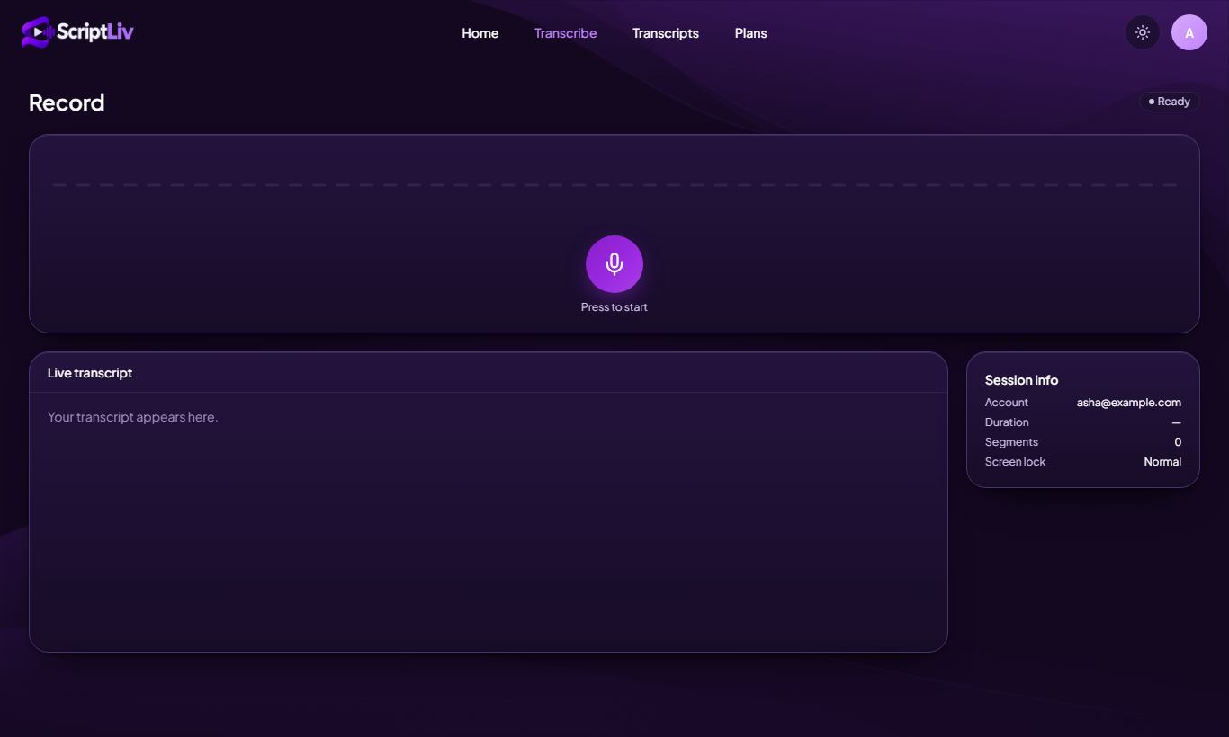
Figure 6. Record page, ready to start.
- Only the speaker uses minutes. People who watch a shared transcript never do.
- Strict limit: when your minutes (or the 30-minute Basic session cap) run out, recording stops at that exact moment. There is no grace period.
- One speaker session per account at a time. Starting on a second device ends the first.
- In Settings you can turn on Prevent auto-lock while transcribing so the screen stays awake.

7. Share a live transcript
You can give others a link so they read your transcript while you speak, or afterwards.
- Open the transcript (live or from Transcripts).
- In Share this transcript, turn sharing on. A link like `.../s/<code>` appears.
- Click Copy and send the link. Anyone with the link can read; they do not need an account and do not use your minutes.
- Click Stop sharing at any time. The link then stops working.
Note: Treat the link like a key: anyone who has it can read the transcript until you stop sharing.

8. Transcripts: search, open, rename, export, delete
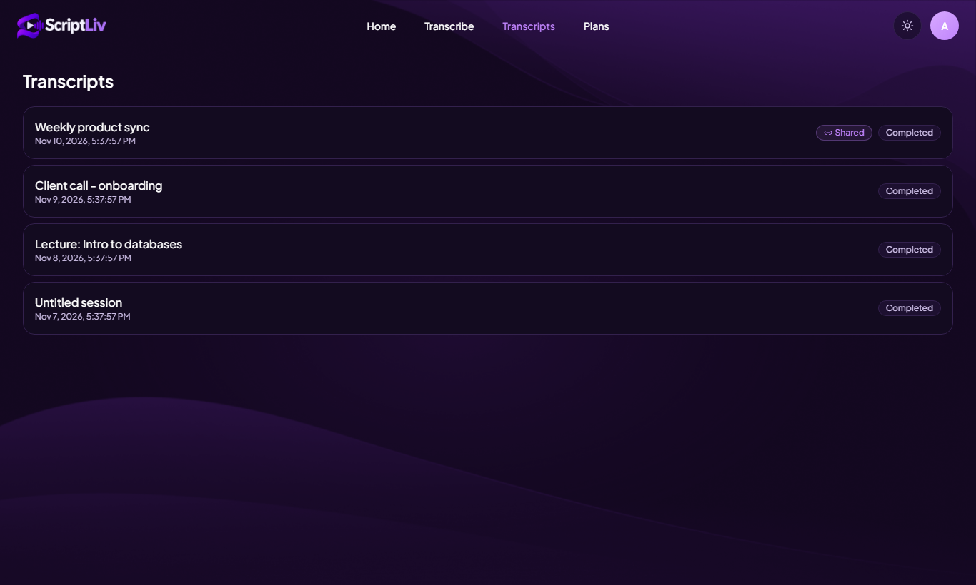
Figure 7. Transcripts list with search.
- Search transcripts using the box at the top.
- Open a transcript by clicking its row.
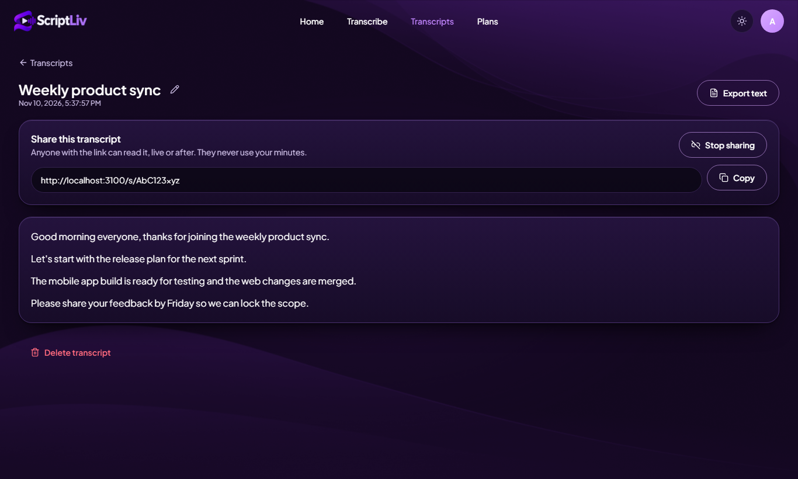
Figure 8. A transcript. Rename with the pencil, export, share, or delete.
Action | How
Rename | Click the pencil next to the title, type a new title, confirm.
Export | Click Export text to download the transcript as a text file.
Share / stop sharing | Use the Share this transcript card (see section 7).
Delete | Click Delete transcript and confirm. Deleting cannot be undone.

9. Plans and minutes
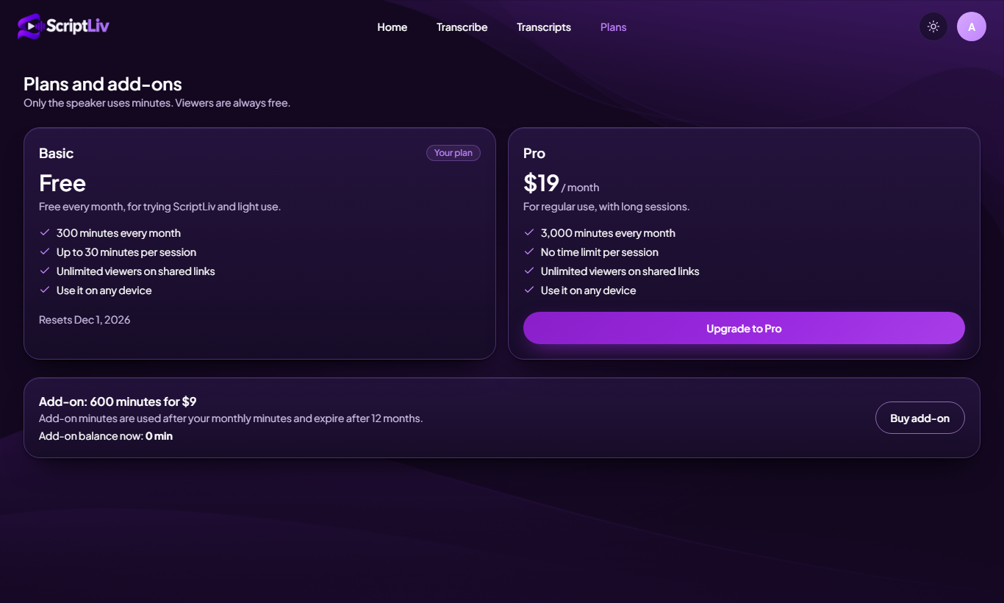
Figure 9. Plans page.
Plan | Minutes | Price | Notes
Basic | 300 per month | Free | 30 minutes per session. Resets each month. No rollover.
Pro | 2,500 per month | $20 | Larger monthly allowance.
Add-on | 1,000 minutes | $10 | Valid until the end of the billing period in which it was bought.

- Included monthly minutes are spent before add-on minutes.
- Only the speaker uses minutes. Viewers are free and unlimited.
Current status: Purchases are not switched on yet. The Plans and Settings pages say "Purchases are not switched on yet" until billing is enabled. Every user is on Basic for now.

10. Settings
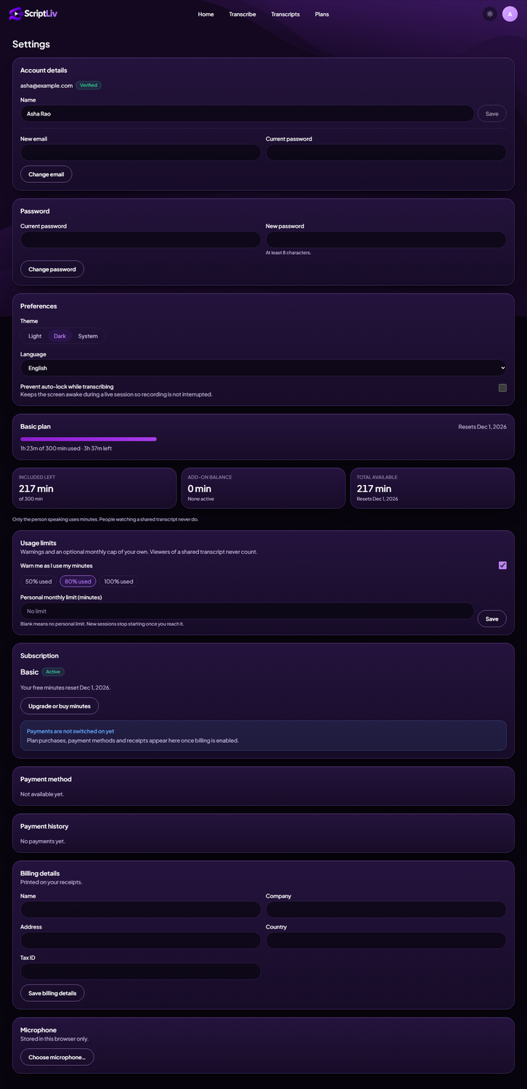
Figure 10. Settings (full page).
Section | What you can do
Account details | See your email and Verified badge. Change your name. Change your email (needs your current password; the new address must be verified).
Password | Change your password (current + new, at least 8 characters).
Preferences | Theme: Light, Dark or System. Language: English. Prevent auto-lock while transcribing.
Plan and usage | Progress bar of minutes used this month, Included left, Add-on balance, Total available and reset date.
Usage limits | Turn warnings on (50%, 80% or 100% used) and set an optional personal monthly limit in minutes. New sessions stop starting once you reach it.
Subscription, Payment method, Payment history, Billing details | Shown for when billing is enabled. Today they say payments are not switched on yet.
Microphone | Choose which microphone this browser uses. Stored in this browser only.

11. Viewing a shared transcript
If someone sends you a ScriptLiv link, open it in any browser. You see the transcript, and if the speaker is live, new text keeps appearing. You do not need an account.
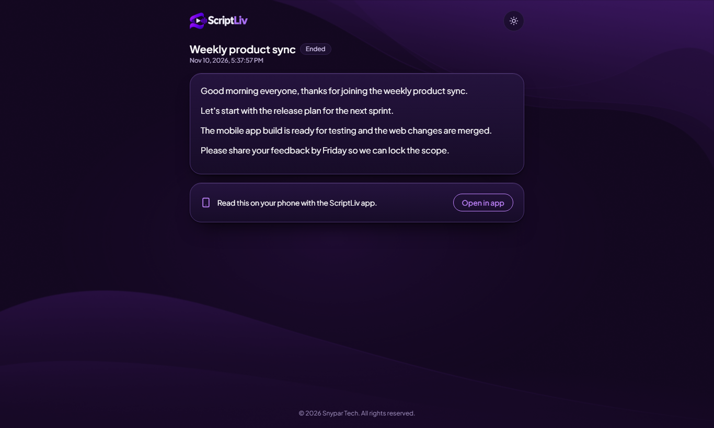
Figure 11. The shared view.

12. Light and dark theme, phone browser
Use the sun/moon button in the top bar, or Settings > Preferences. ScriptLiv also adapts to a phone-sized browser window with the same menu and pages.
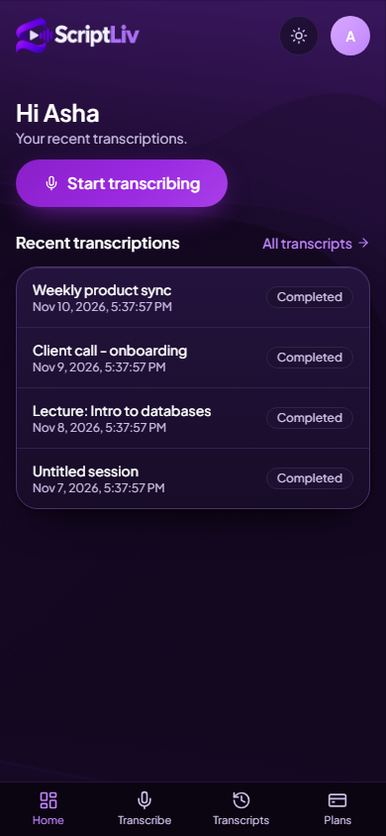
Figure 12. Home in a phone-sized browser.

13. Legal pages and error pages
Terms & Conditions and Privacy Policy are linked from the sign-up form and the footer. They are a draft and have not had legal review yet.
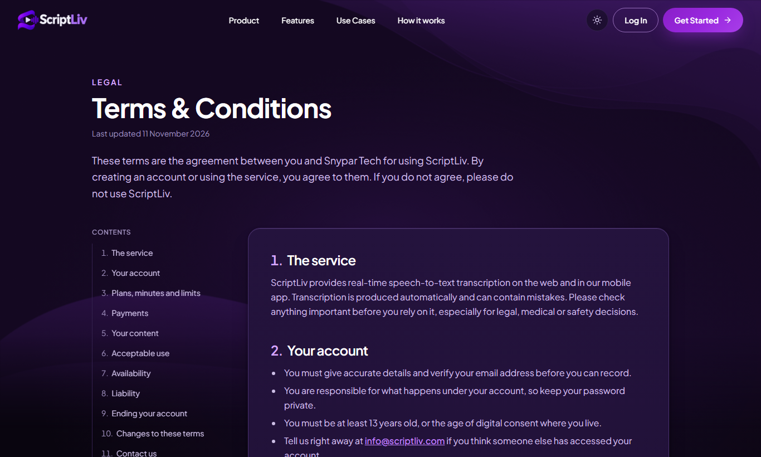
Figure 13. Terms & Conditions.
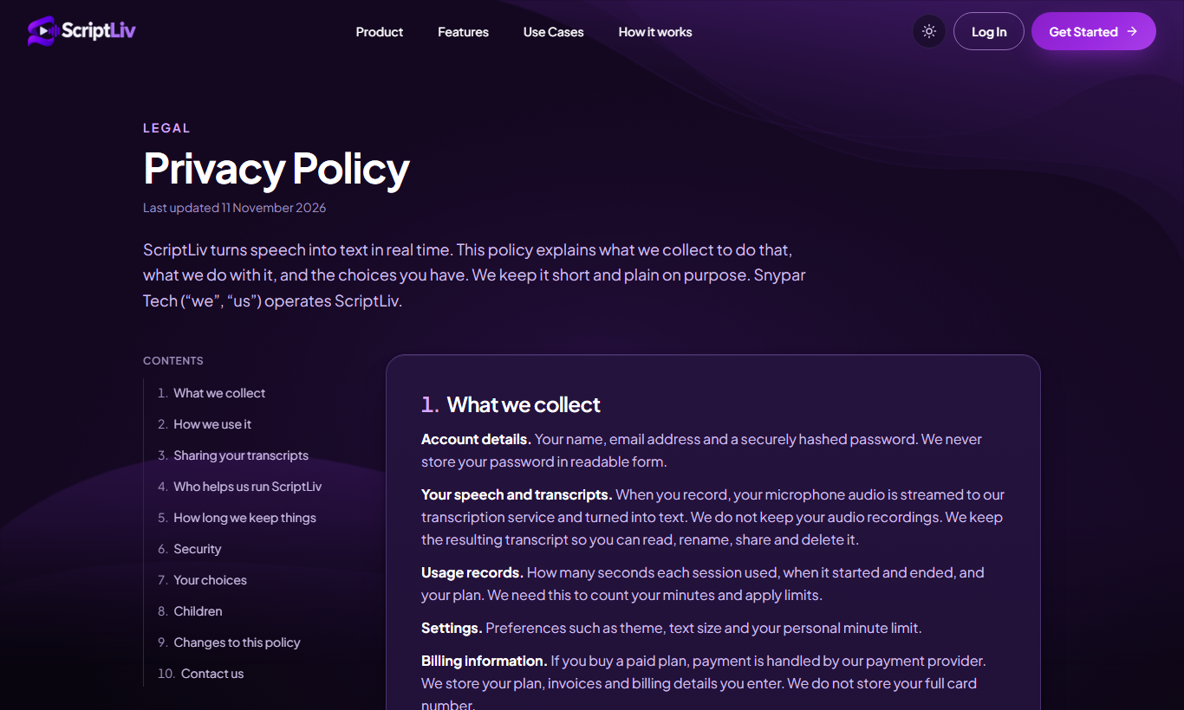
Figure 14. Privacy Policy.
If you open an address that does not exist, ScriptLiv shows a friendly page with a button back to the start.
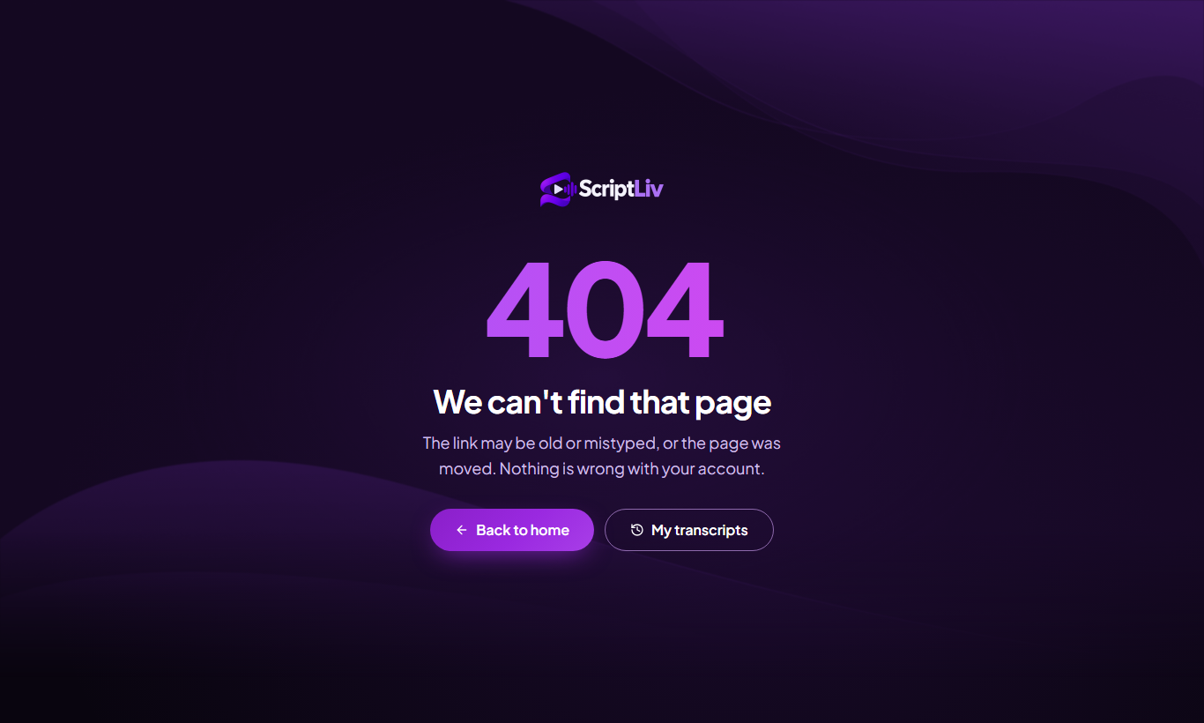
Figure 15. Page not found.

14. Messages and what to do
What you see (in plain words) | What it means | What to do
Sign-in refused: email not verified | You have not clicked the link in the verification email yet. | Open the email from ScriptLiv, click the link (valid 24 hours). If it expired, ask Snypar Tech support to send a new one.
Out of minutes | Your included minutes and any add-on minutes are used up for this billing period. | Wait for the monthly reset (date shown in Settings) or open Plans.
Personal monthly limit reached | You set your own monthly cap in Settings and reached it. | Raise or clear the cap in Settings > Usage limits.
Another session is already running | One account can speak in one session at a time. A newer connection replaced the older one. | Close the other tab or device, then start again.
Server busy, try again | The speech engine is at its live-stream capacity. | Wait a few seconds and press the microphone again.
Connection lost | The speech engine or your network dropped. | Press the microphone to start again. Text already received is kept.
Session ended at 30 minutes (Basic) | Basic plan sessions are capped at 30 minutes each. | Start a new session. Your monthly minutes are unchanged by the cap.
Link not found / link stopped | The owner stopped sharing or the link was typed wrongly. | Ask the owner for a fresh link.
Page not found (404) | The address does not exist. | Use the button on the page to go home.

15. Frequently asked questions
Do I need a card to start? No. Basic is free with 300 minutes each month.
Do people watching my link use my minutes? No. Only the speaker uses minutes.
Which languages work? English only for now. More are planned.
Can I run two recordings at once? No. One speaking session per account at a time.
What happens when minutes run out mid-session? Recording stops at that exact moment and the text so far is kept.
How do I stop someone reading my transcript? Open the transcript and click Stop sharing, or delete the transcript.
Is my audio stored? Ask info@scriptliv.com for the current retention statement. A final retention policy is not yet published.

16. Getting help
Email info@scriptliv.com. Include the email address of your account, what you pressed, and the message you saw. Never send your password.

