Auth0 Implementation
Auth0 Applications page shows both Regular Web App and M2M app registered:
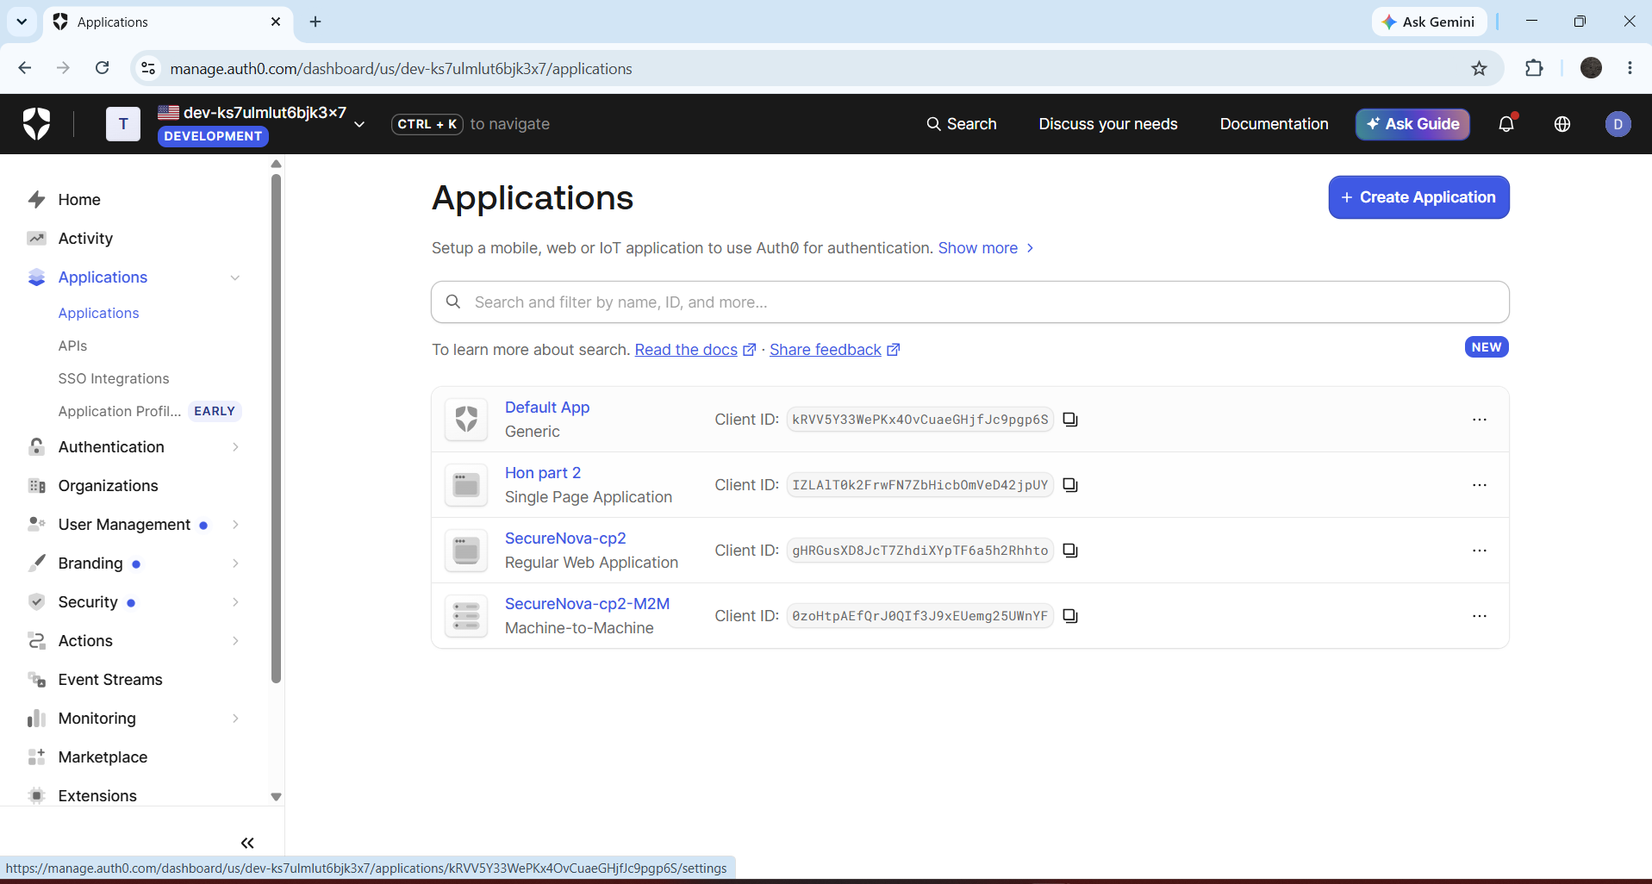

Auth0 APIs page with two custom scopes:

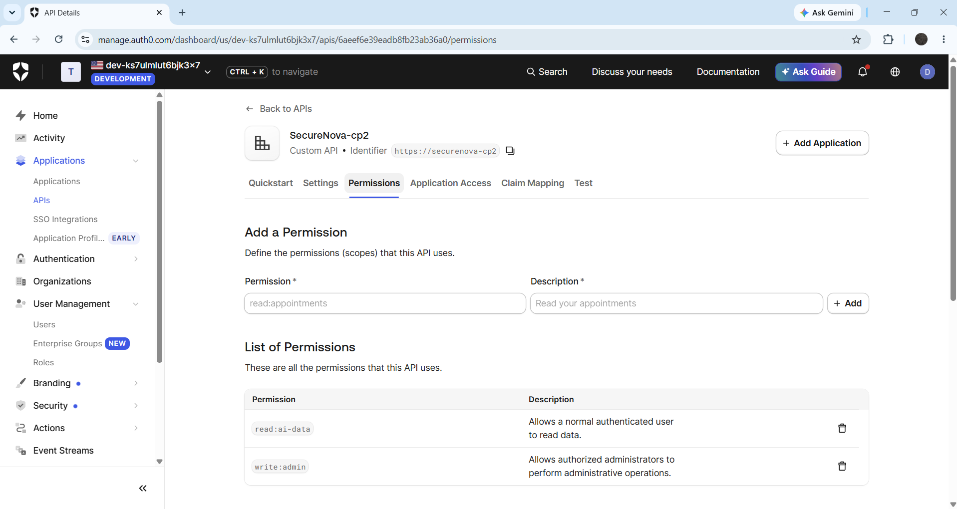

Decoded JWT
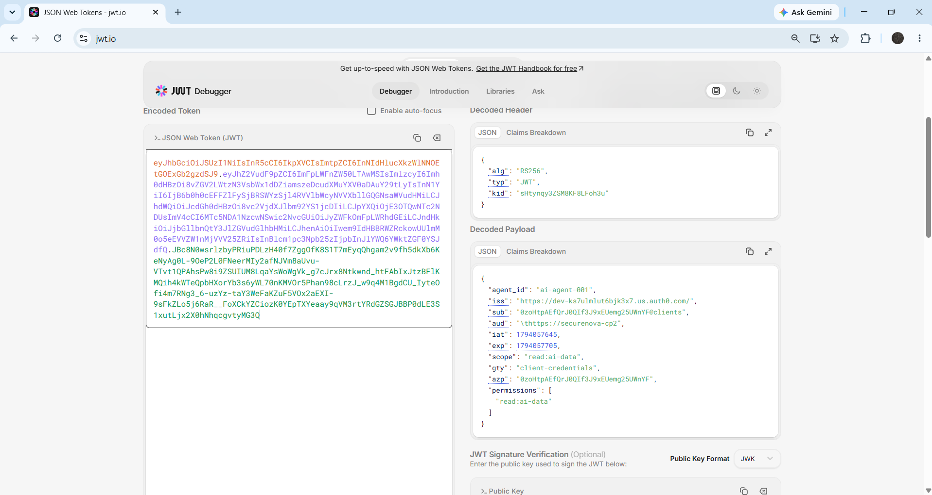

Auth0 Universal Login page in browser with custom branding applied:

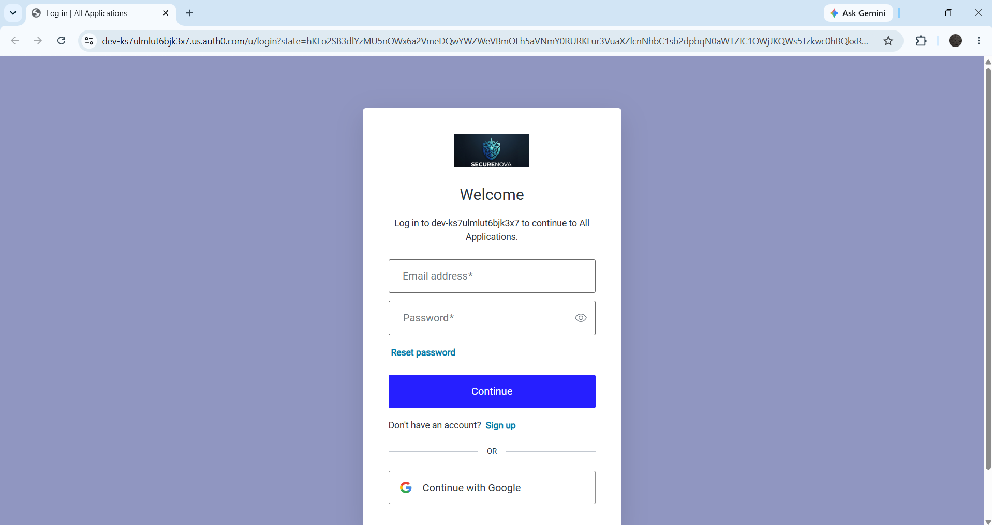

Auth0 MFA enrolment screen:
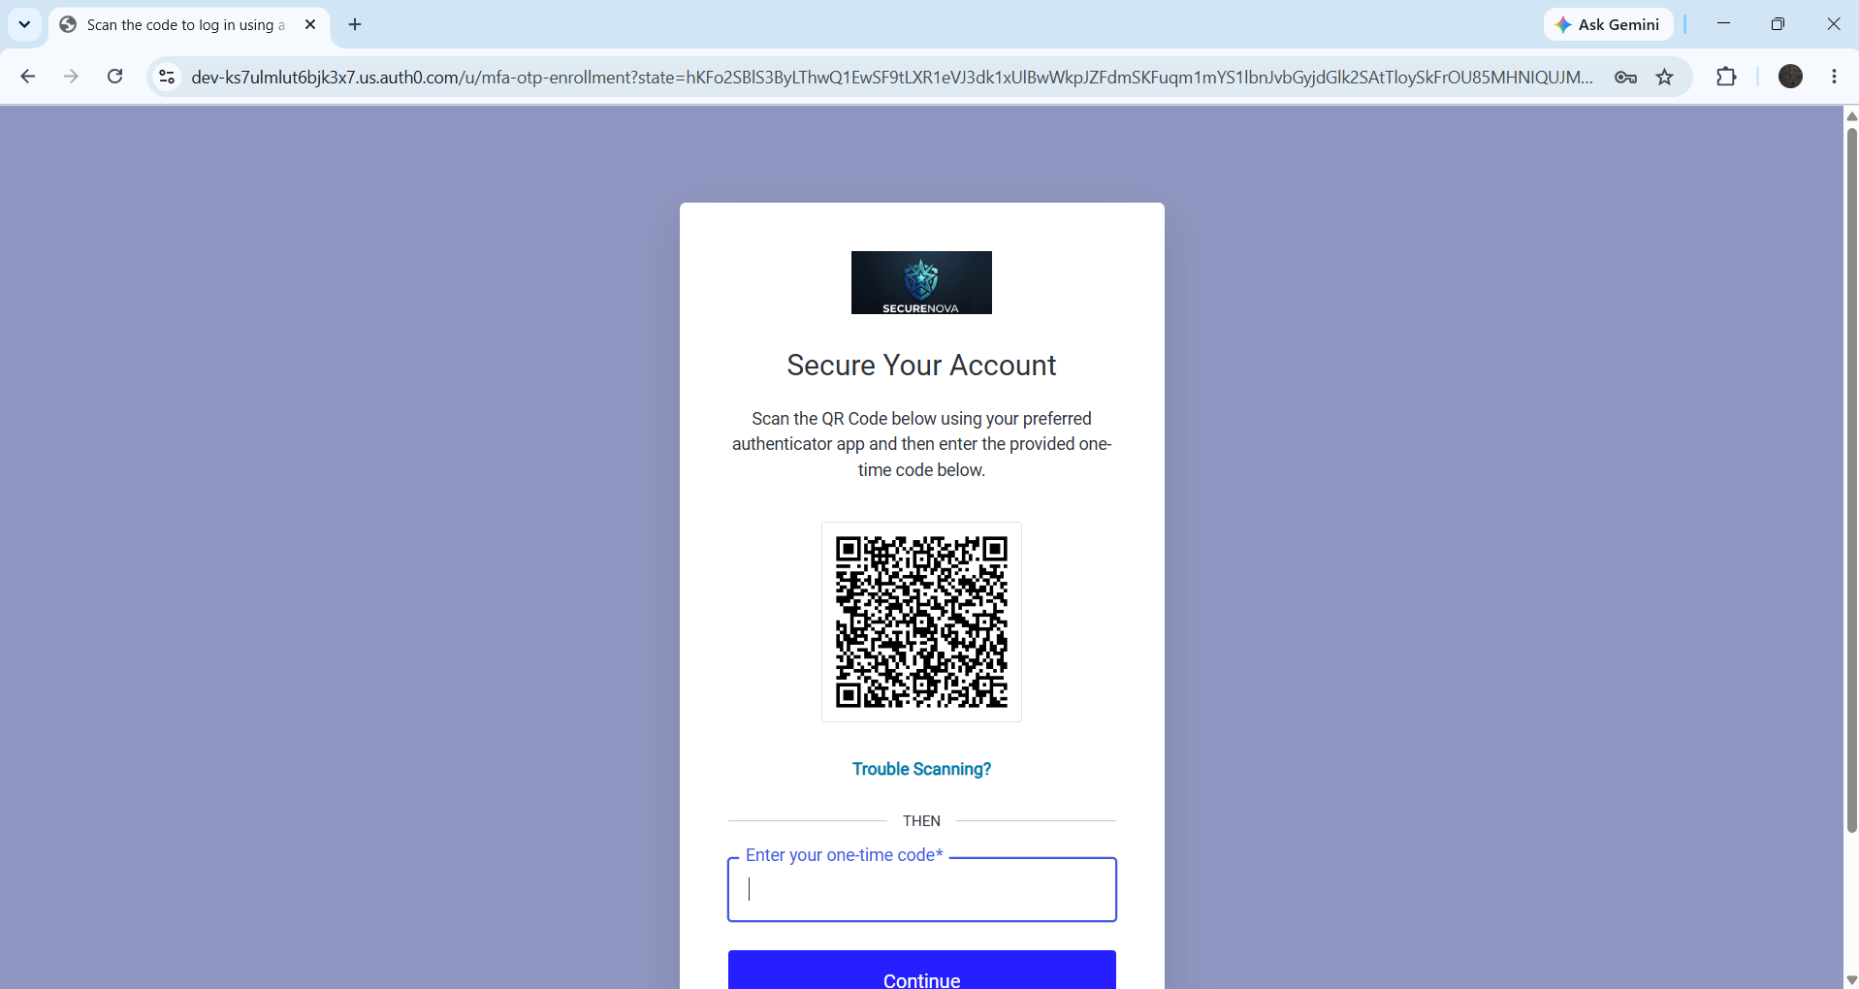
TOTP challenge
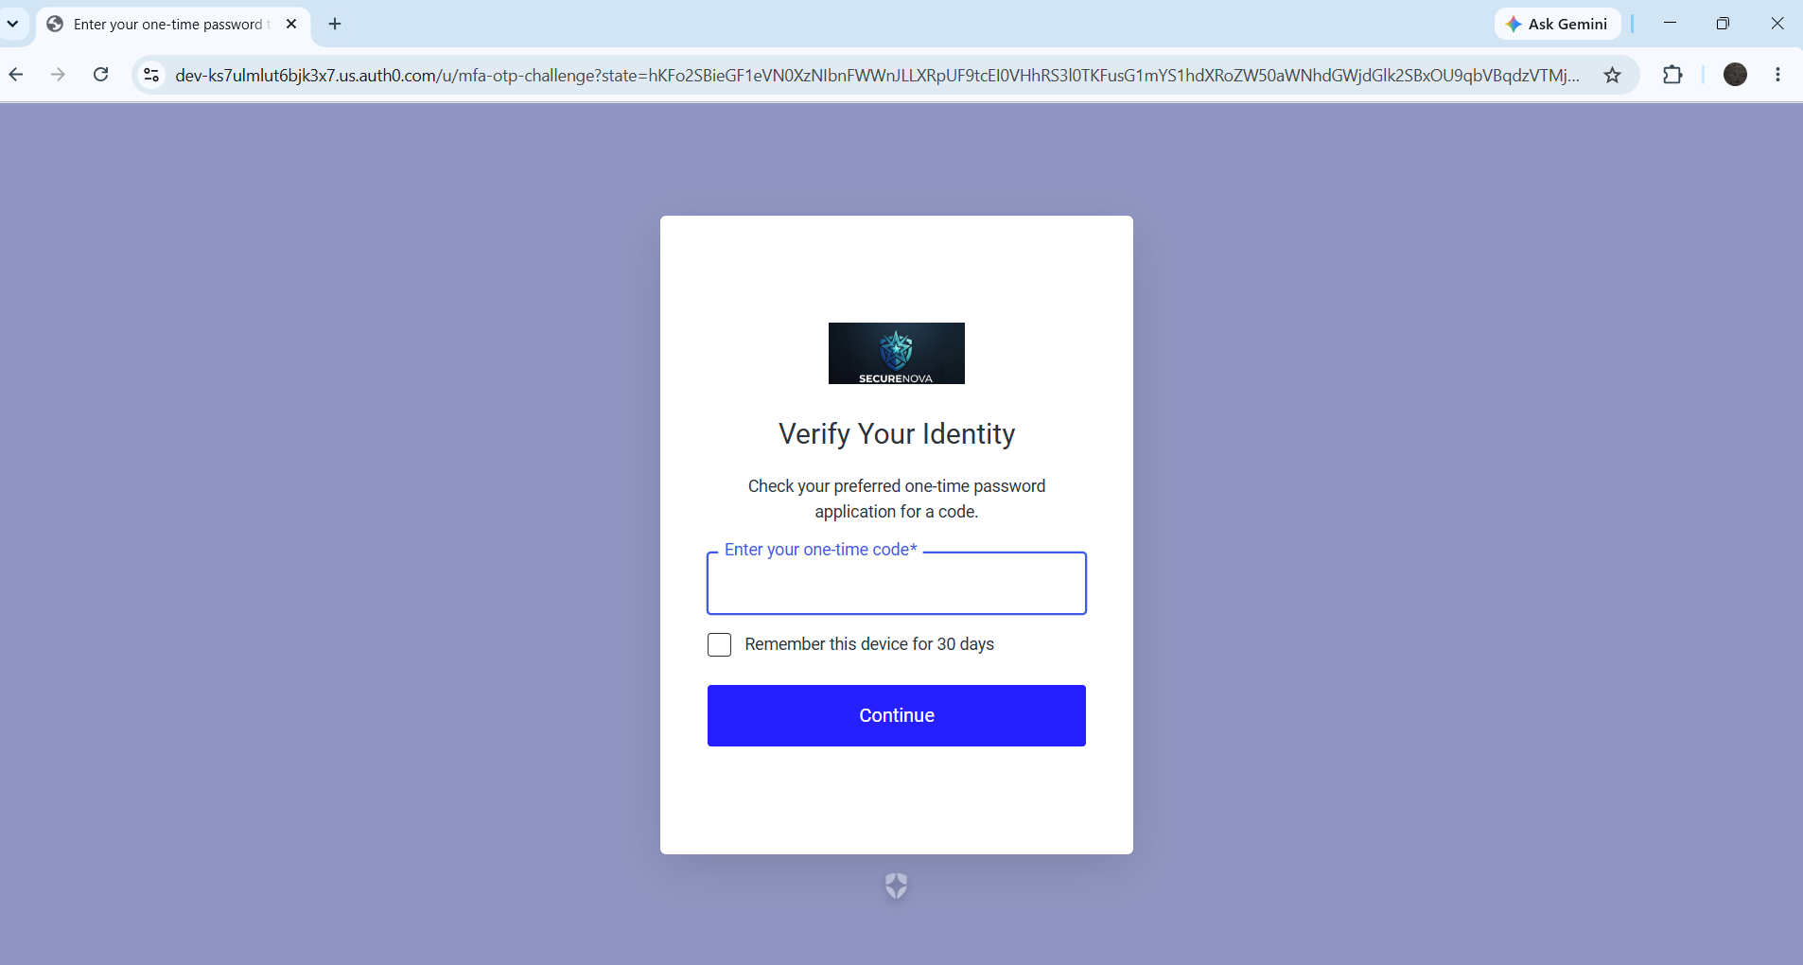

Auth0 Actions editor - post-login Action code showing the agent_id custom claim addition:
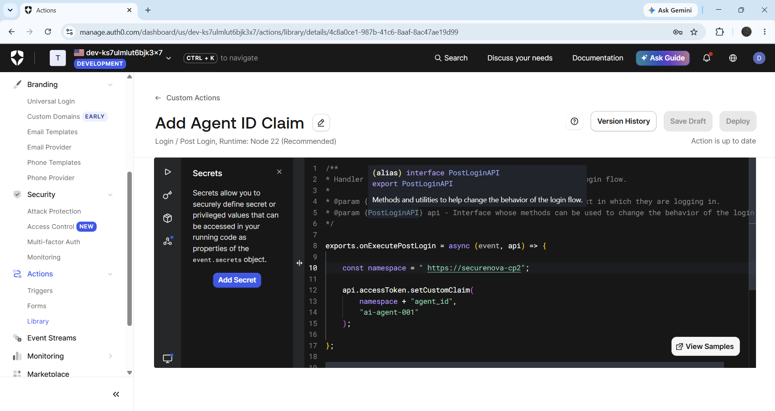

Auth0 Attack Protection panel - Brute-Force Protection and Suspicious IP Throttling both enabled:
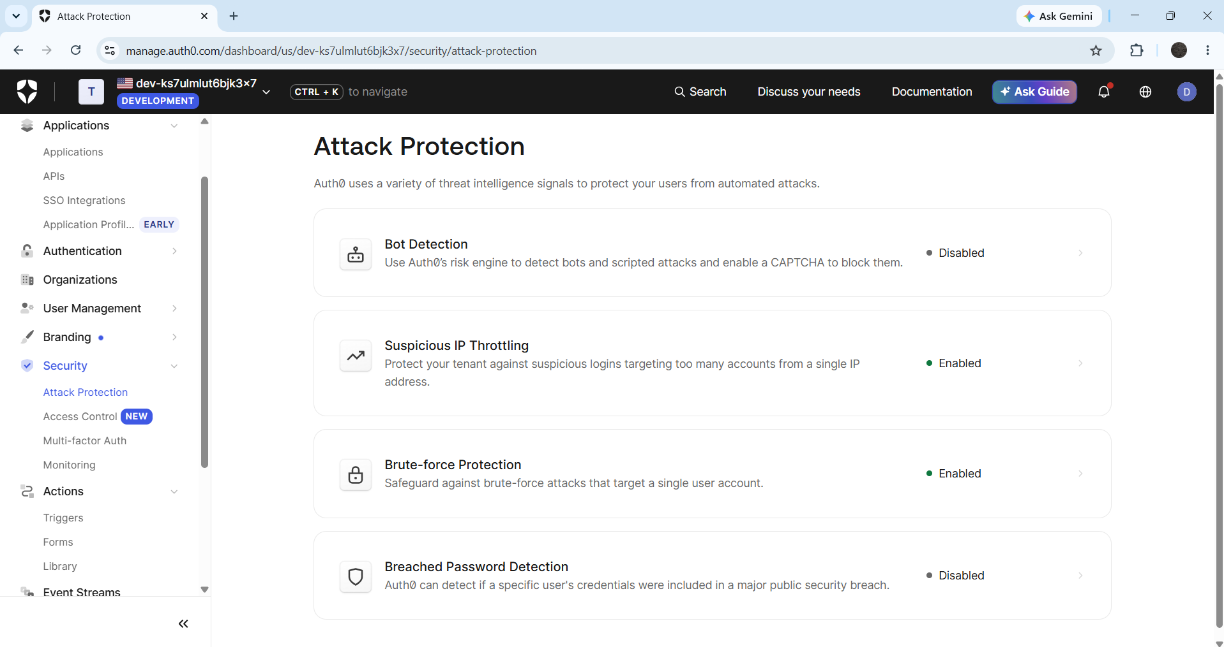

Terminal - credential rotation script showing timestamped 200 OK call then 401 Unauthorised on replay:


