BAMAT207: APPLICATIONS OF PROBABILITY AND STATISTICS
Beyond the Words: A Probabilistic & Bayesian Approach to SMS Spam Detection

Course Name & Code: | Applications of Probability and Statistics (BAMAT207)
Topic: | Probability and Random Variables
Student Name / ID: | Harshith (Harshith1987)
Submission Date: | 27.10.2026
GitHub Repository Link: | https://github.com/Harshith1987/BAMAT207-Probabilistic-SMS-Spam-Detection

1. Executive Summary & Problem Formulation
Unsolicited mobile text messages (SMS spam) present critical challenges in digital communications, including fraud, phishing, and malware distribution. The objective of this project is to develop a mathematically rigorous probabilistic classification system that categorizes an incoming SMS message as either Spam (Y = 1) or Genuine / Ham (Y = 0).
The project applies foundational principles of Probability and Random Variables: computing prior probabilities, evaluating word-level empirical conditional probabilities, mathematically proving and verifying Bayes' Theorem, formulating the classification process as a discrete Bernoulli Random Variable (calculating Expectation and Variance), training a Multinomial Naive Bayes classifier with Laplace smoothing, and conducting an in-depth confusion matrix error audit of False Positives and False Negatives.

2. Dataset Handling & Prior Probabilities
The project uses the SMS Spam Collection dataset from the UCI Machine Learning Repository (ID: 228). Data hygiene was enforced by validating null values and removing duplicate entries to prevent estimation bias.
Metric / Parameter | Value | Statistical Interpretation
Raw Messages | 5,572 | Original corpus from UCI repository
Missing / Null Values | 0 | No data imputation required
Duplicate Records Removed | 403 | Eliminated redundant messages
Clean Unique Messages (N) | 5,169 | Sample space size for probability analysis
Prior Probability P(Ham) | 0.8737 (4,516 msgs) | 87.37% baseline probability of genuine SMS

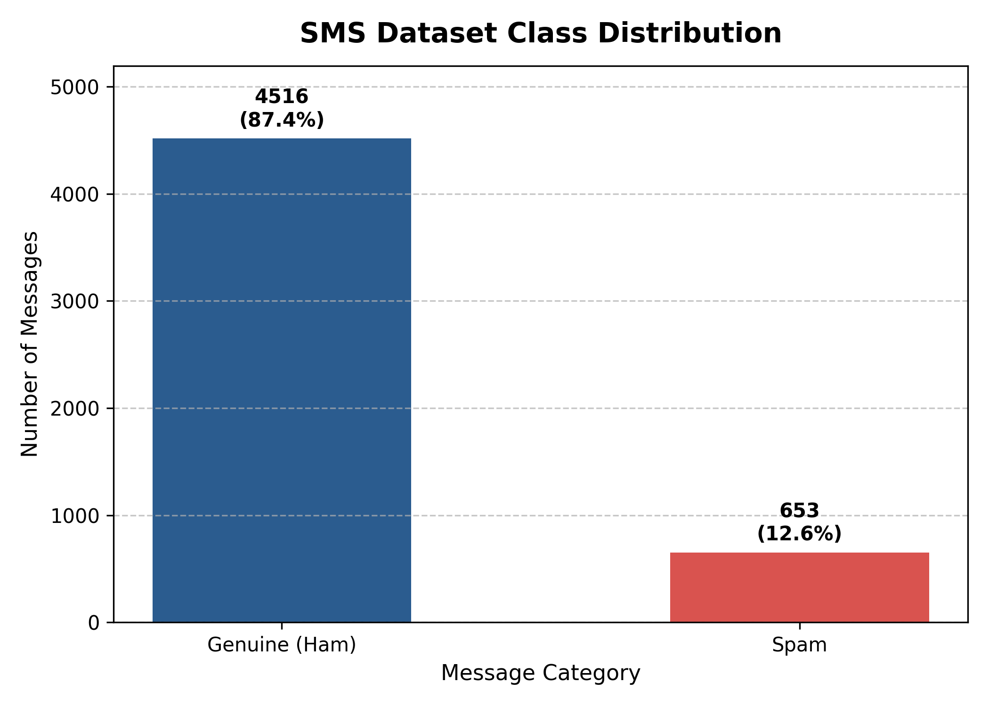
Figure 1: SMS Dataset Class Distribution (Ham vs Spam)

3. Word-Based Probability Analysis & Bayes' Theorem Verification
For any suspicious word W, we calculate the conditional probability P(Spam | W) via two independent methods:
1. Empirical Ratio: P(Spam | W) = Count(Spam containing W) / Count(All messages containing W)
2. Bayes' Theorem: P(Spam | W) = [P(W | Spam) * P(Spam)] / P(W)
Both formulations produce identical numerical results, demonstrating the theorem in practice.
Word (W) | Total (N_W) | Spam (N_S) | P(W|Spam) | P(Spam|W) Bayes | Equivalence Verified
free | 203 | 148 | 0.2266 | 0.7291 (72.91%) | True
prize | 73 | 73 | 0.1118 | 1.0000 (100.0%) | True
win | 55 | 49 | 0.0750 | 0.8909 (89.09%) | True
urgent | 62 | 57 | 0.0873 | 0.9194 (91.94%) | True
offer | 30 | 24 | 0.0368 | 0.8000 (80.00%) | True

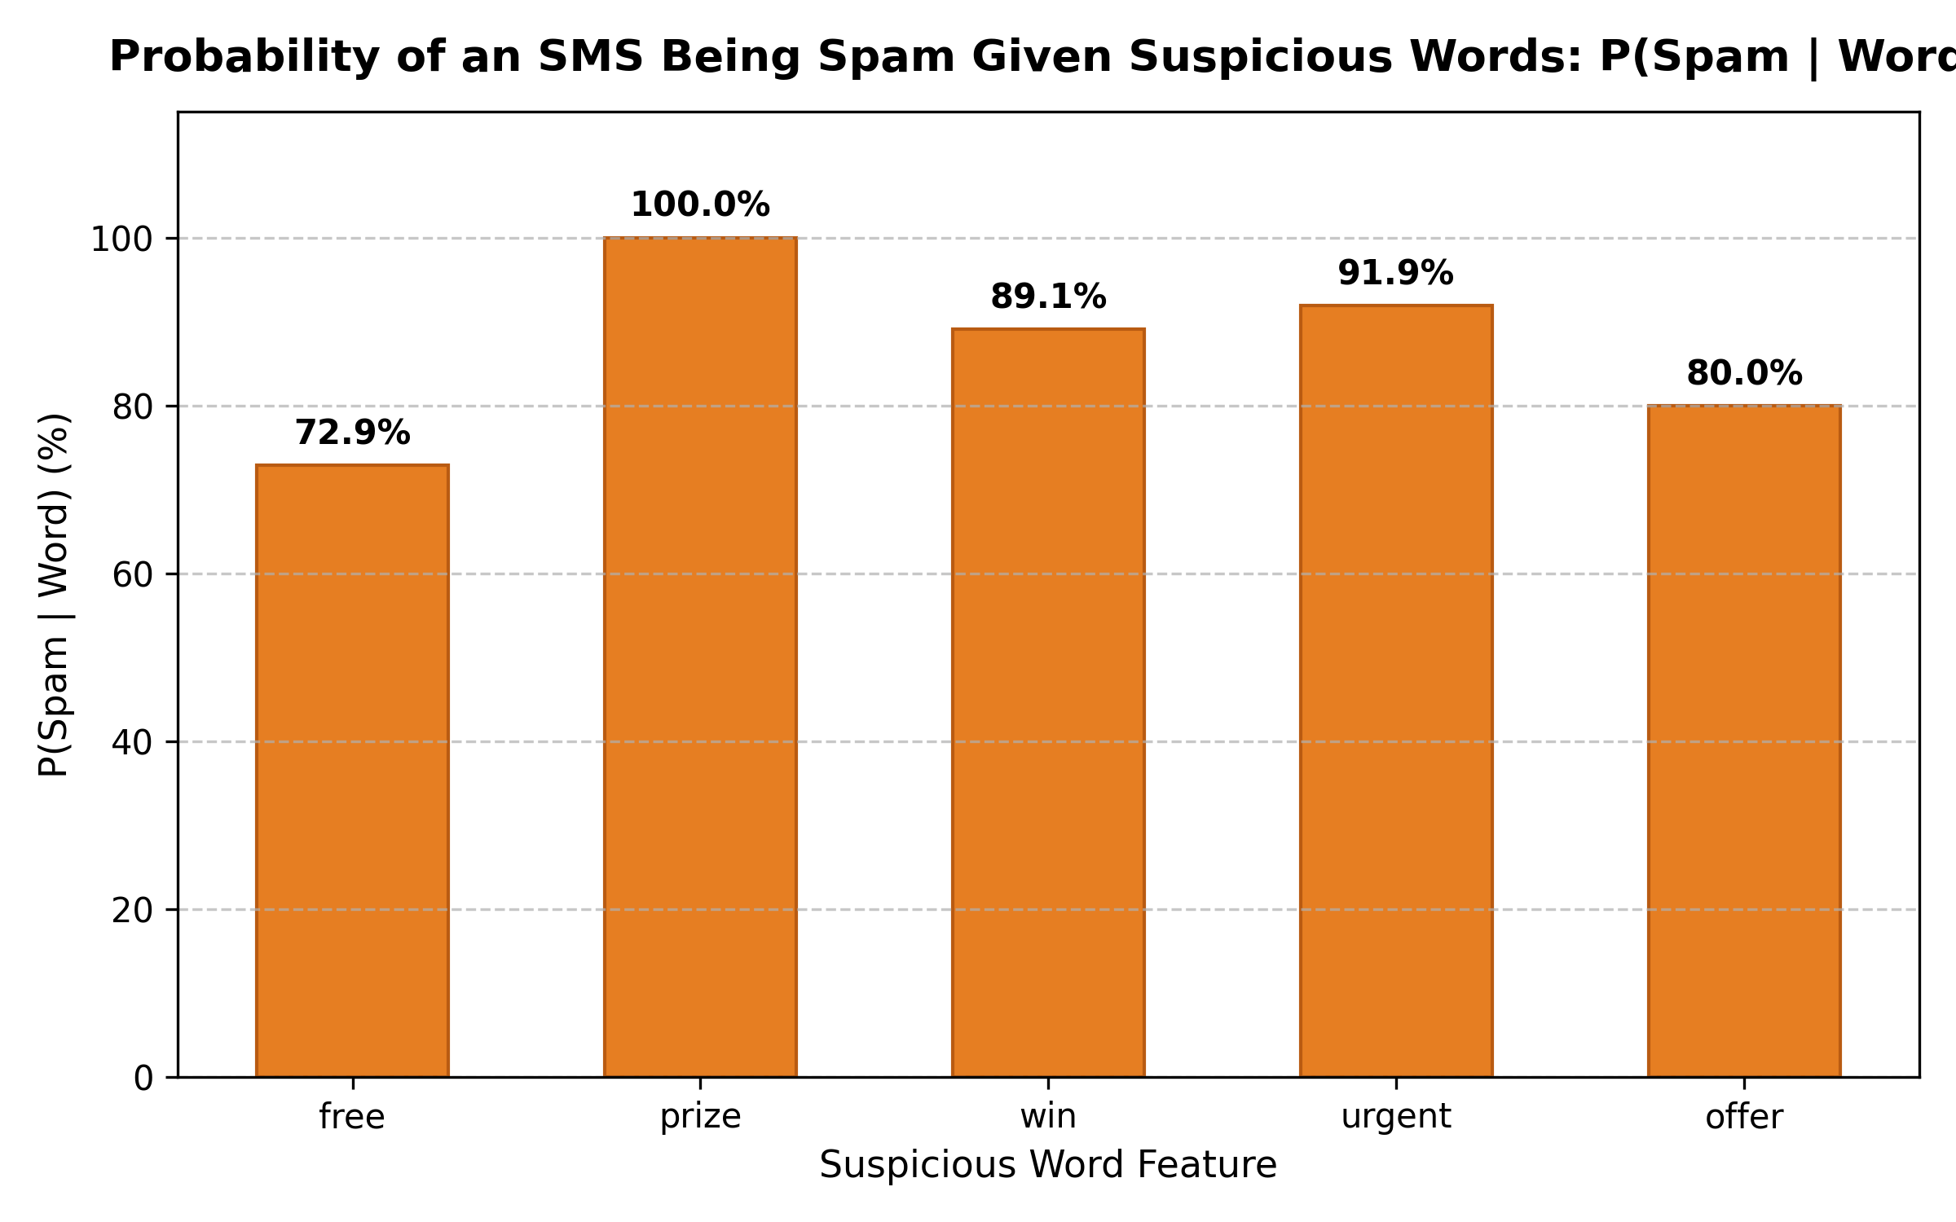
Figure 2: Conditional Probability of Spam Given Suspicious Words: P(Spam | Word)

4. Random Variable Analysis (Bernoulli Distribution)
Let the random variable Y define the classification state of an arbitrary message:
Y = 1 if the message is Spam
Y = 0 if the message is Ham
Here, Y follows a Bernoulli distribution: Y ~ Bernoulli(p) where p = P(Spam) = 0.1263 and q = 1 - p = 0.8737.
• Expectation E(Y):
E(Y) = sum(y * P(Y = y)) = (1 * p) + (0 * q) = p = 0.1263
• Variance Var(Y):
Var(Y) = E[Y^2] - (E[Y])^2 = p - p^2 = p(1 - p) = 0.1263 * 0.8737 = 0.1104
• Standard Deviation SD(Y):
SD(Y) = sqrt(Var(Y)) = sqrt(0.1104) = 0.3322

5. Model Building: Multinomial Naive Bayes
• Data Partitioning: 80% training set (4,135 samples) and 20% testing set (1,034 samples) using stratified sampling (stratify=y) to maintain identical class proportions.
• Feature Extraction: CountVectorizer extracted 7,414 unique word tokens as features.
• Classification Algorithm: Multinomial Naive Bayes (MultinomialNB) with Laplace Add-1 smoothing (alpha = 1.0).

6. Model Evaluation & Error Analysis
Evaluation Metric | Model Score
Overall Test Accuracy | 98.36% (0.9836)
Precision (Spam) | 95.97% (0.9597)
Recall (Spam) | 90.84% (0.9084)
F1-Score (Spam) | 0.9333

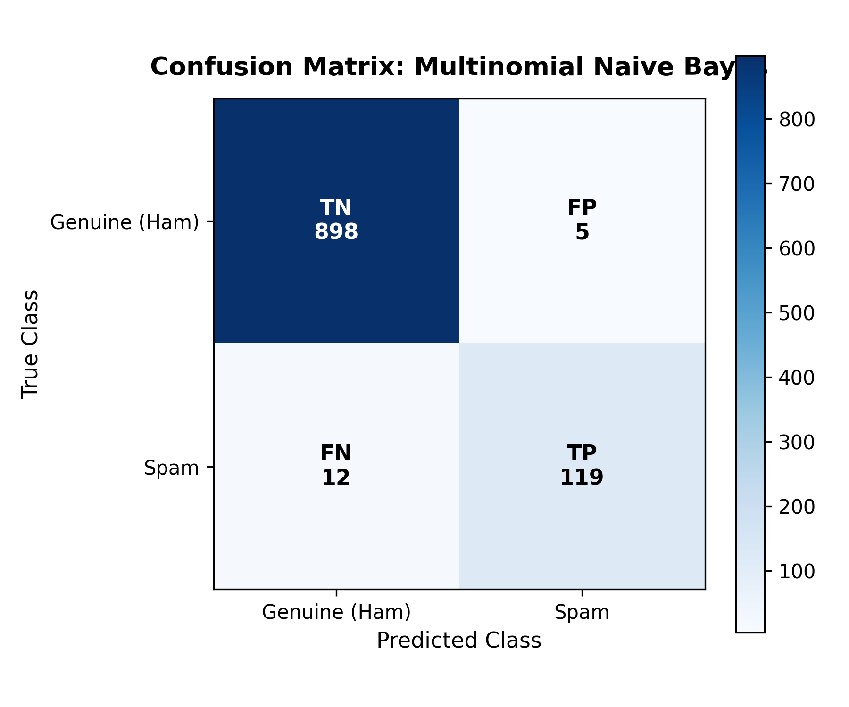
Figure 3: Confusion Matrix (Multinomial Naive Bayes on 1,034 Test Samples)
Critical Error Audit:
1. False Positives (Genuine messages classified as Spam): 5 messages (0.55% error rate on Ham). High precision is paramount to ensure legitimate personal or business messages are not filtered out.
2. False Negatives (Spam messages classified as Genuine): 12 messages.

7. Real-Time Testing & Inference Demonstrations
Input SMS Message | Prediction | P(Spam|Msg) | P(Ham|Msg)
Congratulations! You have won a free prize. Claim now. | Spam | 1.0000 (100.0%) | 0.0000 (0.0%)
Hey, are you free this afternoon to study for the BAMAT207 exam? | Ham | 0.0006 (0.06%) | 0.9994 (99.94%)
URGENT! Your mobile account has won an exclusive $1,000 cash offer. | Spam | 1.0000 (100.0%) | 0.0000 (0.0%)
Can you send me the lecture notes when you get home? | Ham | 0.0028 (0.28%) | 0.9972 (99.72%)
Win a brand new car today! Free entry, text WIN to 80085 immediately. | Spam | 0.9999 (99.99%) | 0.0001 (0.01%)

8. Conclusion & Learning Outcomes
1. Integrated foundational probability theory, conditional probability, Bayes' Theorem, and random variables into a functional AI classifier.
2. Demonstrated that the Bernoulli random variable variance is driven by class balance, and verified Bayes' theorem both analytically and empirically.
3. Evaluated a complete NLP pipeline achieving 98.36% accuracy and 95.97% precision, establishing practical trade-offs between precision and recall.
4. Established a professional GitHub repository profile for coursework submission: https://github.com/Harshith1987/BAMAT207-Probabilistic-SMS-Spam-Detection

