Name: M Harshith Rao

Roll No: 2420090028

Kubernetes
- Install Docker Desktop and make sure it is running.
- Open PowerShell as Administrator.
- Install Minikube using:
winget install Kubernetes.minikube
- Check Minikube using:
minikube version
- Install kubectl using:
winget install -e --id Kubernetes.kubectl
- Check kubectl using:
kubectl version --client
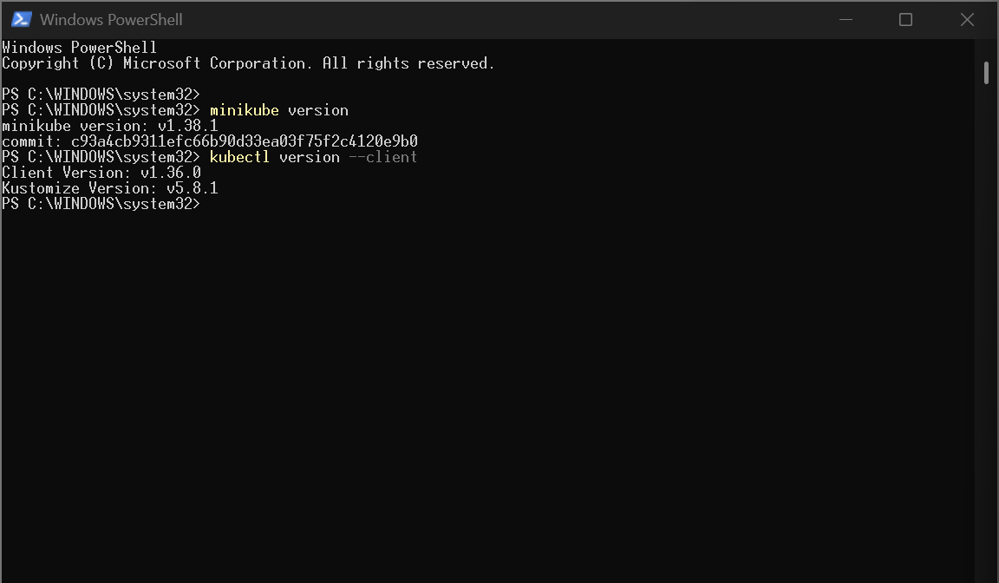
- Start Minikube using:
minikube start --driver=docker
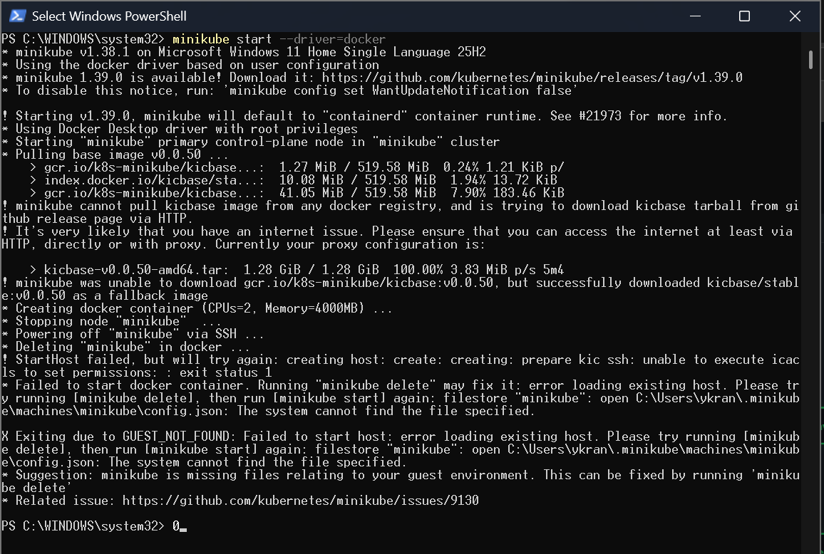
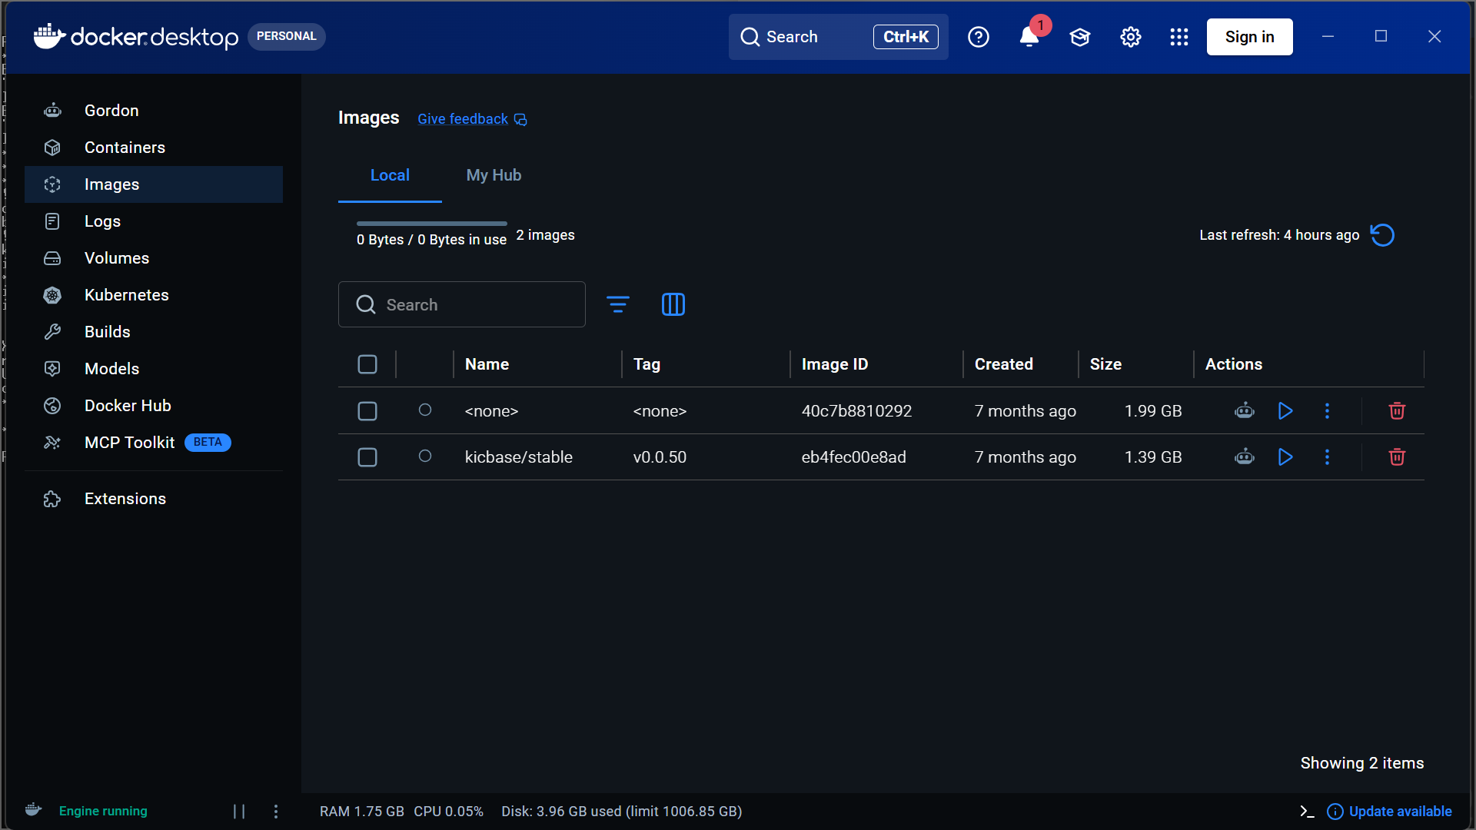
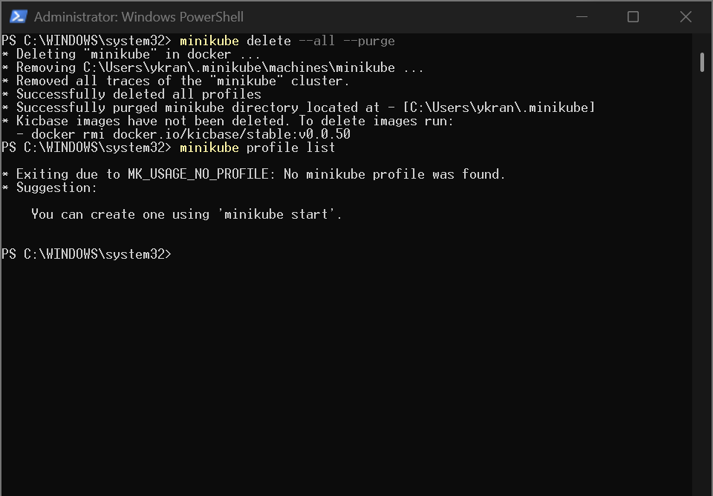
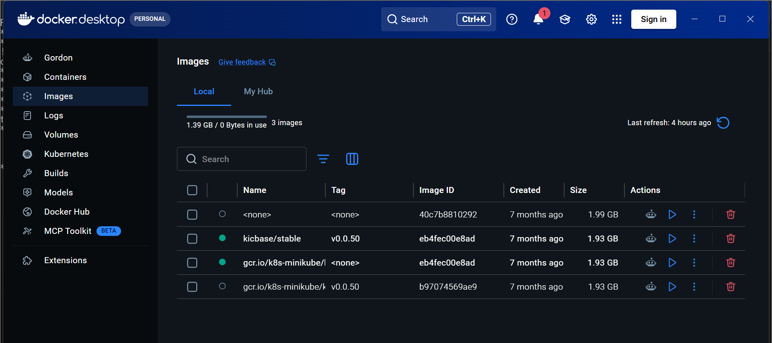
- Check the cluster status using:
minikube status
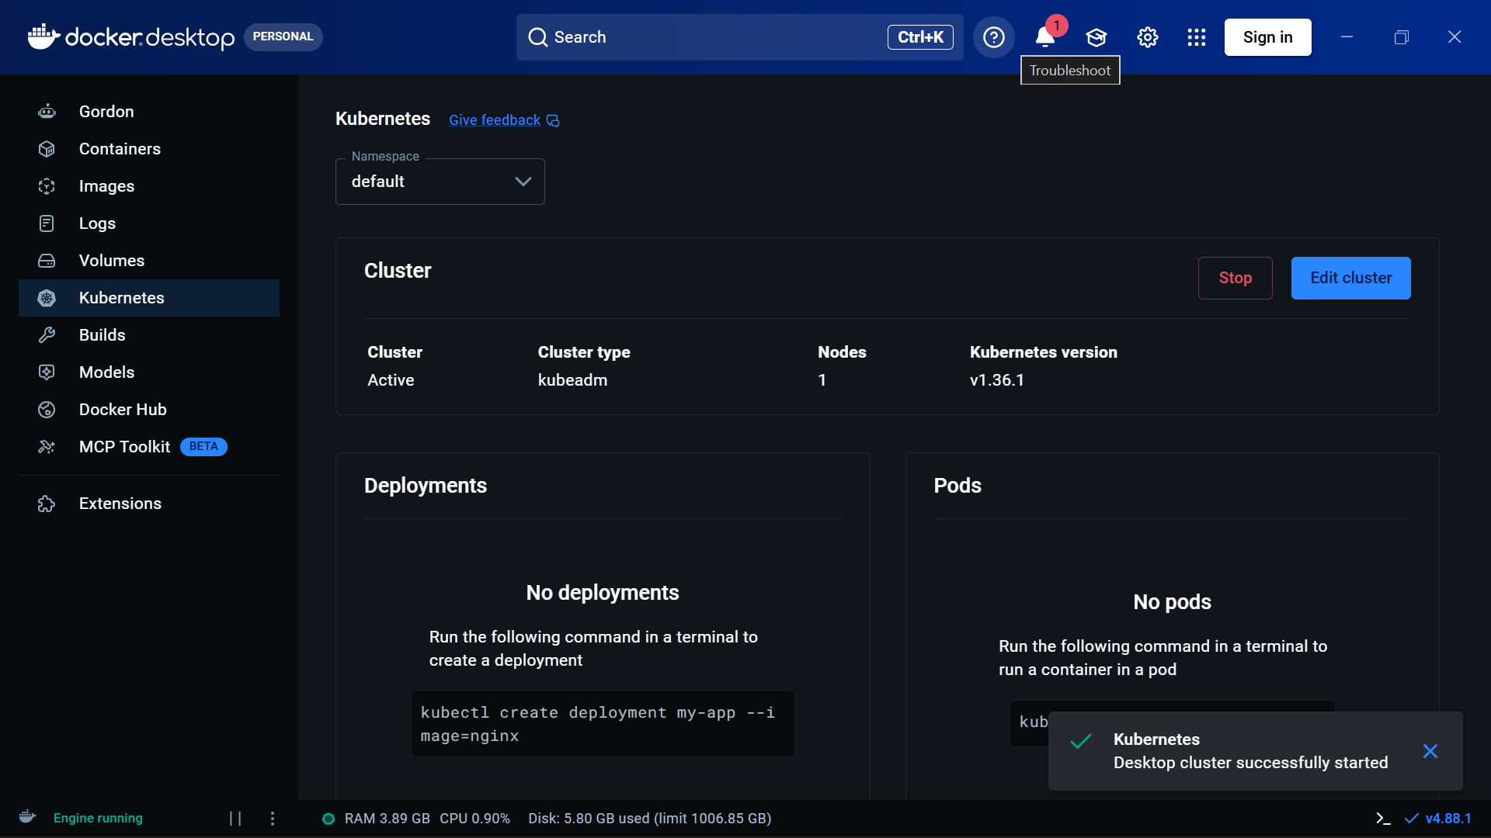
- Check the Kubernetes node using:
kubectl get nodes
- Create a file named nginx-pod.yaml and add the Nginx Pod configuration.
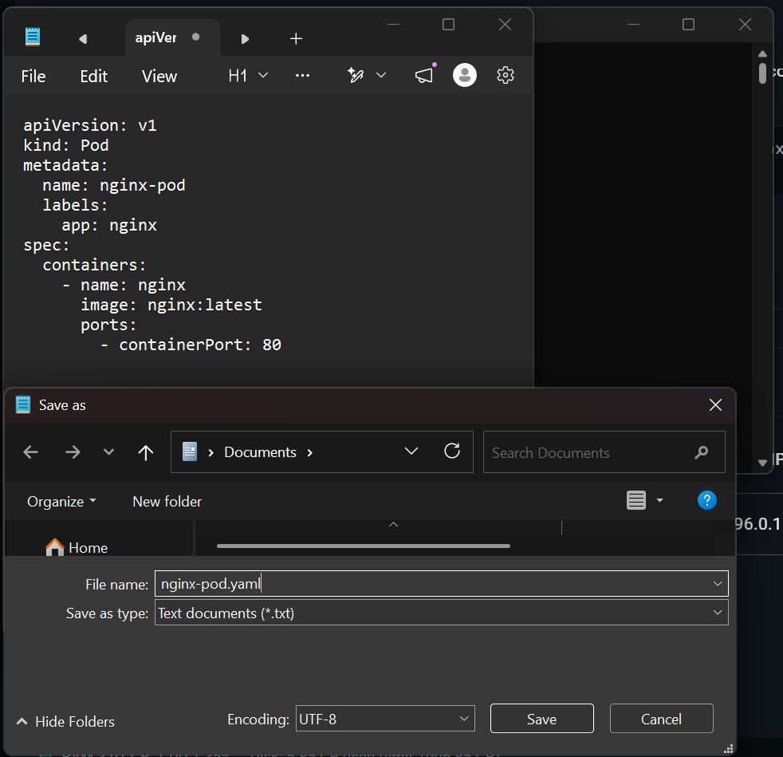
- Deploy the Nginx Pod using:
kubectl apply -f nginx-pod.yaml
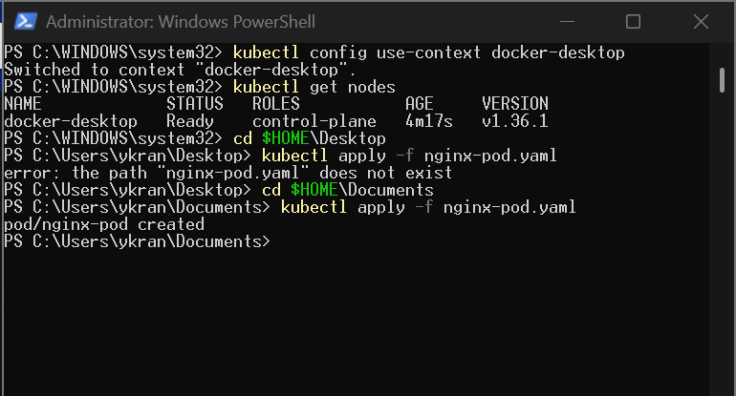
- Check the Pod status using:
kubectl get pods
- View Pod details using:
kubectl describe pod nginx-pod
- Access Nginx using:
kubectl port-forward pod/nginx-pod 8080:80
- Open http://localhost:8080 in the browser.
- Verify that the Welcome to nginx! page is displayed.
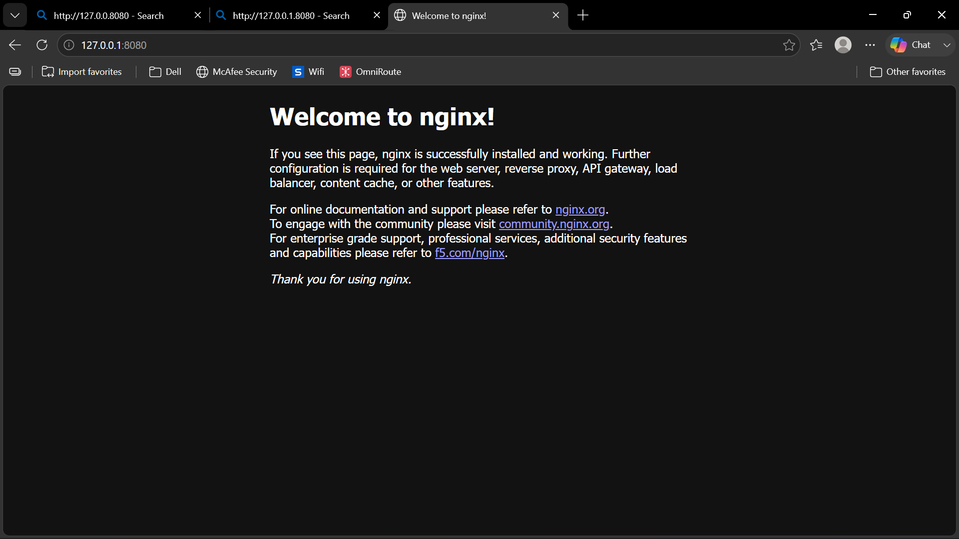
- View Nginx logs using:
kubectl logs nginx-pod
- Delete the Pod using:
kubectl delete -f nginx-pod.yaml
- Stop Minikube using:
minikube stop

