**Real-Time Financial Assistant Chatbot**

**Introduction**

The Real-Time Financial Assistant Chatbot is an AI-powered chatbot designed to assist users with financial queries related to stock markets, personal finance, investment advice, and cryptocurrency. The chatbot leverages real-time financial data integration and multi-modal context retrieval, allowing users to make informed financial decisions efficiently. This report provides a comprehensive overview of the project's objectives, implementation, tools, and methodologies used.

**Objectives**

1. Provide users with real-time financial insights.
2. Retrieve and analyze financial data from multiple sources.
3. Enable users to interact with financial visualizations and sentiment analysis.
4. Ensure a scalable, cloud-native architecture for seamless deployment.
5. Use AI-driven agents to handle specialized financial tasks.
6. Implement multi-modal data retrieval, including text, images, and graphs.
7. Enhance user decision-making with AI-powered recommendations.

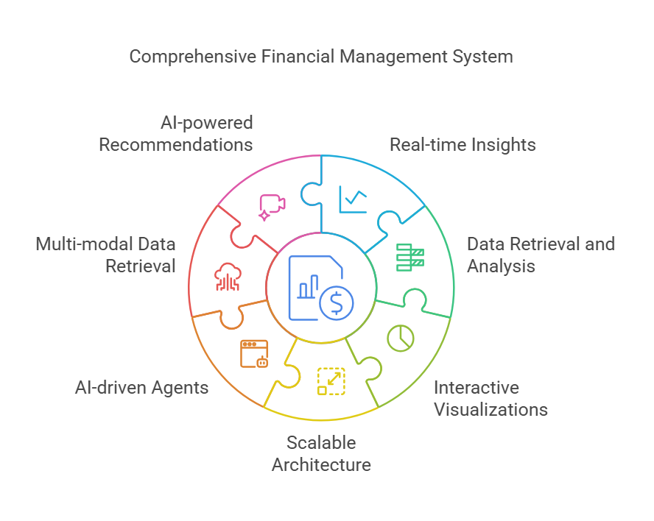

**Technologies and Tools Used**

* **Programming Language**: Python
* **Libraries and APIs**:

phi.agent: Agent-based workflow

phi.model.groq: Groq API for financial research

phi.model.openai: OpenAI GPT-4o for AI responses

phi.tools.yfinance: Financial data extraction

phi.tools.duckduckgo: Web search capabilities

phi.tools.file: File management tools

matplotlib, pandas, numpy: Data processing and visualization

* **Cloud & API Integration**:

OpenAI API for AI-based responses

Phi API for managing workflow automation

AlphaVantage API for financial data

**System Architecture**

The chatbot is built with a modular approach, integrating various AI agents specialized in different financial tasks. The architecture consists of:

1. **User Interface**: The chatbot interface where users interact with the system.
2. **AI Agents**:
   * **Web Search Agent**: Fetches latest financial news.
   * **Financial Analysis Agent**: Analyzes market trends.
   * **Sentiment Analysis Agent**: Evaluates financial sentiment.
   * **Market Alert Agent**: Triggers alerts based on market movements.
3. **Knowledge Base**: Stores relevant financial documents for reference.
4. **Data Processing and Visualization**: Converts raw financial data into meaningful insights.
5. **Cloud Integration**: Ensures scalability and access to live data feeds.

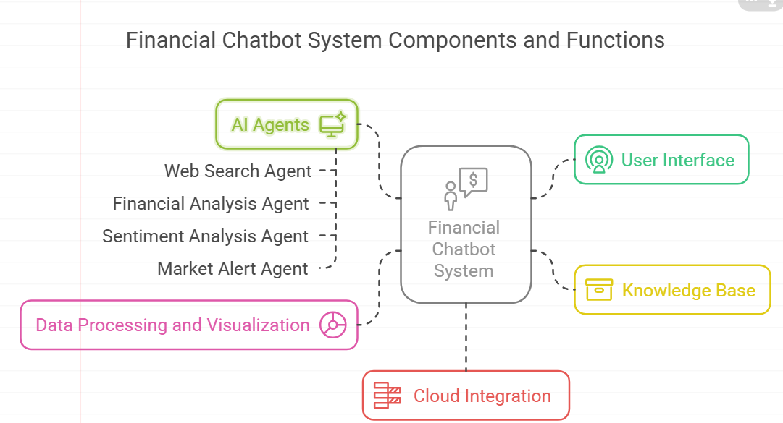

**Key Functionalities**

**1. Multi-Modal Data Analysis**

* Supports **text-based** and **image-based** financial analysis.
* Utilizes OpenAI's vision models to analyze financial charts and graphs.

**2. Custom Tools Implementation**

* **Image Analysis Tool**: Interprets financial graphs and charts.
* **Data Visualization Tool**: Generates graphical representations of financial trends.
* **Sentiment Analysis Tool**: Extracts sentiment from financial news and reports.
* **Market Alert Tool**: Notifies users of significant market movements.

**3. Real-Time Financial Data Retrieval**

* Uses phi.tools.yfinance for stock market data.
* Fetches live news using phi.tools.duckduckgo.

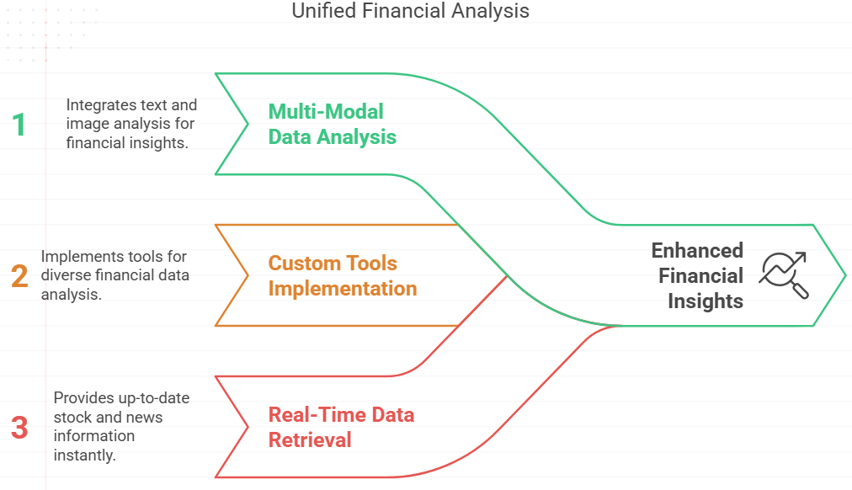

**Implementation**

**1. Environment Setup**

* Environment variables are loaded using dotenv.
* API keys are validated to ensure smooth operation.

**2. Knowledge Base Creation**

* Sample documents on investment, technical analysis, and retirement planning are stored.

**3. AI Agent Orchestration**

* Agents are designed to delegate tasks efficiently.
* Each agent specializes in a particular financial domain.

**4. Data Processing & Visualization**

* Financial data is processed and converted into graphs for better understanding.
* Alerts are generated based on predefined financial conditions.

**Results and Discussion**

The chatbot successfully integrates real-time financial data and AI-powered analysis tools. Users can:

* Retrieve stock market updates in real time.
* Analyze financial trends visually and textually.
* Receive sentiment-based evaluations of financial news.
* Get automatic alerts on market fluctuations.

**Features and Functionalities**

**Chatbot Capabilities**

* Answer finance-related queries in real time.
* Retrieve stock market trends and historical data.
* Provide market sentiment analysis.
* Generate data-driven visualizations.
* Trigger financial alerts based on stock conditions.

**Custom Tools Implemented**

* **Image Analysis Tool**: Uses OpenAI vision model to analyze financial charts.
* **Data Visualization Tool**: Generates line, bar, and pie charts for financial data.
* **Sentiment Analysis Tool**: Evaluates financial news and reports for positive/negative sentiment.
* **Market Alert Tool**: Sets up alerts based on user-defined stock conditions.

**Challenges and Future Enhancements**

**Challenges Faced**

* API rate limits restricting real-time access to financial data.
* Ensuring accurate sentiment analysis of financial reports.
* Handling missing API keys and authentication errors.

**Future Enhancements**

* Implementing a voice-based interaction module.
* Expanding support for additional financial data sources.
* Enhancing chatbot intelligence with Reinforcement Learning (RL).
* Improving real-time response speed through optimized API calls.

**Conclusion**

The Real-Time Financial Assistant Chatbot is a powerful AI-based solution that provides financial insights in real time. By integrating multi-modal AI capabilities, it enhances financial decision-making, offering users a seamless and intelligent experience. Future improvements will further optimize its performance and expand its functionalities.