
MVSR Engineering College


Department of Information Technology
RythuSethu- Bridging Farmers & Customers
VI SEM Section: A AY: 2025–26 Batch :A19
Abstract  Rythu Sethu is a smart web application developed to connect farmers directly with customers and reduce the gap between production and sales. The system allows farmers to upload and sell organic products, while customers can search, compare, and purchase products easily. It includes features such as voice input, trust score calculation, real-time order tracking and location-based product search. Artificial Intelligence is used for demand forecasting, crop recommendation, and route optimization. The platform also provides an admin panel for farmer verification and order management. Rythu Sethu aims to improve farmer income and customer satisfaction through technology. |  |  | Key Terms  - Agriculture Marketplace  - Demand Forecasting  - Crop Recommendation  - Route Optimization and Real-Time Tracking  - Trust Score System  - Voice Input and Online Payments
Project Highlights  - Direct farmer-to-customer marketplace for selling fresh organic products.  - AI-based demand forecasting and crop recommendation for farmers.  - Real-time order and delivery tracking with location services.  - Voice-enabled product management and secure online payments. |  |  | Project Details Theme: Innovation in Agriculture and Smart Farming Project Objective: To connect farmers and customers through an AI-powered marketplace. Guide Details A. Manasa Assistant Professor Department of Information Technology MVSREC, Nadergul, Hyderabad
 |  |  |  | 
Konda Charan Sai Reddy  2451-23-737-001 | Gadipelli Harshith Goud  2451-23-737-041 | Deva Jayanth  2451-23-737-059 |  | A. Manasa  Assistant Professor
Project Description | What were the problems with the process? |  | Technologies Used
Rythu Sethu is an AI-powered agriculture marketplace that connects farmers directly with customers. The platform enables product listing, secure online payments, voice-based interactions, real-time order tracking, and location-based services. It also provides demand forecasting and crop recommendations to help farmers make better decisions and increase productivity. | The traditional farming system faces issues such as middlemen involvement, lack of price transparency, delayed payments, limited market access, and inefficient delivery management. Farmers also struggle with demand prediction and direct communication with customers, reducing overall profitability and efficiency. |  | - React.js  - Node.js  - Express.js  - Mongo DB, Mongo DB Atlas  - Socket IO  - JWT Authentication  - Open Street map  - ML Models
Results | What was the process before? |  | Methodology
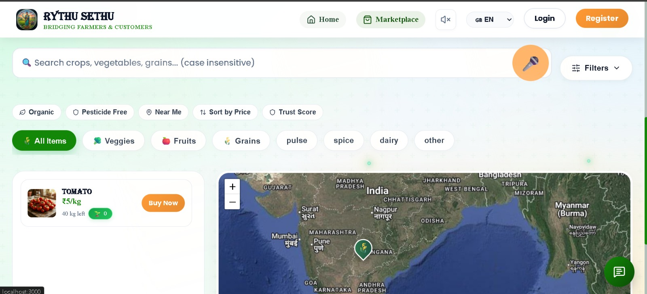 | Traditional agricultural marketing relied on middlemen, local markets, and manual record keeping. Farmers had limited access to customers, often received lower prices, and faced delayed payments. Lack of demand prediction, real-time tracking, and digital platforms made selling products inefficient and reduced overall profitability for farmers. |  | - Farmers upload organic products with prices, quantity, and images.  - Farmers and customers register on the platform with location details  - Customers search, compare, and order products through the marketplace.  - AI models provide demand forecasting and crop recommendations.  - Orders are tracked in real time with secure digital payment support.
Architecture |  | Conclusion
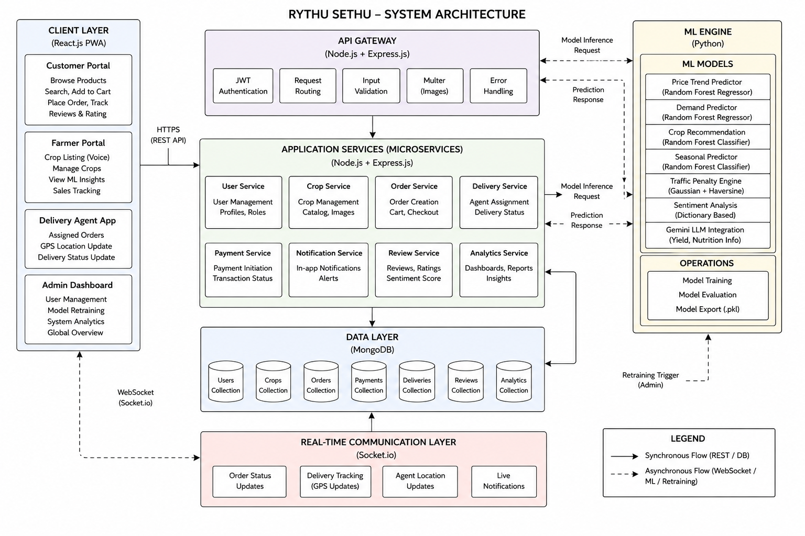 |  | RythuSethu is an AI-powered agriculture marketplace that connects farmers directly with customers, reducing the role of middlemen and improving transparency. The platform integrates demand forecasting, crop recommendations, real-time order tracking, voice-enabled features, and secure digital payments. By combining modern web technologies with machine learning, the system helps farmers make better decisions, increase profitability, and provide customers with fresh organic products through an efficient and user-friendly platform.

