RYTHU SETHU - Bridging farmers and customers

A Mini-Project report submitted in partial fulfillment of the Academic requirements for the award of the Degree of

BACHELOR OF ENGINEERING IN
INFORMATION TECHNOLOGY
By

K. CHARAN SAI REDDY | (2451-23-737-001)
G. HARSHITH GOUD | (2451-23-737-041)
D.JAYANTH | (2451-23-737-059)

Under the guidance of
Mrs. A. MANASA
Assistant Professor, Dept of IT


DEPARTMENT OF INFORMATION TECHNOLOGY
MVSR ENGINEERING COLLEGE
(An Autonomous Institution)
Nadergul, Balapur Mandal, Hyderabad-501510 2025-2026


CERTIFICATE

This is to certify that the Mini Project-II work entitled RYTHUSETHU - Bridging farmers and customers is a bonafide work carried out by Mr. K. Charan Sai Reddy (2451-23-737-001), Mr. G. Harshith goud (2451-23-737-041), Mr. D. Jayanth (2451-23-737-059) in partial fulfilment of the requirements for the award of degree of Bachelor of Engineering in Information Technology from MVSR Engineering College, an Autonomous Institution, Hyderabad, during the Academic Year 2025-2026 under our guidance and supervision.

The results embodied in this report have not been submitted to any other university or institute for
the award of any degree or diploma.

Internal Guide Project Co-ordinator
Mrs. A. Manasa Mrs. M. Sravani
Assistant Professor Assistant Professor
Department of IT Department of IT
MVSREC MVSREC

HOD External Examiner
Dr. A.V. Krishna Prasad
Head Department of IT
MVSREC

i

DECLARATION

This is to certify that the work reported in the present mini project entitled RythuSethu – Bridging Farmers and Customers is a record of bonafide work done by us in the Department of Information Technology, MVSR Engineering College, an Autonomous Institution, affiliated to Osmania University. The reports are based on the project work done entirely by us and not copied from any other source. The results embodied in this project report have not been submitted to any other University or Institute for the award of any degree or diploma to the best of our knowledge and belief.

K. Charan Sai Reddy | G. Harshith goud | D.Jayanth
(2451-23-737-001) | (2451-23-737-041) | (2451-23-737-059)

ii

ACKNOWLEDGEMENT

We would like to express our sincere gratitude to our Project Guide Mrs. A. Manasa Assistant Professor for her valuable suggestions and interest throughout the course of this project.

We would like to express our sincere gratitude and indebtedness to our Project Coordinator, Mrs. M. Sravani, Assistant Professor- Department of Information Technology, for her valued recommendations and attention throughout the course of this project.

We wish to extend our heartfelt gratitude and deep appreciation to our esteemed Professor
Dr. Ch. Samson, AHOD, Department of Information Technology for his invaluable guidance
and unwavering support throughout the duration of this project.

We are also thankful to our Principal Dr. M. Kameswara Rao, Professor, Dr. A.V. Krishna Prasad, Head - Department of Information Technology, MVSR Engineering College, for providing excellent infrastructure and a nice atmosphere for completing this project successfully as a part of our B.E. Degree (IT). We convey our heartfelt thanks to the lab staff for allowing us to use the required equipment whenever needed.

Finally, we would like to take this opportunity to thank our family for their support through the work. We sincerely acknowledge and thank all those who gave directly or indirectly their support in the completion of this work.

K. Charan Sai Reddy (2451-23-737-001)
G. Harshith goud (2451-23-737-041)
D. Jayanth (2451-23-737-059)

iii

VISION & MISSION, PROGRAM EDUCATIONAL OUTCOMES
PROGRAM OUTCOMES (POs)

Vision of the Department:
To impart technical education producing competent and socially responsible engineering professionals in the field of Information Technology.

Mission of the Department:
M1. To make teaching learning process effective and stimulating.
M2. To provide adequate fundamental knowledge of sciences and Information Technology with positive attitude.
M3. To create an environment that enhances skills and technologies required for industry. M4. To encourage creativity and innovation for solving real world problems.
M5. To cultivate professional ethics in students and inculcate a sense of responsibility towards society Program Educational Objectives:

After 3 to 4 years of graduation, graduates of the Information Technology program will:

- Apply knowledge of mathematics and Information Technology to analyze, design and implement solutions for real world problems in core or in multidisciplinary areas.
- Communicate effectively, work in a team, practice professional ethics and apply knowledge of computing technologies for societal development.
- Engage in Professional development or postgraduate education to be a life-long learner.

iv
PROGRAM SPECIFIC OUTCOMES (PSOs):

PSO1: Hardware design: An ability to analyse, design, simulate and implement computer hardware / software and use basic analog/digital circuits, VLSI design for various computing and communication system applications.
PSO2: Software design: An ability to analyze a problem, design algorithm, identify and define the computing requirements appropriate to its solution and implement the same

v

COURSE OBJECTIVES & COURSE OUTCOMES COURSE OBJECTIVES
- Enable students learning by doing.
- Develop capability to analyse and solve real time problems.
- Inculcate innovative ideas.
- Impart team building and management skills.
- Instil writing and presentation skills.

COURSE OUTCOMES

After completion of the course student will be able to:
CO1-Interpret Literature with the purpose to formulate a problem statement. CO2 - Plan, Analyse, Design and implement a project.
CO3-Find the solution of identified problem with the help of modern tools & technology. CO4 - Plan to work as a team to exhibit team skills to meet deadlines.
CO5 - Prepare and submit the Report and deliver presentation.

vi

ABSTRACT

Agriculture is a vital sector of the Indian economy, but traditional supply chains and the involvement of intermediaries often reduce farmers' profits and increase costs for consumers. In addition, the lack of data-driven decision-making makes farmers vulnerable to market fluctuations, improper crop selection, and unpredictable conditions. Rythu Sethu is an AI-driven, multilingual agricultural e-commerce platform that directly connects farmers and consumers through a unified digital ecosystem. Developed using the MERN stack and Python-based Machine Learning, the system provides features such as voice-assisted crop listing, price and demand prediction, crop recommendation, real-time delivery tracking, and AI-powered analytics. It supports four user roles—Farmer, Customer, Delivery Agent, and Admin—and enables farmers to interact in their native language. By integrating Artificial Intelligence, Machine Learning, and real-time communication, Rythu Sethu creates a smart, transparent, and efficient farm-to-consumer marketplace that improves farmer profitability and promotes sustainable agriculture.

K. Charan Sai Reddy (2451-23-737-001)
G. Harshith goud (2451-23-737-041)
D. Jayanth (2451-23-737-059

vii
TABLE OF CONTENTS

CONTENTS PAGE NO

Certificate i
Declaration ii
Acknowledgement iii
Vision & Mission, PEOs iv
POs and PSOs v
Course Objectives & Outcomes vi
Abstract vii
Table of Contents viii
List of Figures ix
List of Tables and List of Abbrevations x
Chapters
- Introduction 12
  - Problem statement
  - Existing system
  - Proposed system
  - Scope
- System Requirement Specifications 13
  - Software Requirements
  - Hardware Requirements
  - System Architecture / Block Diagram
  - Literature survey
- Design & Implementation 15-23
  - Features
  - UML Diagrams
3.2.1-Use case Diagram 3.2.2 Class Diagram
3.2.3 Sequence Diagram 3.2.4 Activity Diagram
3.2.5 Activity Diagram
  - Environmental Setup
  - Implementation /Methodology Steps
- Results & Test Cases 24-27
4.1 Results
4.2 Test Cases
- Conclusion & Future Enhancements 28-29
References
Appendix: A : Folder structure 29-37
viii
LIST OF FIGURES

Figure No. | Figure Name | Page No.
Fig-2.3.1 | System Architecture | 13
Fig-3.2.1 | Use case diagram | 16
Fig-3.2.2 | Class diagram | 17
Fig-3.2.3 | Sequence diagram | 17
Fig-3.2.4 | Activity diagram | 18
Fig-3.3.1 | Visual Code Installation | 18
Fig-3.3.2 | Vs Code Icon | 19
Fig-3.3.3 | License Agreement | 19
Fig-3.3.4 | Additional Task | 20
Fig-3.3.5 | App Installation | 21
Fig-3.3.6 | Vs Code Setup | 21
Fig-3.3.7 | Vs Code Setup Wizard | 22
Fig-3.3.8 | Vs Code Welcome Page | 22
Fig-4.1.1 | Home Page | 24
Fig-4.1.2 | Farmer Dashboard | 24
Fig-4.1.3 | Customer Dashboard | 25
Fig-4.1.4 | Product Marketplace | 25
Fig -4.1.5 | Agent Dashboard | 26
Fig4.1.6 | Admin Dashboard | 26

ix
LIST OF TABLES

Table 2.4.1 Literature Survey
Table 4.1 System Test Cases

LIST OF ABBREVIATIONS

AI - Artificial Intelligence
API - Application Programming Interface
CNN - Convolutional Neural Network
ETA - Estimated Time of Arrival
GPS - Global Positioning System
IoT - Internet of Things
JWT - JSON Web Token
LLM - Large Language Model
MERN - MongoDB, Express.js, React.js and Node.js
NLP - Natural Language Processing
ODM - Object Document Mapper
REST - Representational State Transfer

x

CHAPTER 1
INTRODUCTION

The agricultural sector is highly unpredictable, and farmers often rely on traditional experience rather than data-driven decisions for crop cultivation, harvest timing, and pricing. This frequently leads to market oversupply, price drops, and wastage of produce. Rythu Sethu was developed to address this issue by digitizing the agricultural supply chain and directly connecting farmers with consumers. The platform provides farmers with real-time insights into market demand, crop scarcity, and price trends before cultivation. Built using the MERN stack and Python-based Machine Learning, Rythu Sethu also includes multilingual voice assistance to overcome literacy barriers. The system creates a transparent, efficient, and intelligent agricultural ecosystem that benefits farmers, consumers, delivery agents, and administrators.

PROBLEM STATEMENT
To Develop a digital platform that directly connects farmers and customers to enable fair farmer earnings while providing customers with affordable organic food without intermediaries.

EXISTING SYSTEM

The existing agricultural platforms primarily function as basic e-commerce systems that offer limited features such as product listing and purchasing. These systems lack intelligent capabilities such as price prediction, demand forecasting, crop recommendations, and data-driven decision-making, forcing farmers to rely on traditional methods. Most platforms also depend on English-based interfaces, creating a digital literacy barrier for rural farmers. In addition, they provide limited logistics support and do not offer real-time tracking or integrated Machine Learning services. As a result, existing systems fail to provide a unified, intelligent, and farmer-friendly ecosystem that efficiently connects farmers, consumers, delivery agents, and administrators.

PROPOSED SYSTEM

Rythu Sethu is a multilingual, AI-driven agricultural e-commerce platform designed to directly connect farmers and consumers through a unified digital ecosystem. The system eliminates the dependency on intermediaries and enables efficient management of agricultural activities through a single platform. It provides intelligent support for crop listing, market analysis, price prediction, and delivery management while allowing farmers to interact using their native language. By integrating Artificial Intelligence, Machine Learning, and real-time communication technologies, the proposed system creates a smart, transparent, and data-driven farm-to-consumer marketplace that improves decision-making and enhances agricultural productivity.

SCOPE
The scope of Rythu Sethu encompasses the development and deployment of a full-stack, multi-tiered agricultural platform that directly connects farmers and consumers. It includes the development of a responsive Progressive Web Application (PWA) using React and Vite, along with a secure Node.js and Express backend for handling REST API requests and user authentication. The project also covers the integration of Machine Learning models for price prediction, demand forecasting, and crop recommendation, as well as a centralized Admin dashboard for model retraining and system monitoring. In addition, it supports multilingual voice assistance and real-time delivery tracking through WebSocket communication, creating a smart, efficient, and data-driven farm-to-consumer ecosystem

CHAPTER 2

SYSTEM REQUIREMENT SPECIFICATIONS

SOFTWARE REQUIREMENTS
    - Operating System: Windows 10/11.
    - Frontend Framework: React.js 18 with Vite.
    - Backend Framework: Node.js and Express.js.
    - Programming Language: Python 3.10+.
    - Database Management System: MongoDB with Mongoose ODM. Machine Learning Libraries: Scikit-Learn and PyMongo.
    - Real-Time Communication: Socket.io. Authentication: JSON Web Token (JWT).
    - Voice Assistance: Web Speech API. Development Environment: Visual Studio Code.

HARDWARE REQUIREMENTS
    - Processor: Intel Core i5 / AMD Ryzen 5 or higher.
    - RAM: 8 GB Minimum (16 GB Recommended). Storage: 20 GB Free SSD Space.
    - Network: Broadband Internet / Wi-Fi Connection.
    - Client Device: Smartphone, Laptop, or Desktop Computer.

SYSTEM ARCHITECTURE

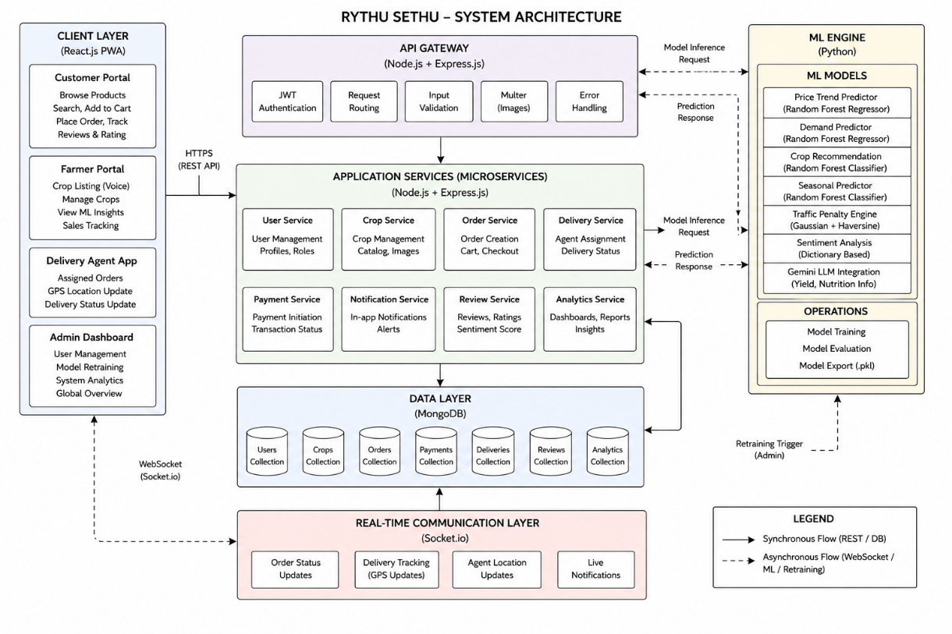
Fig-2.3.1 System Architecture

LITERATURE SURVEY

S.No | Author | Year | Title | Modules Covered | Key Points | Adopted Features | Limitations
1 | I. Rahman, Riyazulla | 2024 | Farm to Fork | Farmer, Customer, Market | Digital farm marketplace | Farmer-consumer platform | No AI support
2 | Univ. of Washington | 2020 | Farm-to-Table System | Farmer, Customer, Admin, Delivery | Organized supply chain | Delivery tracking | Region specific
3 | S. G. Yogesh, D. S. Ravindran | 2023 | Organic Sales Profitability | Farmer, Customer, Admin | Improves farmer income | Direct digital sales | Literacy issues
4 | S. Pudumalar et al. | 2017 | Crop Recommendation | Farmer, Recommendation | Soil-based crop selection | ML recommendation | Limited dataset
5 | N. H. Kulkarni et al. | 2018 | Crop Productivity | Farmer, Analytics | Improves productivity | Ensemble learning | No real-time support
6 | Y. J. N. Kumar et al. | 2020 | Crop Yield Prediction | Farmer, ML Engine | Predicts crop yield | Yield forecasting | Data dependent
7 | N. Shirisha et al. | 2024 | Multilingual Farming | Farmer, Voice Module | Supports native languages | NLP assistance | Translation errors
8 | S. Sultana et al. | 2025 | Organic Farming Landscape | Farmer, Market | Studies market trends | Buyer insights | Limited implementation

CHAPTER 3

DESIGN AND IMPLEMENTATION

FEATURES
3.1.1 Price Trend Prediction
The system uses the Random Forest Regressor algorithm to predict crop prices based on market demand, supply, and seasonal factors. This helps farmers make informed decisions and reduce losses caused by market fluctuations. Algorithm Used: Random Forest Regressor
3.1.2 Crop Recommendation System
The system recommends suitable crops by analyzing soil nutrients, temperature, humidity, rainfall, and soil pH values. It helps farmers select crops that are most appropriate for their agricultural conditions. Algorithm Used: Random Forest Classifier
3.1.3 Route Optimization and ETA Prediction
The system calculates the shortest delivery route and estimates delivery time using geographical distance and traffic conditions.
Techniques Used: Haversine Formula and Gaussian Traffic Penalty Algorithm
3.1.4 Sentiment Analysis
Customer reviews are analyzed to determine positive, negative, or harmful feedback. This helps maintain platform reliability and improve trust between farmers and consumers. Technique Used: Natural Language Processing (NLP)
3.1.5 Delivery Agent Assignment
The system automatically assigns the nearest available delivery agent by calculating the geographical distance between farms and active agents, improving delivery efficiency. Technique Used: Haversine Distance Matching
3.1.6 Voice Assistance and Multilingual Support
The platform enables farmers to interact using their native language through voice commands. Speech is converted into text and automatically populated into the system.
Technologies Used: Web Speech API and React Context API
3.1.7 Generative AI Integration: The system integrates Google Gemini to provide intelligent agricultural assistance such as yield prediction, nutritional information, and AI-based insights. Technology Used: Google Gemini 1.5 Flash
3.1.8 Real-Time Delivery Tracking : The platform provides live delivery updates by continuously tracking the delivery agent's location and updating customers in real time. Technology Used: Socket.io
3.1.9 Image Validation and Search Suggestions: The system validates uploaded crop images and provides smart search suggestions to help customers quickly find relevant products. Techniques Used: Image Integrity Validation and AI-based Search Filtering

  - UML DIAGRAMS
3.2.1 Use case Diagram

Fig-3.2.1

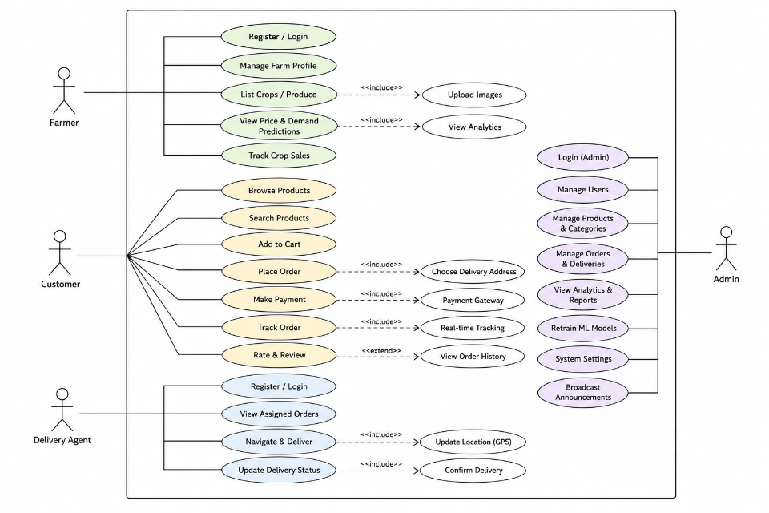
    - Class Diagram

Fig-3.2.2

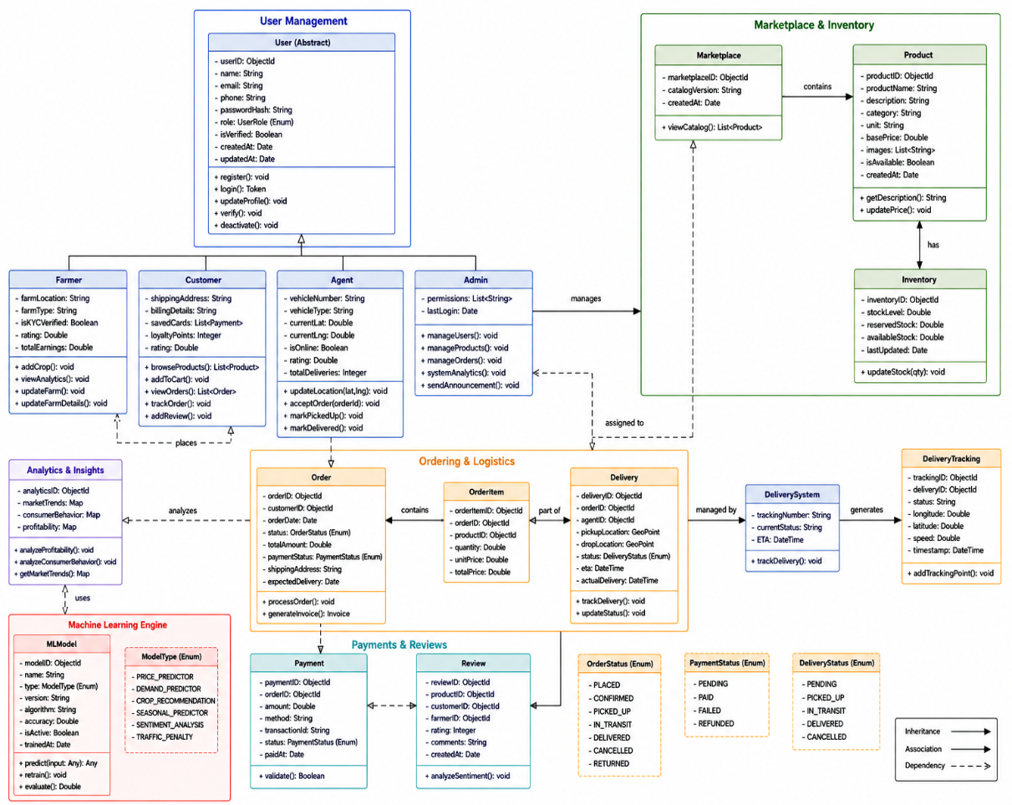
    - Sequence Diagram
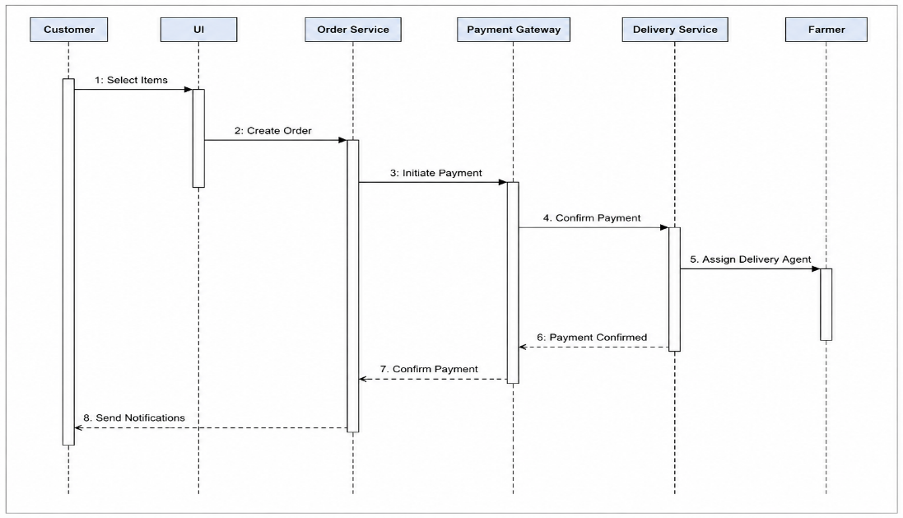

Fig-3.2.3

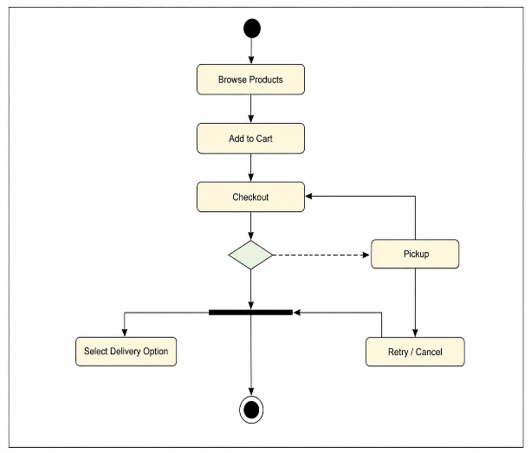
    - Activity Diagram

Fig-3.2.4

ENVIRONMENTAL SETUP
Installing An Editor: Visual Studio (VS) Code
- Visit the official website of the Visual Studio Code using any web browser like Google Chrome, Microsoft Edge, etc.
Press the “Download for Windows” button on the website to start the download of the Visual Studio Code Application.

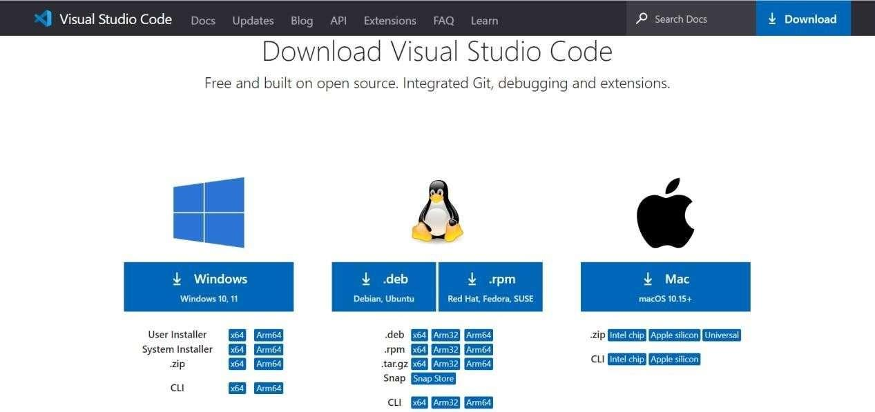
Fig-3.3.1 Visual Code Installation

- When the download finishes, then the Visual Studio Code icon appears in the downloads folder.

Fig-3.3.2 Vs Code Icon

- Click on the installer icon to start the installation process of the Visual Studio Code. After the Installer opens, it will ask you for accepting the terms and conditions of theVisual Studio Code. Click on I accept the agreement and then click the Next button.



Fig-3.3.3 License Agreement

- Choose the location data for running the Visual Studio Code. It will then ask you for browsing the location. Then click on Next button.
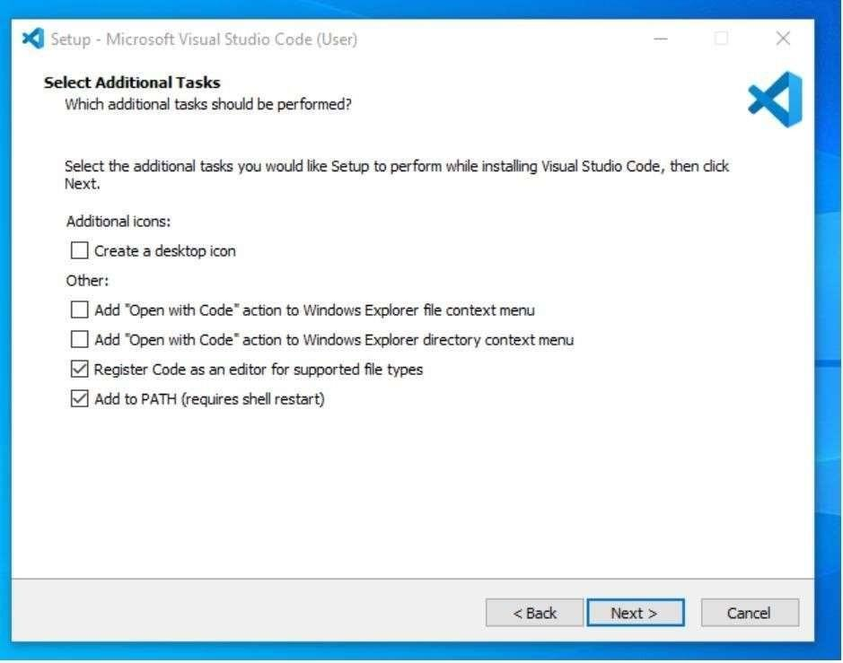
Fig-3.3.4 Additional Task

- Then it will ask for beginning the installing setup. Click on the Install button.
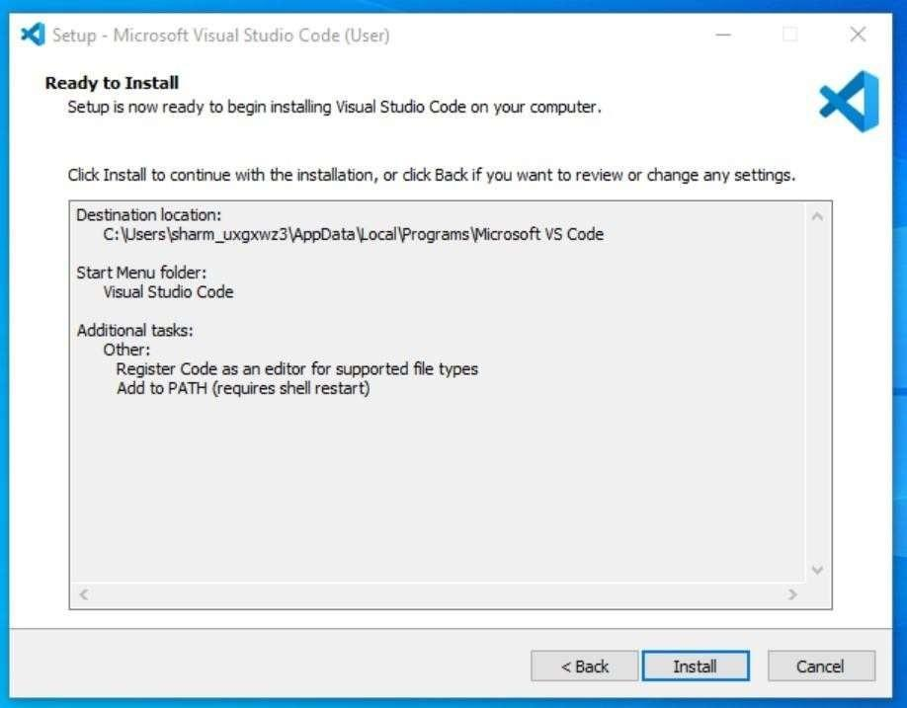
Fig-3.3.5 App Installation

- After clicking on Install, it will take about 1 minute to install the Visual Studio Code on your device.
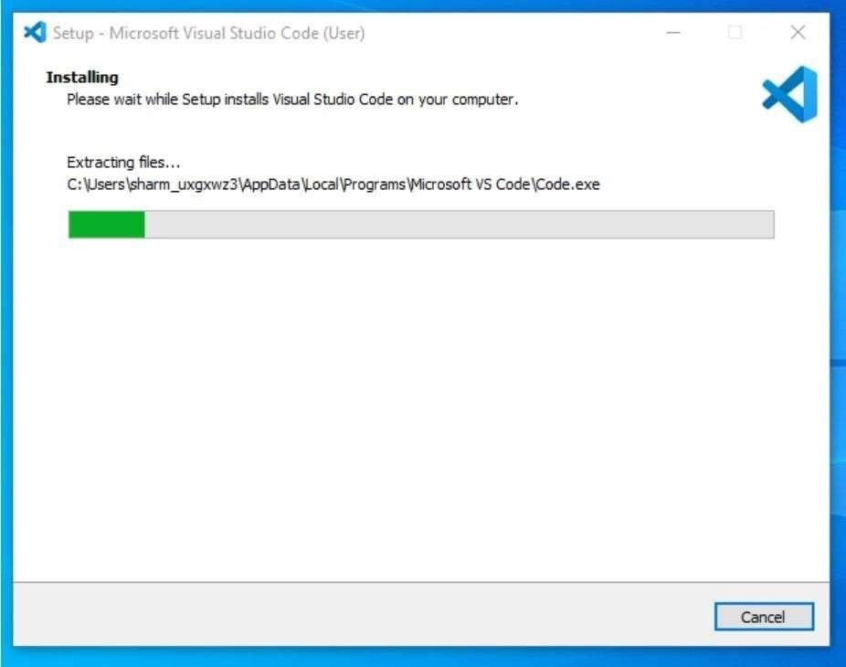
Fig-3.3.6 Vs Code Setup
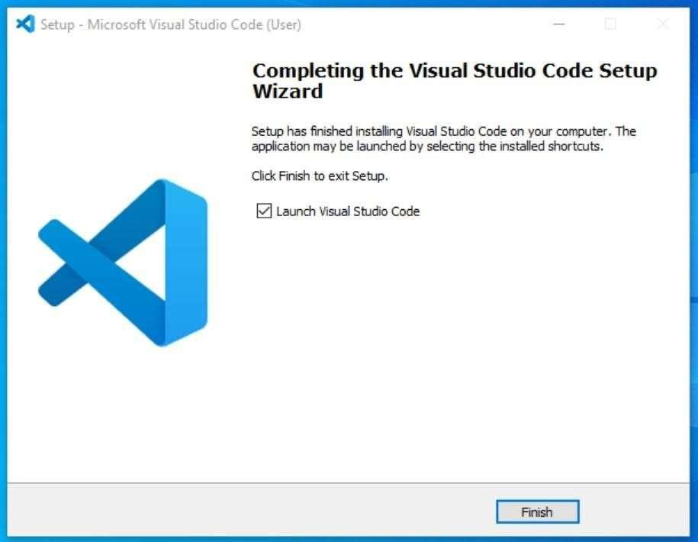
- After the Installation setup for Visual Studio Code is finished, it will show a window like this below. Tick the “Launch Visual Studio Code” checkbox and then click Next.

Fig-3.3.7 Vs Code Setup Wizard
- After the previous step, the Visual Studio Code window opens successfully. Now you can create a new file in the Visual Studio Code window and choose a language of yours to begin your programming journey!
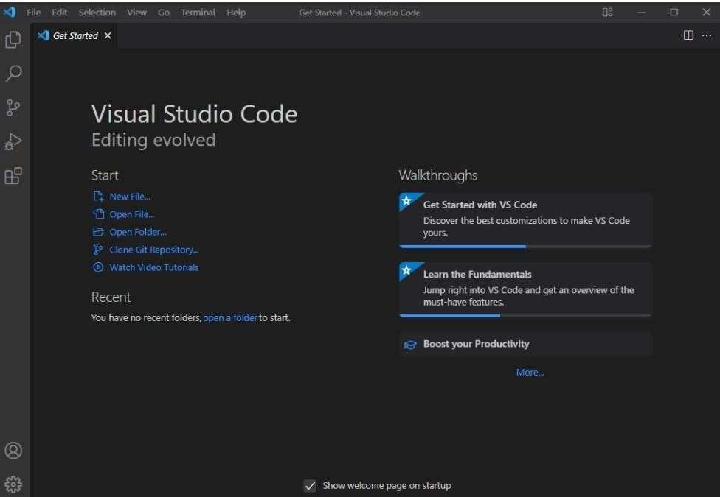
Fig-3.3.8 Vs Code Welcome Page
So this is how we successfully installed Visual Studio Code on our Windows system.
  - IMPLEMENTATION AND METHODOLOGY STEPS

The development by Agile Software Development Life Cycle (SDLC) to ensure a systematic, scalable, and iterative development process. Initially, the requirements and challenges faced by farmers and consumers were analyzed to define the project objectives. A multi-tier architecture was then designed to integrate the frontend, backend, database, and Machine Learning modules into a unified platform. The system was developed using the MERN stack along with Python-based Machine Learning models to provide intelligent agricultural services. Real-time communication and multilingual voice assistance were incorporated to improve accessibility and user interaction. Finally, the application was tested and validated to ensure reliability, security, and efficient performance.

- Requirement Analysis
The requirements of farmers, customers, delivery agents, and administrators were analyzed, and the limitations of existing agricultural systems were identified.
- System Design
The overall system architecture, database schema, user workflows, and UML diagrams were designed to establish a structured framework.
- Frontend Development
A responsive Progressive Web Application (PWA) was developed using React.js and Vite to provide an interactive and user-friendly interface.

- Backend Development
Node.js and Express.js were used to develop REST APIs for authentication, order management, business logic, and user management.

- Database Integration
MongoDB was integrated to store and manage user, crop, order, delivery, and review data.

- Machine Learning Integration
Python-based Machine Learning models were implemented for price prediction, demand forecasting, and crop recommendation.

- Real-Time Communication Integration
Socket.io was integrated to provide live delivery tracking and real-time order updates.

- Voice Assistance Integration
Multilingual voice support was implemented using the Web Speech API to enable farmers to interact in their native language.

- Testing and Deployment
The system was tested for functionality, performance, security, and accuracy before deployment.
- Version Control: Used Git/GitHub for code management with commands: git add ., git commit, git push.

4.1 UI Screenshots
CHAPTER 4
RESULTS & DISCUSSION

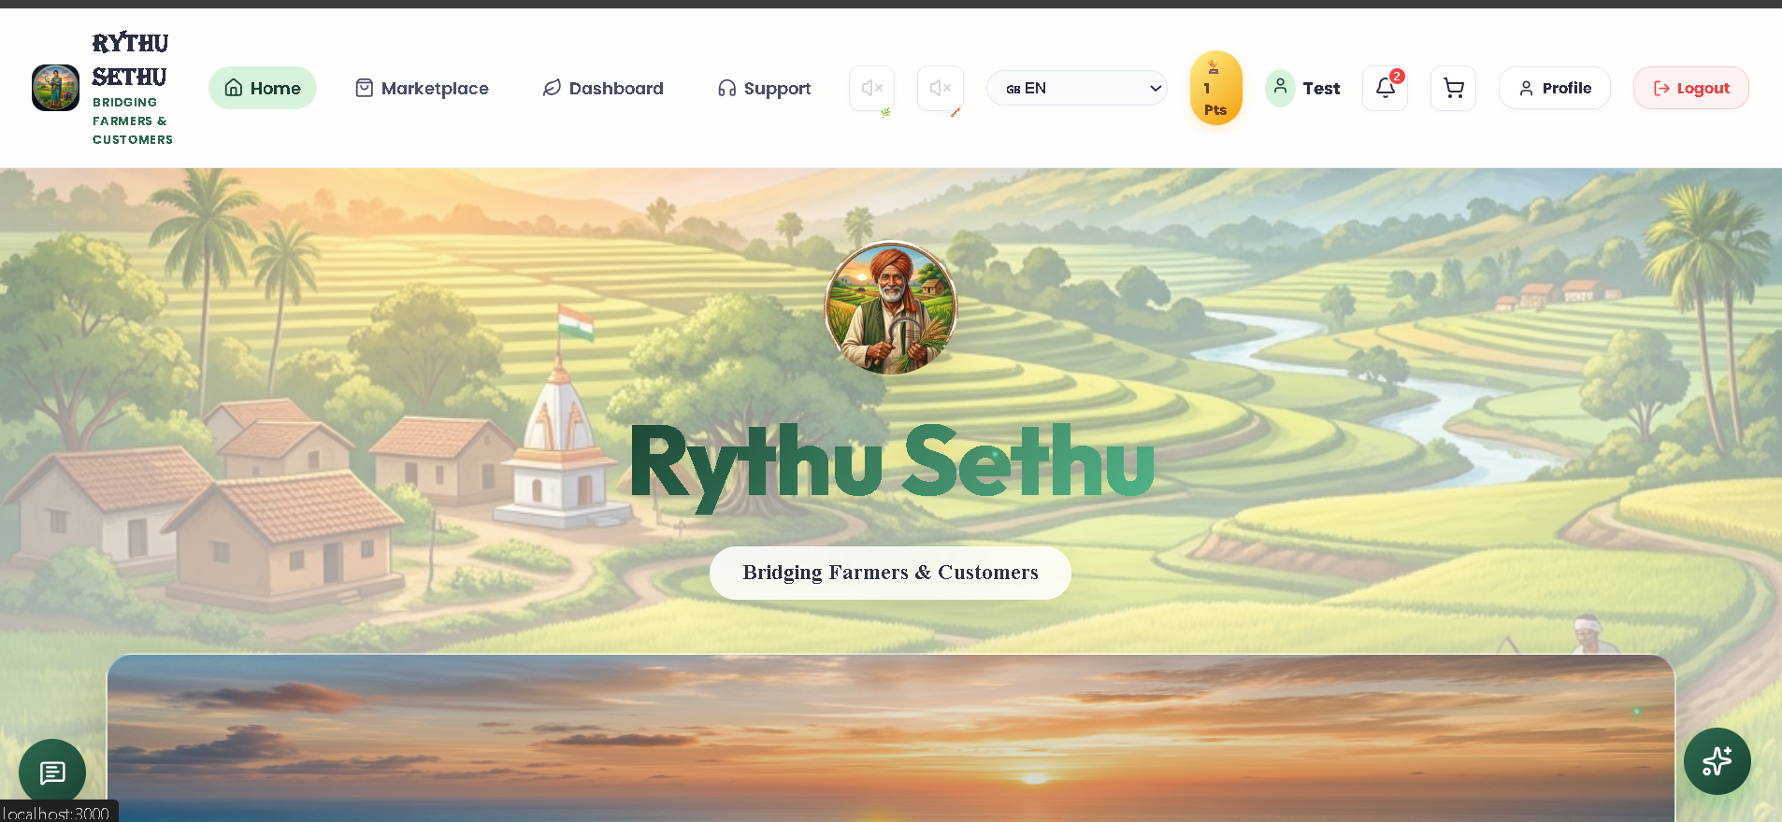
Fig-4.1.1 Home page

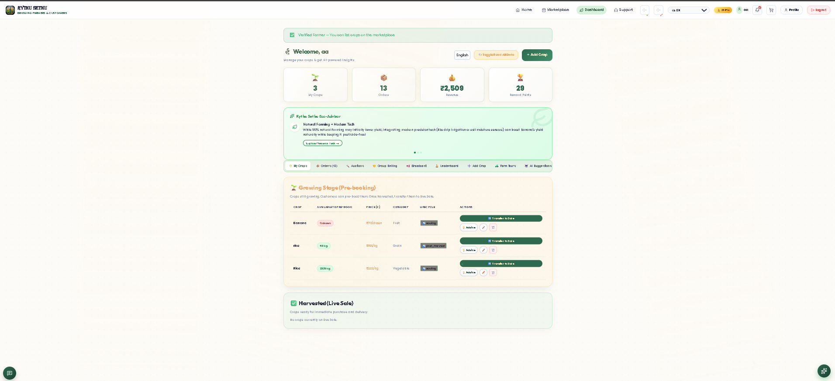

Fig-4.1.2 Farmer Page

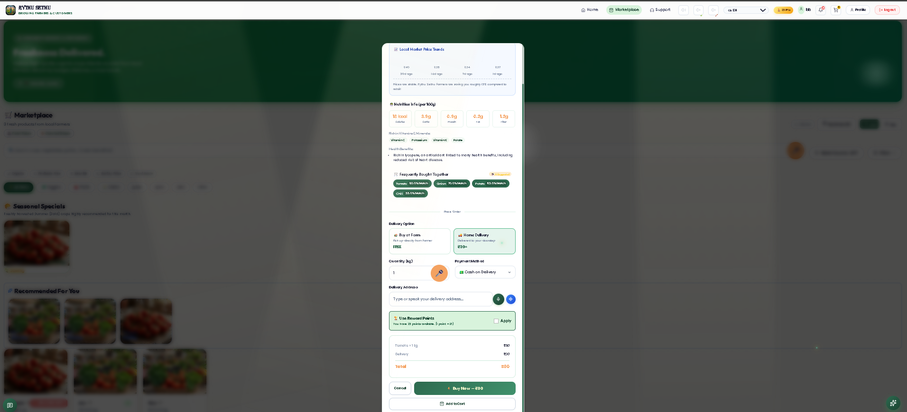

Fig-4.1.3 Customer page

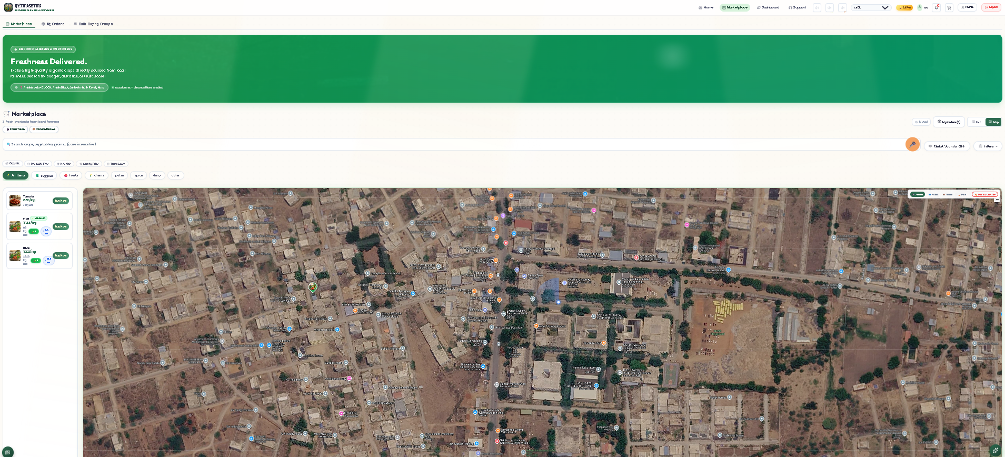

Fig-4.1.4 Marketplace Page

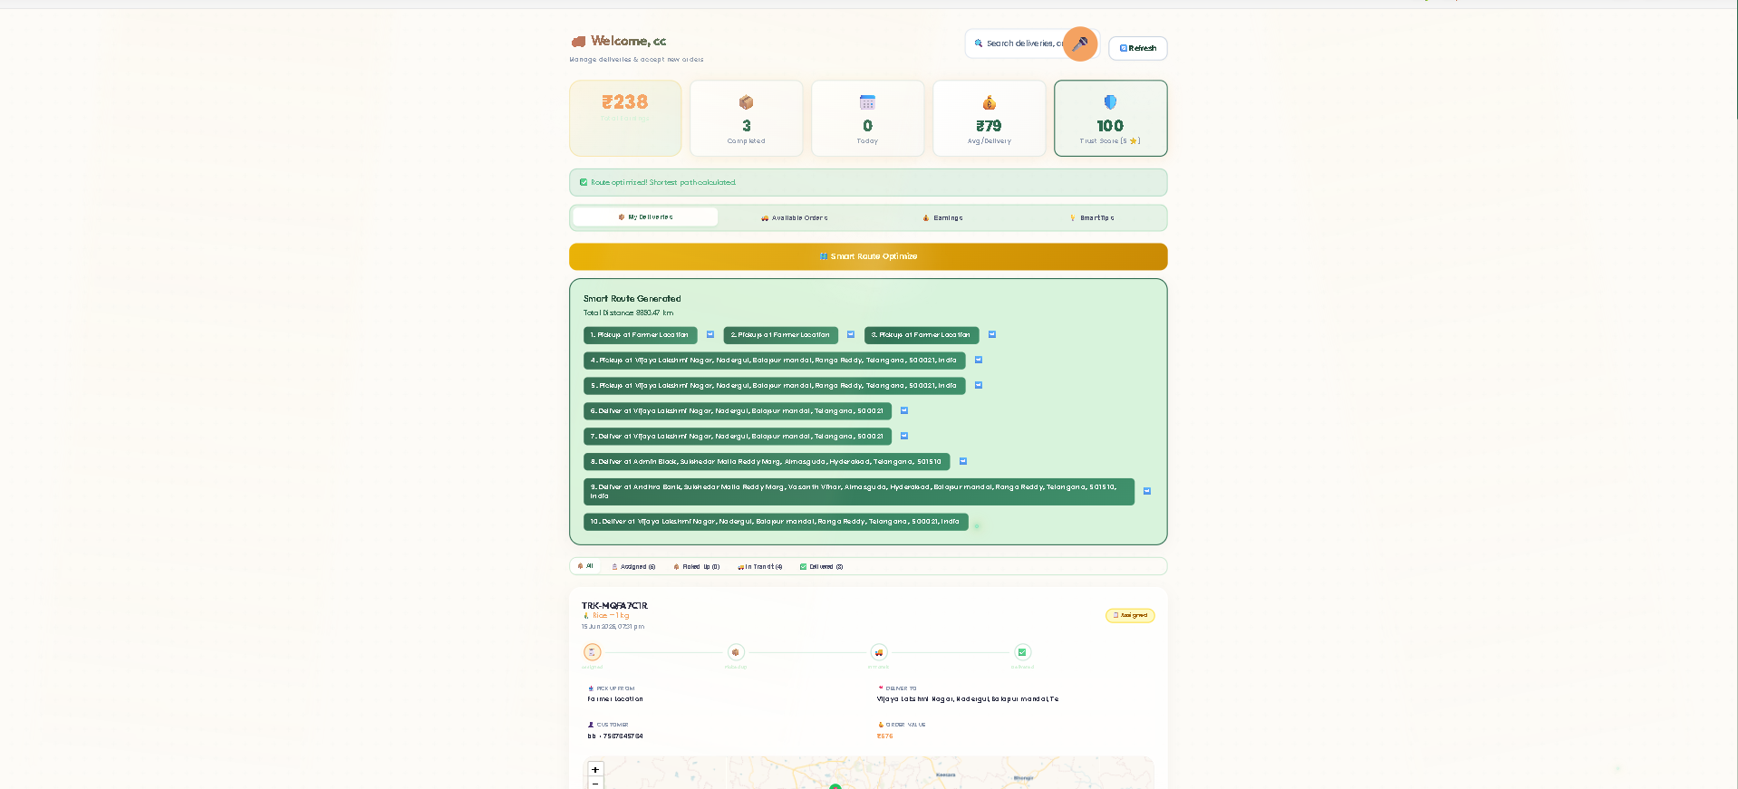

Fig-4.1.5 Agent dashboard

Fig-4.1.6 Admin Page

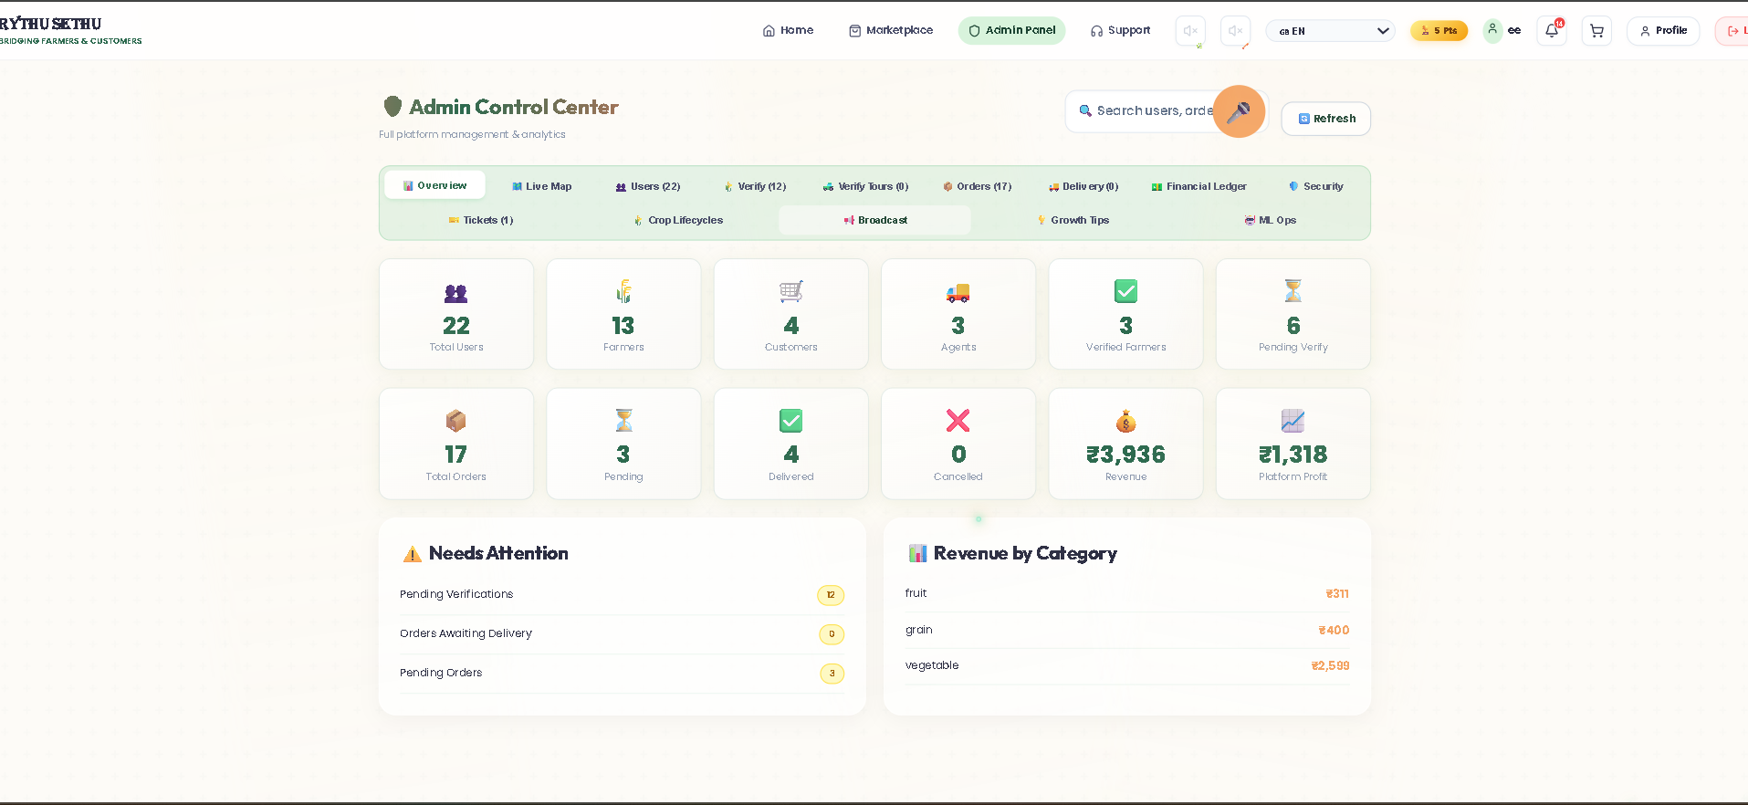
SYSTEM TEST CASES

Table 4.2: System Test Cases

Test Case No. | Test Case Name | Test Case Description | Test Case Input | Test Case Output | Status
1 | Database Connection | Verifies MongoDB connection. | Execute mongoose.connect() with MongoDB on port 27017. | Displays "MongoDB Connected". | Pass
2 | Voice Authentication | Verifies voice registration. | Say "Register as Farmer". | Registration form is auto-filled. | Pass
3 | Frontend PWA | Verifies responsive mobile view. | Open tables in mobile view. | Horizontal scrolling works properly. | Pass
4 | Real-Time Location Tracking | Verifies live location updates. | Trigger agent_location_update event. | Consumer map updates instantly. | Pass
5 | API Security (JWT) | Verifies protected route access. | Send an invalid JWT token. | Returns 401 Unauthorized. | Pass
6 | User Login | Verifies user authentication. | Enter valid login credentials. | User dashboard is displayed. | Pass
7 | Crop Listing | Verifies crop upload functionality. | Farmer uploads crop details and image. | Crop is added successfully. | Pass
8 | Price Prediction | Verifies AI price prediction. | Enter crop and market details. | Predicted price is displayed. | Pass
9 | Crop Recommendation | Verifies crop suggestion module. | Enter N, P, K, temperature, humidity, rainfall and pH. | Recommended crops are displayed. | Pass
10 | Order Placement | Verifies customer order creation. | Add products and place an order. | Order is generated successfully. | Pass
11 | Payment Processing | Verifies payment functionality. | Complete payment process. | Payment status is updated. | Pass
12 | Admin Dashboard | Verifies admin monitoring. | Access analytics dashboard. | User, crop and order data are displayed. | Pass

CHAPTER 5
CONCLUSION AND FUTURE ENHANCEMENTS

  - CONCLUSION
Rythu Sethu is an AI-driven agricultural platform that directly connects farmers and consumers through a smart digital ecosystem. The system addresses the limitations of traditional agricultural supply chains by reducing dependency on intermediaries and enabling data-driven decision-making. Features such as price prediction, crop recommendation, multilingual voice assistance, and real-time delivery tracking improve accessibility and operational efficiency. By integrating the MERN stack, Machine Learning, and real-time communication technologies, Rythu Sethu provides a transparent, efficient, and sustainable farm-to-consumer marketplace that enhances farmer profitability and promotes modern agricultural practices.
FUTURE ENHANCEMENTS
Rythu Sethu to improve its functionality and scalability in the future. IoT-based sensors can be integrated to automatically collect soil moisture, temperature, and pH data for accurate crop recommendations. Blockchain technology can be implemented to provide secure and transparent agricultural transactions. Computer Vision techniques can be introduced to detect plant diseases using crop images and provide instant treatment suggestions. In addition, advanced AI models can be integrated to improve demand forecasting and price prediction accuracy. The platform can also be expanded to support regional languages, government scheme integration, and nationwide deployment to create a more intelligent and sustainable agricultural ecosystem.
REFERENCES

[1] I. Rahman and Riyazulla, “Farm to Fork,” International Journal of Scientific Research in Engineering and Management (IJSREM), vol. 8, pp. 1–6, 2024, doi: 10.55041/IJSREM28019. [Online]. Available: https://doi.org/10.55041/IJSREM28019
[2] University of Washington Food Systems Program, “Farm-to-Table System Design,” University of Washington, Seattle, WA, USA, 2020. [Online]. Available: https://depts.washington.edu/f2w/wp-content/uploads/2020/09/Farm-to-Table-NTR631_FinalReport_March-2020.pdf
[3] S. G. Yogesh and D. S. Ravindran, “Profitability through Organic Sales,” Agronomy, vol. 13, no. 5, 2023. [Online]. Available: https://www.mdpi.com/2073-4395/13/5/1200
[4] S. Sultana, B. Barman, R. Singh, and P. K. Velayudhan, “Organic Farming Research Landscape,” Discover Agriculture, Springer Nature, vol. 2, 2025. [Online]. Available: https://link.springer.com/article/10.1007/s43621-025-01306-6
[5] G. Biau, “Analysis of a Random Forests Model,” Journal of Machine Learning Research, vol. 13, pp. 1063–1095, 2012. [Online]. Available: https://www.jmlr.org/papers/v13/biau12a.html
[6] S. Pudumalar, E. Ramanujam, R. H. Rajashree, C. Kavya, T. Kiruthika, and J. Nisha, “Crop recommendation system for precision agriculture,” in Proc. 8th Int. Conf. on Advanced Computing (ICoAC), Chennai, India, 2017, pp. 32–36, doi: 10.1109/ICoAC.2017.7951740.
[Online]. Available: https://ieeexplore.ieee.org/document/7951740
[7] N. H. Kulkarni, G. N. Srinivasan, B. M. Sagar, and N. K. Cauvery, “Improving crop productivity through a crop recommendation system using ensembling technique,” in Proc. 3rd Int. Conf. on Computational Systems and Information Technology for Sustainable Solutions (CSITSS), Bengaluru, India, 2018, pp. 114–119, doi: 10.1109/CSITSS.2018.8768790. [Online]. Available: https://ieeexplore.ieee.org/document/8768790
[8] A. Priyadharshini, S. Chakraborty, A. Kumar, and O. R. Pooniwala, “Intelligent crop recommendation system using machine learning,” in Proc. 5th Int. Conf. on Computing Methodologies and Communication (ICCMC), 2021, pp. 843–848, doi: 10.1109/ICCMC51019.2021.9418375. [Online]. Available: https://ieeexplore.ieee.org/document/9418375
[9] Y. J. N. Kumar, V. Spandana, V. S. Vaishnavi, K. Neha, and V. G. R. R. Devi, “Supervised machine learning approach for crop yield prediction in agriculture sector,” in Proc. 5th Int. Conf. on Communication and Electronics Systems (ICCES), 2020, pp. 736–741, doi: 10.1109/ICCES48766.2020.9137868. [Online]. Available: https://ieeexplore.ieee.org/document/9137868
[10] M. Garanayak, G. Sahu, S. N. Mohanty, and A. K. Jagadev, “Agricultural recommendation system for crops using different machine learning regression methods,” International Journal of Agricultural and Environmental Information Systems, vol. 12, no. 1, pp. 1–20, 2021. [Online]. Available: https://www.igi-global.com/article/agricultural-recommendation-system-for-crops-using-different-machine-learning-regression-methods/273707
[11] N. Shirisha, M. Srivani, K. Kowsalyadevi, G. B. P. Ram, P. K. Vadrevu, and V. B. Murthy, “Real-time multilingual farming assistance using NLP integrated Web API,” in Proc. 3rd Int. Conf. on Automation, Computing and Renewable Systems (ICACRS), 2024, doi: 10.1109/ICACRS62842.2024.10841558. [Online]. Available: https://ieeexplore.ieee.org/document/10841558
[12] A. Patel, S. Shah, and R. Mehta, “Voice-assisted smart farming system for Indian agriculture,” in Proc. IEEE Int. Conf. on Smart Computing and Communication, 2023. [Online]. Available: https://ieeexplore.ieee.org/document/10193010

APPENDIX A: Folder structure
RythuSethu/
├── backend
│ ├── config
│ │ ├── db.js
│ │ ├── jwt.js
│ │ └── multer.js
│ ├── controllers
│ │ ├── adminController.js
│ │ ├── agentController.js
│ │ ├── aiController.js
│ │ ├── authController.js
│ │ ├── cropController.js
│ │ ├── customerController.js
│ │ ├── deliveryController.js
│ │ ├── farmerController.js
│ │ ├── mlController.js
│ │ ├── orderController.js
│ │ └── paymentController.js
│ ├── data
│ │ └── seedData.js
│ ├── middleware
│ │ ├── authMiddleware.js
│ │ ├── errorMiddleware.js
│ │ ├── roleMiddleware.js
│ │ ├── upload.js
│ │ └── uploadMiddleware.js
│ ├── models
│ │ ├── Admin.js
│ │ ├── Agent.js
│ │ ├── AILog.js
│ │ ├── Auction.js
│ │ ├── Block.js
│ │ ├── BoxSubscription.js
│ │ ├── Cart.js
│ │ ├── Crop.js
│ │ ├── CropRequest.js
│ │ ├── Customer.js
│ │ ├── Delivery.js
│ │ ├── Demand.js
│ │ ├── Farm.js
│ │ ├── Farmer.js
│ │ ├── FarmTourBooking.js
│ │ ├── GlobalConfig.js
│ │ ├── Group.js
│ │ ├── Notification.js
│ │ ├── Order.js
│ │ ├── Payment.js
│ │ ├── Policy.js
│ │ ├── Prediction.js
│ │ ├── Review.js
│ │ ├── Subscription.js
│ │ ├── Ticket.js
│ │ └── User.js
│ ├── public
│ │ └── uploads
│ │ ├── aadhaarPhoto-1781519509873.jpg
│ │ ├── carrot.png
│ │ ├── delivery_1781335323017.jpg
│ │ ├── delivery_1781335804207.jpg
│ │ ├── delivery_1781501225177.webp
│ │ ├── farm_vegetables.png
│ │ ├── farmerPhoto-1781519509872.webp
│ │ ├── image-1781191225440.jpg
│ │ ├── image-1781250648935.jpg
│ │ ├── image-1781334694825.jpg
│ │ ├── image-1781521635989.jpg
│ │ ├── potato.png
│ │ ├── productPhoto-1781519509873.jpeg
│ │ ├── productPhoto-1782049255711.jpg
│ │ ├── productPhoto-1782049277856.jpg
│ │ └── tomato.png
│ ├── routes
│ │ ├── adminRoutes.js
│ │ ├── aiRoutes.js
│ │ ├── auctionRoutes.js
│ │ ├── authRoutes.js
│ │ ├── boxRoutes.js
│ │ ├── cropRoutes.js
│ │ ├── deliveryRoutes.js
│ │ ├── ecommerceRoutes.js
│ │ ├── farmerRoutes.js
│ │ ├── farmTourRoutes.js
│ │ ├── groupRoutes.js
│ │ ├── mlRoutes.js
│ │ ├── notificationRoutes.js
│ │ ├── orderRoutes.js
│ │ ├── paymentRoutes.js
│ │ ├── policyRoutes.js
│ │ ├── publicRoutes.js
│ │ ├── reportRoutes.js
│ │ ├── subscriptionRoutes.js
│ │ └── ticketRoutes.js
│ ├── services
│ │ ├── cropSuggestionService.js
│ │ ├── deliveryRouteService.js
│ │ ├── demandPredictionService.js
│ │ ├── geminiService.js
│ │ ├── nutritionAnalysisService.js
│ │ ├── trustScoreService.js
│ │ └── weatherService.js
│ ├── uploads
│ │ └── farm_vegetables.png
│ ├── utils
│ │ ├── blockchain.js
│ │ ├── helpers.js
│ │ ├── logger.js
│ │ └── validators.js
│ ├── .env
│ ├── .env.example
│ ├── .gitignore
│ ├── check_orders.js
│ ├── fix_db.js
│ ├── package-lock.json
│ ├── package.json
│ ├── seed_users.js
│ ├── server.js
│ └── test_auto_assign.js
├── frontend
│ ├── .vite
│ │ ├── deps
│ │ │ ├── _metadata.json
│ │ │ └── package.json
│ │ └── deps_temp_0663c7ec
│ │ └── package.json
│ ├── node_modules_old
│ │ ├── @esbuild
│ │ │ └── win32-x64
│ │ │ └── esbuild.exe
│ │ └── @rollup
│ │ └── rollup-win32-x64-msvc
│ │ └── rollup.win32-x64-msvc.node
│ ├── public
│ │ ├── agent.png
│ │ ├── seetha_customer.png
│ │ ├── sw.js
│ ├── src
│ │ ├── api
│ │ │ └── api.js
│ │ ├── components
│ │ │ ├── AdminGlobalMap.jsx
│ │ │ ├── AgentLiveMap.jsx
│ │ │ ├── AIAssistant.jsx
│ │ │ ├── AssistantOverlay.jsx
│ │ │ ├── AudioManager.jsx
│ │ │ ├── AuthenticityCertificate.jsx
│ │ │ ├── AutoSuggestInput.jsx
│ │ │ ├── BottomNav.css
│ │ │ ├── BottomNav.jsx
│ │ │ ├── CartSidebar.jsx
│ │ │ ├── EcoAdvisor.jsx
│ │ │ ├── FarmTourModal.jsx
│ │ │ ├── LiveMapModal.jsx
│ │ │ ├── LocationButton.jsx
│ │ │ ├── LocationPickerMap.jsx
│ │ │ ├── MapComponent.jsx
│ │ │ ├── MarketAnnouncer.jsx
│ │ │ ├── MarketplaceMap.jsx
│ │ │ ├── Navbar.jsx
│ │ │ ├── PaymentModal.jsx
│ │ │ ├── RouteMap.jsx
│ │ │ ├── RythuSethuAnimation.jsx
│ │ │ ├── ToastNotification.jsx
│ │ │ ├── VoiceField.jsx
│ │ │ └── VoiceMicButton.jsx
│ │ ├── context
│ │ │ ├── AuthContext.jsx
│ │ │ ├── CartContext.jsx
│ │ │ ├── LangContext.jsx
│ │ │ ├── LayoutContext.jsx
│ │ │ └── SocketContext.jsx
│ │ ├── hooks
│ │ │ └── useMarketAudio.js
│ │ ├── pages
│ │ │ ├── Admin
│ │ │ │ ├── AdminDashboard.jsx
│ │ │ │ └── AdminFinancials.jsx
│ │ │ ├── Agent
│ │ │ │ ├── AgentDashboard.jsx
│ │ │ │ └── AgentFinancialLedger.jsx
│ │ │ ├── Auth
│ │ │ │ ├── Login.jsx
│ │ │ │ └── Register.jsx
│ │ │ ├── Farmer
│ │ │ │ ├── AddCrop.jsx
│ │ │ │ ├── Analytics.jsx
│ │ │ │ ├── FarmerDashboard.jsx
│ │ │ │ ├── FarmerFinancialLedger.jsx
│ │ │ │ ├── FarmerGroups.jsx
│ │ │ │ ├── FarmerLeaderboard.jsx
│ │ │ │ ├── FarmerProfitCalculator.jsx
│ │ │ │ └── FarmerTours.jsx
│ │ │ ├── Landing
│ │ │ │ └── LandingPage.jsx
│ │ │ ├── Marketplace
│ │ │ │ ├── CuratedBoxes.jsx
│ │ │ │ ├── CustomerFarmTours.jsx
│ │ │ │ ├── CustomerGroups.jsx
│ │ │ │ ├── CustomerOfflineTours.jsx
│ │ │ │ ├── CustomerOrders.jsx
│ │ │ │ └── Marketplace.jsx
│ │ │ └── Support
│ │ │ └── Support.jsx
│ │ ├── styles
│ │ │ ├── animations.css
│ │ │ ├── dashboard.css
│ │ │ ├── global.css
│ │ │ └── layout.css
│ │ ├── utils
│ │ │ ├── auth.js
│ │ │ ├── helpers.js
│ │ │ ├── tts.js
│ │ │ ├── useAutoSuggest.js
│ │ │ ├── useVoiceInput.js
│ │ │ ├── voiceParser.js
│ │ │ └── voiceParser.js.bak
│ │ ├── App.jsx
│ │ ├── index.css
│ │ └── main.jsx
│ ├── .gitignore
│ ├── index.html
│ ├── package-lock.json
│ ├── package.json
│ └── vite.config.js
├── ml_models
│ ├── __pycache__
│ │ ├── crop_suggestion.cpython-310.pyc
│ │ ├── demand_prediction.cpython-310.pyc
│ │ └── price_prediction.cpython-310.pyc
│ ├── data
│ │ └── nutrition_data.json
│ ├── inference
│ │ ├── crop_suggestion.py
│ │ ├── demand_prediction.py
│ │ ├── farmer_suggestion.py
│ │ ├── market_basket.py
│ │ ├── nutrition_analysis.py
│ │ ├── price_prediction.py
│ │ └── seasonal_prediction.py
│ ├── models
│ │ ├── crop_model.pkl
│ │ ├── demand_crops_map.pkl
│ │ ├── demand_model.pkl
│ │ ├── model_columns.pkl
│ │ ├── price_model.pkl
│ │ └── seasonal_model.pkl
│ ├── training
│ │ ├── __pycache__
│ │ │ └── train_demand_model.cpython-310.pyc
│ │ ├── dataset_generator.py
│ │ ├── train_crop_model.py
│ │ ├── train_demand_model.py
│ │ ├── train_model.py
│ │ └── train_seasonal_model.py
│ └── requirements.txt
├── .gitignore
├── Folder_Structure.txt
├── ML_Analysis.md
├── Project_Documentation.txt
├── Project_Report.md
├── README.md
├── setup_and_run.bat
├── temp_tree.txt
└── test.pn

