Degree Certificate Verification System
Software Architecture & Design Document
STT (CS 202) Course Project | IIT Gandhinagar

1. Project Architecture and Design Decisions
The system automates verification of degree-certificate details against the official student record, built around a fixed IIT Gandhinagar certificate template. Genuine certificates follow this fixed template, so their layout, fonts, and field positions are predictable. This predictability is the central design insight: it lets the system combine text extraction (OCR) with geometric layout checks, rather than relying on OCR text alone.

Key Design Decisions
- Template-anchored verification instead of free-form parsing. Because every certificate shares one fixed layout, fields are cropped from known pixel regions rather than located dynamically. This makes OCR far more reliable and keeps the check simple.
- Separate static vs. dynamic field checks. Static text (labels, boilerplate) is verified by fixed pixel coordinates, while dynamic (student-specific) text is verified by line center, width, and baseline — since its exact position can shift slightly with name length.
- Field-specific matching strategies rather than one generic comparator. Roll numbers need exact matches, names need fuzzy tolerance for OCR noise, and degree/branch need vocabulary matching — so each field type gets the comparison method suited to it.
- Confidence scoring with hard overrides. A high overall score must never mask a critical mismatch, so critical fields (roll number, degree) can force a case to review regardless of the aggregate score.
- Human-in-the-loop, not full automation. The system is designed to auto-verify confident cases and route uncertain or flagged ones to staff, keeping a human decision-maker for edge cases.

Frameworks and Tools
Component | Tool / Library | Purpose
Language | Python | Core implementation language
Image processing | OpenCV | Alignment, cropping of fixed field regions
OCR | Tesseract | Text extraction per field
Fuzzy matching | RapidFuzz | Similarity scoring for name fields
Data store | SQLite | Student roster and reference records
Service layer | FastAPI | API for verification pipeline

2. Requirements the Architecture Focuses On
The architecture is driven by a small set of quality attributes that matter most for an institute-scale certificate verification tool:
Requirement | How the Architecture Addresses It
Functionality | Verifies bilingual (Hindi/English) names, degree, branch, and layout against the official roster and template in a single pipeline.
Accuracy / Reliability | Combines OCR text matching with independent pixel-level layout checks, so a single point of failure (e.g. OCR noise) cannot silently pass a bad certificate.
Robustness to Noise | Fuzzy matching (RapidFuzz) tolerates minor OCR errors in names without letting genuine mismatches slip through.
Security / Tamper Resistance | Detects alterations such as changed names, degree/branch, or subtly repositioned fields, which is the primary tampering threat model.
Scalability | Automates a process that is manual today, letting it scale to large batches of certificates without proportional increases in staff effort.
Extensibility | Field-specific matchers (exact, fuzzy, vocabulary, coordinate) are modular, so new field types or a new certificate template can be added without redesigning the pipeline.
Auditability | Every field produces its own confidence score, and flagged cases are routed to a staff review queue with the anomalous region highlighted.

3. Overall System Structure
Each certificate moves through a fixed sequence of stages before a verification decision is made. The diagram below shows the run-time flow of data through the system's components.
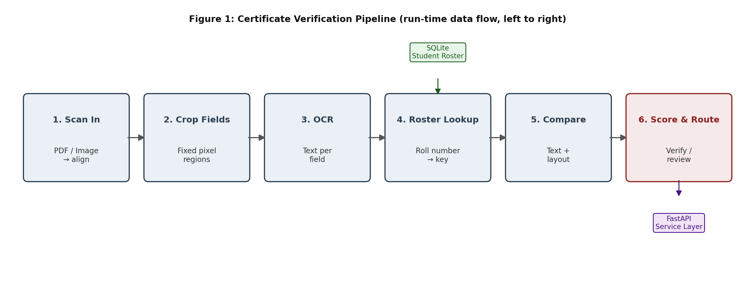
Static text (labels and boilerplate printed by the institute) is checked against fixed pixel coordinates from the reference template. Dynamic text (student-specific fields such as name, roll number, degree, and branch) is checked using the OCR'd line's center position, width, and baseline, since minor shifts are expected depending on text length.

Interfaces and Data Flow
- Input interface: A scanned PDF/image of a certificate enters the pipeline and is aligned to the reference template's coordinate space.
- Roster interface: The Roster Lookup stage queries the SQLite student database using the roll number as the key, retrieving the authoritative record to compare against.
- Comparison interface: The Compare stage receives OCR output plus layout coordinates and dispatches each field to the matching strategy appropriate for its type (Section 5).
- Output interface: The Score & Route stage exposes a verification decision (auto-verified or sent to review) via the FastAPI service layer, along with per-field confidence scores.

4. Major Modules and Communication
The pipeline is organized into modules that each own one stage of verification. Data passes between them as structured records (cropped images, OCR text, coordinates, and scores), keeping each module independently testable.
Module | Responsibility | Communicates With
Alignment Module (OpenCV) | Aligns the scanned certificate to the reference template's coordinate space. | Sends aligned image → Field Cropping Module
Field Cropping Module (OpenCV) | Crops fixed pixel regions corresponding to each field (name, roll no., degree, branch, layout markers). | Sends cropped regions → OCR Module
OCR Module (Tesseract) | Extracts text per field, in both English and Hindi where applicable. | Sends extracted text + coordinates → Comparison Module
Roster Module (SQLite) | Looks up the authoritative student record using the roll number extracted by OCR. | Sends reference record → Comparison Module
Comparison Module (RapidFuzz + rules) | Applies the field-specific matcher (exact, fuzzy, vocabulary, or coordinate check) to each field. | Sends per-field results → Scoring Module
Scoring & Routing Module | Aggregates field-level results into a confidence score and applies critical-field override rules. | Sends decision → API / Review Queue
API Layer (FastAPI) | Exposes the pipeline as a service and returns the verification decision with supporting evidence. | Serves results → Staff Review UI / calling systems

Verification Strategies by Field Type
Strategy | Applies To | Description
Exact Match | Roll No. / Date | Character-for-character match; no tolerance, since a small change means a different student.
Fuzzy Match | English / Hindi Name | RapidFuzz similarity scoring tolerates minor OCR noise while still flagging genuine mismatches.
Vocabulary Match | Degree / Branch | OCR output is matched against a small, fixed list of valid degree and branch names.
Coordinate Check | Layout / Indentation | Compares pixel-level position, center, and width of each text line against the reference template.

5. How the Structure Satisfies the Requirements
Each design decision maps directly to one or more of the requirements in Section 2:
- Modular, staged pipeline (Section 3 & 4) → Extensibility and Auditability. Because Alignment, Cropping, OCR, Roster Lookup, Comparison, and Scoring are separate modules communicating through well-defined data, a new field type or certificate template can be added by extending one module, and every stage's output is logged for later audit.
- Field-specific matchers (Section 4) → Functionality and Robustness. Exact, fuzzy, vocabulary, and coordinate checks each target the failure mode most likely for that field type, so the system handles bilingual names, categorical fields, and identifiers correctly instead of forcing one comparison method onto all of them.
- Static vs. dynamic coordinate checks (Section 1 & 3) → Security. Verifying layout independently of OCR text means an attacker who edits the text but not the surrounding layout geometry — or vice versa — is still caught, directly addressing the tampering threat model.
- Confidence scoring with critical-field overrides (Section 4) → Reliability. A high aggregate score cannot hide a critical mismatch (e.g. roll number matches but degree is wrong), which keeps the system from confidently approving a tampered certificate.
- Auto-verify / staff-review split (Section 3) → Scalability without sacrificing accuracy. Confident, unambiguous cases are cleared automatically, so staff effort is concentrated only on genuinely uncertain cases, letting the process scale to institute-wide volumes.

Future Work
- Watermark, seal, and signature verification using image similarity (SSIM), extending tamper detection beyond text and layout.
- Automated certificate generation directly from the verified template and student data.
- Authentication and audit logging for the staff review workflow.
Human review stays in the loop for uncertain cases — the system is designed to assist staff, not replace them.

