**Process Design Document**

**Care-ECHS OP**

|  |  |  |
| --- | --- | --- |
| **SN.No** | **Content** | **Page.No** |
| **1** | **Introduction** | **1** |
|  | 1.1. Summary | 1 |
|  | 1.2 Objective | 1 |
|  | 1.3 Scope | 1 |
| **2** | **Process Description** | **1** |
|  | 2.1 Process Overview | 1 |
|  | 2.2 Detailed Process Map | 2 |
|  | 2.3 Detailed Process | 3 |
|
|  | 2.4 Exception Handling | 5 |

1. **Introduction**

**1.1 Summary**

The Ex-Servicemen Contributory Health Scheme (ECHS) Out-Patient Automation process aims to streamline patient services for ex-servicemen and their dependents. This automation typically involves digitizing, Classifies, Extracts and automating various steps within the patient management workflow to enhance efficiency and reduce manual intervention.

**1.2 Objective**

The ECHS Outpatient Automation process is to streamline and enhance the efficiency of outpatient data management by leveraging UiPath's automation capabilities. This process aims to

* **Automate Data Extraction**
* Improve Data Accuracy
* Enable Seamless Portal Integration
* Reduce Processing Time
* Enhance Data Security and Compliance

This automation ultimately supports the ECHS system by optimizing data workflows, improving accuracy, and freeing up resources for higher-value tasks.

**1.3 Scope**

The ECHS Outpatient Automation process includes the following components:

* **Document Understanding and Data Extraction**
* Machine Learning Skill
* Web Portal Automation
* Data Upload and Validation
* Error Handling and Exception Management
* Security and Compliance
* Testing and Validation

All stages of the outpatient record management workflow, from data extraction in PDFs to secure data uploads to the ECHS portal, ensuring an accurate, compliant, and efficient automated process.

1. **Process Description**
   1. **Process overview**

General information about the process selected for RPA implementation

|  |  |
| --- | --- |
| **ECHS Out Patient Details** | |
| Process full name | Ex-Servicemen Contributory Health Scheme (ECHS) Out-Patient |
| Function | Document Uploading |
| Department | Insurance |
| Process description | Ex-Servicemen Contributory Health Scheme Out-Patient, automating the process of uploading the relevant documents to the ECHS Portal |
| Process Schedule | Daily |
| Input Data | Client Data |
| Output Data | Status of the Uploaded Pdf's. |

The ECHS Out Patient Automation process involves the following steps to streamline the out patient data management

* **Document Collection and Preparation**
* Data Extraction Using Document Understanding
* **Data Validation and Correction**
* Web Portal Login and Navigation
* **Data Upload to ECHS Portal**
* **Error Handling and Exception Management**
* **Logging and Reporting**

By automating these steps, the process significantly reduces manual effort, enhances data accuracy, and speeds up the handling of outpatient records for the ECHS system

* 1. **Detailed Process Map**

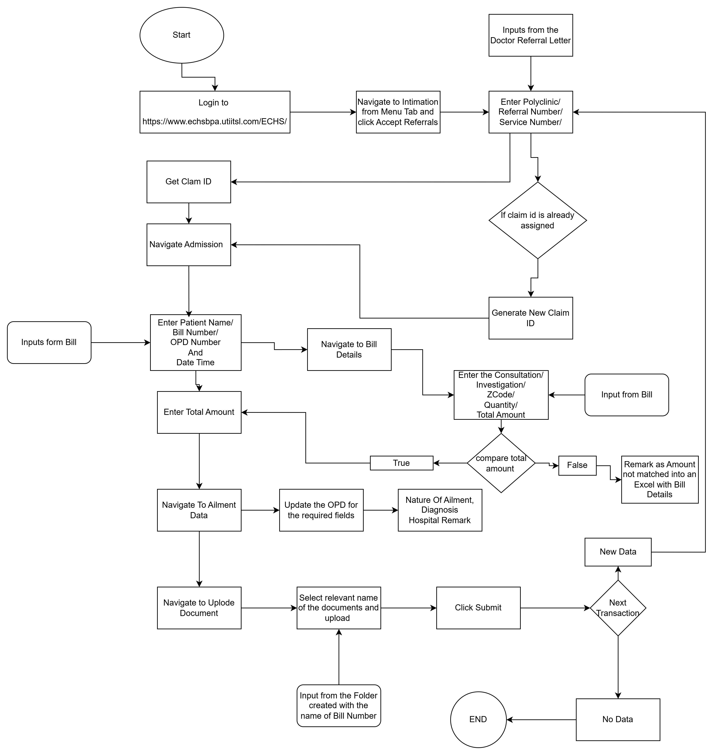

* 1. **Detailed Process**

The complete steps in the process, including Keystrokes and clicks are to be defined with screen shorts. If any data restrictions, mask the sensitive information.

|  |  |  |  |  |
| --- | --- | --- | --- | --- |
| **SN.No** | **Steps**  **/Actions** | **Screenshot** | **Expected Result** | **Remark** |
| **1.1** | Open echsbpa.utiitsl portal |  | Display of Web-page | Handle Exception is web app is not available |
| **1.2** | Login to the portal  With the username, password and Captach |  | Access to the Dashboard | Handle exception if the credentials are incorrect |
| **1.3** | Click the check box for everytime and Navigate to the information menu and click on Accept Referrals |  | Navigate to the Patient Referral Page |  |
| **1.4** | Give all the corresponding inputs and click on search |  | Navigated to Referral Conformation |  |
| **1.5** | Click Yes radio button to conform the patient is belongs to own hospital and click on submit |  | Conformation Notice Window |  |
| **1.6** | Copy the clam ID which is shown in the Window and click on close |  | Popup Window closed |  |
| **1.7** | Navigate to admission and enter the details of OP Date/ Time, OPD Number |  | Claim Submission for Out-Patient |  |
| **1.8** | Navigate to Bills and enter the Bill number and Date and click on the Expenses and Add Consultation and Investigation |  | Pop-up Window to enter the Expenses for the patient |  |
| **1.9** | Compare the total amount with the bill and enter the total amount in the Claim Amount Field |  | Claim Submission for Out-Patient |  |
| **1.10** | Navigate to Ailment Details and enter the Nature of Ailment, Diagnosis and Hospital Remark as OPD |  | Claim Submission for Out-Patient |  |
| **1.11** | Navigate to Uplode Documment’s and select the file name and uplode the revelent document and submit form |  | Upload Documents Claim Submission for Out-Patient |  |
| **1.12** | Continue with the next documment |  |  |  |

* 1. **Exceptions Handling**

|  |  |  |  |
| --- | --- | --- | --- |
| **SN.No** | **Exception Name** | **Step where exception encountered** | **Exception Handling** |
| **1** | Incorrect Email or Password | If message for the incorrect Username and Password and Captcha | If the login validation failed for the first time, it need ‘s to be tried for only 2 times only and send a mail to the respective user |
| **2** | No new data |  | Stop Process |