

**FTP Server Functional Requirements**

**Group-3 (Sprint 2)**

**Table of content**

|  |  |  |  |
| --- | --- | --- | --- |
| **S.No** |  | **Description** | **Page No** |
| **1** |  | **Introduction** |  |
| **2** |  | **Detailed System Design** |  |
|  | **2.1** | Flow chart of server.c |  |
|  | **2.2** | Flow chart of cient.c |  |
| **3** |  | **Environment Description** |  |
|  | **3.1** | Time zone support |  |
|  | **3.2** | Language Support |  |
|  | **3.3** | User Desktop Requirements |  |
|  | **3.4** | Server side requirements |  |
|  | **3.5** | Integration Requirements |  |
|  | **3.6** | Network |  |
|  | **3.7** | Configuration |  |
|  | **3.8** | Operating System |  |
|  | **3.9** | Minimum Standard Configuration. |  |

**Chapter 1: Introduction.**

The introduction of the software requirement specification provides an overview of the entire Software. The entire SRS with overview description purpose, scope, tools used and basic description. The aim of this document is to gather, analyse and give an in-depth insight into the FTP Server Functional Requirements by defining the problem statement in detail. The detailed requirements of the application are provided in this document.

**1.1 Project Purpose:**

The purpose of this project is to build and server client application which handles multiple clients. Where authorised clients can browse, update and download the files from server and anonymous clients can only upload the file to server.

**1.2 Intended Audience**

This document is intended to be read by the client.

**1.3 In Scope**

Server can handle multiple client and depending upon their accessibility they can perform browse, upload and download file.

**1.4 Assumptions, Dependencies and Constraints**.

Operating systems: It is made for Linux Operating system.

End-user: Must have valid User ID to login.

**Chapter 2: Detailed System Design**

**Flow Diagram:**

**Server side:**

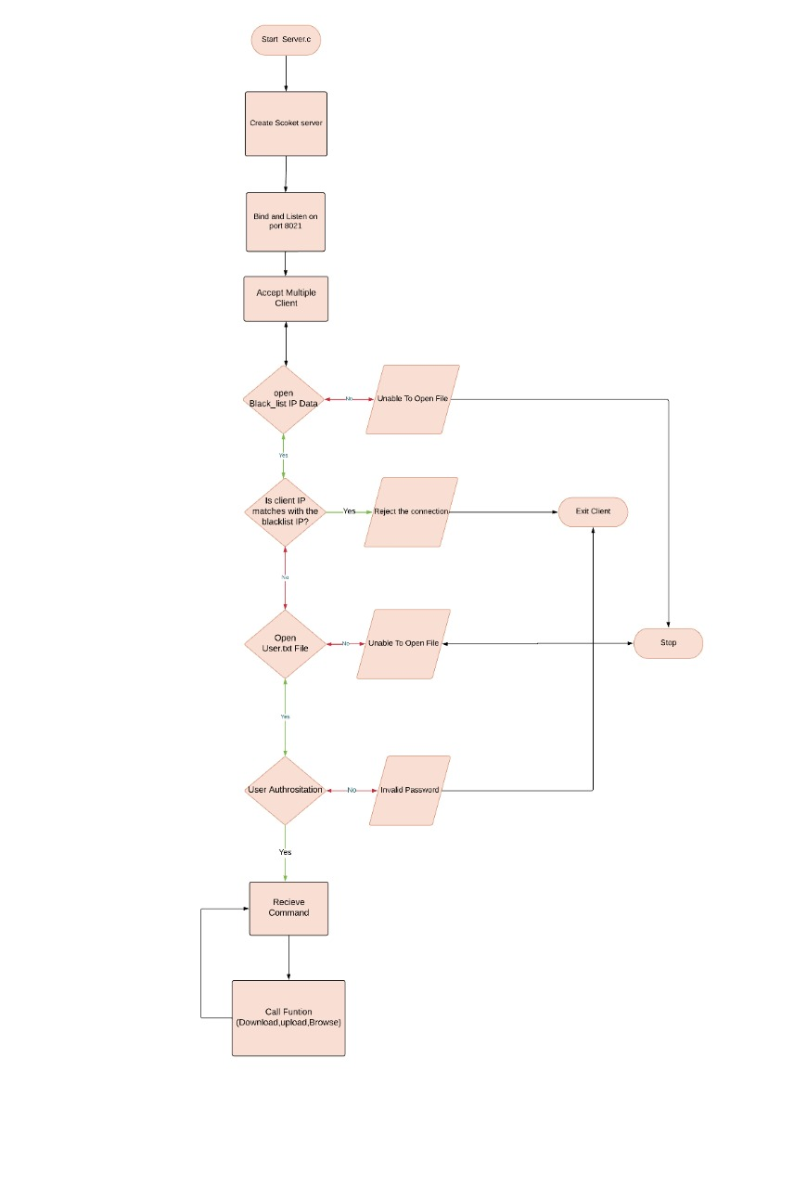

**Client side:**

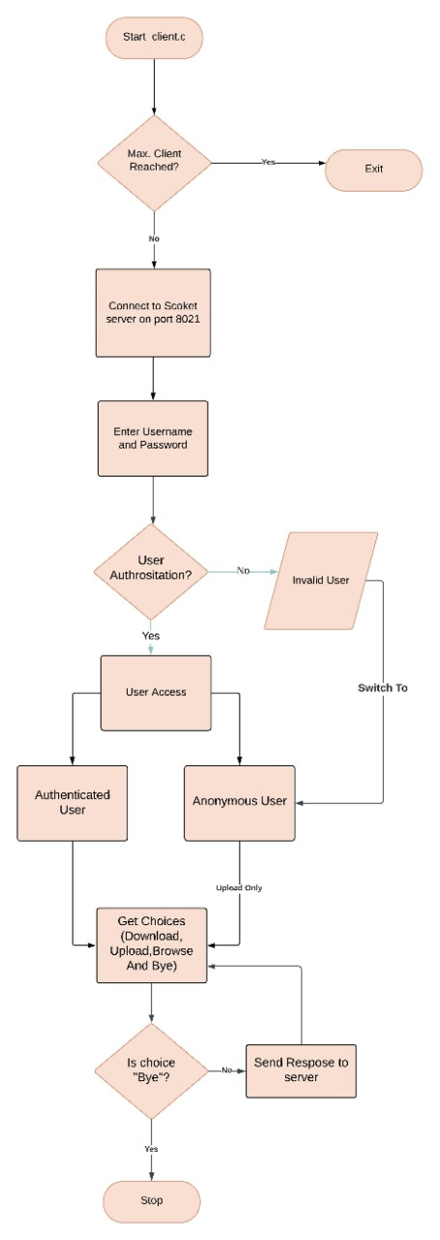

**Chapter 3: Environment Description**

They are set or reset each time a shell is started. From the system-management point of view, it is important to ensure the user is set up with the correct values at log in. Most of these variables are set during system initialization. Windows uses environment variables to store valuable information about system processes, resource usage, file path, and more.

## 3.1 Time Zone Support

The time functions access and reformat the current system date and time. You do not need to specify any special flag to the compiler to use the time functions. Include the header file for these functions in the program.

## 

## 3.2 Language Support

English is only supported language.

**3.3 User Desktop Requirements**

* **Operating systems**: Windows 10/11, Windows 8.1, Windows Server 2019, Windows Server 2016, Windows Server 2012 R2
* **CPU**: 1vCPU with 1 GHz or faster processor
* **RAM**: 1024 MB
* **Hard drive**: 100 MB or more.
* **Video**: DirectX 9 or later with WDDM 1.0 driver

## 

## 3.4 Server-Side Requirements

server-side code has full access to the server operating system and the developer can choose what programming language (and specific version) they wish to use. Developers typically write their code using web frameworks.

### 3.5 Integration Requirements

system integration involves both the integration of components and the integration of functions. High-level functions can be obtained by integrating components into a comprehensive working system instead of individual disconnected subsystems

### 3.6 Network

As a cloud SaaS application, Oracle Fusion Cloud Warehouse Management, formerly Log Fire, is accessed over the internet. Adequate bandwidth is required to provide a responsive experience. Bandwidth requirements vary based on the volume at a client site. Bandwidth is not the only determining factor for application responsiveness.

## 3.7 Configuration

Only configurations that directly apply for use with Configuration Manager are included here.

### 3.8 Operating System

Operating system management is the task of an individual who is usually referred to, in UNIX literature, as the system administrator. Unfortunately, only a few system administrator activities are straightforward enough to be correctly called administration. This and related guides are intended to help system administrators with their numerous duties.

This operating system provides its own version of system-management support in order to promote ease of use and to improve security and integrity.

In most cases, running 32-bit applications on 64-bit hardware is not a problem, because 64-bit hardware can run both 64-bit and 32-bit software. However, 32-bit hardware cannot run 64-bit software.

**3.9 Minimum Standard Configuration**

* Intel i5 or equivalent AMD processor
* 8 GB RAM minimum
* 500 GB solid state (SSD) hard drive minimum
* Web camera
* Network: 10/100/1000 BASE-T Ethernet
* Wireless: 802.11 g/n dual band (2.4/5.0 GHz)
* Laptop Security Cable Lock (highly recommended for resident students)
* Windows 10 Professional / MacOS