CS-374-NLP
SKIP-GRAM-MODEL
ROLL NO-423135
NAME- HARSHITH SUDA

CODE:

OUTPUT:

COSINE SIMILARITY-1:

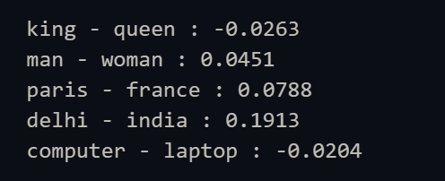

ANALOGY:
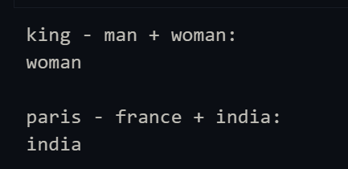

COSINE SIMILARITY-2:

