

**School of Computer Science Engineering and Information Systems**

**M.Tech (Integrated) Software Engineering**

**FALL 2024-2025**

**Project Report**

**Automated Solar Alignment System For Electricity Generation**

**SWE 1901 : Technical Answers for Real World Problems (TARP)**

**Offered during FALL 2024-2025**

**(Dr. B.Prabadevi)**

***by***

**HARSHITHA S 21MIS0036**

**HITHAISHINI K 21MIS0041**

**NANDHITHA H 21MIS0107**

**ILLAVARASAN D 21MIS0327**

**SWETHA S A 21MIS0418**

NOVEMBER 2024

**School of Computer Science Engineering and Information Systems**

**M.Tech (Integrated) Software Engineering**

**FALL 2024-2025**

Automated Solar Alignment System For Electricity Generation

**TEAM Number :** **2**

**Team Member(s) with Reg # and Name :**

HARSHITHA S ; 21MIS0036 ; 8015279808 ; [harshitha.s2021@vitstudent.ac.in](mailto:harshitha.s2021@vitstudent.ac.in)

HITHAISHINI K ; 21MIS0041 ; 6379739765 ; [hithaishini.2021@vitstudent.ac.in](mailto:hithaishini.2021@vitstudent.ac.in)

NANDHITHA H ; 21MIS0107 ; 9489485208 ; [nandhitha.h2021@vitstudent.ac.in](mailto:nandhitha.h2021@vitstudent.ac.in)

ILLAVARASAN D ; 21MIS0327 ; 9345592133 ; [illavarasan.d2021@vitstudent.ac.in](mailto:illavarasan.d2021@vitstudent.ac.in)

SWETHA S A ; 21MIS0418 ; 9360529032 ; [swetha.sa2021@vitstudent.ac.in](mailto:swetha.sa2021@vitstudent.ac.in)

**Project Title :**  Automated Solar Alignment System For Electricity Generation

**1. Introduction**

* 1. **Background (System Study Details in brief)**

A sun-tracking solar panel system is designed to optimize the amount of sunlight captured by solar panels throughout the day. Unlike stationary solar panels, which are fixed at one angle, sun-tracking systems automatically adjust the position of the panels to face the sun. This increases the efficiency of the solar energy system by ensuring that the panels are exposed to the highest possible amount of sunlight at all times. There are two main types of tracking systems: single-axis and dual-axis trackers. Single-axis trackers move the panel along one axis, typically following the sun’s east-to-west movement, while dual-axis trackers allow for both horizontal and vertical adjustments, following the sun’s position more accurately. The use of sensors, such as Light Dependent Resistors (LDRs), plays a key role in detecting the sun's intensity and sending signals to a microcontroller, which then controls the movement of the solar panels via motors. This technology significantly enhances the performance and energy output of solar panels.

* 1. **Problem Statement**

Conventional stationary solar panels are inefficient as they cannot adapt to the sun's movement, leading to reduced energy capture. A sun-tracking solar panel system addresses this issue by dynamically adjusting the panel's position throughout the day to maximize sunlight exposure. The challenge is to design an effective and cost-efficient tracking system, utilizing components like Light Dependent Resistors (LDRs), Arduino, and servo motors, to enhance solar energy output while ensuring reliability and scalability.

* 1. **Abstract**

The need for renewable energy, particularly solar power, arises from the urgent need to combat climate change caused by excessive fossil fuel use. Current solar panel systems are predominantly fixed, leading to inefficiencies as they cannot track the sun's movement throughout the day, resulting in reduced energy output. To address this limitation, the proposed Solar Tracker system dynamically adjusts the panel’s orientation using Light Dependent Resistors (LDRs) to detect sunlight intensity and an Arduino-controlled servo motor to follow the sun's position. This innovative solution allows a 180-degree rotation, ensuring maximum sunlight capture throughout the day, enhancing energy generation efficiency. The Solar Tracker reduces reliance on fossil fuels, lowers the cost of solar energy systems by eliminating the need for additional panels, and minimizes manual adjustments. By offering an affordable and automated system, it significantly boosts renewable energy adoption while addressing the challenges of climate change and making solar power more accessible and sustainable.

* 1. **SDG goal Alignment Justification**

**Sustainable Development Goal (SDG) 11:** Sustainable Cities and Communities.

* The Solar Tracker system aligns with Sustainable Development Goal (SDG) 11: Sustainable Cities and Communities, which focuses on creating sustainable urban environments by improving energy efficiency and promoting renewable energy use.
* By optimizing solar energy capture, the system enhances the efficiency and affordability of solar power, making it a viable alternative for urban and rural communities.
* This reduces reliance on non-renewable energy sources, lowering greenhouse gas emissions and contributing to climate resilience.
* The automated and cost-effective nature of the Solar Tracker supports energy accessibility, enabling communities to adopt clean energy solutions, thereby fostering sustainability and reducing the environmental impact of energy consumption in cities and communities.

**2. Related Works**

**2.1 Literature Survey (Should be elaborately discussed with its citation)**

**1]** **B. Sujatha, J. S. Kalyani, and K. Priyanka, "Optimization and Performance Evaluation of Single Axis Arduino Solar Tracker," *International Journal on Recent and Innovation Trends in Computing and Communication*, vol. 6, no. 4, Aug. 2019.**

Sujatha et al explores the optimization and performance evaluation of a single-axis Arduino-based solar tracker. The tracker uses Light Dependent Resistors (LDRs) to measure sunlight intensity, sending signals to a microcontroller that adjusts the position of the solar panel using servo motors. Although single-axis tracking improves solar panel efficiency, it is less effective than dual-axis tracking, and adding more LDRs to improve accuracy requires expanding the system size.

**2]** **Al-Saadi, Y. R., Tapou, M. S., Badi, A. A., Abdulla, S., & Diykh, M. (2022). Developing Smart Self Orienting Solar Tracker for Mobile PV Power Generation Systems. *IEEE Access*, 10, 79090-79099.**

Al-Saadi et al. developed a smart self-orienting solar tracker for mobile PV systems, which increases energy efficiency by automatically adjusting the panel's orientation to maximize sunlight exposure. The system reduces manual intervention and improves autonomy, making it ideal for mobile and off-grid applications. However, its high complexity and cost, along with potential reliability concerns and the need for maintenance, may limit its practical use for small-scale or stationary solar systems. Despite these drawbacks, it significantly enhances solar energy harvesting compared to traditional stationary panels.

**3] Yap, K. Y., Sarimuthu, C. R., & Lim, J. M. Y. (2020). Artificial intelligence based MPPT techniques for solar power system: A review. *Journal of Modern Power Systems and Clean Energy*, 8(6), 1043-1059.**

Yap et al. reviewed artificial intelligence-based Maximum Power Point Tracking (MPPT) techniques for solar power systems. They discussed how AI methods, such as neural networks and fuzzy logic, optimize MPPT performance by improving the efficiency of solar energy harvesting. These techniques adapt to changing environmental conditions, offering better tracking accuracy and faster response times compared to traditional methods. However, the complexity and computational demand of AI-based methods can increase the system's cost and power consumption, which may limit their application in small-scale solar installations.

**4] Shrivastava, P., Gupta, P., Chaubey, R. K., & Jain, R. (2020). Design and Development of Sun Tracking Solar Panel with Implementation in Irrigation System using IoT. *International Journal of Advanced Research in Computer Science and Electronics Engineering*, 9(5), 52-56.**

Shrivastava et al. designed a sun-tracking solar panel integrated with IoT for irrigation systems. The system uses solar tracking technology to ensure optimal sunlight exposure, improving energy efficiency. IoT integration allows remote monitoring and control, enhancing system performance in agricultural applications. However, the added complexity of IoT increases system cost and maintenance requirements.

**5] Saeedi, M., & Effatnejad, R. (2021). A new design of dual-axis solar tracking system with LDR sensors by using the Wheatstone bridge circuit. *IEEE Sensors Journal*, 21(13), 14915-14922.**

Saeedi and Effatnejad developed a dual-axis solar tracking system using LDR sensors integrated with a Wheatstone bridge circuit. This design improves sunlight detection accuracy, enabling precise alignment of the solar panel with the sun. The dual-axis system enhances energy efficiency by allowing better tracking of the sun’s movement throughout the day, making it more effective than single-axis trackers in optimizing solar power generation.

**6] Wardhana, I., Priyatman, H., & Judiarto, H. (2023). Monitoring System Design of Tracking System on Solar Panel Following the Sun Rotation Based on Internet of Things. *Telecommunications, Computers, and Electricals Engineering Journal (TELECTRICAL)*, 1(1), 63-72.**

Wardhana et al. designed a solar panel tracking system that follows the sun's movement, utilizing the Internet of Things (IoT) for real-time monitoring and control. The system ensures optimal sunlight exposure by adjusting the panel's position throughout the day. With IoT integration, users can remotely monitor and manage the system, enhancing energy efficiency and convenience. This approach improves solar energy generation while reducing manual intervention and maintenance efforts.

**7] Rao, K. Sreenivasa, and M. Mahesh. "ARM based solar tracking system." *International Journal of Modern Engineering Research (IJMER)* 2.4 (2019): 2504-2507.**

Rao et al. developed an ARM-based solar tracking system that optimizes solar panel orientation using sensors to follow the sun's position. This system enhances the efficiency of solar energy collection by automatically adjusting the panel's direction throughout the day. The ARM microcontroller ensures accurate tracking, providing maximum exposure to sunlight for improved energy conversion and generation. The main drawback of the ARM-based solar tracking system is its complexity and higher cost compared to simpler microcontroller-based systems, making it less suitable for small-scale projects.

**8] Rajan, D., & Ramachandran, E. T. (2021). Design and Development of Sun Tracking Solar Panel. *Int. J. Adv. Eng. Manag.*, 3, 1343-1357.**

Rajan et al. developed a sun tracking solar panel system aimed at improving solar energy efficiency. The system adjusts the position of the solar panel to always face the sun, thereby maximizing energy capture throughout the day. Their design enhances the performance of solar panels by minimizing energy loss due to misalignment and ensuring optimal exposure to sunlight. The study emphasizes the significance of effective sun tracking in solar energy systems.

**9] Bala, D., Waliullah, G. M., Hossain, M. S., Abdullah, M. I., & Hossain, M. A. (2021). Design and Implementation of Low Cost Dual Axis Solar Tracking System using Microcontroller. *IITM Journal of Management and IT*, 12(1), 88-92.**

Bala et al. designed and implemented a low-cost dual-axis solar tracking system using a microcontroller. The system allows solar panels to track the sun's movement both horizontally and vertically, ensuring maximum sunlight exposure throughout the day. By using a microcontroller, the system becomes cost-effective while improving energy efficiency compared to fixed or single-axis tracking systems. This dual-axis approach significantly enhances the energy capture and output of solar panels.

**10] Bano, U. S., Shah, S. I. A., & Abro, A. A. (2022). Sun Tracking and Control Design for PV Solar Energy System. *International Journal of Innovative Science and Technology*, 77-93.**

Bano, Shah, and Abro (2022) designed a sun tracking and control system for photovoltaic (PV) solar energy systems. Their approach optimizes the alignment of solar panels to the sun's position, enhancing energy efficiency. By incorporating an automated tracking system, the design ensures maximum sunlight capture, improving the overall performance and energy generation of the PV system. The study highlights the importance of precise tracking for better utilization of solar energy.

**11] Chowdhury, M. E., Khandakar, A., Hossain, B., & Abouhasera, R. (2019). A Low-Cost Closed-Loop Solar Tracking System Based on the Sun Position Algorithm. *Journal of Sensors*, 2019(1), 3681031.**

Chowdhury et al. proposed a low-cost, closed-loop solar tracking system that uses the Sun Position Algorithm (SPA) to track the sun's movement. This system improves solar energy collection by adjusting the panel’s position based on the sun’s exact location throughout the day. The approach aims to optimize solar energy harvesting, reduce costs, and increase efficiency, making it a practical solution for sustainable solar power generation.

**12] Deshmukh, A., et al. "Automated Dual Axis Sun Tracking Solar Panels based on LDR and RTC Sensor." *International Journal of Engineering Research & Technology (IJERT)*, vol. 10, no. 04, 2021.**

Deshmukh et al. (2021) developed an automated dual-axis sun tracking solar panel system that utilizes Light Dependent Resistors (LDRs) and an RTC (Real-Time Clock) sensor. The system adjusts the panel's orientation in two axes to track the sun's movement accurately, improving energy capture throughout the day. This dual-axis tracking offers enhanced efficiency compared to single-axis systems by optimizing the solar panel’s exposure to sunlight.

**13] Haris, A., Wahjuni, S., Sukoco, H., Rahmawan, H., Neyman, S. N., Sikumbang, H., & Elly, M. J. "Technology Sun Tracking System for Solar Power Plants Based on Recurrent Neural Networks." In *International Seminar of Science and Applied Technology (ISSAT 2020)*, pp. 223-226, December 2020. Atlantis Press.**

Haris et al. introduced a sun tracking system for solar power plants using recurrent neural networks (RNNs) to predict the sun’s position and adjust the panel accordingly, improving energy efficiency. While it enhances solar power generation by ensuring more accurate tracking, it is complex to implement and may require significant computational resources for the neural network’s operation.

**14]** **Pardosi, C. H., Siregar, M., & Pandjaitan, L. W. (2024). Design and Implementation of A Dual-Axis Solar Tracking System using Arduino Uno Microcontroller. *Jurnal ELTIKOM: Jurnal Teknik Elektro, Teknologi Informasi dan Komputer*, 8(1), 44-56.**

Pardosi et al. designed and implemented a dual-axis solar tracking system using an Arduino Uno microcontroller to enhance solar energy collection efficiency. This system adjusts the solar panel's orientation on both horizontal and vertical axes, following the sun's movement throughout the day. The dual-axis tracking ensures that the solar panel is always positioned optimally, capturing maximum sunlight. However, the system's complexity is higher compared to single-axis trackers, and the need for more components can increase the cost and maintenance requirements.

**15] Preethi, G., Lavanya, D., Sreesureya, V., & Boopathimanikandan, S. (2019). Real-time monitoring and controlling of solar panel using LabVIEW. *International Journal of Scientific & Technology Research*, 8(08).**

Preethi et al. developed a real-time monitoring and controlling system for solar panels using LabVIEW software. The system allows users to monitor solar panel performance and make adjustments remotely, improving efficiency and ensuring optimal power generation. However, the reliance on LabVIEW may limit accessibility for users without prior experience in the software. But, the setup can be expensive and may require specialized hardware for seamless integration with solar systems.

**16] Parashar, S., & Tripathi, S. K. (2021). A Review on Solar Tracking System. *International Journal of Innovative Research in Engineering & Management*, 8(6), 366-369.**

Parashar et al. provide a comprehensive review of solar tracking systems, discussing various types like single-axis and dual-axis trackers. They emphasize the advantages of tracking systems in maximizing solar energy collection by adjusting the panel’s orientation to the sun's position. However, they also highlight challenges such as increased complexity, cost, and maintenance needs for these systems. The review offers valuable insights into how these systems can improve solar energy efficiency.

**17] Neagoe, M., & Burduhos, B. (2021). Comparative Performance Analysis of Solar Tracking System Types at Different Latitudes. *Journal of Solar Energy Research Updates*, 8, 1-10.**

Neagoe et al. analyze and compare the performance of different solar tracking systems (single-axis, dual-axis) at varying latitudes. They discuss how the efficiency of tracking systems changes depending on geographic location and the sun’s angle, helping determine the most effective tracking solution for specific regions. The study concludes that dual-axis trackers are more efficient at higher latitudes, though their complexity and cost can be limiting factors.

**18] Mamodiya, Udit, and Neeraj Tiwari. "Dual-axis solar tracking system with different control strategies for improved energy efficiency." *Computers and Electrical Engineering*, 111 (2023): 10892.**

Mamodiya and Tiwari explore a dual-axis solar tracking system with various control strategies aimed at improving energy efficiency. Their research examines how different control methods, such as adaptive or fuzzy logic-based controllers, affect the system's ability to track the sun and maximize solar energy capture. The study demonstrates that these strategies significantly enhance the system’s performance, leading to higher energy output compared to traditional fixed or single-axis systems. However, the added complexity of the dual-axis system may lead to higher costs and maintenance requirements.

**19] Mahesh, P. V., Meyyappan, S., & Alla, R. "Maximum power point tracking with regression machine learning algorithms for solar PV systems." *International Journal of Renewable Energy Research*, 12(3), 1327-1338.**

Mahesh et al. discuss the use of regression-based machine learning algorithms to improve the Maximum Power Point Tracking (MPPT) for solar photovoltaic (PV) systems. The authors propose an innovative approach to track the maximum power point more accurately and efficiently than traditional methods. By integrating machine learning, the system adapts to varying environmental conditions like temperature and light intensity, which enhances energy output. However, the complexity of implementing machine learning algorithms and the requirement for computational resources could be a challenge in some applications, especially for small-scale or low-budget projects.

**20] Kumar, K., Varshney, L., Ambikapathy, A., Ali, I., Rajput, A., Bhatnagar, A., & Omar, S. "Vision based solar tracking system for efficient energy harvesting." *International Journal of Power Electronics and Drive Systems*, 12(3), 1431.**

Kumar et al. present a vision-based solar tracking system aimed at enhancing energy harvesting from solar panels. The system uses computer vision techniques to track the sun's position and adjust the panel's orientation accordingly, ensuring maximum exposure to sunlight. The authors emphasize its ability to improve solar power generation efficiency in real-time. However, the reliance on vision sensors might lead to challenges in low-light conditions, and the computational requirements for image processing can increase system complexity.

**2.2 Comparative statement (Tabulation) and Research gap Summary**

|  |  |  |
| --- | --- | --- |
| **Title** | **Objective** | **Key Techniques** |
| 1. Real-Time Monitoring and Controlling of Solar Panel Using LabVIEW | Monitor and control solar panel position in real time based on sun's position | LabVIEW GUI, Arduino-Stepper motor interface, LDR sensors |
| 2. Optimization and Performance Evaluation of Single Axis Arduino Solar Tracker | Maximize solar panel exposure and optimize power generation | Single-axis tracking with LDR sensors and servo motor control |
| 3. AI-Based MPPT Techniques for Solar Power System: A Review | Assess AI-based Maximum Power Point Tracking (MPPT) techniques | AI methods (Fuzzy Logic, ANN, Genetic Algorithms, ML) |
| 4. Technology Sun Tracking System Using Recurrent Neural Networks | Enhance solar panel tracking efficiency using RNNs | Recurrent Neural Networks (RNNs), varying weather conditions |
| 5. ARM-Based Solar Tracking System | Improve solar energy capture with an ARM-controlled solar tracker | ARM7TDMI processor, sensor input, control of panel position |
| 6. Smart Single-Axis Solar Tracking Device | Improve solar tracking efficiency with a low-cost single-axis tracker | Arduino microcontroller, low-cost components |
| 7. Dual Axis Solar Tracking Systems | Analyze dual-axis solar tracking improvements over two decades | Dual-axis trackers, efficiency trajectory and functional models |
| 8. MPPT with Regression Machine Learning Algorithms for Solar PV Systems | Optimize PV panel performance with machine learning predictions | Machine learning, Matlab/Simulink, boost converter adjustment |
| 9. Dual-Axis Solar Tracking System Using Arduino Uno | Increase photovoltaic efficiency with a dual-axis tracker | Arduino Uno, LDR sensors, stepper motors |
| 10. IoT-Based Monitoring System for Solar Panel Tracking | Use IoT for dynamic solar panel monitoring and energy maximization | IoT technology, ambient light sensors, cloud-based monitoring |
| 11. IoT-Powered Solar Tracker for Irrigation Systems | Integrate solar tracking with IoT for sustainable agriculture | IoT, motorized tracker, real-time monitoring |
| 12. Low-Cost Dual Axis Solar Tracker with Arduino | Maximize solar energy with a budget-friendly dual-axis tracker | Arduino UNO, LDRs, servo motors, analog-digital conversion |
| 13. Review on Solar Tracking Systems | Compare various solar tracking systems and effectiveness | Dual-axis and single-axis comparisons, efficiency analysis |
| 14. Comparative Performance Analysis at Different Latitudes | Examine solar tracking efficiency at different latitudes | Single and dual-axis tracking, numerical simulations |
| 15. Low-Cost Closed-Loop Solar Tracking Based on Sun Position | Maximize solar energy via sun position algorithms | Astronomical Almanac Algorithm (AA), 8-bit microcontroller |
| 16. Smart Self-Orienting Solar Tracker for Mobile PV | Develop mobile solar tracker for energy optimization | GPS, digital compass, gyro orientation sensor, microcontroller |
| 17. Dual-Axis Tracker Using Wheatstone Bridge Circuit | Ensure optimal PV panel alignment with LDRs and Wheatstone bridge | LDR sensors, Wheatstone bridge, manual and auto modes |
| 18. Sun Tracking Solar Panel with PILOT System | Maximize energy with microcontroller-controlled tracking | Microcontroller, LDRs, light-to-frequency converter |
| 19. Sun Tracking and Control Design for PV Systems | Enhance PV system efficiency with sun tracking | LDRs, PV sensors, Arduino UNO, shadow casting technique |
| 20. Vision-Based Solar Tracking for Energy Efficiency | Maximize solar energy using image processing for tracking | LDR sensors, digital image processing, microcontroller |

**Research Gap Summary**

1. Limited Environmental Adaptability: Many systems are not adaptable to varying environmental conditions, such as cloudy or low-light settings, which impacts efficiency. Future research could focus on enhancing sensor sensitivity to improve performance in diverse conditions.
2. High Dependency on Specific Geographies: Several studies found that solar tracking effectiveness was location-sensitive. Incorporating GPS and adaptive algorithms for automatic recalibration based on location could be beneficial.
3. Scalability Challenges: A number of tracking systems were tested on isolated PV panels, lacking experimental validation on larger systems. Further studies are needed to assess scalability and performance of these methods for large-scale applications.
4. Cost-Effectiveness and Accessibility: High costs related to dual-axis systems, IoT integration, and AI implementation limit their adoption, especially in remote areas. More affordable, sustainable solutions could help make these systems viable for small-scale or remote users.
5. Sensor Limitations: LDRs and PV sensors are often hindered by sensitivity issues, particularly in tracking accuracy during low-light periods. Research could explore alternative sensor technologies or hybrid tracking methods, such as combining LDRs with image processing, to improve accuracy and resilience.
6. Energy Consumption of Tracking Systems: Some systems, while effective, consume considerable energy. Methods to optimize power usage in tracking, such as incorporating low-power controllers and energy recycling modules, could increase net energy output.
7. Integration of Smart and AI-based Tracking Systems: Although AI has proven to enhance tracking precision, many AI-based models lack real-world testing. Future research should aim to bridge the gap between simulation and experimental verification for AI-driven solar tracking systems.

**2.3 Hardware Requirements**

* **Arduino UNO**: The main microcontroller board for programming and controlling the components.
* **Light Dependent Resistors (LDRs)**: Used as light sensors to detect the position of the sun.
* **Servo Motors**: Controls the movement of the solar panel by rotating it based on the light intensity detected by the LDRs.
* **Solar Panel**: The primary component that needs to track the sun for optimal energy generation.
* **Resistors**: Used to adjust the sensitivity of the LDRs.
* **Jumper Wires**: Connects the components to the Arduino board.
* **Breadboard (optional)**: To simplify connections and avoid soldering.

**2.4 Software Requirements**

* **Arduino IDE**: Used to write, compile, and upload the code to the Arduino UNO.
* **Servo Library**: A built-in Arduino library that enables easy control of the servo motors, which is crucial for moving the solar panel in alignment with the sun's position.

**3. System Design**

**3.1 High-Level Design**

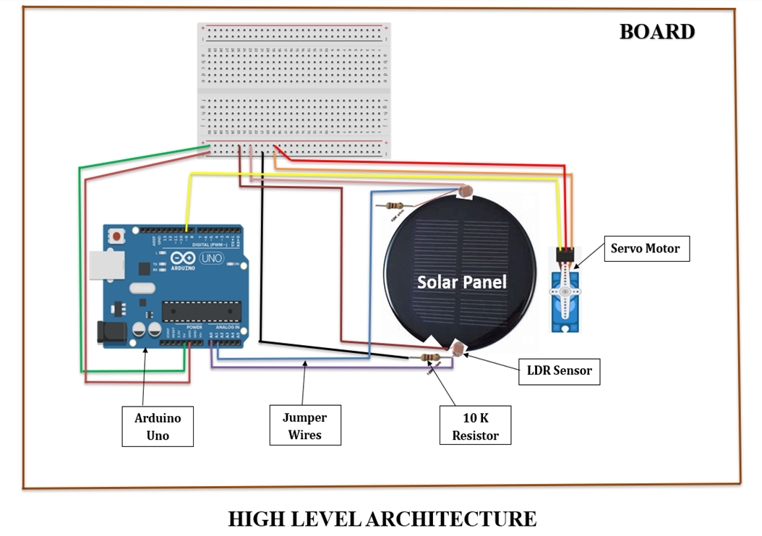

**ARCHITECTURE DESCRIPTION:**

* + **Arduino Uno:** The microcontroller serves as the brain of the system, controlling the movements of the solar panel by processing data from the LDR sensors.
  + **Light Dependent Resistors (LDRs):** Two LDRs are used to detect the sunlight intensity. They are placed on opposite sides of the solar panel to measure the light difference.
  + **10k Resistors:** These resistors are connected to each LDR to limit the current and ensure accurate sensor readings.
  + **Servo Motor:** The motor rotates the solar panel in the direction where the light intensity is strongest. It responds to the signals sent by the Arduino based on LDR data.
  + **Solar Panel:** Mounted on the servo motor, it adjusts its position to maximize sunlight capture for efficient power generation.
  + **Jumper Wires:** Used to connect all the components on the Arduino board, allowing the circuit to function.
  + **Board:** This serves as a base to mount all components, keeping the system stable and organized.

**3.2 Low-Level Design (Detailed design)**

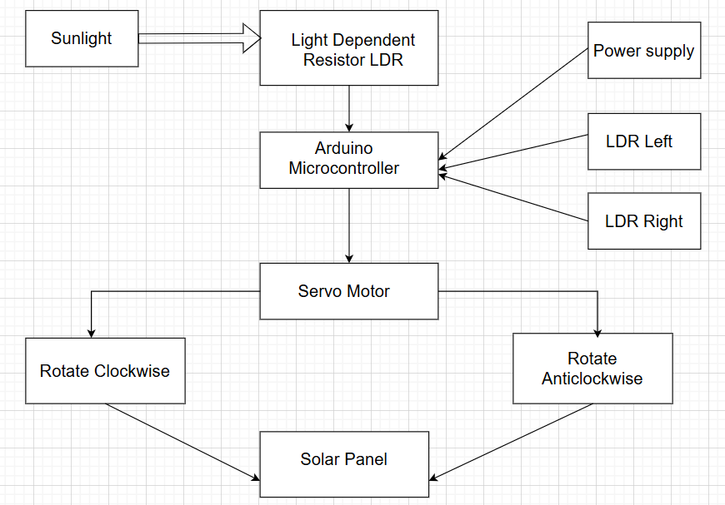

**3.3 Methodology**

# 3.3.1. Components Selection:

1. **Servo Motor:**

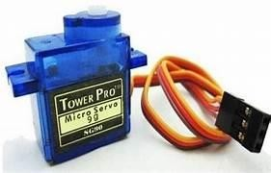

**Functionality:** The Servo motor is used to control the position of the solar panel to cover the whole path of the sun. It will rotate the solar panel depending on the sun's position. Here we are using a 5V servo motor.

# A close-up of a transistor Description automatically generatedLight Dependent Resistor (LDR):

**Functionality:** Two LDRs are used to detect the sunlight intensity. They are placed on opposite sides of the solar panel to measure the light difference.

# Arduino Uno:

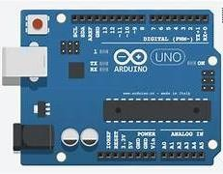

**Functionality:** Arduino will act as a controller. It will collect the light intensity information from LDR and operate the Servo motor to rotate through the sun's direction.

**4.Solar Panel:**

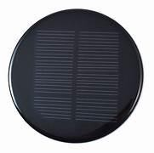

**Functionality:** It is used to collect the sun's solar radiation and convert it into electrical energy. It is also called Photovoltaics.

**5. 10K Resistor:**

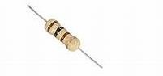

**Functionality:** The resistor will limit the flow of current and it will protect from sudden high voltage current. The function of the Resistor is to decrease the Voltage of the current that passes through the circuit.

# 6. Jumper Wire:

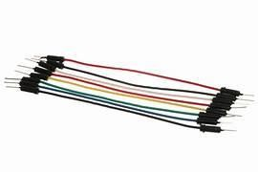

**Functionality:** It is a simple wire used to connect all the components on the Arduino board, allowing the circuit to function.

**3.3.2. Modules of the project**

**Module 1: Sun Tracking System**

**Description: This module tracks the sun's movement using the LDR and adjusts the solar panel's angle accordingly.**

**Components: LDR, 10k Ohm Resistor, Arduino Uno, Servo Motor**

**Functionality: Reads LDR data, calculates optimal panel angle, and adjusts servo motor position**

**Module 2: Servo Motor Control**

**Description: This controls the servo motor to adjust the solar panel's angle.**

**Components: Servo Motor, Arduino Uno**

**Functionality: Receives angle data from sun tracking system drives servo motor to desired position**

**Module 3: Solar Panel Mounting**

**Description: This module provides a sturdy mounting system for the solar panel.**

**Components: MDF Board, Jumper Wires**

**Functionality: Supports and positions the solar panel for optimal energy collection**

**Module 4: Power Supply**

**Description: This module manages power supply to the Arduino and servo motor.**

**Components: Solar Panel, Jumper Wires**

**Functionality: Regulates power supply, monitors voltage and current levels**

**3.3.3. Flowchart and Circuit diagram:**

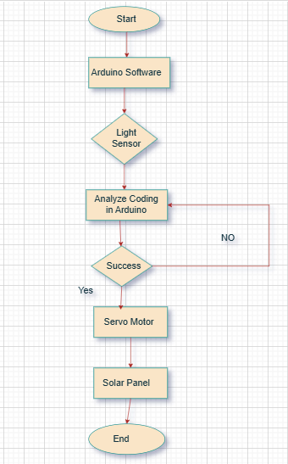

**3.3.4. Algorithm:**

The sun-tracking algorithm follows these steps:

* **Sensor Data Reading**: The microcontroller reads voltage values from the LDRs.
* **Comparison and Decision**: The microcontroller compares the values to determine the direction of maximum sunlight.
* **Motor Control**: Based on the comparison, the microcontroller adjusts the motors to align the panel with the sun.
* **IoT Integration**: Sensor data and panel positions are transmitted to the IoT platform for remote monitoring and analysis.

**4. Results and Discussion**

**4.1 Implementation Code and Results**

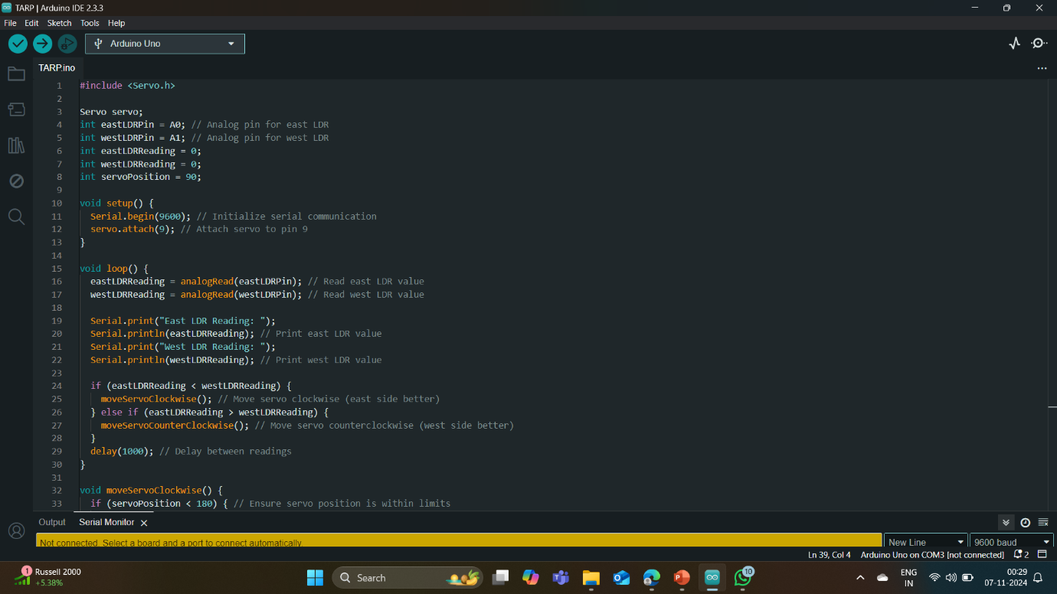

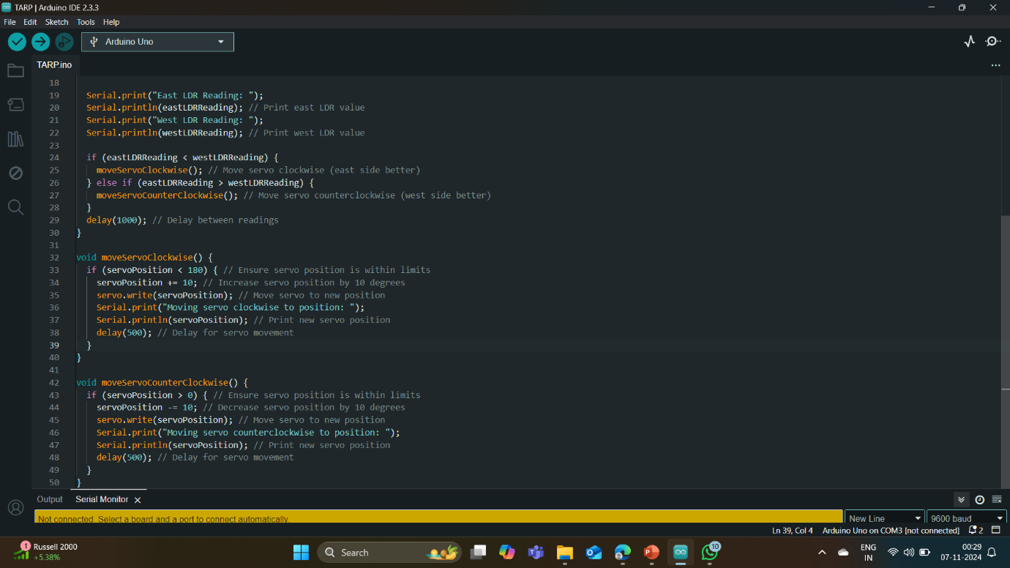

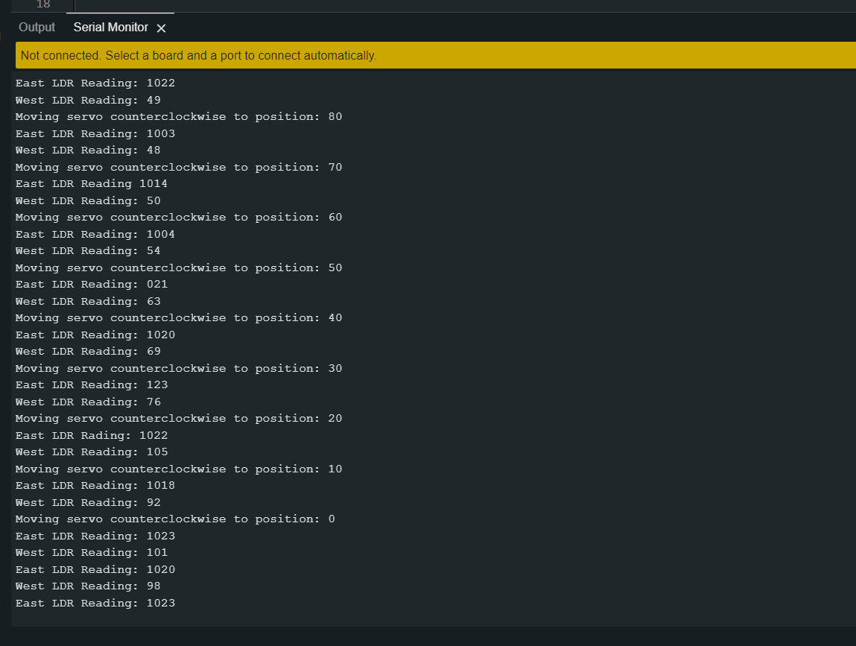

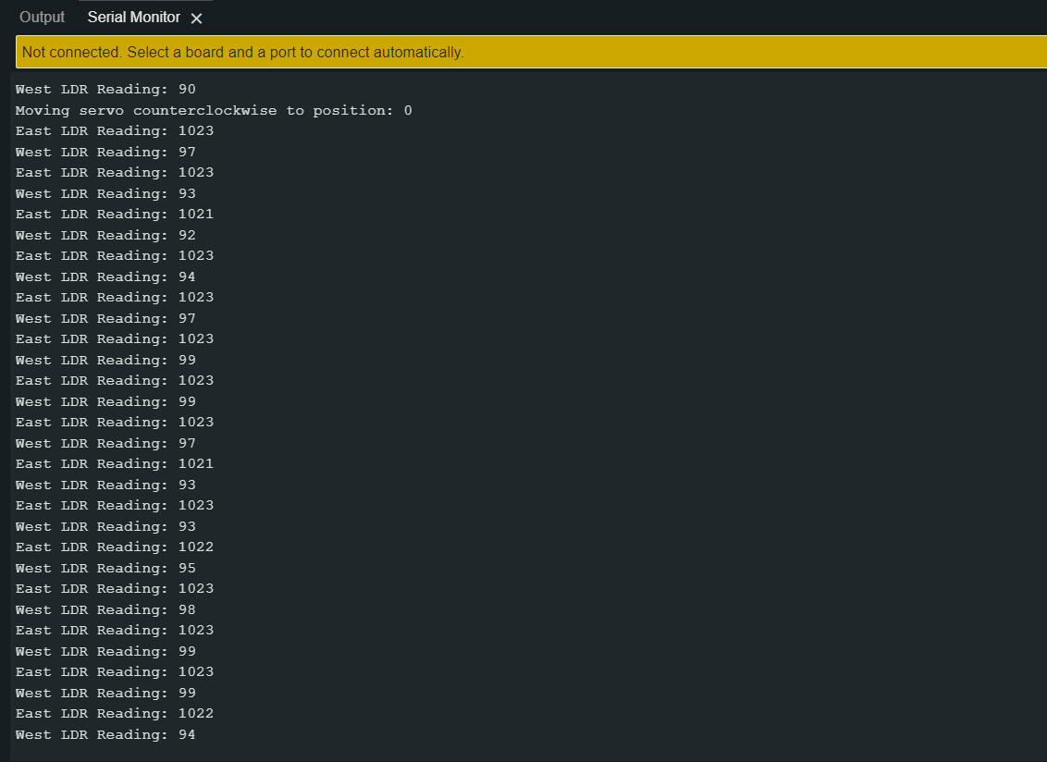

# 4.2 Metrics

# Energy Efficiency (%):

# • Measures how efficiently each system converts solar energy into electricity.

# • Sun-tracking systems often have a higher efficiency since they adjust to maximize sunlight capture.

# Power Output (kWh/day):

# • Indicates the actual electricity generated each day.

# • Since a tracking system follows the sun’s movement, it typically produces more energy than a fixed panel.

# Capacity Factor (%):

# • The capacity factor is the ratio of the actual energy output over a period to the maximum possible energy output if the system operated at full capacity all the time. It measures how effectively a system uses its rated capacity.

# • A fixed system might have a capacity factor of around 20-25%, while a tracking system could reach 30-35%.

# Degradation Rate (% per Year):

# • The annual decrease in energy output as the system ages, often due to wear on panels or mechanical parts.

# • Lower degradation rates lead to a longer effective lifespan and higher long-term power generation.

# • Tracking systems may have a slightly higher degradation rate (e.g., 1% per year) compared to fixed systems (e.g., 0.8% per year) due to additional mechanical wear.

# Shadow Tolerance:

# • The system’s ability to maintain output even when shadows partially cover the panels, affecting land use planning.

# • Systems with high shadow tolerance can be placed in closer proximity, leading to better land utilization, which is critical in large installations.

# Weather Resilience:

# • The ability of the system to withstand adverse weather conditions, such as high winds, hail, or snow.

# • A fixed system might be rated to withstand winds up to 150 km/h, while tracking systems may require additional reinforcements to match this resilience.

# Efficiency under Diffuse Light Conditions (%):

# • The efficiency of each system under cloudy or overcast conditions where direct sunlight is limited.

# • Sun-tracking systems are designed to optimize for direct sunlight, but performance under cloudy conditions may differ.

# • A tracking system might have slightly lower efficiency under diffuse light (e.g., 60%) than a fixed system, which could maintain 65% efficiency in such conditions.

**4.3 Results in table/Graph/Data ( No screenshots, only text form of data in table), Graph should be drawn using Excel or python.**

|  |  |  |  |
| --- | --- | --- | --- |
| **S.NO** | **WEST LDR** | **EAST LDR** | **SERVO POSITION** |
| 1 | 1022 | 49 | 80 |
| 2 | 1003 | 48 | 70 |
| 3 | 1014 | 50 | 60 |
| 4 | 1004 | 54 | 50 |
| 5 | 1021 | 63 | 40 |
| 6 | 1020 | 69 | 30 |
| 7 | 1123 | 76 | 30 |
| 8 | 1022 | 105 | 20 |
| 9 | 1018 | 92 | 10 |
| 10 | 1023 | 101 | 0 |
| 11 | 1020 | 98 | 0 |
| 12 | 1023 | 97 | 0 |
| 13 | 1021 | 93 | 0 |
| 14 | 1023 | 97 | 0 |
| 15 | 1013 | 94 | 0 |

**4.4 Mapping the results with problem statement and existing systems**

| **Key Element** | **Problem Statement** | **Proposed Solution** | **Mapping Outcome** |
| --- | --- | --- | --- |
| **Efficiency Limitation** | Stationary panels cannot adapt to the sun's movement, reducing energy generation. | Dynamic tracking using LDRs and servo motors ensures panels follow the sun throughout the day. | Addresses the core issue of misalignment, resulting in enhanced energy efficiency. |
| **Limited Sunlight Capture** | Panels in fixed positions fail to capture sunlight optimally during the day. | 180-degree tracking maximizes sunlight absorption over a wide range of sun positions. | Solves the limitation of fixed panels by adapting dynamically, ensuring constant alignment with the sun. |
| **Cost Implications** | Reduced energy generation leads to higher costs for additional panels or adjustments. | Enhanced efficiency reduces the number of panels needed and minimizes manual interventions. | Contributes to cost savings, making solar energy systems more affordable. |
| **Renewable Energy Accessibility** | Inefficient systems hinder the wider adoption of solar technology. | Improved performance, lower costs, and user-friendly features make solar power more accessible. | Aligns with the goal of combating climate change by promoting renewable energy adoption. |
| **Existing Systems: Fixed Panels** | Completely stationary; cannot follow the sun. | Real-time adjustments using sensors and motors improve sunlight capture compared to fixed systems. | Provides a significant upgrade over traditional fixed solar panels. |
| **Existing Systems: Single-Axis Trackers** | Partial improvement in sunlight capture but limited range and adaptability. | Offers a wider 180-degree tracking range, surpassing the capability of single-axis systems. | Demonstrates clear advantages in sunlight capture and system flexibility. |

**4.5 Discussions**

This project demonstrates a significant improvement in solar energy utilization by addressing the limitations of stationary and single-axis tracking systems. By dynamically adjusting the solar panel's orientation using LDRs and Arduino-controlled motors, the system ensures optimal sunlight absorption throughout the day, substantially boosting energy efficiency. Its cost-effective design reduces the need for additional panels, making renewable energy systems more accessible and affordable. User-friendly features, such as manual controls and safety mechanisms, combined with durable, enhance reliability and ease of maintenance. Despite challenges like achieving precise sensor calibration and optimizing motor control, the project successfully provides a practical and efficient solution for maximizing solar energy generation.

# 5. Conclusion and Future Development:

# Conclusion

# The sun-tracking solar system offers significant advantages over traditional fixed solar systems in terms of energy efficiency, power output, and environmental impact. By actively following the sun's path, these systems maximize sunlight exposure, increasing energy production and providing a more effective solution for locations with high solar potential. Despite a higher upfront cost and slightly increased maintenance requirements, sun-tracking systems deliver better energy yields and contribute to greater CO₂ reduction, making them a valuable investment for sustainable energy solutions.

# Future Development

# Future advancements in sun-tracking solar systems could focus on the following areas:

# 1. AI-Driven Precision Tracking: Implementing artificial intelligence and machine learning could enhance tracking accuracy by predicting sunlight patterns based on real-time weather data and adjusting panel angles dynamically for optimal efficiency, even in cloudy or low-light conditions.

# 2. Lower-Cost, Durable Materials: Developing cost-effective materials with improved durability could reduce installation and maintenance expenses. New materials that withstand harsh weather and require less frequent upkeep would make these systems more accessible and affordable.

# 3. Integrated Battery Storage: Future systems may integrate high-capacity battery storage to store excess energy generated during peak sunlight hours, improving energy availability during cloudy days or nighttime and creating a more reliable and continuous energy source.

# 4. Enhanced Environmental Resilience: Advanced designs that increase the resilience of tracking systems against extreme weather—such as high winds, hail, or dust could further extend lifespan & reduce downtime, particularly in areas with harsh environmental conditions.

**6. Student Feedback (Student Experience in this Course Project)**

**Each team member can share your learning experience and others**

# Harshitha S (21MIS0036):

# I enjoyed this project as it gave me hands-on experience with Arduino and sensors. I learned how light sensors (LDRs) work and how to make the solar panel follow the sun using a servo motor. It was exciting to see how coding can control physical devices. Working with my team was great, and we shared ideas to solve problems. This project helped me learn more about renewable energy and how technology can improve it.

# Hithaishini K (21MIS0041):

# This project was a good learning experience. I learned how to use the Arduino board and how the solar panel moves based on light detected by the LDRs. I also improved my coding skills while programming the Arduino. The best part was seeing the system work in real life. I enjoyed working with my team and learned a lot from them. Overall, this project taught me a lot about renewable energy and technology.

# Nandhitha H (21MIS0107):

# I really enjoyed working on this project. I learned how to use the Arduino to control the solar panel and move it according to the light intensity. Working with sensors and motors was interesting, and I improved my programming skills. It was also a good chance to learn more about solar energy and how it can be tracked for better performance. The teamwork was very helpful, and I enjoyed solving problems together.

# Illavarasan D (21MIS0327):

# This project gave me a lot of practical experience with Arduino and sensors. I learned how to make the solar panel track the sun using the LDRs and a servo motor. It helped me improve my programming skills and understand renewable energy better. I also got a chance to work with my team, share ideas, and troubleshoot issues together. It was a fun and educational experience, and I learned a lot from it.

# Swetha S A (21MIS0418):

# I learned a lot from this project. I got to work with the Arduino board and understood how to use it for controlling motors. Programming the servo motor to move the solar panel was fun and interesting. I also learned how important teamwork is, as we all worked together to make sure everything worked properly. This project gave me practical knowledge of how solar energy can be used efficiently, and it was a great learning experience.

**7. References**

1] B. Sujatha, J. S. Kalyani, and K. Priyanka, "Optimization and Performance Evaluation of Single Axis Arduino Solar Tracker," *International Journal on Recent and Innovation Trends in Computing and Communication*, vol. 6, no. 4, Aug. 2019.

2] Al-Saadi, Y. R., Tapou, M. S., Badi, A. A., Abdulla, S., & Diykh, M. (2022). Developing Smart Self Orienting Solar Tracker for Mobile PV Power Generation Systems. *IEEE Access*, 10, 79090-79099.

3] Yap, K. Y., Sarimuthu, C. R., & Lim, J. M. Y. (2020). Artificial intelligence based MPPT techniques for solar power system: A review. *Journal of Modern Power Systems and Clean Energy*, 8(6), 1043-1059.

4] Shrivastava, P., Gupta, P., Chaubey, R. K., & Jain, R. (2020). Design and Development of Sun Tracking Solar Panel with Implementation in Irrigation System using IoT. *International Journal of Advanced Research in Computer Science and Electronics Engineering*, 9(5), 52-56.

5] Saeedi, M., & Effatnejad, R. (2021). A new design of dual-axis solar tracking system with LDR sensors by using the Wheatstone bridge circuit. *IEEE Sensors Journal*, 21(13), 14915-14922.

6] Wardhana, I., Priyatman, H., & Judiarto, H. (2023). Monitoring System Design of Tracking System on Solar Panel Following the Sun Rotation Based on Internet of Things. *Telecommunications, Computers, and Electricals Engineering Journal (TELECTRICAL)*, 1(1), 63-72.

7] Rao, K. Sreenivasa, and M. Mahesh. "ARM based solar tracking system." *International Journal of Modern Engineering Research (IJMER)* 2.4 (2019): 2504-2507.

8] Rajan, D., & Ramachandran, E. T. (2021). Design and Development of Sun Tracking Solar Panel. *Int. J. Adv. Eng. Manag.*, 3, 1343-1357.

9] Bala, D., Waliullah, G. M., Hossain, M. S., Abdullah, M. I., & Hossain, M. A. (2021). Design and Implementation of Low Cost Dual Axis Solar Tracking System using Microcontroller. *IITM Journal of Management and IT*, 12(1), 88-92.

10] Bano, U. S., Shah, S. I. A., & Abro, A. A. (2022). Sun Tracking and Control Design for PV Solar Energy System. *International Journal of Innovative Science and Technology*, 77-93.

11] Chowdhury, M. E., Khandakar, A., Hossain, B., & Abouhasera, R. (2019). A Low-Cost Closed-Loop Solar Tracking System Based on the Sun Position Algorithm. *Journal of Sensors*, 2019(1), 3681031.

12] Deshmukh, A., et al. "Automated Dual Axis Sun Tracking Solar Panels based on LDR and RTC Sensor." *International Journal of Engineering Research & Technology (IJERT)*, vol. 10, no. 04, 2021.

13] Haris, A., Wahjuni, S., Sukoco, H., Rahmawan, H., Neyman, S. N., Sikumbang, H., & Elly, M. J. "Technology Sun Tracking System for Solar Power Plants Based on Recurrent Neural Networks." In *International Seminar of Science and Applied Technology (ISSAT 2020)*, pp. 223-226, December 2020. Atlantis Press.

14] Pardosi, C. H., Siregar, M., & Pandjaitan, L. W. (2024). Design and Implementation of A Dual-Axis Solar Tracking System using Arduino Uno Microcontroller. *Jurnal ELTIKOM: Jurnal Teknik Elektro, Teknologi Informasi dan Komputer*, 8(1), 44-56.

15] Preethi, G., Lavanya, D., Sreesureya, V., & Boopathimanikandan, S. (2019). Real-time monitoring and controlling of solar panel using LabVIEW. *International Journal of Scientific & Technology Research*, 8(08).

16] Parashar, S., & Tripathi, S. K. (2021). A Review on Solar Tracking System. *International Journal of Innovative Research in Engineering & Management*, 8(6), 366-369.

17] Neagoe, M., & Burduhos, B. (2021). Comparative Performance Analysis of Solar Tracking System Types at Different Latitudes. *Journal of Solar Energy Research Updates*, 8, 1-10.

18] Mamodiya, Udit, and Neeraj Tiwari. "Dual-axis solar tracking system with different control strategies for improved energy efficiency." *Computers and Electrical Engineering*, 111 (2023): 10892.

19] Mahesh, P. V., Meyyappan, S., & Alla, R. "Maximum power point tracking with regression machine learning algorithms for solar PV systems." *International Journal of Renewable Energy Research*, 12(3), 1327-1338.

20] Kumar, K., Varshney, L., Ambikapathy, A., Ali, I., Rajput, A., Bhatnagar, A., & Omar, S. "Vision based solar tracking system for efficient energy harvesting." *International Journal of Power Electronics and Drive Systems*, 12(3), 1431.