Industrial Internship Report on
” Implementation of an E-Auction System Using Python and Django Framework ”
Prepared by
[Y. Harshitha]

Executive Summary
This report provides details of the Industrial Internship provided by upskill Campus and The IoT Academy in collaboration with Industrial Partner UniConverge Technologies Pvt Ltd (UCT).
This internship was focused on a project/problem statement provided by UCT. We had to finish the project including the report in 6 weeks’ time.
My project was (Tell about ur Project)
This internship gave me a very good opportunity to get exposure to Industrial problems and design/implement solution for that. It was an overall great experience to have this internship.

TABLE OF CONTENTS
1 Preface 3
2 Introduction 4
2.1 About UniConverge Technologies Pvt Ltd 4
2.2 About upskill Campus 8
2.3 Objective 9
2.4 Reference 9
2.5 Glossary 10
3 Problem Statement 11
4 Existing and Proposed solution 12
5 Proposed Design/ Model 13
5.1 High Level Diagram (if applicable) 13
5.2 Low Level Diagram (if applicable) 13
5.3 Interfaces (if applicable) 13
6 Performance Test 14
6.1 Test Plan/ Test Cases 14
6.2 Test Procedure 14
6.3 Performance Outcome 14
7 My learnings 15
8 Future work scope 16

Preface

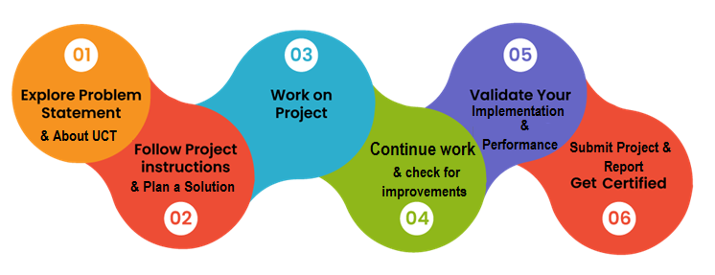
The modern engineering landscape demands a seamless transition from theoretical knowledge to practical application, making a structured internship a vital cornerstone of career development. In a rapidly evolving tech industry, hands-on experience with industry-standard frameworks like Django and JavaScript provides the professional edge necessary to solve real-world problems. This internship provided a unique opportunity to bridge that gap, moving beyond classroom concepts to build a scalable, secure, and production-ready web application.
During this intensive six-week program, I undertook the development of an "Online Auction Platform," a project designed to address the complexities of real-time data management and secure user transactions in a digital marketplace. The problem statement focused on creating a robust bidding engine capable of handling concurrent requests while maintaining data integrity and a high-quality user experience.
This invaluable learning experience was made possible through the opportunity provided by UniConverge Technologies Pvt Ltd (UCT) in affiliation with upSkill Campus (USC). The program was designed to mirror an industry "sprint" environment, where each week focused on a specific module of the Model-View-Template (MVT) architecture, ensuring a comprehensive understanding of full-stack development.
In summary, these six weeks represented a period of significant technical growth. By successfully deploying the Online Auction Platform, I have not only mastered the nuances of the Django framework but also gained critical insights into software architecture, version control, and UI/UX principles. This internship has been instrumental in shaping my professional identity as a software developer, providing me with the confidence and technical proficiency to contribute effectively to the global technology sector.

Introduction

About UniConverge Technologies Pvt Ltd
A company established in 2013 and working in Digital Transformation domain and providing Industrial solutions with prime focus on sustainability and RoI.
For developing its products and solutions it is leveraging various Cutting Edge Technologies e.g. Internet of Things (IoT), Cyber Security, Cloud computing (AWS, Azure), Machine Learning, Communication Technologies (4G/5G/LoRaWAN), Java Full Stack, Python, Front end etc.

- UCT IoT Platform()
UCT Insight is an IOT platform designed for quick deployment of IOT applications on the same time providing valuable “insight” for your process/business. It has been built in Java for backend and ReactJS for Front end. It has support for MySQL and various NoSql Databases.
- It enables device connectivity via industry standard IoT protocols - MQTT, CoAP, HTTP, Modbus TCP, OPC UA
- It supports both cloud and on-premises deployments.
It has features to
• Build Your own dashboard
• Analytics and Reporting
• Alert and Notification
• Integration with third party application(Power BI, SAP, ERP)
• Rule Engine

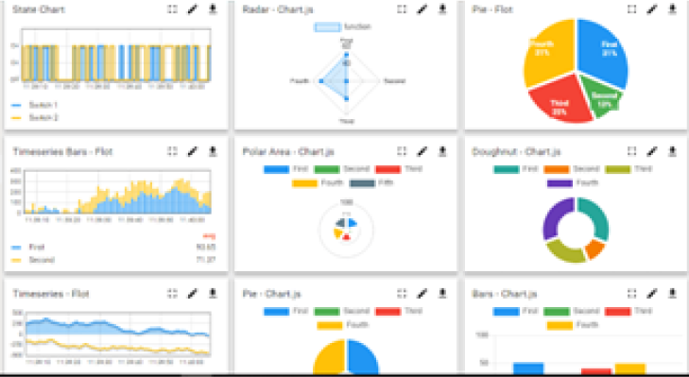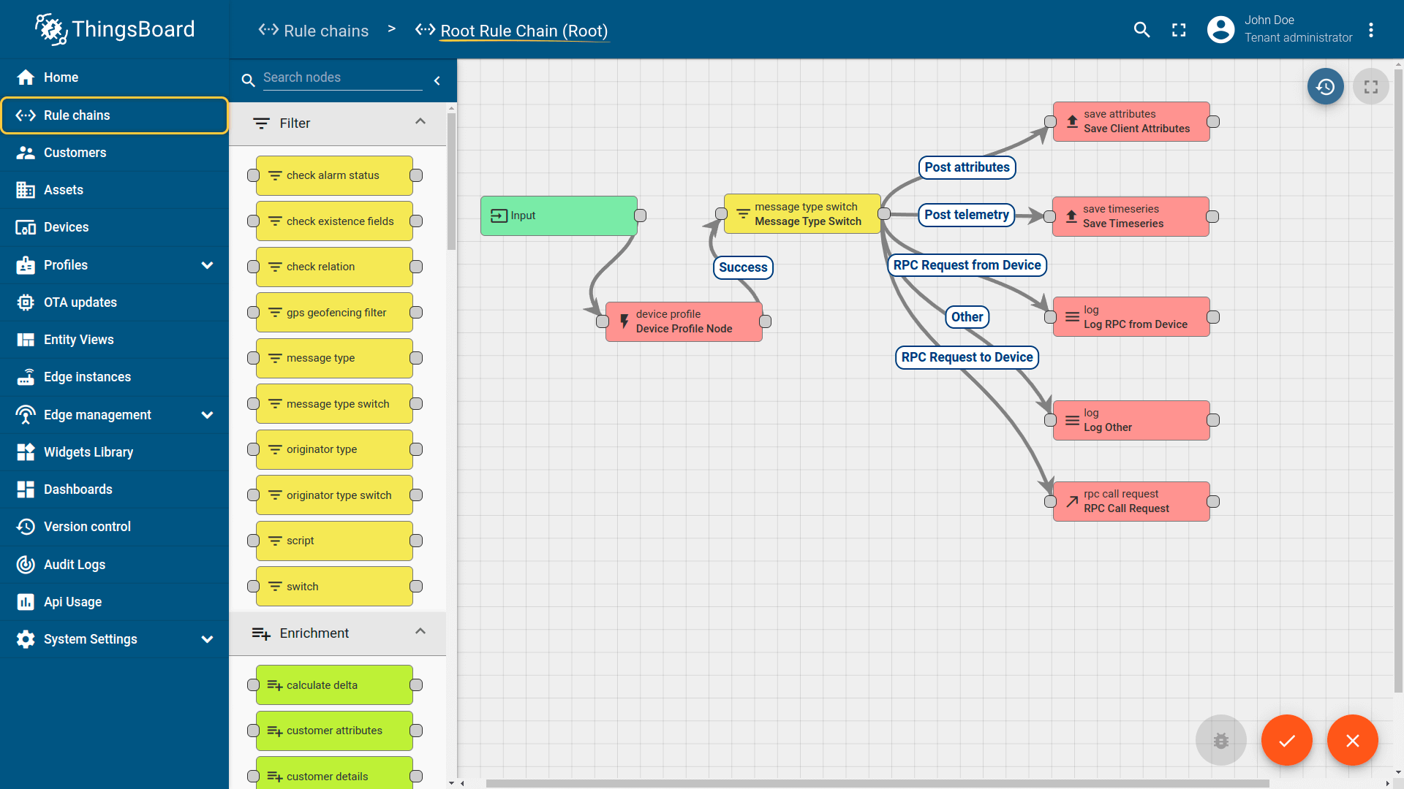

- Smart Factory Platform ()
Factory watch is a platform for smart factory needs.
It provides Users/ Factory
- with a scalable solution for their Production and asset monitoring
- OEE and predictive maintenance solution scaling up to digital twin for your assets.
- to unleased the true potential of the data that their machines are generating and helps to identify the KPIs and also improve them.
- A modular architecture that allows users to choose the service that they what to start and then can scale to more complex solutions as per their demands.
Its unique SaaS model helps users to save time, cost and money.
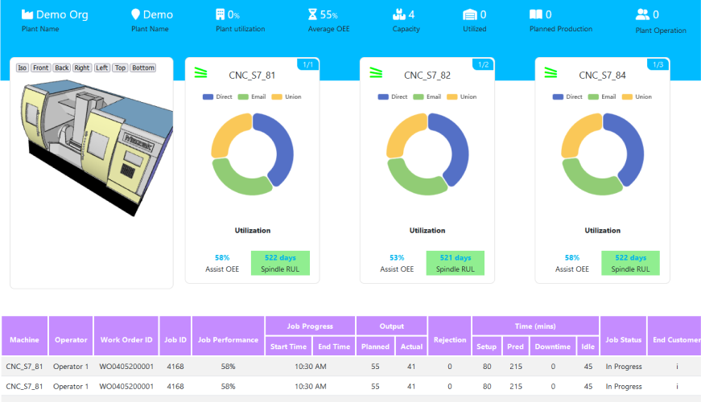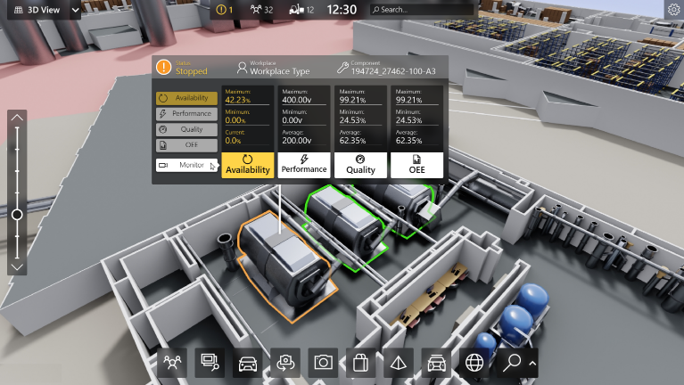

- based Solution
UCT is one of the early adopters of LoRAWAN teschnology and providing solution in Agritech, Smart cities, Industrial Monitoring, Smart Street Light, Smart Water/ Gas/ Electricity metering solutions etc.
- Predictive Maintenance
UCT isproviding Industrial Machine health monitoring and Predictive maintenance solution leveraging Embedded system, Industrial IoT and Machine Learning Technologies by finding Remaining useful life time of various Machines used in production process.
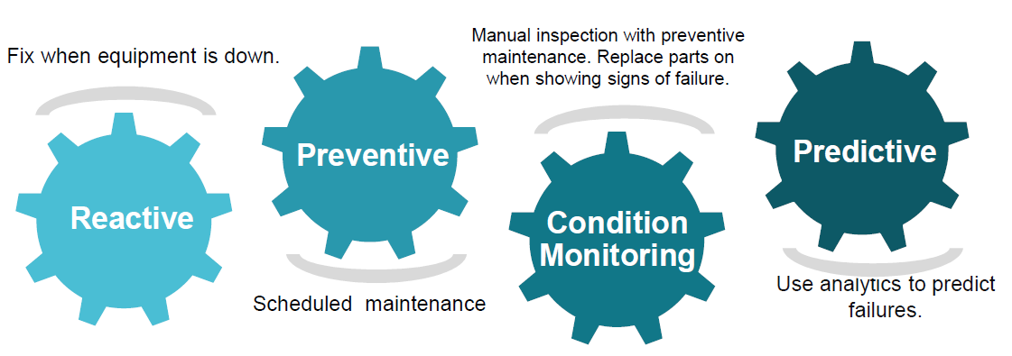

About upskill Campus (USC)
upskill Campus along with The IoT Academy and in association with Uniconverge technologies has facilitated the smooth execution of the complete internship process.
USC is a career development platform that delivers personalized executive coaching in a more affordable, scalable and measurable way.




Seeing need of upskilling in self paced manner along-with additional support services e.g. Internship, projects, interaction with Industry experts, Career growth Services
https://www.upskillcampus.com/
upSkill Campus aiming to upskill 1 million learners in next 5 year

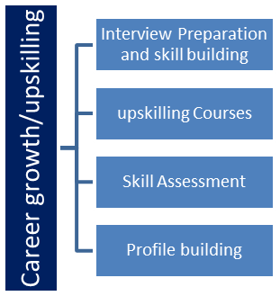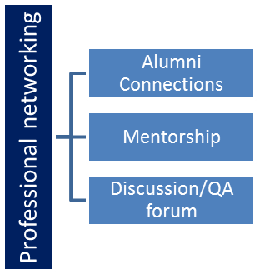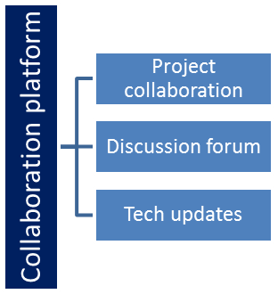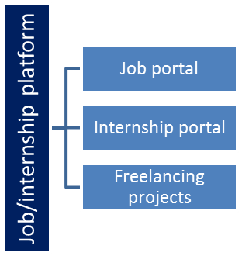

The IoT Academy
The IoT academy is EdTech Division of UCT that is running long executive certification programs in collaboration with EICT Academy, IITK, IITR and IITG in multiple domains.

Objectives of this Internship program
The objective for this internship program was to
- To design and develop a web-based auction platform using the Django framework that enables users to create, manage, and participate in online auctions.
- To implement a secure user authentication system and enforce access control so that only registered users can place bids and create listings.
- To develop a dynamic bidding mechanism that validates bids, updates current prices in real time, and determines the winning bidder when the auction ends.

Reference
[1] https://www.geeksforgeeks.org/python/online-auction-system-using-django/
[2] https://github.com/joel-jaimon/Auctions-Django-Project
[3] https://github.com/Latishfaction/E-commerce-Auction-Django

Problem Statement

The primary challenge of this project was to design and implement a centralized, secure, and real-time Online Auction Platform that overcomes the limitations of traditional, static e-commerce systems. Traditional web applications often suffer from slow synchronization, where users must manually refresh pages to see updated prices, leading to a fragmented and frustrating bidding experience.
Furthermore, the project addressed three critical technical hurdles:
- Concurrency & Data Integrity: Ensuring that multiple users can bid on the same item simultaneously without causing database conflicts or allowing a lower bid to overwrite a higher one.
- Security & Authentication: Protecting user data and financial integrity by restricting critical actions (like creating listings or placing bids) to verified, authenticated users.
- User Engagement: Transitioning from a static "Request-Response" model to a dynamic interface that utilizes asynchronous updates (AJAX/Fetch) to reflect current auction statuses and countdowns in real-time.
The goal was to utilize the Django MVT architecture to build a modular solution that is not only scalable and easy to maintain but also provides a seamless, "live" auction feel for the end-user.

During our internship at UniConverge Technologies Pvt Ltd, affiliated with upSkill Campus, we developed a Full Stack web-based auction platform using the Django framework. The system allows users to register, login, and create auction listings for items they wish to sell. Users can participate in real-time bidding, with each bid validated to ensure it is higher than the current price, and self-bidding is prevented. The application uses Django’s ORM for efficient database management and built-in authentication for secure user access. The frontend, developed with HTML, CSS, and JavaScript, provides an interactive and responsive user experience, including features like countdown timers for auctions. Additional functionalities such as comments and watchlists enhance usability and user engagement. Auction tracking ensure smooth operation of the platform. Overall, the project demonstrates effective integration of frontend and backend technologies. It provides a solid foundation for future enhancements like real-time updates, payment integration, and scalability improvements.

Existing and Proposed solution

Provide summary of existing solutions provided by others, what are their limitations?
What is your proposed solution?
What value addition are you planning?

Code submission (Github link)
https://github.com/Harshitha-388/UpSkill-Internship.git

Report submission (Github link) : first make placeholder, copy the link.

Proposed Design/ Model
The methodology for this project follows a modular and iterative approach, ensuring that each layer of the Model-View-Template (MVT) architecture is built upon a stable foundation. By breaking the development into five distinct phases, the project maintains high standards of code quality and security while allowing for systematic testing at every stage.

High Level Diagram (if applicable)
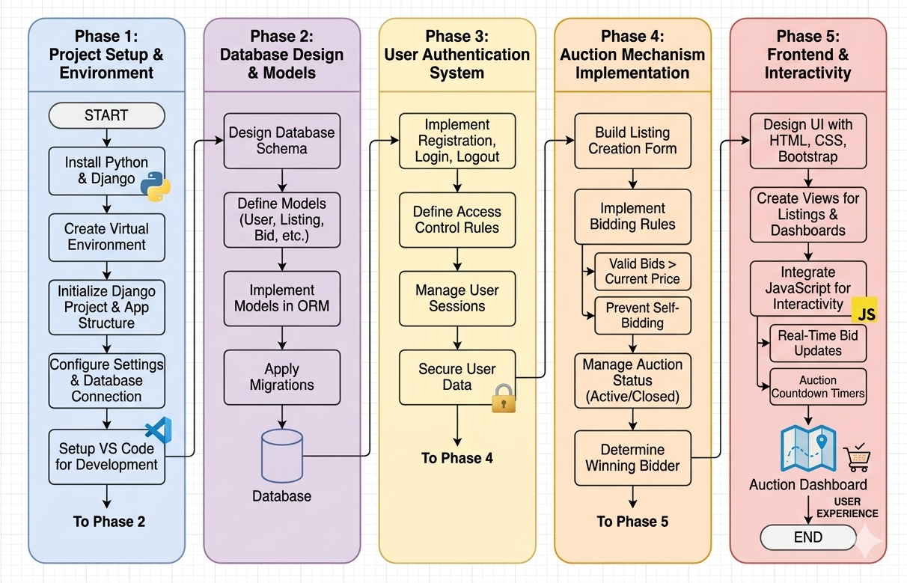
Figure 1: HIGH LEVEL DIAGRAM OF THE SYSTEM

Phase 1: Environment and Project Initialization
The initial phase focuses on establishing a professional development workflow. This involves configuring a Python virtual environment to manage dependencies and initializing the Django project structure. By isolating the environment, we ensure that the application remains portable and free from library conflicts, while tools like VS Code are configured to handle debugging and real-time server testing.

Phase 2: Schema Design and Data Modeling
At the core of the platform is a robust relational database designed using Django’s Object-Relational Mapper (ORM). This phase involves defining the "Models" for Users, Auction Listings, Bids, and Comments. By establishing clear relationships between these entities (such as one-to-many links between a listing and its bids), we ensure data integrity and prepare the backend for complex queries.

Phase 3: Secure Authentication and Access Control
Security is prioritized in the third phase through the implementation of a comprehensive user management system. Leveraging Django’s built-in Authentication middleware, we develop secure registration, login, and logout functionalities. This phase also establishes "Decorator-based" access control, ensuring that critical actions—like creating a listing or placing a bid—are strictly reserved for verified, logged-in users.

Phase 4: Bidding Logic and Auction Engine
The fourth phase represents the "Brain" of the application, where the business logic for the auction is implemented. This involves creating views that handle the submission of bids, validating that every new bid exceeds the current price, and preventing sellers from bidding on their own items. The engine also manages the status of the auction, transitioning listings from "Active" to "Closed" once the winning conditions are met.

Phase 5: Frontend Design and Dynamic Interactivity
The final phase focuses on the User Experience (UX) by building a responsive interface using Bootstrap and CSS. Beyond aesthetics, this phase integrates Vanilla JavaScript to provide dynamic updates. By using asynchronous requests, the platform can update current prices and countdown timers in real-time, providing the fast-paced, interactive environment essential for a modern digital auction.

Performance Test

To ensure the Online Auction Platform meets industrial standards, we identified three primary technical constraints: Concurrency & Race Conditions, Data Integrity, and Latency.

Identified Constraints
- Concurrency (The "Sniper" Problem): In real-world auctions, multiple users often bid in the final seconds. If two users bid the same amount simultaneously, the system must prevent "double-wins" or price desync.
- Latency (Speed): A delay in updating the current price can lead to a poor user experience, where a user thinks they are the highest bidder when they have already been outbid.
- Memory & Storage Scalability: As the number of product images and user sessions grows, the database must handle increased I/O without slowing down the page load.

Design Solutions
How these constraints were addressed in the Django architecture:
- Database Transactions: We utilized Django's select_for_update() and atomic transactions. This locks the specific "Listing" row in the database during a bid update, ensuring that if two bids hit the server at the same millisecond, they are processed sequentially rather than overlapping.
- Asynchronous Updates: To solve the latency issue, we moved away from traditional form submissions. By implementing JavaScript Fetch API, the frontend polls the server (or uses WebSockets) to update the price instantly without refreshing the entire page.
- Optimized Queries: We used select_related and prefetch_related in the Django ORM to reduce the number of SQL queries (the N+1 problem), significantly lowering the MIPS (Million Instructions Per Second) required by the CPU.

Performance Outcome
The outcome of the following internship project is the web platform for online auctions as follows:
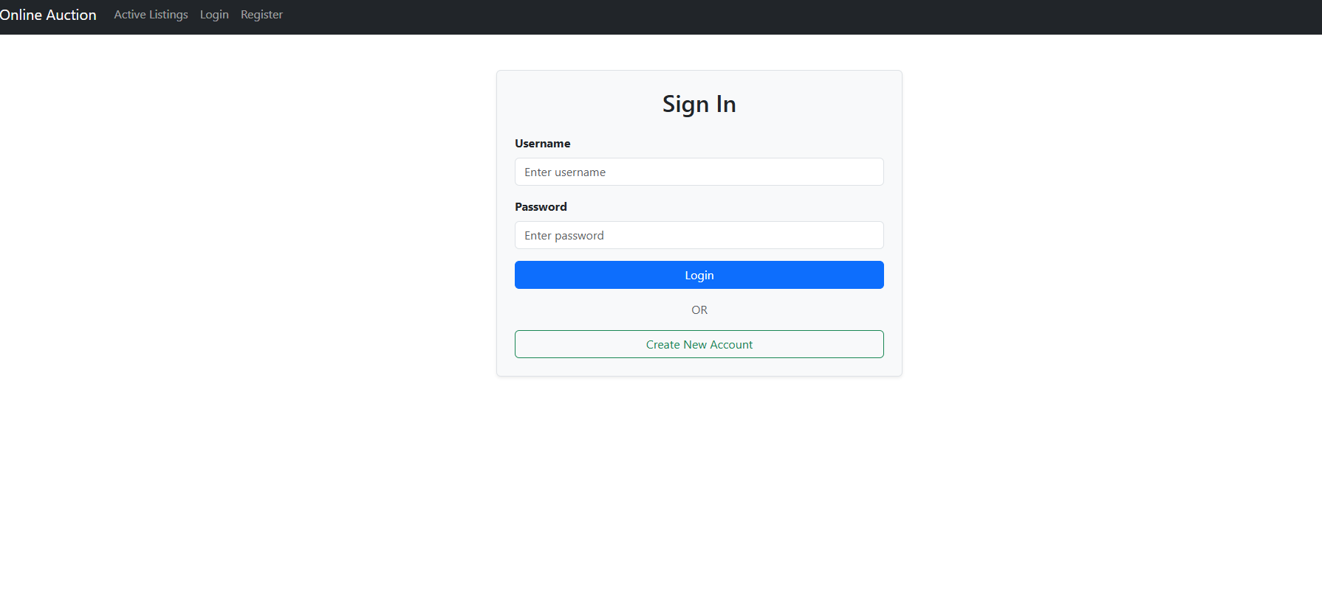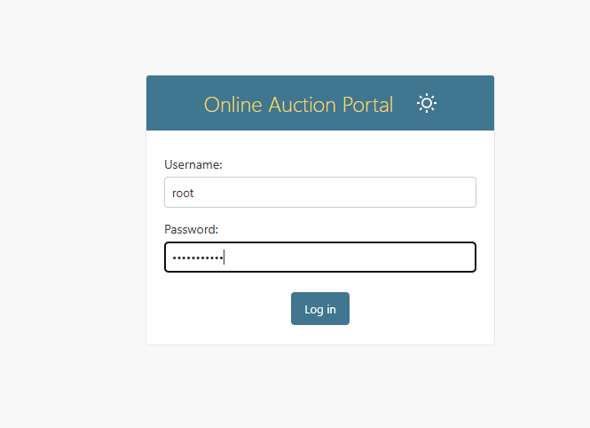
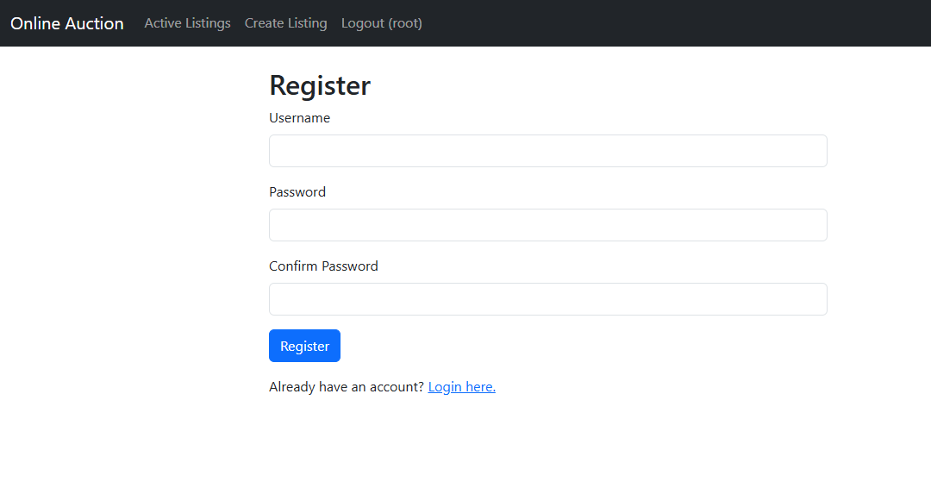
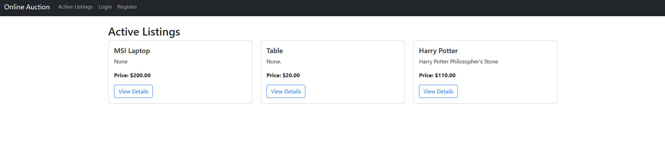
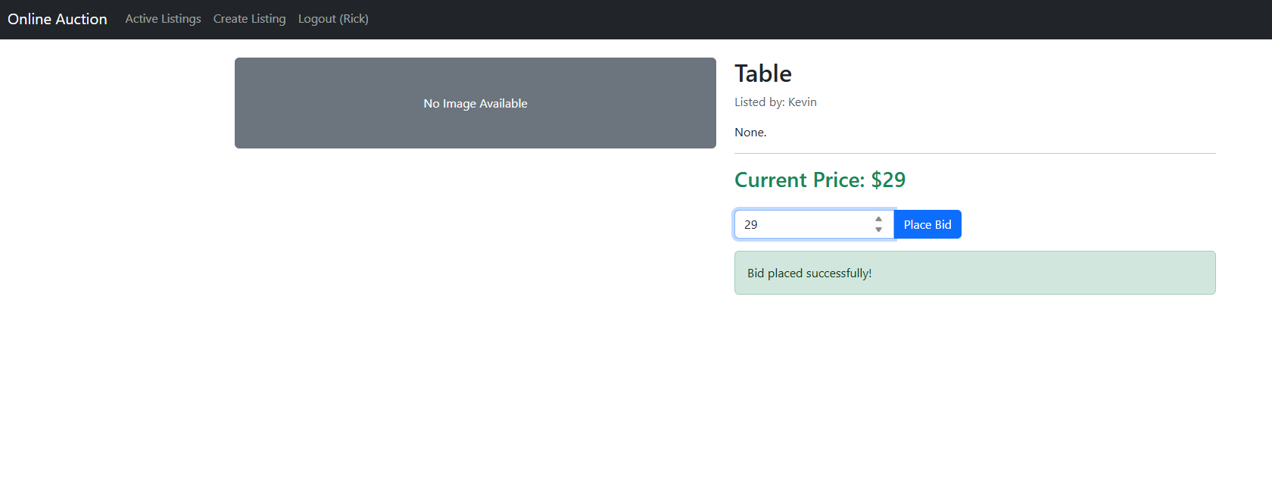

My learnings

Through the development of the Online Auction Platform, I have transitioned from a conceptual understanding of web development to a practical mastery of the full-stack lifecycle. My primary learning centered on the Model-View-Template (MVT) architecture, where I learned to decouple complex business logic from the presentation layer to ensure scalability. I gained hands-on experience in database normalization and relational mapping via the Django ORM, ensuring data integrity during high-frequency bidding events. Furthermore, I mastered the use of Asynchronous JavaScript (Fetch API) to bridge the gap between static backends and dynamic, real-time user interfaces. Beyond the code, this internship taught me the importance of security-first design, implementing robust authentication and CSRF protection to safeguard user transactions, and following a modular project management approach to meet industry-standard deadlines.

Future work scope

In the future workspace, the skills acquired during this project will serve as a foundation for building high-performance, enterprise-grade web applications and distributed systems. The logic used in the bidding engine is directly applicable to domains requiring real-time data processing, such as fintech platforms, stock trading interfaces, and e-commerce inventory management. As I move into professional environments, I plan to integrate these full-stack capabilities with MLOps and Cloud Infrastructure, utilizing tools like Docker, Redis, and AWS to scale applications for millions of concurrent users. My experience at UniConverge Technologies has prepared me to thrive in agile, collaborative teams where the focus is on creating secure, low-latency solutions that solve complex user needs through efficient architecture and seamless interactivity.

