**Assignment_3ML_B**

Harshitha Boyapati

700761387

Github link:

Video link:

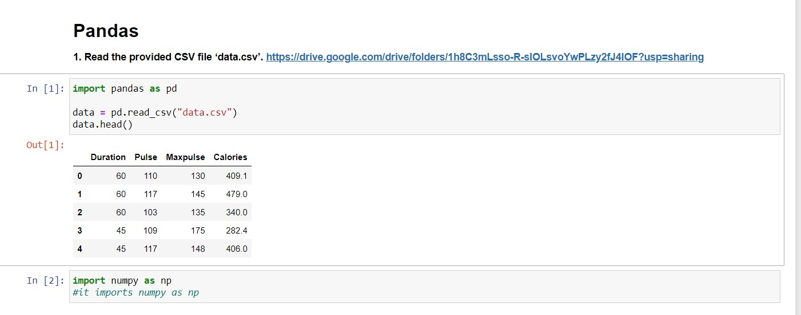

Description: In the above code, it reads the data.csv file

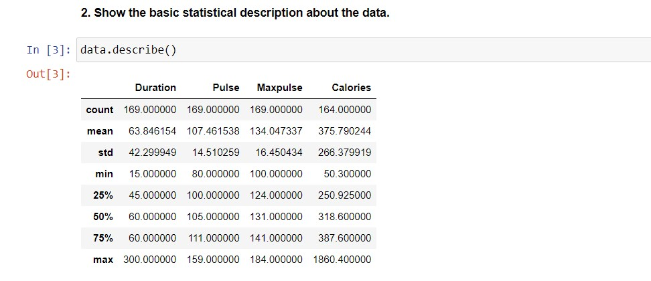

Using describe() function it shows the statistical data

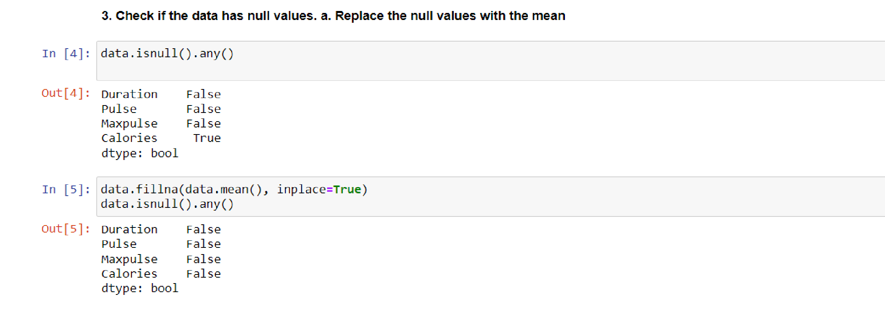Isnull() is used here to check if there is any null values is present and it will replace with mean values using function fillna() function.

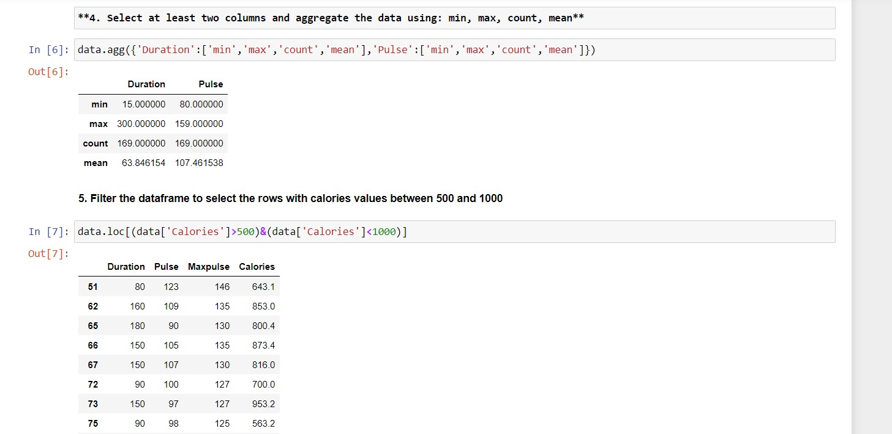

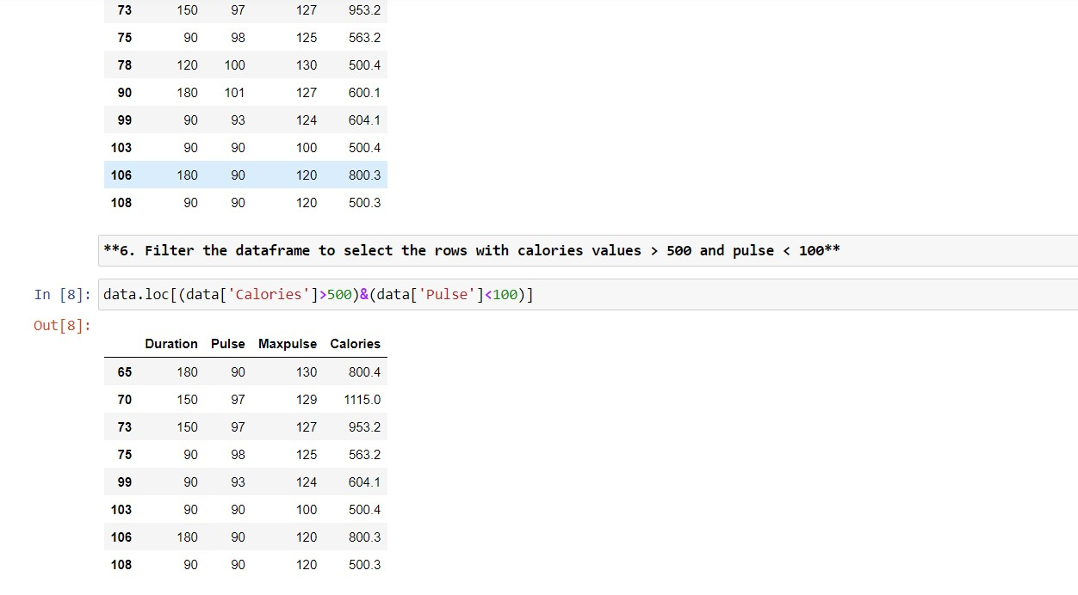

Again, filter the data with calories >500 & <100

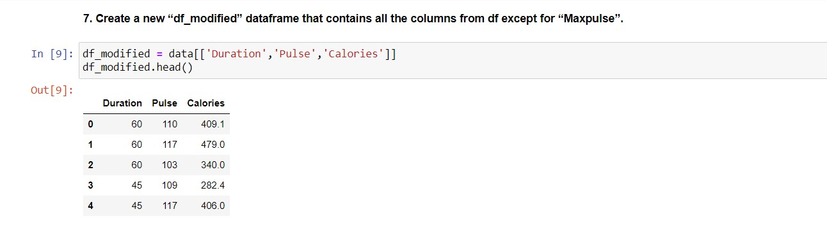

A new df_modified dataframe is created which contains all the coloumns from df expect for Maxpulse

