**ReactJS HOL:**

**Exercise 1:**

**App.js:**

import React from 'react';

function App() {

  return (

    <div>

      <h1>Welcome to the first session of React</h1>

    </div>

  );

}

export default App;

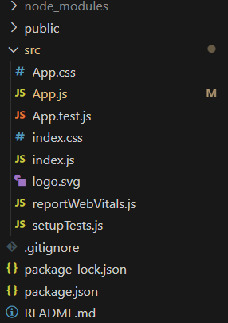

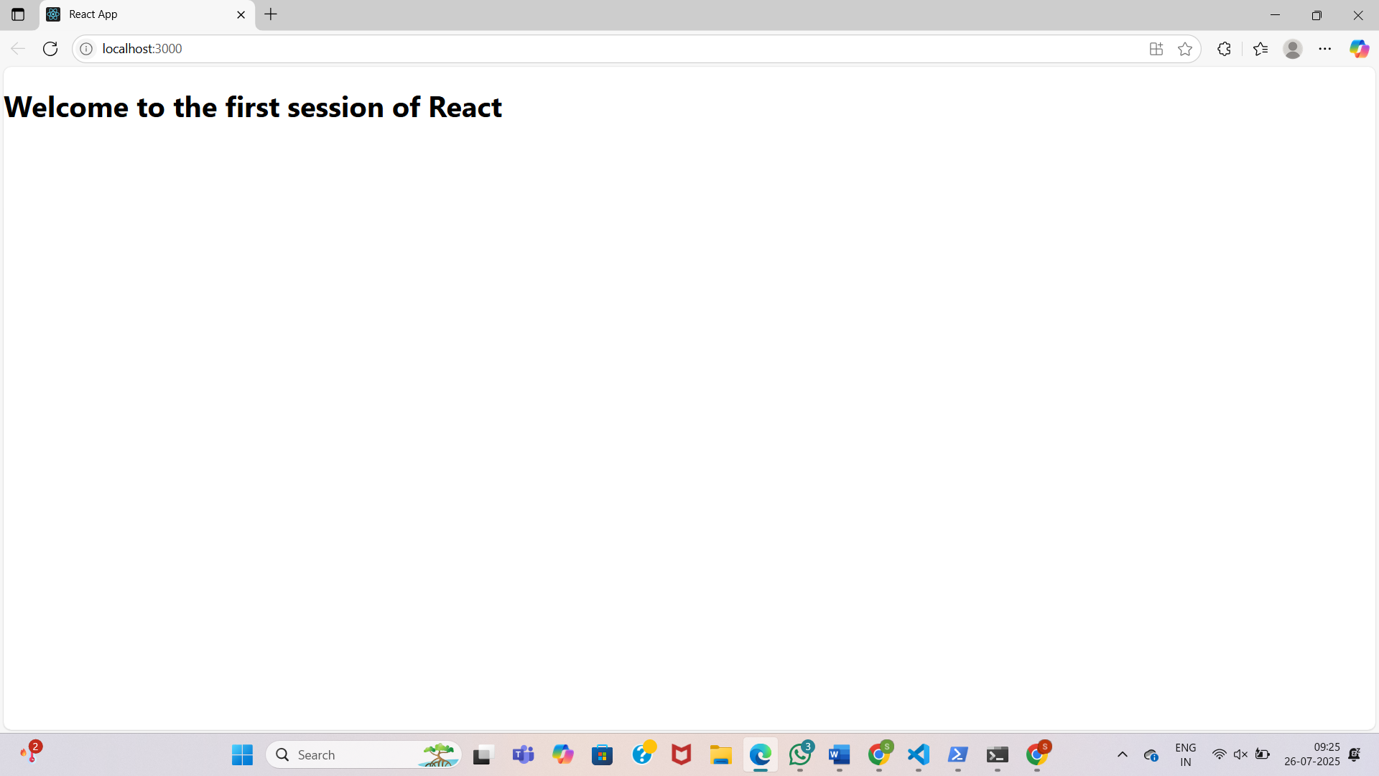

**Exercise 2:**

**Home.js**

import React from 'react';

class Home extends React.Component {

render() {

return (

<div>

<h2>Welcome to the Home page of Student Management Portal</h2>

</div>

);

}

}

export default Home;

**About.js**

import React from 'react';

class About extends React.Component {

render() {

return (

<div>

<h2>Welcome to the About page of the Student Management Portal</h2>

</div>

);

}

}

export default About;

**Contact.js**

import React from 'react';

class Contact extends React.Component {

render() {

return (

<div>

<h2>Welcome to the Contact page of the Student Management Portal</h2>

</div>

);

}

}

export default Contact;

**App.js**

import React from 'react';

import Home from './Components/Home';

import About from './Components/About';

import Contact from './Components/Contact';

function App() {

return (

<div className="App">

<h1>Student Management Portal</h1>

<Home />

<About />

<Contact />

</div>

);

}

export default App;

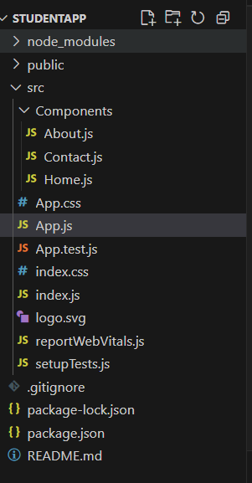

**Exercise 3:**

**CalculateScore.js**

import React from 'react';

import '../Stylesheets/mystyle.css';

function CalculateScore(props) {

const average = props.total / props.goal;

return (

<div className="score-container">

<h2>Student Score Calculator</h2>

<p><strong>Name:</strong> {props.name}</p>

<p><strong>School:</strong> {props.school}</p>

<p><strong>Total Marks:</strong> {props.total}</p>

<p><strong>Subjects:</strong> {props.goal}</p>

<p className="average-score"><strong>Average Score:</strong> {average.toFixed(2)}</p>

</div>

);

}

export default CalculateScore;

**mystyle.css**

.score-container {

background-color: #f0f8ff;

padding: 20px;

border-radius: 10px;

width: 60%;

margin: 30px auto;

box-shadow: 0 0 10px rgba(0, 0, 0, 0.1);

font-family: Arial, sans-serif;

}

.score-container h2 {

text-align: center;

color: #333;

}

.average-score {

color: green;

font-weight: bold;

font-size: 18px;

}

**App.js**

import React from 'react';

import './App.css';

import CalculateScore from './Components/CalculateScore';

function App() {

return (

<div className="App">

<CalculateScore

name="Kavya"

school="Sunrise Public School"

total={450}

goal={5}

/>

</div>

);

} export default App;

**Exercise 4:**

**Posts.js:**

import React from "react";

import Post from "./Post";

class Posts extends React.Component {

constructor(props) {

super(props);

this.state = {

posts: [

{ id: 1, title: "My Blog", body: "Welcome to my blog content." },

{ id: 2, title: "Learning React", body: "React is very interesting!" },

{ id: 3, title: "JSX Rules", body: "JSX makes it easy to write UI." },

],

};

}

render() {

return (

<div>

<h1>My Custom Blog Posts</h1>

{this.state.posts.map((post) => (

<Post key={post.id} title={post.title} body={post.body} />

))}

</div>

);

}

componentDidCatch(error, info) {

console.error("An error occurred:", error, info);

}

}

export default Posts;

**Post.js:**

import React from 'react';

class Post extends React.Component {

render() {

return (

<div>

<h2>{this.props.title}</h2>

<p>{this.props.body}</p>

</div>

);

}

}

export default Post;

**App.js:**

import React from 'react';

import './App.css';

import Posts from './Posts';

function App() {

return (

<div className="App">

<Posts />

</div>

);

}

export default App;

**Exercise 5:**

**App.js:**

import React from 'react';

import CohortDetails from './CohortDetails';

function App() {

const cohortData = [

{ name: "React Bootcamp", trainer: "Abirami ", status: "ongoing", startDate: "2025-07-15" },

{ name: "Node.js Mastery", trainer: "Supraja", status: "completed", startDate: "2025-06-10" },

{ name: "Angular Crash Course", trainer: "Kalpana", status: "ongoing", startDate: "2025-07-01" },

{ name: "Vue Basics", trainer: "Rosy", status: "completed", startDate: "2025-05-20" }

];

return (

<div>

<h1>Cohorts Details</h1>

{cohortData.map((cohort, index) => (

<CohortDetails

key={index}

name={cohort.name}

trainer={cohort.trainer}

status={cohort.status}

startDate={cohort.startDate}

/>

))}

</div>

);

}

export default App;

**CohortDetails.js:**

import React from 'react';

import styles from './CohortDetails.module.css';

function CohortDetails(props) {

return (

<div className={styles.box}>

<h3 style={{ color: props.status === 'ongoing' ? 'green' : 'blue' }}>

{props.name}

</h3>

<dl>

<dt>Trainer:</dt>

<dd>{props.trainer}</dd>

<dt>Status:</dt>

<dd>{props.status}</dd>

<dt>Start Date:</dt>

<dd>{props.startDate}</dd>

</dl>

</div>

);

}export default CohortDetails;

**CohortDetails.module.css:**

.box {

width: 300px;

display: inline-block;

margin: 10px;

padding: 10px 20px;

border: 1px solid black;

border-radius: 10px;

}

dt {

font-weight: 500;

}

