Creating Microservices for account and loan

**Create Account Microservice**

**AccountApplication.java:**

package com.cognizant.account;  
  
import org.springframework.boot.SpringApplication;  
import org.springframework.boot.autoconfigure.SpringBootApplication;  
  
@SpringBootApplication  
public class AccountApplication {  
 public static void main(String[] args) {  
 SpringApplication.*run*(AccountApplication.class, args);  
 }  
}

**AccountController.java**

package com.cognizant.account.controller;  
  
import org.springframework.web.bind.annotation.GetMapping;  
import org.springframework.web.bind.annotation.PathVariable;  
import org.springframework.web.bind.annotation.RequestMapping;  
import org.springframework.web.bind.annotation.RestController;  
  
import java.util.HashMap;  
import java.util.Map;  
@RestController  
@RequestMapping("/accounts")  
public class AccountController {  
  
 @GetMapping("/{number}")  
 public Map<String, Object> getAccountDetails(@PathVariable String number) {  
 Map<String, Object> account = new HashMap<>();  
 account.put("number", number);  
 account.put("type", "savings");  
 account.put("balance", 234343);  
 return account;  
   
}}

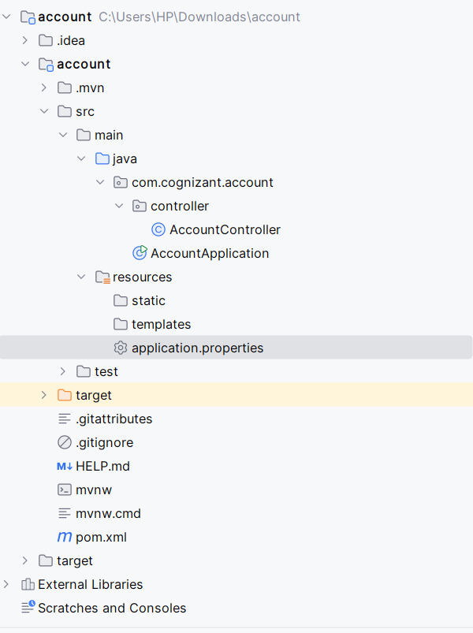

**Account Microservice Output**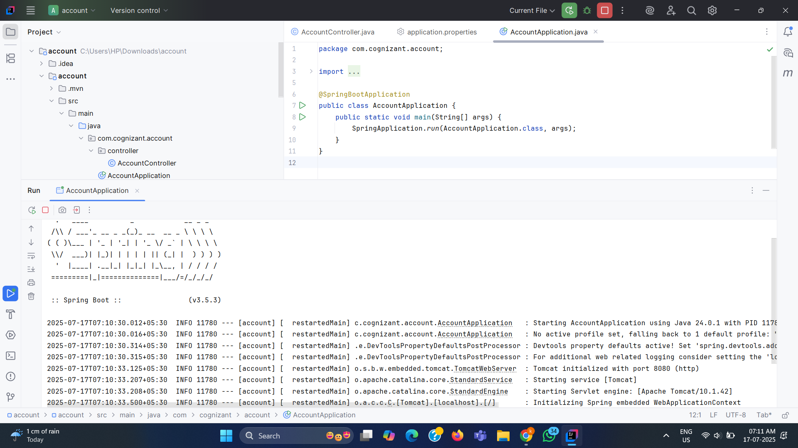

**Create Loan Microservice (Same Process)**

**LoanApplication.java**

package com.cognizant.loan;  
  
import org.springframework.boot.SpringApplication;  
import org.springframework.boot.autoconfigure.SpringBootApplication;  
  
@SpringBootApplication  
public class LoanApplication {  
 public static void main(String[] args) {  
 SpringApplication.*run*(LoanApplication.class, args);  
 }  
}

**LoanController.java:**

package com.cognizant.loan.controller;  
import org.springframework.web.bind.annotation.GetMapping;  
import org.springframework.web.bind.annotation.PathVariable;  
import org.springframework.web.bind.annotation.RequestMapping;  
import org.springframework.web.bind.annotation.RestController;  
  
import java.util.HashMap;  
import java.util.Map;  
  
@RestController  
@RequestMapping("/loans")  
public class LoanController {  
  
 @GetMapping("/{number}")  
 public Map<String, Object> getLoanDetails(@PathVariable String number) {  
 Map<String, Object> loan = new HashMap<>();  
 loan.put("number", number);  
 loan.put("type", "car");  
 loan.put("loan", 400000);  
 loan.put("emi", 3258);  
 loan.put("tenure", 18);  
 return loan;  
 }  
}

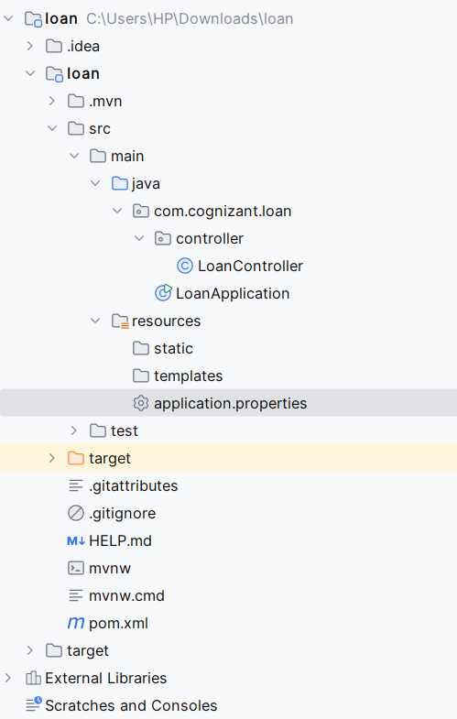

**Loan Microservice Output**

