Module1: Advanced SQL server

1.SQL Exercise -Advanced Concepts
Exercise 1: Ranking and Window Functions
SELECT *
FROM (
SELECT
ProductID,
ProductName,
Category,
Price,
ROW_NUMBER() OVER (PARTITION BY Category ORDER BY Price DESC) AS Row_Num,
RANK() OVER (PARTITION BY Category ORDER BY Price DESC) AS Rank_Num,
DENSE_RANK() OVER (PARTITION BY Category ORDER BY Price DESC) AS Dense_Rank_Num
FROM Products
) AS RankedProducts
WHERE Row_Num <= 3
OR Rank_Num <= 3
OR Dense_Rank_Num <= 3
ORDER BY Category, Price DESC;
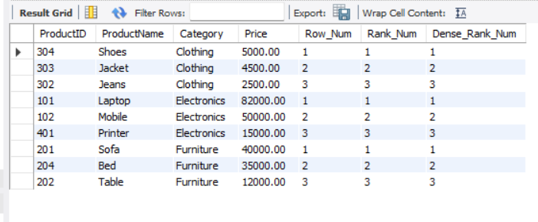
Exercise 2: Aggregation with GROUPING SETS, CUBE, and ROLLUP
SELECT
c.Region,
p.Category,
SUM(od.Quantity) AS Total_Quantity,
'Region + Category' AS Summary
FROM Orders o
JOIN OrderDetails od ON o.OrderID = od.OrderID
JOIN Customers c ON o.CustomerID = c.CustomerID
JOIN Products p ON od.ProductID = p.ProductID
GROUP BY c.Region, p.Category
UNION ALL
SELECT
c.Region,
'All Categories' AS Category,
SUM(od.Quantity) AS Total_Quantity,
'Region Total' AS Summary
FROM Orders o
JOIN OrderDetails od ON o.OrderID = od.OrderID
JOIN Customers c ON o.CustomerID = c.CustomerID
JOIN Products p ON od.ProductID = p.ProductID
GROUP BY c.Region
UNION ALL
SELECT
'All Regions' AS Region,
p.Category,
SUM(od.Quantity) AS Total_Quantity,
'Category Total' AS Summary
FROM Orders o
JOIN OrderDetails od ON o.OrderID = od.OrderID
JOIN Customers c ON o.CustomerID = c.CustomerID
JOIN Products p ON od.ProductID = p.ProductID
GROUP BY p.Category
UNION ALL
SELECT
'All Regions' AS Region,
'All Categories' AS Category,
SUM(od.Quantity) AS Total_Quantity,
'Grand Total' AS Summary
FROM Orders o
JOIN OrderDetails od ON o.OrderID = od.OrderID
JOIN Customers c ON o.CustomerID = c.CustomerID
JOIN Products p ON od.ProductID = p.ProductID;
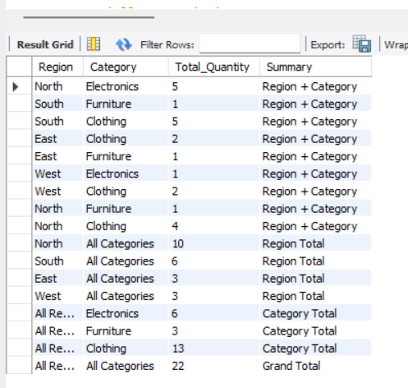

Exercise 3: CTEs and MERGE (MySQL Version)
-- Part A: Recursive CTE to generate dates
WITH RECURSIVE Calendar AS (
SELECT DATE('2025-01-01') AS CalendarDate
UNION ALL
SELECT DATE_ADD(CalendarDate, INTERVAL 1 DAY)
FROM Calendar
WHERE CalendarDate < '2025-01-31'
)
SELECT * FROM Calendar;
-- Part B: Create StagingProducts table
CREATE TABLE IF NOT EXISTS StagingProducts (
ProductID INT PRIMARY KEY,
ProductName VARCHAR(100),
Category VARCHAR(50),
Price DECIMAL(10,2)
);
-- Insert sample data into staging table
INSERT INTO StagingProducts
VALUES
(101, 'Laptop A', 'Electronics', 85000),
(102, 'Laptop B', 'Electronics', 76000),
(105, 'Smart Watch', 'Electronics', 12000);
-- MERGE equivalent in MySQL
INSERT INTO Products (ProductID, ProductName, Category, Price)
SELECT
ProductID,
ProductName,
Category,
Price
FROM StagingProducts
ON DUPLICATE KEY UPDATE
ProductName = VALUES(ProductName),
Category = VALUES(Category),
Price = VALUES(Price);
-- View updated Products table
SELECT * FROM Products;
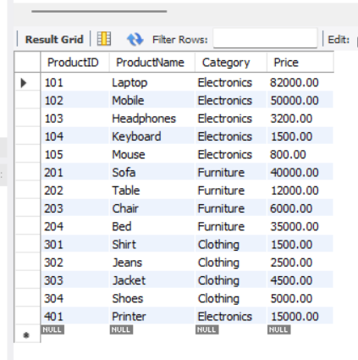
-- Exercise 4: PIVOT and UNPIVOT (MySQL Version)
-- Step 1 & 2: Pivot monthly sales quantity
SELECT
p.ProductName,
SUM(CASE WHEN MONTH(o.OrderDate) = 1 THEN od.Quantity ELSE 0 END) AS January,
SUM(CASE WHEN MONTH(o.OrderDate) = 2 THEN od.Quantity ELSE 0 END) AS February,
SUM(CASE WHEN MONTH(o.OrderDate) = 3 THEN od.Quantity ELSE 0 END) AS March
FROM Orders o
JOIN OrderDetails od
ON o.OrderID = od.OrderID
JOIN Products p
ON od.ProductID = p.ProductID
GROUP BY p.ProductName;
-- Step 3: Unpivot back to row format
SELECT ProductName, 'January' AS Month, January AS Quantity
FROM (
SELECT
p.ProductName,
SUM(CASE WHEN MONTH(o.OrderDate) = 1 THEN od.Quantity ELSE 0 END) AS January,
SUM(CASE WHEN MONTH(o.OrderDate) = 2 THEN od.Quantity ELSE 0 END) AS February,
SUM(CASE WHEN MONTH(o.OrderDate) = 3 THEN od.Quantity ELSE 0 END) AS March
FROM Orders o
JOIN OrderDetails od
ON o.OrderID = od.OrderID
JOIN Products p
ON od.ProductID = p.ProductID
GROUP BY p.ProductName
) AS PivotTable
UNION ALL
SELECT ProductName, 'February', February
FROM (
SELECT
p.ProductName,
SUM(CASE WHEN MONTH(o.OrderDate) = 1 THEN od.Quantity ELSE 0 END) AS January,
SUM(CASE WHEN MONTH(o.OrderDate) = 2 THEN od.Quantity ELSE 0 END) AS February,
SUM(CASE WHEN MONTH(o.OrderDate) = 3 THEN od.Quantity ELSE 0 END) AS March
FROM Orders o
JOIN OrderDetails od
ON o.OrderID = od.OrderID
JOIN Products p
ON od.ProductID = p.ProductID
GROUP BY p.ProductName
) AS PivotTable
UNION ALL
SELECT ProductName, 'March', March
FROM (
SELECT
p.ProductName,
SUM(CASE WHEN MONTH(o.OrderDate) = 1 THEN od.Quantity ELSE 0 END) AS January,
SUM(CASE WHEN MONTH(o.OrderDate) = 2 THEN od.Quantity ELSE 0 END) AS February,
SUM(CASE WHEN MONTH(o.OrderDate) = 3 THEN od.Quantity ELSE 0 END) AS March
FROM Orders o
JOIN OrderDetails od
ON o.OrderID = od.OrderID
JOIN Products p
ON od.ProductID = p.ProductID
GROUP BY p.ProductName
) AS PivotTable;
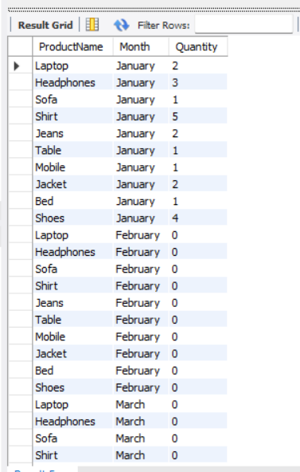
-- Exercise 5: Using CTE to Simplify a Query

WITH CustomerOrders AS (
SELECT
c.CustomerID,
c.CustomerName,
COUNT(o.OrderID) AS TotalOrders
FROM Customers c
JOIN Orders o
ON c.CustomerID = o.CustomerID
GROUP BY c.CustomerID, c.CustomerName
)
SELECT
CustomerID,
CustomerName,
TotalOrders
FROM CustomerOrders
WHERE TotalOrders > 3;
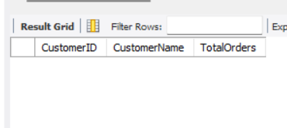
2. SQL Exercise – Index

CREATE TABLE Customers (
CustomerID INT PRIMARY KEY,
Name VARCHAR(100),
Region VARCHAR(50)
);
CREATE TABLE Products (
ProductID INT PRIMARY KEY,
ProductName VARCHAR(100),
Category VARCHAR(50),
Price DECIMAL(10,2)
);
CREATE TABLE Orders (
OrderID INT PRIMARY KEY,
CustomerID INT,
OrderDate DATE,
FOREIGN KEY (CustomerID) REFERENCES Customers(CustomerID)
);
CREATE TABLE OrderDetails (
OrderDetailID INT PRIMARY KEY,
OrderID INT,
ProductID INT,
Quantity INT,
FOREIGN KEY (OrderID) REFERENCES Orders(OrderID),
FOREIGN KEY (ProductID) REFERENCES Products(ProductID)
);
INSERT INTO Customers VALUES
(1, 'Alice', 'North'),
(2, 'Bob', 'South'),
(3, 'Charlie', 'East'),
(4, 'David', 'West');
INSERT INTO Products VALUES
(1, 'Laptop', 'Electronics', 1200.00),
(2, 'Smartphone', 'Electronics', 800.00),
(3, 'Tablet', 'Electronics', 600.00),
(4, 'Headphones', 'Accessories', 150.00);
INSERT INTO Orders VALUES
(1, 1, '2023-01-15'),
(2, 2, '2023-02-20'),
(3, 3, '2023-03-25'),
(4, 4, '2023-04-30');
INSERT INTO OrderDetails VALUES
(1, 1, 1, 1),
(2, 2, 2, 2),
(3, 3, 3, 1),
(4, 4, 4, 3);
-- Exercise 1: Before index
SELECT * FROM Products
WHERE ProductName = 'Laptop';
-- Create index on ProductName
CREATE INDEX idx_ProductName
ON Products(ProductName);
-- After index
SELECT * FROM Products
WHERE ProductName = 'Laptop';
-- Exercise 2: Before index
SELECT * FROM Orders
WHERE OrderDate = '2023-01-15';
-- Create index on OrderDate
CREATE INDEX idx_OrderDate
ON Orders(OrderDate);
-- After index
SELECT * FROM Orders
WHERE OrderDate = '2023-01-15';
-- Exercise 3: Before index
SELECT * FROM Orders
WHERE CustomerID = 1
AND OrderDate = '2023-01-15';
-- Create composite index
CREATE INDEX idx_CustomerID_OrderDate
ON Orders(CustomerID, OrderDate);
-- After index
SELECT * FROM Orders
WHERE CustomerID = 1
AND OrderDate = '2023-01-15';
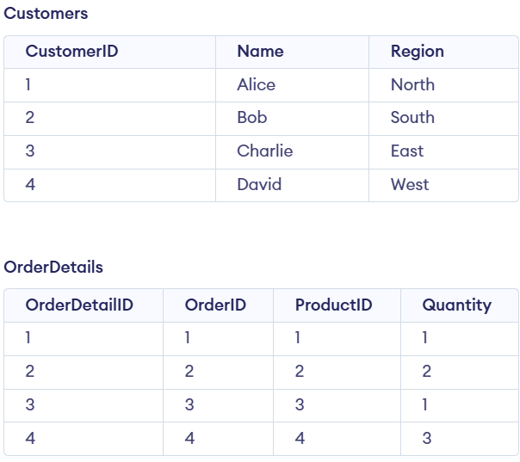
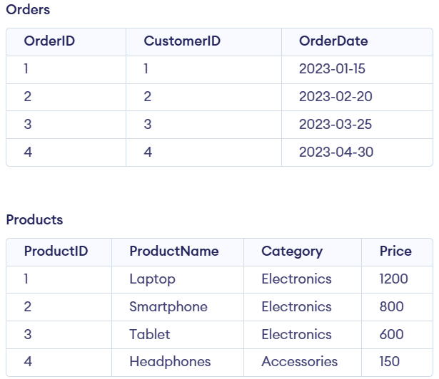
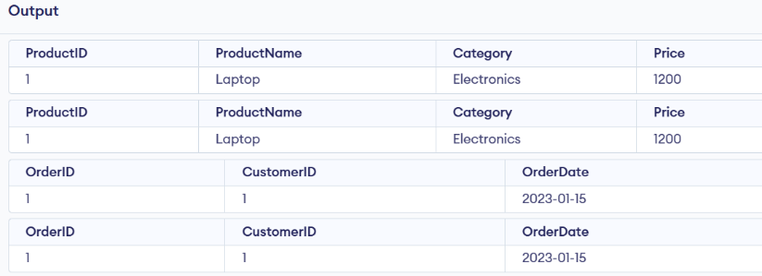

3. SQL Exercise - Views
CREATE TABLE Departments (
DepartmentID INT PRIMARY KEY,
DepartmentName VARCHAR(100)
);
CREATE TABLE Employees (
EmployeeID INT PRIMARY KEY,
FirstName VARCHAR(50),
LastName VARCHAR(50),
DepartmentID INT,
Salary DECIMAL(10,2),
JoinDate DATE,
FOREIGN KEY (DepartmentID) REFERENCES Departments(DepartmentID)
);
INSERT INTO Departments VALUES
(1,'HR'),
(2,'IT'),
(3,'Finance'),
(4,'Marketing');
INSERT INTO Employees VALUES
(101,'Divya','K',2,30000,'2024-01-10'),
(102,'Rahul','Sharma',1,25000,'2023-06-15'),
(103,'Priya','Reddy',3,35000,'2022-09-20'),
(104,'Arjun','Kumar',4,28000,'2024-03-05');
CREATE VIEW vw_EmployeeBasicInfo AS
SELECT
e.EmployeeID,
e.FirstName,
e.LastName,
d.DepartmentName
FROM Employees e
JOIN Departments d
ON e.DepartmentID = d.DepartmentID;
CREATE VIEW vw_EmployeeFullName AS
SELECT
EmployeeID,
CONCAT(FirstName,' ',LastName) AS FullName
FROM Employees;
CREATE VIEW vw_EmployeeAnnualSalary AS
SELECT
EmployeeID,
FirstName,
LastName,
Salary,
Salary * 12 AS AnnualSalary
FROM Employees;
CREATE VIEW vw_EmployeeReport AS
SELECT
e.EmployeeID,
CONCAT(e.FirstName,' ',e.LastName) AS FullName,
d.DepartmentName,
e.Salary,
e.Salary * 12 AS AnnualSalary,
(e.Salary * 12) * 0.10 AS Bonus
FROM Employees e
JOIN Departments d
ON e.DepartmentID = d.DepartmentID;
SELECT * FROM vw_EmployeeBasicInfo;
SELECT * FROM vw_EmployeeFullName;
SELECT * FROM vw_EmployeeAnnualSalary;
SELECT * FROM vw_EmployeeReport;

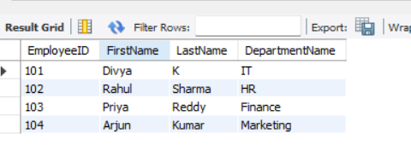
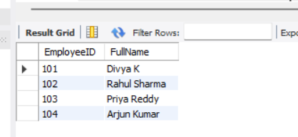
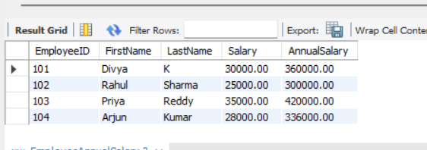
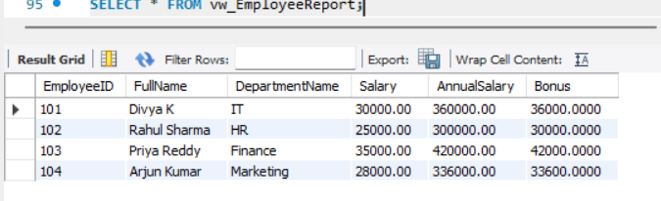
4. SQL Exercise – Stored Procedure

Exercise 1: Create a Stored Procedure
CREATE DATABASE IF NOT EXISTS EmployeeManagement;
USE EmployeeManagement;
DROP TABLE IF EXISTS Employees;
DROP TABLE IF EXISTS Departments;
CREATE TABLE Departments (
DepartmentID INT PRIMARY KEY,
DepartmentName VARCHAR(100)
);
CREATE TABLE Employees (
EmployeeID INT AUTO_INCREMENT PRIMARY KEY,
FirstName VARCHAR(50),
LastName VARCHAR(50),
DepartmentID INT,
Salary DECIMAL(10,2),
JoinDate DATE,
FOREIGN KEY (DepartmentID) REFERENCES Departments(DepartmentID)
);
INSERT INTO Departments (DepartmentID, DepartmentName) VALUES
(1, 'HR'),
(2, 'Finance'),
(3, 'IT'),
(4, 'Marketing');
INSERT INTO Employees
(FirstName, LastName, DepartmentID, Salary, JoinDate)
VALUES
('John', 'Doe', 1, 5000.00, '2020-01-15'),
('Jane', 'Smith', 2, 6000.00, '2019-03-22'),
('Michael', 'Johnson', 3, 7000.00, '2018-07-30'),
('Emily', 'Davis', 4, 5500.00, '2021-11-05');
SELECT * FROM Departments;
SELECT * FROM Employees;
DELIMITER $$
CREATE PROCEDURE sp_GetEmployeesByDepartment(
IN p_DepartmentID INT
)
BEGIN
SELECT EmployeeID,
FirstName,
LastName,
DepartmentID,
Salary,
JoinDate
FROM Employees
WHERE DepartmentID = p_DepartmentID;
END $$
DELIMITER ;
CALL sp_GetEmployeesByDepartment(3);
DELIMITER $$
CREATE PROCEDURE sp_InsertEmployee(
IN p_FirstName VARCHAR(50),
IN p_LastName VARCHAR(50),
IN p_DepartmentID INT,
IN p_Salary DECIMAL(10,2),
IN p_JoinDate DATE
)
BEGIN
INSERT INTO Employees
(FirstName, LastName, DepartmentID, Salary, JoinDate)
VALUES
(p_FirstName, p_LastName, p_DepartmentID, p_Salary, p_JoinDate);
END $$
DELIMITER ;
CALL sp_InsertEmployee(
'Robert',
'Brown',
3,
6500.00,
'2022-06-15'
);
SELECT * FROM Employees;
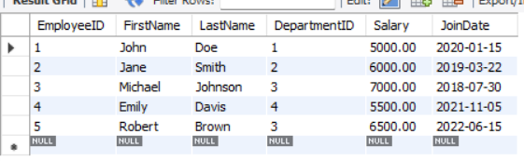
Exercise 2: Modify a Stored Procedure
DROP PROCEDURE IF EXISTS sp_GetEmployeesByDepartment;
DELIMITER $$
CREATE PROCEDURE sp_GetEmployeesByDepartment(
IN p_DepartmentID INT
)
BEGIN
SELECT
EmployeeID,
FirstName,
LastName,
DepartmentID,
Salary,
JoinDate
FROM Employees
WHERE DepartmentID = p_DepartmentID;
END $$
DELIMITER ;
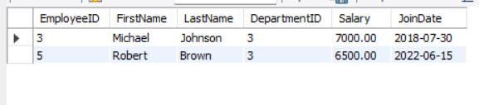

Exercise 3: Delete a Stored Procedure
DROP PROCEDURE IF EXISTS sp_GetEmployeesByDepartment;
DELIMITER $$
CREATE PROCEDURE sp_GetEmployeesByDepartment(
IN p_DepartmentID INT
)
BEGIN
SELECT EmployeeID,
FirstName,
LastName,
DepartmentID,
Salary,
JoinDate
FROM Employees
WHERE DepartmentID = p_DepartmentID;
END $$
DELIMITER ;
CALL sp_GetEmployeesByDepartment(3);
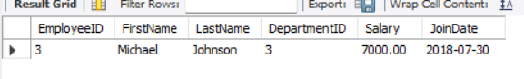
Exercise 4: Execute a Stored Procedure
DROP PROCEDURE IF EXISTS sp_GetEmployeesByDepartment;
DELIMITER $$
CREATE PROCEDURE sp_GetEmployeesByDepartment(
IN p_DepartmentID INT
)
BEGIN
SELECT EmployeeID,
FirstName,
LastName,
DepartmentID,
Salary,
JoinDate
FROM Employees
WHERE DepartmentID = p_DepartmentID;
END $$
DELIMITER ;
CALL sp_GetEmployeesByDepartment(3);
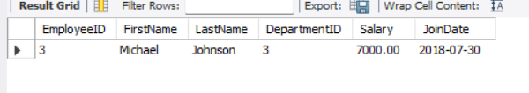
Exercise 5: Return Data from a Stored Procedure
DROP PROCEDURE IF EXISTS sp_GetEmployeeCountByDepartment;
DELIMITER $$
CREATE PROCEDURE sp_GetEmployeeCountByDepartment(
IN p_DepartmentID INT
)
BEGIN
SELECT COUNT(*) AS TotalEmployees
FROM Employees
WHERE DepartmentID = p_DepartmentID;
END $$
DELIMITER ;
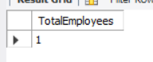
Exercise 6: Use Output Parameters in a Stored Procedure
DROP PROCEDURE IF EXISTS sp_GetTotalSalaryByDepartment;
DELIMITER $$
CREATE PROCEDURE sp_GetTotalSalaryByDepartment(
IN p_DepartmentID INT,
OUT p_TotalSalary DECIMAL(10,2)
)
BEGIN
SELECT SUM(Salary)
INTO p_TotalSalary
FROM Employees
WHERE DepartmentID = p_DepartmentID;
END $$
DELIMITER ;
CALL sp_GetTotalSalaryByDepartment(3, @TotalSalary);
SELECT @TotalSalary AS TotalSalary;
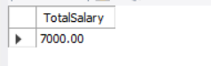
Exercise 7: Create a Stored Procedure with Multiple Parameters
DROP PROCEDURE IF EXISTS sp_UpdateEmployeeSalary;
DELIMITER $$
CREATE PROCEDURE sp_UpdateEmployeeSalary(
IN p_EmployeeID INT,
IN p_NewSalary DECIMAL(10,2)
)
BEGIN
UPDATE Employees
SET Salary = p_NewSalary
WHERE EmployeeID = p_EmployeeID;
END $$
DELIMITER ;
CALL sp_UpdateEmployeeSalary(1, 5500.00);
SELECT * FROM Employees WHERE EmployeeID = 1;
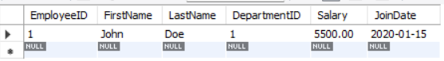

Exercise 8: Create a Stored Procedure with Conditional Logic
DROP PROCEDURE IF EXISTS sp_GiveBonus;
DELIMITER $$
CREATE PROCEDURE sp_GiveBonus(
IN p_DepartmentID INT,
IN p_BonusAmount DECIMAL(10,2)
)
BEGIN
IF p_DepartmentID IS NOT NULL THEN
UPDATE Employees
SET Salary = Salary + p_BonusAmount
WHERE DepartmentID = p_DepartmentID;
END IF;
END $$
DELIMITER ;
CALL sp_GiveBonus(1, 500.00);
SELECT * FROM Employees WHERE DepartmentID = 1;
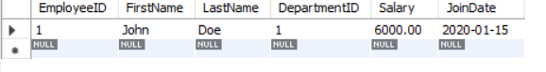
Exercise 9: Use Transactions in a Stored Procedure
DROP PROCEDURE IF EXISTS sp_UpdateSalaryTransaction;
DELIMITER $$
CREATE PROCEDURE sp_UpdateSalaryTransaction(
IN p_EmployeeID INT,
IN p_NewSalary DECIMAL(10,2)
)
BEGIN
START TRANSACTION;
UPDATE Employees
SET Salary = p_NewSalary
WHERE EmployeeID = p_EmployeeID;
COMMIT;
END $$
DELIMITER ;
CALL sp_UpdateSalaryTransaction(1, 6000.00);
SELECT * FROM Employees WHERE EmployeeID = 1;
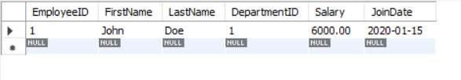
Exercise 10: Use Dynamic SQL in a Stored Procedure
DROP PROCEDURE IF EXISTS sp_GetEmployeesDynamic;
DELIMITER $$
CREATE PROCEDURE sp_GetEmployeesDynamic(
IN p_FilterColumn VARCHAR(50),
IN p_FilterValue VARCHAR(50)
)
BEGIN
SET @sql = CONCAT(
'SELECT * FROM Employees WHERE ',
p_FilterColumn,
' = ?'
);
PREPARE stmt FROM @sql;
SET @value = p_FilterValue;
EXECUTE stmt USING @value;
DEALLOCATE PREPARE stmt;
END $$
DELIMITER ;
CALL sp_GetEmployeesDynamic('DepartmentID', '3');
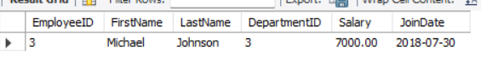
Exercise 11: Handle Errors in a Stored Procedure
DROP PROCEDURE IF EXISTS sp_UpdateSalaryWithErrorHandling;
DELIMITER $$
CREATE PROCEDURE sp_UpdateSalaryWithErrorHandling(
IN p_EmployeeID INT,
IN p_NewSalary DECIMAL(10,2)
)
BEGIN
DECLARE EXIT HANDLER FOR SQLEXCEPTION
BEGIN
ROLLBACK;
SELECT 'Error occurred while updating employee salary.' AS Message;
END;
START TRANSACTION;
UPDATE Employees
SET Salary = p_NewSalary
WHERE EmployeeID = p_EmployeeID;
COMMIT;
SELECT 'Salary updated successfully.' AS Message;
END $$
DELIMITER ;
CALL sp_UpdateSalaryWithErrorHandling(1, 6500.00);
SELECT * FROM Employees WHERE EmployeeID = 1;
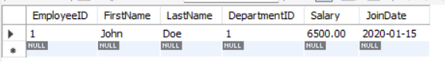
5. SQL Exercise - Funtions
CREATE TABLE Departments (
DepartmentID INT PRIMARY KEY,
DepartmentName VARCHAR(100)
);
CREATE TABLE Employees (
EmployeeID INT PRIMARY KEY,
FirstName VARCHAR(50),
LastName VARCHAR(50),
DepartmentID INT,
Salary DECIMAL(10,2),
JoinDate DATE
);
INSERT INTO Departments VALUES
(1, 'HR'),
(2, 'IT'),
(3, 'Finance');
INSERT INTO Employees VALUES
(1, 'John', 'Doe', 1, 5000.00, '2020-01-15'),
(2, 'Jane', 'Smith', 2, 6000.00, '2019-03-22'),
(3, 'Bob', 'Johnson', 3, 5500.00, '2021-07-01');
-- Annual Salary
SELECT EmployeeID, FirstName, Salary,
Salary * 12 AS AnnualSalary
FROM Employees;
-- Bonus 10%
SELECT EmployeeID, FirstName, Salary,
Salary * 0.10 AS Bonus
FROM Employees;
-- Bonus 15%
SELECT EmployeeID, FirstName, Salary,
Salary * 0.15 AS Bonus
FROM Employees;
-- IT Department
SELECT *
FROM Employees
WHERE DepartmentID = 2;
-- Finance Department
SELECT *
FROM Employees
WHERE DepartmentID = 3;
-- Annual salary of Employee 1
SELECT EmployeeID, FirstName, Salary,
Salary * 12 AS AnnualSalary
FROM Employees
WHERE EmployeeID = 1;
-- Total Compensation
SELECT EmployeeID, FirstName, Salary,
(Salary * 12) + (Salary * 0.15) AS TotalCompensation
FROM Employees;
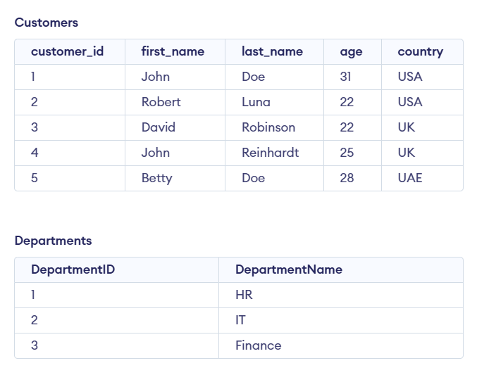
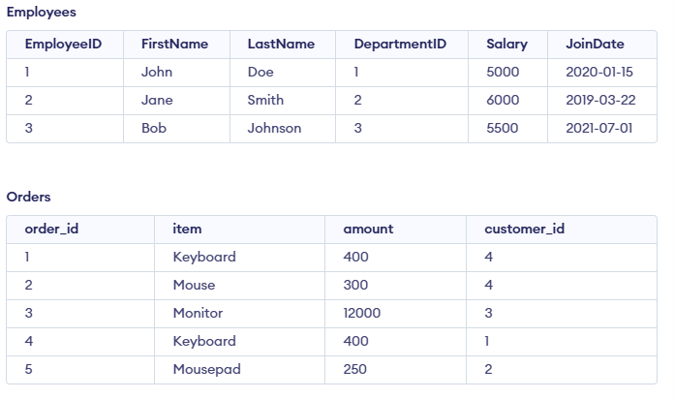

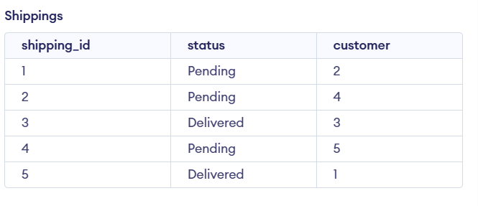
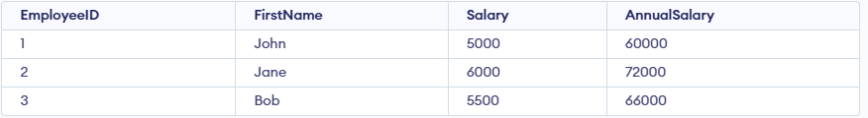
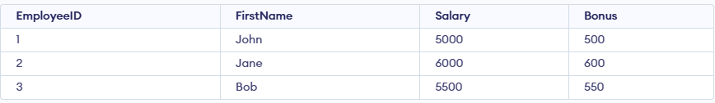
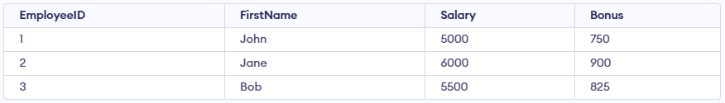
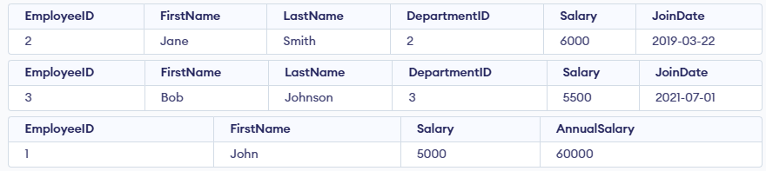
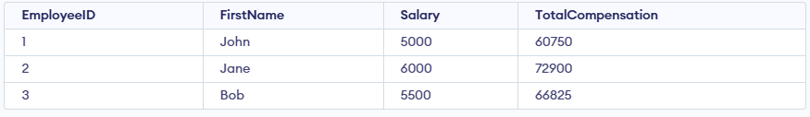

6. SQL Exercise-Triggers
Exercise 1: Create an After Trigger
create database db;
use db;
CREATE TABLE Departments (
DepartmentID INT PRIMARY KEY,
DepartmentName VARCHAR(100)
);
CREATE TABLE Employees (
EmployeeID INT PRIMARY KEY,
FirstName VARCHAR(50),
LastName VARCHAR(50),
DepartmentID INT,
Salary DECIMAL(10,2),
JoinDate DATE,
FOREIGN KEY (DepartmentID) REFERENCES Departments(DepartmentID)
);
INSERT INTO Departments (DepartmentID, DepartmentName) VALUES
(1, 'HR'),
(2, 'Finance'),
(3, 'IT'),
(4, 'Marketing');
INSERT INTO Employees (EmployeeID, FirstName, LastName, DepartmentID, Salary, JoinDate) VALUES
(1, 'John', 'Doe', 1, 5000.00, '2022-01-15'),
(2, 'Jane', 'Smith', 2, 6000.00, '2021-03-22'),
(3, 'Michael', 'Johnson', 3, 7000.00, '2020-07-30'),
(4, 'Emily', 'Davis', 4, 5500.00, '2019-11-05');
CREATE TABLE EmployeeChanges (
ChangeID INT AUTO_INCREMENT PRIMARY KEY,
EmployeeID INT,
OldSalary DECIMAL(10,2),
NewSalary DECIMAL(10,2),
ChangeDate DATETIME DEFAULT CURRENT_TIMESTAMP
);
DELIMITER $$
CREATE TRIGGER trg_AfterSalaryUpdate
AFTER UPDATE ON Employees
FOR EACH ROW
BEGIN
IF OLD.Salary <> NEW.Salary THEN
INSERT INTO EmployeeChanges
(EmployeeID, OldSalary, NewSalary)
VALUES
(OLD.EmployeeID, OLD.Salary, NEW.Salary);
END IF;
END$$
DELIMITER ;
UPDATE Employees
SET Salary = 5500.00
WHERE EmployeeID = 1;
SELECT * FROM EmployeeChanges;
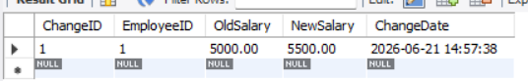

Exercise 2: Create an Instead of Trigger
DELIMITER $$
CREATE TRIGGER trg_PreventEmployeeDelete
BEFORE DELETE ON Employees
FOR EACH ROW
BEGIN
SIGNAL SQLSTATE '45000'
SET MESSAGE_TEXT = 'Deletion of employee records is not allowed';
END$$
DELIMITER ;
DELETE FROM Employees
WHERE EmployeeID = 1;
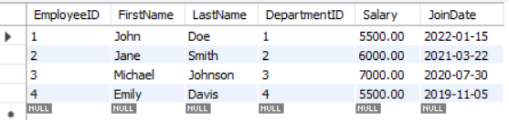

Exercise 3: Create a Logon Trigger
CREATE TRIGGER trg_RestrictLogin
ON ALL SERVER
FOR LOGON
AS
BEGIN
IF DATEPART(HOUR, GETDATE()) >= 2
AND DATEPART(HOUR, GETDATE()) < 3
BEGIN
ROLLBACK;
RAISERROR ('Login is not allowed during maintenance hours (2 AM - 3 AM).', 16, 1);
END
END;
GO
Output:
Login is not allowed during maintenance hours (2 AM - 3 AM).
Login failed.
Exercise 4: Modify a Trigger using SSMS
DELIMITER $$
CREATE TRIGGER trg_AfterSalaryUpdate
AFTER UPDATE ON Employees
FOR EACH ROW
BEGIN
IF NEW.Salary > OLD.Salary THEN
INSERT INTO EmployeeChanges
(EmployeeID, OldSalary, NewSalary)
VALUES
(OLD.EmployeeID, OLD.Salary, NEW.Salary);
END IF;
END$$
DELIMITER ;
UPDATE Employees
SET Salary = 6500.00
WHERE EmployeeID = 2;
SELECT * FROM EmployeeChanges;
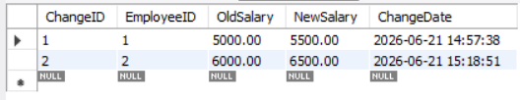
Exercise 5: Delete a Trigger
DROP TRIGGER IF EXISTS trg_AfterSalaryUpdate;
SHOW TRIGGERS;
Exercise 6: Create a Trigger to Update a Computed Column
ALTER TABLE Employees
ADD COLUMN AnnualSalary DECIMAL(12,2);
UPDATE Employees
SET AnnualSalary = Salary * 12
WHERE EmployeeID > 0;
DELIMITER $$
CREATE TRIGGER trg_UpdateAnnualSalary
BEFORE UPDATE ON Employees
FOR EACH ROW
BEGIN
SET NEW.AnnualSalary = NEW.Salary * 12;
END$$
DELIMITER ;
UPDATE Employees
SET Salary = 8000.00
WHERE EmployeeID = 3;
SELECT EmployeeID, FirstName, Salary, AnnualSalary
FROM Employees;
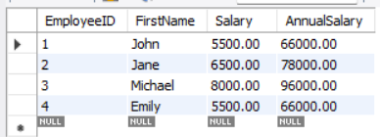
7. SQL Exercise - Cursors
CREATE TABLE Departments (
DepartmentID INT PRIMARY KEY,
DepartmentName VARCHAR(100)
);
CREATE TABLE Employees (
EmployeeID INT PRIMARY KEY,
FirstName VARCHAR(50),
LastName VARCHAR(50),
DepartmentID INT,
Salary DECIMAL(10,2),
JoinDate DATE
);
INSERT INTO Departments VALUES
(1,'HR'),
(2,'IT'),
(3,'Finance');
INSERT INTO Employees VALUES
(1,'John','Doe',2,5000,'2020-01-15'),
(2,'Jane','Smith',1,6000,'2019-03-22'),
(3,'Bob','Johnson',3,5500,'2021-07-30');
-- Instead of CURSOR (not supported in MySQL/SQLite),
-- we directly fetch row-by-row result using SELECT
SELECT
EmployeeID,
FirstName,
LastName,
DepartmentID,
Salary,
JoinDate
FROM Employees;
SELECT
e.EmployeeID,
e.FirstName,
e.LastName,
d.DepartmentName,
e.Salary,
e.JoinDate
FROM Employees e
JOIN Departments d
ON e.DepartmentID = d.DepartmentID;
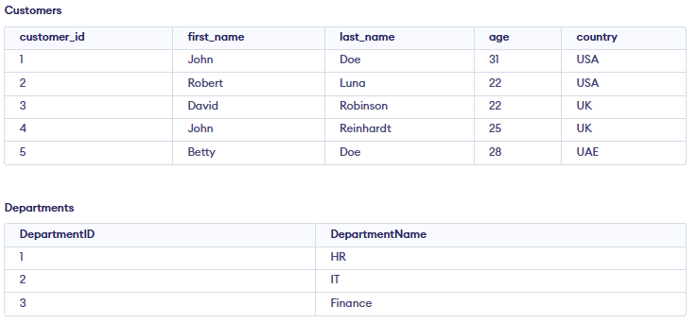
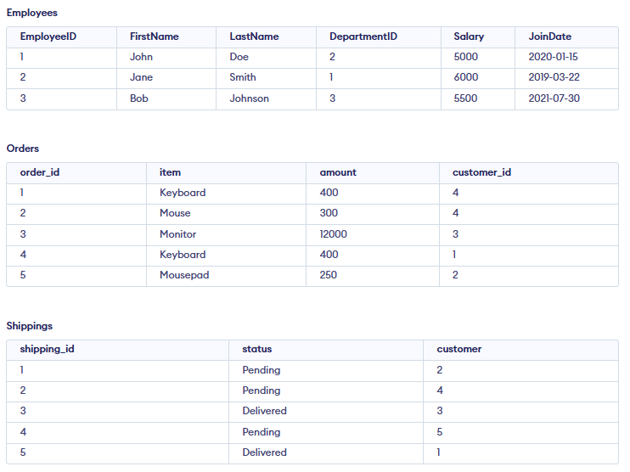
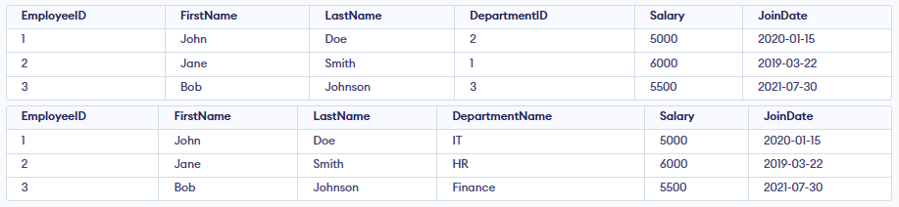

8. SQL Exercise – Exception handling
CREATE TABLE Departments (
DepartmentID INT PRIMARY KEY,
DepartmentName TEXT NOT NULL
);
CREATE TABLE Employees (
EmployeeID INT PRIMARY KEY,
FirstName TEXT,
LastName TEXT,
Email TEXT UNIQUE,
Salary REAL,
DepartmentID INT
);
CREATE TABLE AuditLog (
LogID INTEGER PRIMARY KEY AUTOINCREMENT,
Action TEXT,
ErrorMessage TEXT,
ActionDate DATETIME DEFAULT CURRENT_TIMESTAMP
);
INSERT INTO Departments VALUES (1, 'IT');
INSERT INTO Departments VALUES (2, 'HR');
-- VALID INSERT
INSERT INTO Employees VALUES (101, 'John', 'Doe', 'john@gmail.com', 5000, 1);

-- LOW SALARY ERROR SIMULATION
INSERT INTO AuditLog(Action, ErrorMessage)
VALUES ('Add Employee', 'Warning: Salary too low (simulated)');
-- INVALID SALARY SIMULATION
INSERT INTO AuditLog(Action, ErrorMessage)
VALUES ('Add Employee Failed', 'Salary must be greater than zero (simulated)');
INSERT INTO AuditLog(Action, ErrorMessage)
VALUES ('Throw Simulation', 'Error re-raised (simulated behavior)');
-- SUCCESS UPDATE
UPDATE Employees
SET DepartmentID = 2
WHERE EmployeeID = 101;
-- ERROR LOG (department not found simulation)
INSERT INTO AuditLog(Action, ErrorMessage)
VALUES ('Transfer Failed', 'Department does not exist (simulated)');
BEGIN TRANSACTION;
INSERT INTO Employees VALUES (102, 'Alice', 'Smith', 'alice@gmail.com', 3000, 1);
INSERT INTO Employees VALUES (103, 'Bob', 'Marley', 'bob@gmail.com', 4500, 2);
INSERT INTO Employees VALUES (104, 'Eva', 'Brown', 'eva@gmail.com', 3500, 1);
COMMIT;
INSERT INTO AuditLog(Action, ErrorMessage)
VALUES ('Batch Insert', 'Transaction completed successfully')
SELECT * FROM Departments;
SELECT * FROM Employees;
SELECT * FROM AuditLog;
