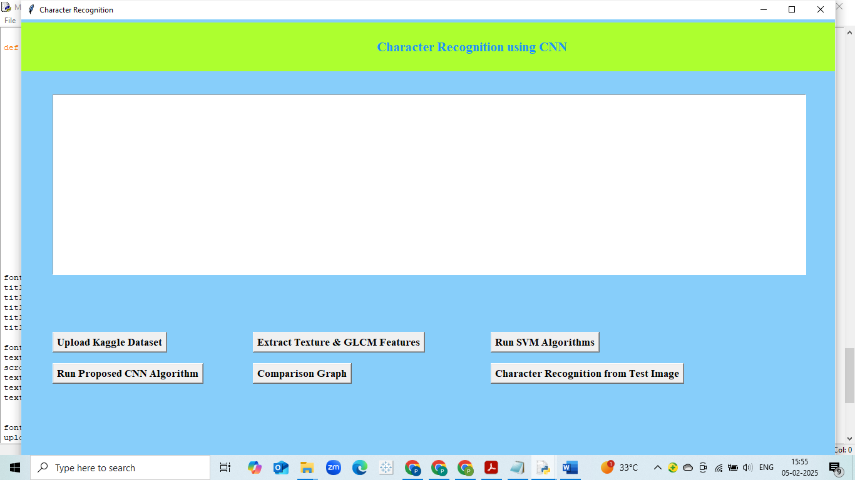
Fig: Graphical user interface
This is user interface to execute the project.
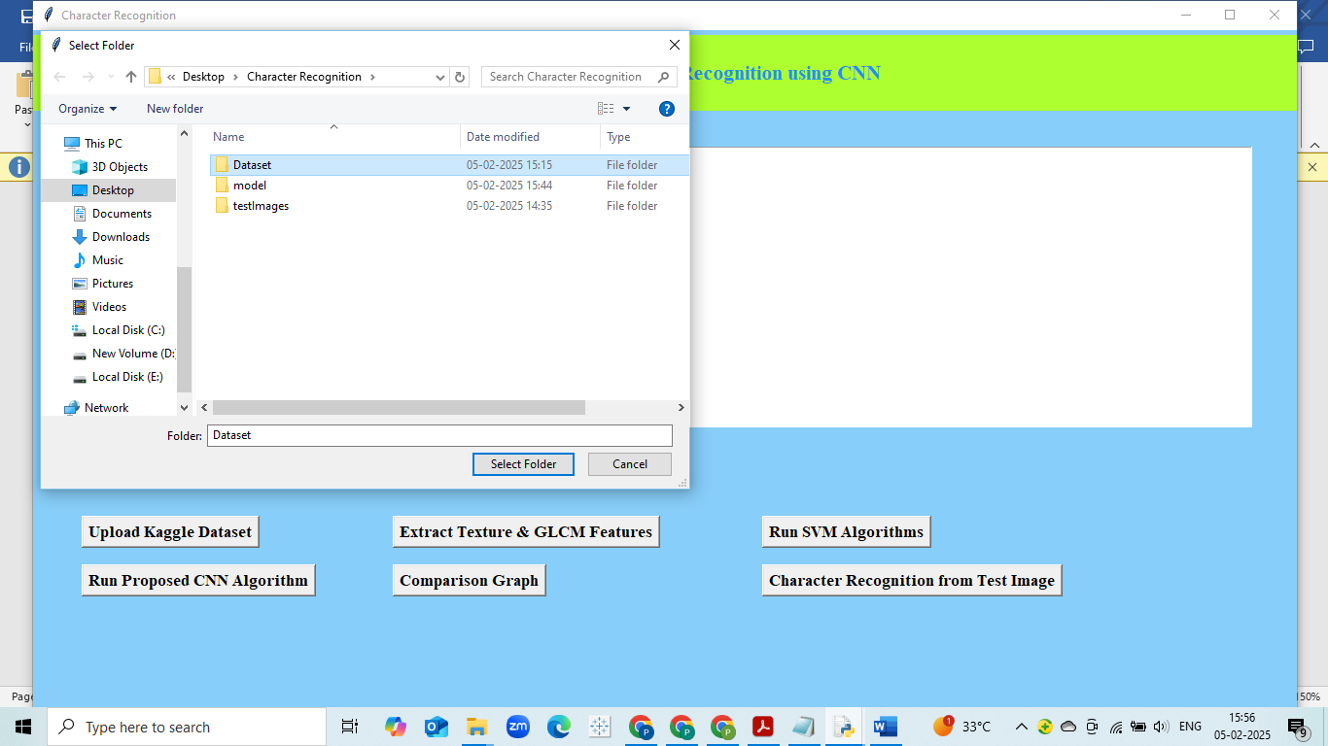
Fig: Upload dataset
First step is uploading the Kaggle dataset.
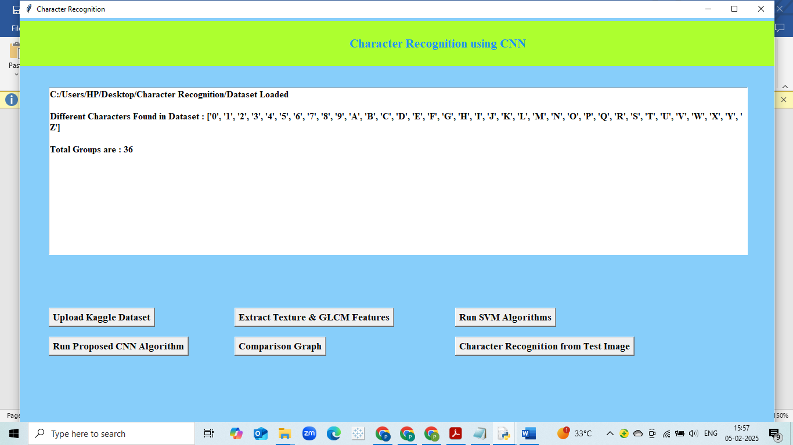
Fig: Dataset loaded
Dataset is loaded with different character groups.
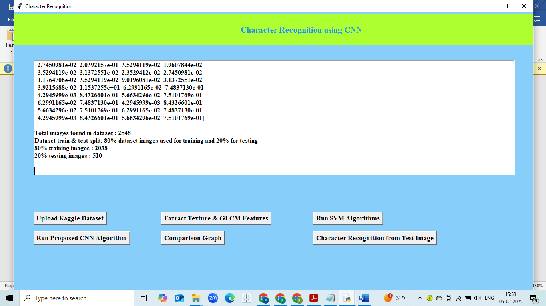
Fig: Feature extraction
Data preprocessing and feature extraction is done.
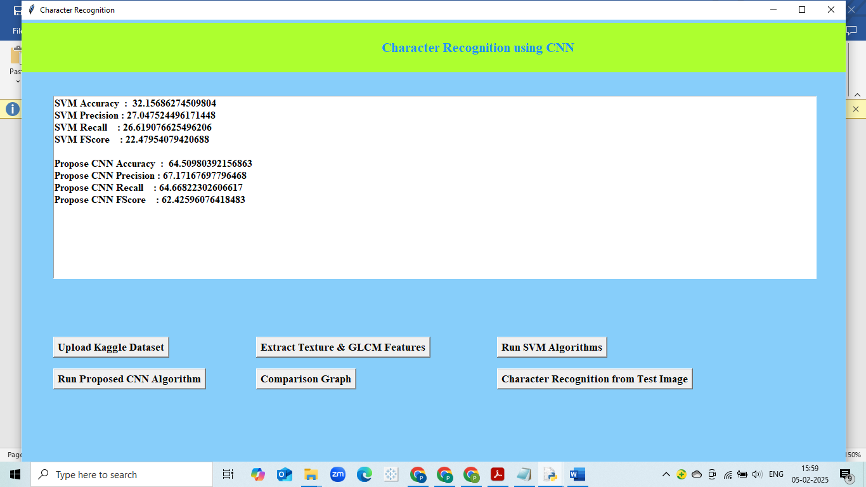
Fig: Performance of SVM and CNN algorithm
This is performance of two algorithms svm and cnn with different performance metrics.

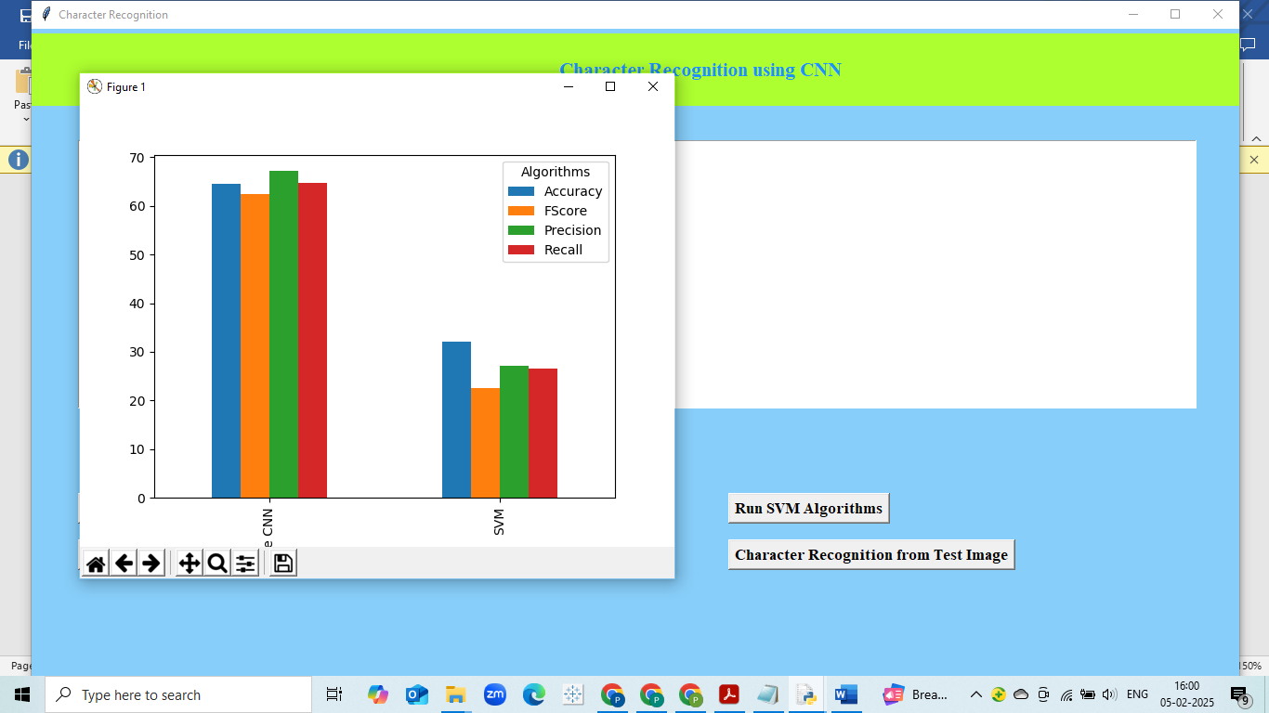
Fig: comparison graph of SVM and CNN algorithm.

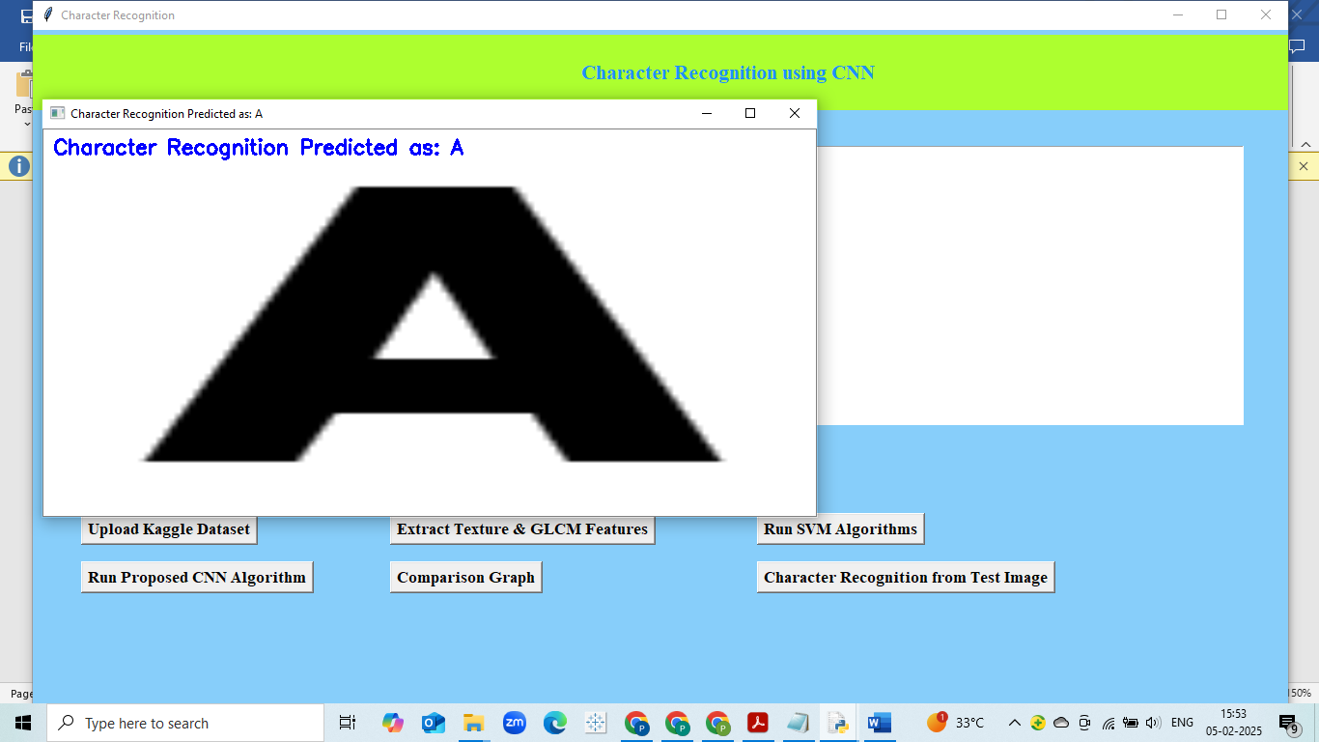
Fig: Character prediction as A

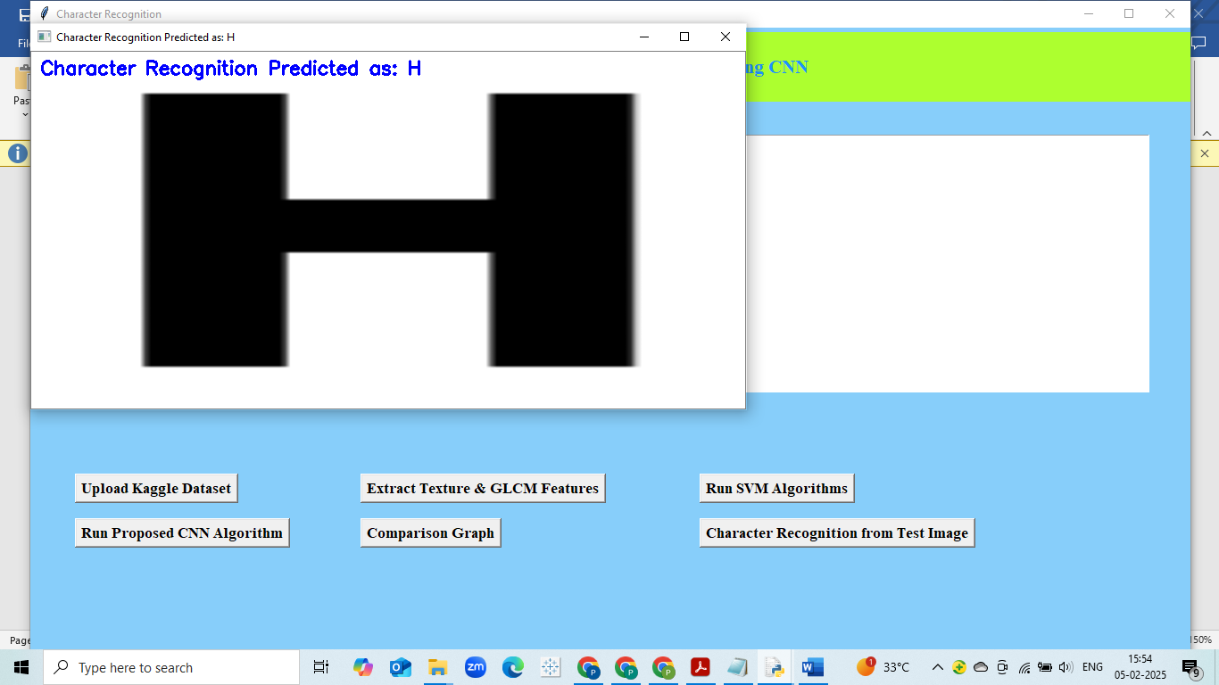
Fig: Character prediction as H
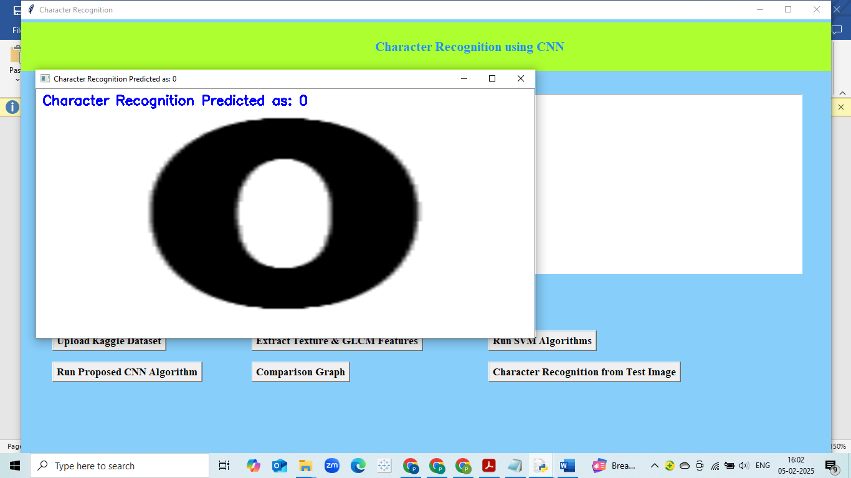
Fig: Character prediction as 0

