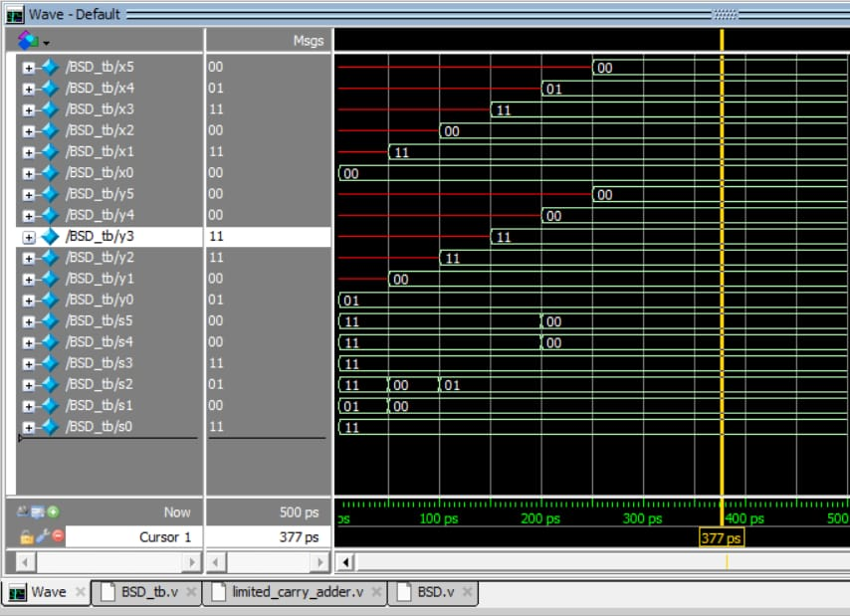

The given output waveform shows the BSD addition of +6 and -11
+6 is input as 00 01 11 00 11 00
-11 is input as 00 00 11 11 00 01
Output is 00 00 11 01 00 11

The out gives -5 as output which is correct.

