SWIFT SHIP TRACKER

User Story:
The SwiftShip Tracker is a centralized Salesforce-based parcel management system developed to simplify shipment operations by allowing customers to book parcels, monitor delivery status, and manage shipments through an easy-to-use interface with conversational AI assistance. The system maintains Sender, Receiver, Parcel, and Delivery details using Salesforce custom objects and their relationships. Salesforce Flows automate parcel-related processes and notifications, while Agentforce AI and Prompt Builder allow customers to access parcel information and communicate with the system using natural language. Delivery agents can update parcel statuses in real time, while Experience Cloud, security controls, reports, and dashboards ensure secure customer access and provide clear visibility into delivery operations.
1. INTRODUCTION
1.1 Project Overview:
The SwiftShip Tracker is a Salesforce-based CRM solution designed to streamline parcel booking, shipment tracking, and delivery management. It manages the complete parcel lifecycle, starting from booking and dispatch to shipment tracking and final delivery confirmation. Customers can conveniently access their shipment details, while delivery agents can update parcel information and delivery statuses.
1.2 Purpose:
The primary purpose of SwiftShip Tracker is to:
● Maintain parcel and delivery information in a centralized system.
● Make parcel booking and shipment tracking easier and more efficient.
● Provide real-time visibility into shipment status.
● Automate delivery status updates and customer notifications.
● Support conversational parcel tracking through AgentForce AI and Prompt Builder.

OBJECTIVES
- The main objective of developing the Swift Ship Tracker CRM is to streamline parcel operations by bringing the entire shipment lifecycle into a single, integrated system. The solution replaces manual tracking processes and disconnected communication with automated, real-time workflows, helping to reduce administrative effort and prevent data entry errors.
- The system aims to improve customer satisfaction by providing clear shipment visibility and conversational self-service tracking, thereby improving customer confidence and reducing the need for frequent support assistance. In addition, the CRM provides business administrators with real-time operational dashboards to monitor deliveries, identify delays, and address potential bottlenecks efficiently.
- The system also ensures secure management of parcel information through role-based access controls, allowing users to access data and features according to their assigned responsibilities.

1.IDEATION PHASE
  - Problem Statement (Customer Problem Statement Template)

PS | I am  (Customer) | I’m trying to | But | Because | Which makes me  feel
PS-1 | Customer /  Sender | book a parcel easily | The booking process may require assistance or multiple applications | Parcel-related operations are not centralized | frustrated
PS-2 | Customer /  Sender | Track my parcel easily | I do not have a simple real-time tracking experience | Shipment information is difficult to access | confused
PS-3 | Delivery Agent | update parcel status | status updates require manual handling | Centralized operational tracking is needed | concerned
PS-4 | Customer | receive delivery updates | Notifications may not be available at every stage of delivery | Communication needs to be automated | uncertain
PS-5 | Admin | monitor parcel operations | Parcel flow and delivery performance are difficult to monitor | operational data needs centralized reporting | Overwhelmed

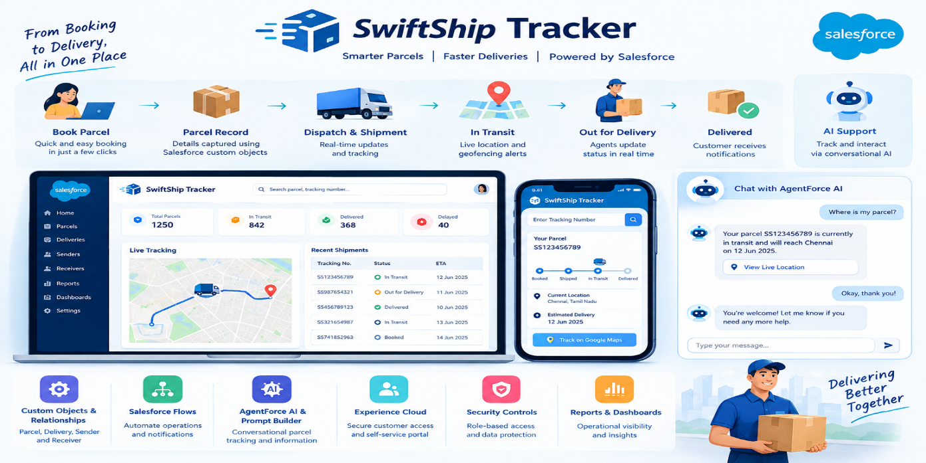
  - Empathy Map Canvas
User Persona: Customer / Sender
- Gain: Access to real-time shipment visibility, easy self-service tracking, convenient parcel booking, and timely delivery notifications
- Hear: Gets shipment-related information, delivery notifications, and status updates from the parcel service.
- Pain: Experiences delivery delays, difficulty understanding shipment status, limited tracking options, and reliance on support or multiple applications.
- Say & Do: Places parcel bookings, monitors shipment progress, and contacts the service for delivery-related updates.
- See: Views parcel details, current tracking status, expected delivery date, and other shipment information.
- Think & Feel: Looks for a convenient and straightforward way to book and monitor parcels without frequently depending on customer support.

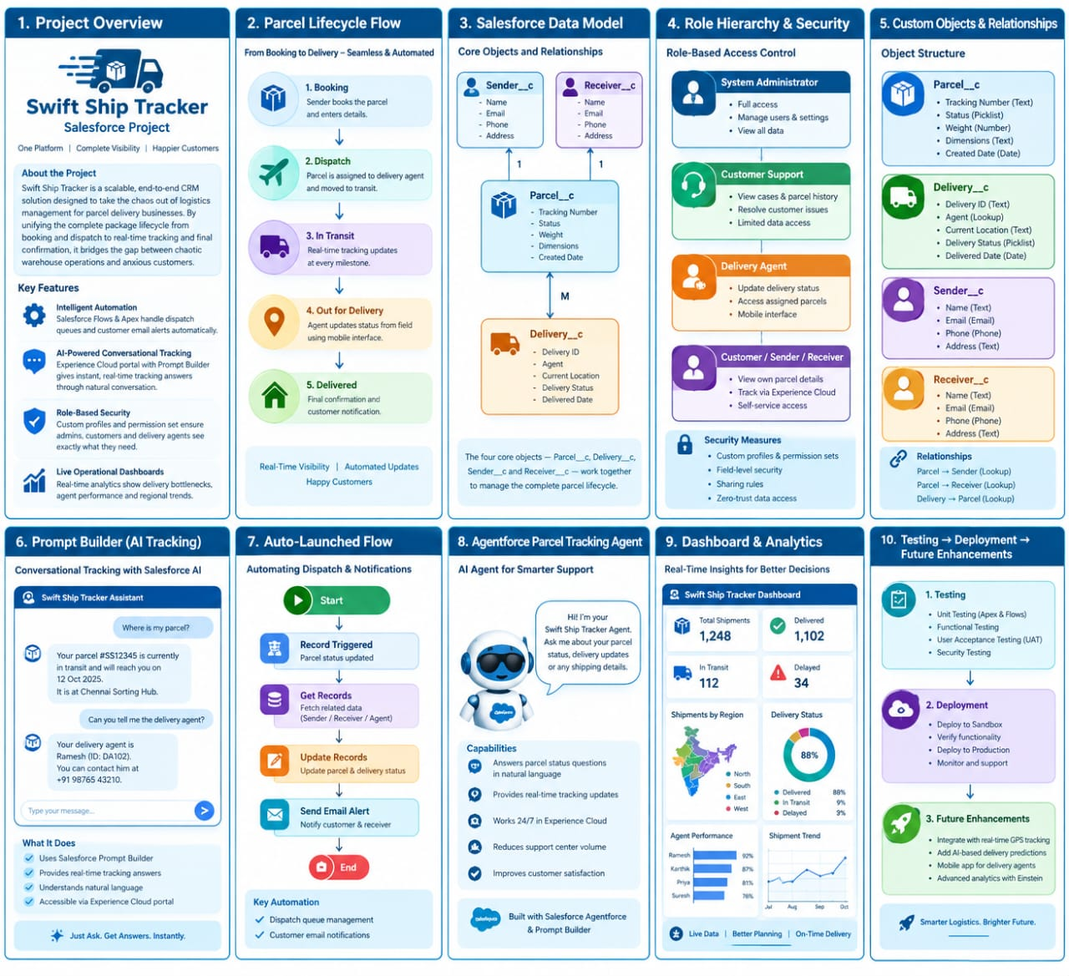
1.1 Brainstorming & Idea Prioritization
Ideas Considered
● Manual record maintenance
● Spreadsheet-based parcel tracking
● Independent parcel management portal
● Salesforce CRM integrated with AgentForce AI
Final Selection
Salesforce CRM was selected because it provides:
● Centralized management of parcel information
● Automated processes using Salesforce Flows
● Real-time visibility of shipment progress
● Conversational AI-based customer assistance
● Secure access based on user roles
● Comprehensive reports and dashboards for operational monitoring

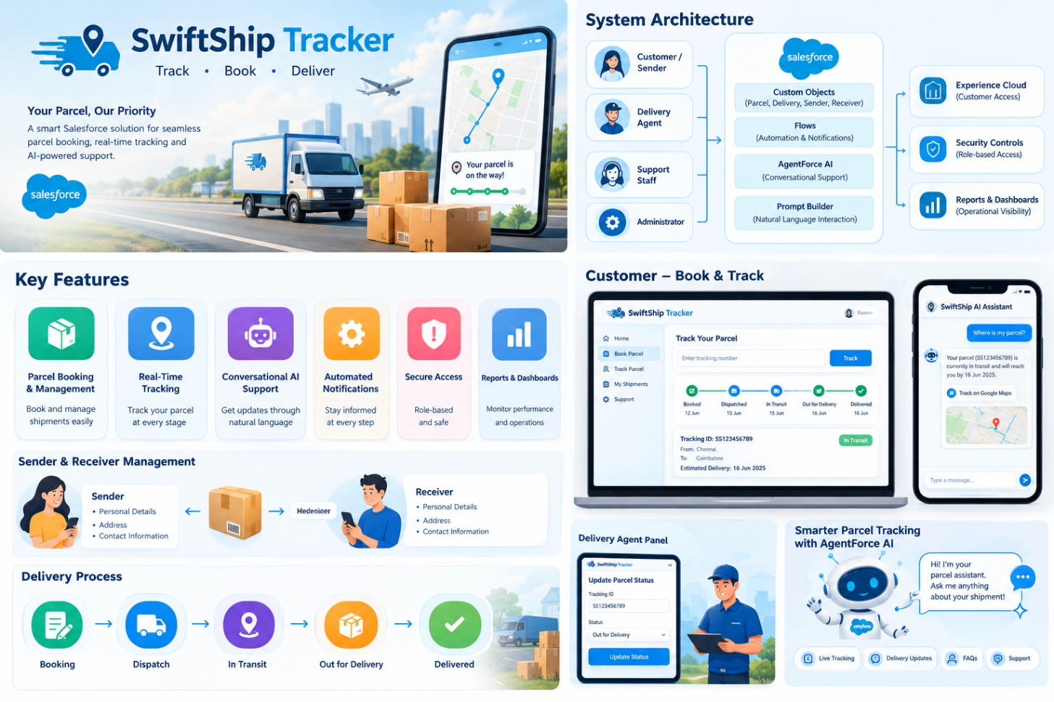

3.REQUIREMENT ANALYSIS PHASE
3.1 Customer Journey Map
A Customer Journey Map represents the different stages a customer goes through while using the SwiftShip Tracker system, from booking a parcel to receiving the final delivery confirmation. It helps identify the customer’s actions, needs, challenges, and interactions at each stage of the parcel delivery process.

Stage | Customer Action | Customer Need | Possible Challenge | SwiftShip Tracker Solution
1. Parcel Booking | Enters sender, receiver, and parcel details | Easy and quick booking | Manual entry or complicated booking process | Centralized parcel booking
2. Booking Confirmation | Reviews and confirms the shipment | Confirmation of successful booking | Lack of immediate confirmation | Automated confirmation and notifications
3. Shipment Tracking | Checks the parcel status | Real-time shipment visibility | Difficulty accessing tracking information | Real-time tracking status
4. Delivery Updates | Receives shipment notifications | Timely information about delivery progress | Missed or delayed updates | Automated status notifications
5. Delivery | Receives the parcel | Successful and timely delivery | Delivery delays or uncertainty | Delivery status updates
6. Delivery Confirmation | Confirms receipt of the parcel | Clear completion of shipment | Lack of final status information | Automated delivery confirmation
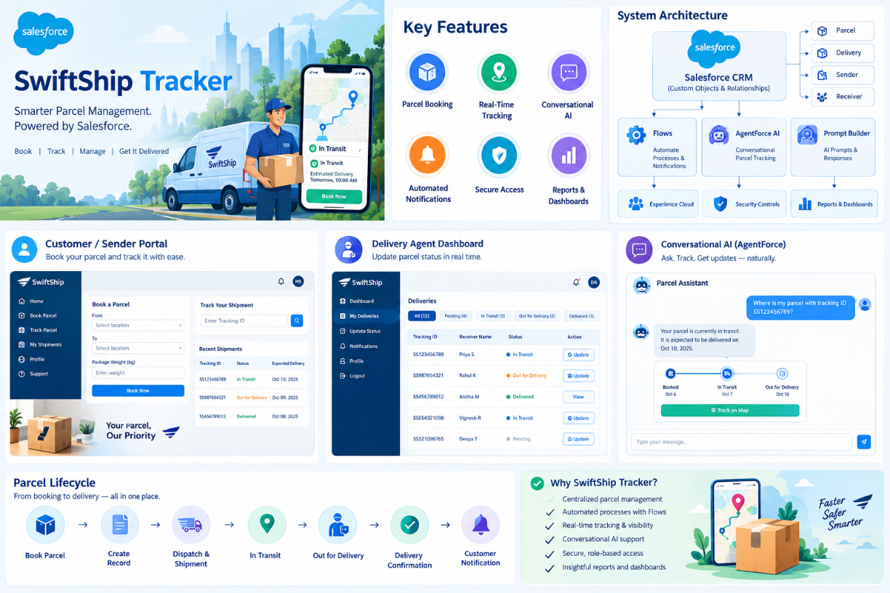

  - Solution Requirements

Functional Requirements

FR No | Requirement | Person/Actor
FR-1 | Parcel booking and record creation | Customer / Sender
FR-2 | Parcel status tracking | Customer / Sender
FR-3 | Weight management | Customer / Agent
FR-8 | Parcel status updates | Delivery Agent
FR-9 | Automated customer notifications | System → Customer
FR-11 | Reports and dashboards | Admin
FR-12 | Experience Cloud access | Customer

Non-Functional Requirements

NFR No | Requirement
NFR-1 | Security: Parcel and customer information should be protected through appropriate Salesforce security controls.
NFR-2 | Performance: The system should respond quickly when users access parcel details and tracking information.
NFR-3 | Reliability: The system should provide consistent parcel tracking and delivery information with minimal failures.
NFR-4 | Usability: The application should have a simple and user-friendly interface for customers, agents, and administrators.
NFR-5 | Scalability: The system should support increasing numbers of parcels, customers, and delivery records.
NFR-6 | Availability: Parcel information and tracking services should be accessible whenever required.
NFR-7 | Maintainability: The system should be easy to maintain, update, and modify when business requirements change.
NFR-8 | Data Integrity: Parcel, sender, receiver, and delivery information should remain accurate and consistent.
NFR-9 | Accessibility: Customers should be able to access shipment information through the Salesforce Experience Cloud interface.
NFR-10 | Automation Efficiency: Automated workflows and notifications should execute accurately and reduce unnecessary manual effort.

Functional Requirement | Description
Parcel Booking | The system should allow customers or senders to create a parcel booking by entering sender, receiver, and parcel details.
Parcel Management | The system should store and manage parcel information in a centralized Salesforce database.
Shipment Tracking | Customers should be able to view the current status and progress of their parcels.
Status Updates | Delivery agents should be able to update parcel statuses at different stages of delivery.
Automated Notifications | The system should automatically send customers notifications when the parcel status changes.
Delivery Management | The system should maintain delivery details and record the completion of deliveries.
AgentForce AI Assistance | Customers should be able to interact with the AI assistant to obtain parcel and delivery information using conversational queries.
Prompt Builder | Prompt Builder should support AI-based responses for parcel-related customer queries.
Reports and Dashboards | Administrators should be able to view parcel, delivery, and operational information through reports and dashboards.
Role-Based Access | The system should provide appropriate access to customers, delivery agents, and administrators based on their assigned roles.

  - Data Flow Diagram
Main entities:
- Customer / Sender
- Delivery Agent
- Admin
- SwiftShip Tracker (Salesforce CRM)
- AgentForce AI
- Experience Cloud

Flow:
Customer / Shipper
↓
Shipment Request
↓
Shipment Entry Creation
↓
Sender & Recipient Details
↓
Delivery Information
↓
Shipment Progress Updates
↓
Live Location & Expected Arrival
↓
Automatic Status Alerts
↓
Online Tracking / AgentForce AI Support
↓
Administrative Reports & Dashboards

AI Tracking Flow
Customer
↓
Tracking Query
↓
AgentForce AI
↓
Parcel / Tracking ID
↓
Salesforce CRM
↓
Retrieve Shipment Details
↓
Process Tracking Information
↓
Current Status + Location + ETA
↓
AI-Generated Response
↓
Customer

The Prompt Builder configuration fetches essential parcel details, including the Parcel ID, current Status, Weight, and Estimated Delivery Date, to generate accurate tracking responses for customers..

3.4 Technology Stack

Technology / Tool | Purpose in the Project
Salesforce CRM | Acts as the central platform for storing and managing parcel, sender, receiver, and delivery information.
Salesforce Custom Objects | Used to create and organize records such as Parcel, Delivery, Sender, and Receiver.
Salesforce Flows | Automates processes such as status updates, notifications, and record-related operations.
AgentForce AI | Provides conversational assistance for customers to ask questions and track their parcels.
Prompt Builder | Creates AI prompts that retrieve relevant parcel information and generate tracking responses.
Salesforce Experience Cloud | Provides a customer-facing portal where users can access shipment and tracking information.
Apex | Used to implement custom business logic and functionality that cannot be handled directly through standard Salesforce features.
Reports & Dashboards | Used by administrators to monitor parcel activity, delivery progress, and operational information.
Salesforce Security & Access Controls | Controls user access to data and features according to their roles and responsibilities.

- PROJECT DESIGN PHASE
The Project Design Phase focuses on defining the overall structure, components, data organization, user interactions, and system workflows of the SwiftShip Tracker. The design ensures that parcel booking, shipment tracking, delivery updates, notifications, and AI-based assistance work together as a unified Salesforce solution.
4.1 System Architecture
The SwiftShip Tracker follows a Salesforce-based architecture where Salesforce CRM acts as the central platform. Customer and delivery information is stored using custom objects and relationships. Salesforce Flows automate business processes and notifications, while Apex supports additional custom logic. AgentForce AI and Prompt Builder provide conversational parcel-tracking assistance. Experience Cloud enables customers to access shipment information, while Reports and Dashboards help administrators monitor operations.
4.2 Data Model Design
The system uses Salesforce custom objects to organize parcel-related information. The main data components include:
- Parcel – Stores shipment details such as Parcel ID, weight, status, and estimated delivery date.
- Sender – Maintains information about the person sending the parcel.
- Receiver – Stores details of the person receiving the parcel.
- Delivery – Contains delivery-related information such as delivery status and current location.
- Relationships – Connects parcel, sender, receiver, and delivery records to maintain consistent and accessible information.
4.3 User Interface Design
The interface is designed to provide simple access to parcel services. Customers can book shipments and check tracking information, while delivery agents can update delivery status. Administrators can use Salesforce dashboards and reports to monitor overall parcel operations.
4.4 Automation Design
Salesforce Flows are designed to automate repetitive parcel-management activities. They can handle status-based updates, notifications, and other business processes, reducing manual work and improving consistency.
4.5 AI Tracking Design
AgentForce AI and Prompt Builder are integrated into the system to support conversational tracking. When a customer submits a tracking query, the system retrieves relevant parcel information from Salesforce and generates a response containing details such as Parcel ID, status, weight, and estimated delivery date.
4.6 Security Design
The system uses Salesforce security features and role-based access controls to ensure that users can access only the information and functions appropriate to their responsibilities. This helps protect customer, parcel, and delivery information.

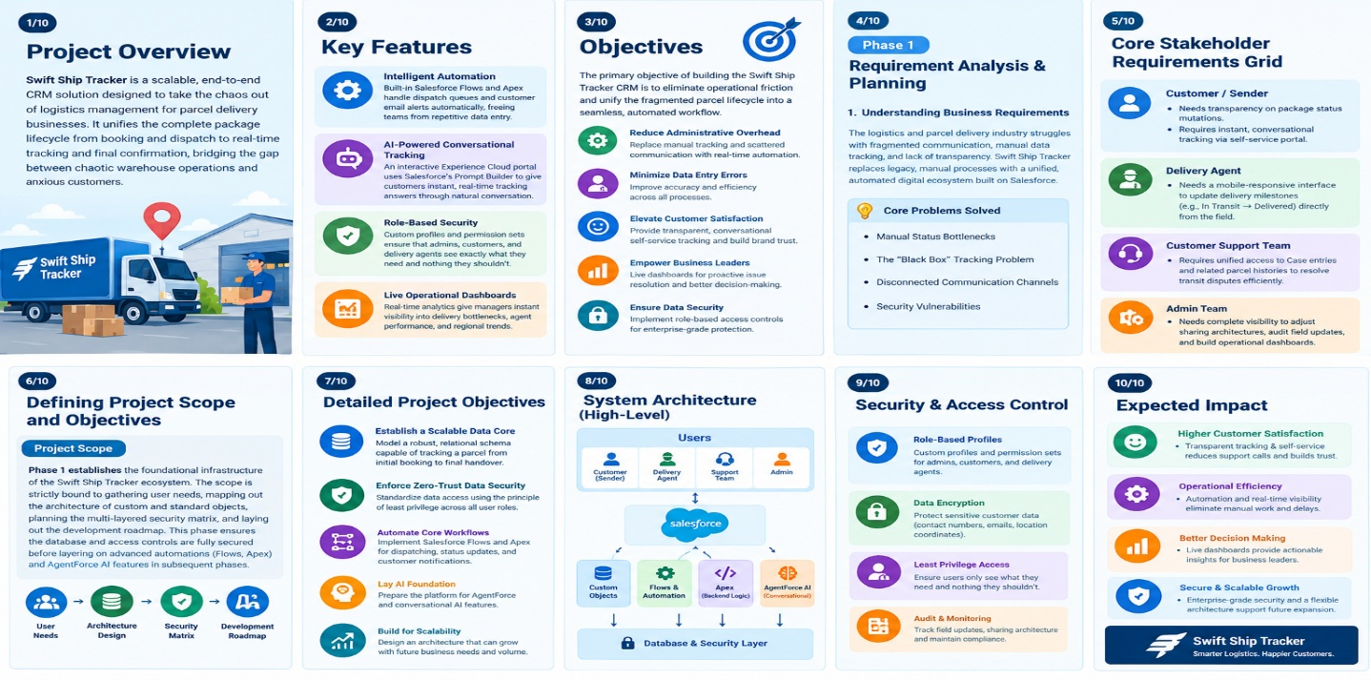
  - Proposed Solution
Functional Requirements

Parameter | Description
Challenge | Traditional parcel operations can involve fragmented processes, making shipment booking and monitoring difficult to manage efficiently.
Proposed Approach | A centralized Salesforce CRM platform that brings parcel, customer, and delivery activities together in one system.
Key Technology | Conversational tracking through AgentForce AI and Prompt Builder, combined with Salesforce automation for handling shipment-related processes.
Expected Outcome | Improved shipment visibility, simplified parcel handling, automated customer communication, and better coordination of delivery activities.
Operational Scope | Covers shipment processing, customer information, delivery-agent activities, support functions, and administrative management.
Future Expansion | The platform can accommodate increasing shipment volumes and can be extended through Experience Cloud and connections with external logistics services.

  - Solution Architecture ArchitectureComponen:

Customer Layer
Customers access the system through Salesforce Experience Cloud to book parcels, view shipment information, and track deliveries.

Application Layer
Salesforce CRM manages parcel booking, sender and receiver details, delivery records, and shipment status information using custom objects and relationships.

Automation Layer
Salesforce Flows automate activities such as record updates, status-based processes, and customer notifications, reducing manual intervention.

AI Layer
AgentForce AI provides conversational support for parcel-related queries. Prompt Builder retrieves relevant shipment information and helps generate appropriate tracking responses.

Custom Logic Layer
Apex can be used to implement additional business logic and customized operations that require functionality beyond standard Salesforce configuration.

Monitoring Layer
Reports and Dashboards provide administrators with a consolidated view of parcel activity, delivery progress, and operational performance.

Security Layer
Salesforce security mechanisms and role-based access controls protect system data and ensure that users receive access according to their responsibilities.

Architecture Flow

Customer / Sender
↓
Experience Cloud
↓
Salesforce CRM
↓
Custom Objects & Relationships
↓
Parcel, Sender, Receiver & Delivery Data
↓
Salesforce Flows & Apex
↓
Automated Status Updates & Notifications
↓
AgentForce AI + Prompt Builder
↓
Shipment Tracking Details
↓
Customer
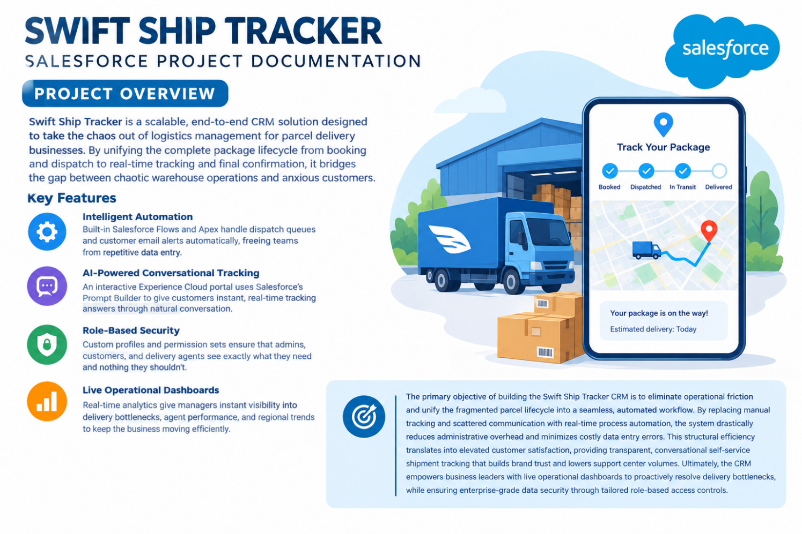

5. PROJECT PLANNING & SCHEDULING

Project planning and scheduling define the activities, resources, responsibilities, and timeline required to develop the SwiftShip Tracker system successfully. The project is divided into different phases to ensure that each stage is completed systematically and within the planned time.
The development process includes requirement analysis, system design, Salesforce configuration, automation development, AI integration, testing, and final documentation. Each phase is assigned specific tasks and coordinated among the project team members.

5.1 Project Activities

The major activities involved in the development of SwiftShip Tracker are:
- Requirement Analysis – Identify the needs of customers, delivery agents, and administrators.
- System Design – Design the solution architecture, data model, user interface, and system workflows.
- Salesforce Configuration – Create custom objects, fields, relationships, and required Salesforce settings.
- Automation Development – Implement Salesforce Flows and Apex for shipment processing, status updates, and notifications.
- AI Integration – Configure AgentForce AI and Prompt Builder to support conversational parcel tracking.
- Experience Cloud Development – Provide customers with an interface for parcel booking and shipment tracking.
- Testing – Verify system functionality, automation, security, and AI responses.
- Documentation – Prepare project documentation, screenshots, results, and final reports.

5.2 Project Schedule

Phase | Major Activities | Duration
Phase 1 | Requirement Analysis | Week 1
Phase 2 | System Design & Planning | Week 2
Phase 3 | Salesforce Object & Data Model Setup | Week 3
Phase 4 | Flows, Apex & Automation | Week 4
Phase 5 | AgentForce AI & Prompt Builder Integration | Week 5
Phase 6 | Experience Cloud Development | Week 6
Phase 7 | Testing & Error Correction | Week 7
Phase 8 | Documentation & Final Presentation | Week 8

5.3 Scheduling Approach

The project follows a phased development approach in which each stage is completed and reviewed before moving to the next stage. Regular testing and verification are carried out throughout the development process to identify errors early and maintain the reliability of the system.

Product Backlog, Sprint Schedule, and Estimation

The SwiftShip Tracker project follows an Agile development approach. The project requirements are organized into a product backlog and implemented through short development sprints. Each sprint focuses on a specific set of features and is estimated based on the complexity of the tasks.

Product Backlog, Sprint Schedule, and Estimation

Sprint | Functional Requirement (Epic) | User Story Number | User Story / Task | Story Points | Priority | Team Members
Sprint-1 | Shipment Registration | USN-1 | As a customer, I want to submit shipment information through the system so that a new parcel can be registered for delivery. | 3 | High | Member1
Sprint-2 | CRM Data Structure | USN-2 | As an administrator, I want to establish separate records for shipments, senders, recipients, and deliveries so that related information can be maintained in an organized manner. | 5 | High | Member2
Sprint-2 | Application Setup | USN-3 | As an employee, I want a dedicated Salesforce application with appropriate navigation items so that I can access SwiftShip functions without difficulty. | 5 | High | Member3
Sprint-3 | Data Validation | USN-4 | As a system, I want to check shipment inputs and compulsory information before saving so that erroneous records are avoided. | 3 | High | Member4
Sprint-3 | Workflow Automation | USN-5 | As a delivery coordinator, I want shipment progress to be handled automatically through Salesforce Flows so that routine updates do not require repeated manual actions. | 3 | High | Member4
Sprint-4 | Custom Business Logic | USN-6 | As a system, I want Apex logic to manage specific shipment operations so that customized business rules are executed whenever required. | 5 | High | Member1
Sprint-4 | Bulk Record Processing | USN-7 | As an operations administrator, I want Batch Apex to handle large sets of shipment records so that parcel information can be processed efficiently. | 5 | High | Member2
Sprint-5 | Operational Reporting | USN-8 | As a manager, I want analytical reports for shipment progress and delivery activities so that I can review the overall performance of parcel operations. | 4 | High | Member3
Sprint-6 | Analytics & AI Assistance | USN-9 | As a manager, I want visual dashboards for shipment monitoring and AgentForce AI support for customer tracking queries so that information can be accessed quickly. | 4 | Medium | Member4

Sprint Schedule

Sprint | Duration | Major Tasks
Sprint 1 | Week 1–2 | Requirements, Parcel, Sender and Receiver setup
Sprint 2 | Week 3–4 | Delivery management, tracking and Salesforce Flows
Sprint 3 | Week 5–6 | Experience Cloud, AgentForce AI and Prompt Builder
Sprint 4 | Week 7–8 | Reports, security, testing and final documentation

Estimation

The project uses Story Points to estimate the relative effort and complexity of each backlog item. Smaller tasks are assigned fewer points, while complex tasks such as AI integration require higher points. The total estimated effort for the listed backlog items is 47 Story Points.

5.Project Development Phase:

Phase 1: Requirement Analysis & Planning
Objective:
Sprint | Total Story Points | Duration | Sprint Start Date | Sprint End Date (Planned) | Story Points Completed | Sprint Release Date (Actual)
Sprint-1 | 16 | 5 Days | 01 Sep 2026 | 05 Sep 2026 | 16 | 05 Sep 2026
Sprint-2 | 18 | 5 Days | 07 Sep 2026 | 11 Sep 2026 | 18 | 11 Sep 2026
Sprint-3 | 14 | 5 Days | 14 Sep 2026 | 18 Sep 2026 | 14 | 18 Sep 2026
Sprint-4 | 16 | 5 Days | 21 Sep 2026 | 25 Sep 2026 | 16 | 25 Sep 2026
Sprint-5 | 12 | 4 Days | 28 Sep 2026 | 01 Oct 2026 | 12 | 01 Oct 2026
Sprint-6 | 10 | 1 Day | 02 Oct 2026 | 02 Oct 2026 | 10 | 02 Oct 2026
Total | 86 | 25 Days | — | 02 Oct 2026 | 86 | 02 Oct 2026
The objective of this phase is to understand the parcel management requirements, identify the needs of all system users, establish the project scope, and prepare a clear development plan. It includes analyzing the existing challenges in parcel booking and tracking, defining user roles, identifying required Salesforce features, and planning the data structure and system functionality for SwiftShip Tracker.

Defining Project Scope & Objectives
Project Scope:
- Develop a flexible Salesforce CRM platform that enables parcel delivery organizations to handle customer requests, shipment records, and delivery activities in a centralized environment.
- Manage the complete parcel journey, beginning with shipment registration and continuing through dispatch, movement tracking, delivery, and final confirmation.
- Implement an organized data model along with Salesforce Flows, Apex logic, email notifications, AI-based Prompt Builder functionality, and analytical dashboards to support parcel operations.
- Establish controlled access for administrators, delivery personnel, and customers using Salesforce profiles, permission sets, Experience Cloud, and other access-control features.
- Provide customers with up-to-date shipment information while helping delivery agents monitor and manage parcel activities through conversational AI-supported operations.
Objectives Summary:
● Automate key shipment activities, including parcel registration, status tracking, and delivery notifications, thereby minimizing repetitive manual work.
● Provide customers with clear and timely shipment information along with convenient self-service tracking capabilities.
● Improve delivery-agent productivity by providing centralized information, dashboards, and guided Salesforce Flows for updating shipment progress.
● Support management decisions through reports and dashboards that present shipment activity, delivery performance, and agent-related information.
● Maintain secure and dependable operations by applying Salesforce role hierarchies, sharing controls, permission settings, and appropriate data-access mechanisms.
Gathering & Analysing User Needs
Users Involved:
● Customers / Senders – Individuals who create shipment requests, monitor parcel movement, and receive delivery notifications through the customer portal or AI-based assistance.
● Delivery Agents – Personnel assigned to handle shipments, record parcel progress, update delivery stages, and complete the delivery process.
● Customer Support Team – Staff responsible for addressing shipment concerns, assisting customers with queries, and coordinating delivery-related communication.
● Admin Team – Responsible for maintaining the Salesforce setup, controlling user permissions, configuring security, and supervising overall parcel operations.
● System Integrator / Developer – Handles Salesforce customization, workflow implementation, AI configuration, and required system-side integrations.
Key Functional Needs:
Provide customers with an easy-to-use facility for registering shipments and viewing tracking information through Salesforce Experience Cloud or AI assistance.
Allow delivery personnel to record shipment progress in real time using stages such as Booked → In Transit → Out for Delivery → Delivered.
Automatically generate customer notifications and email messages whenever the parcel reaches a new stage in its delivery journey.
Maintain complete sender and receiver information, including delivery address, telephone number, and email details required for shipment communication.
Incorporate AgentForce AI with Prompt Builder to respond to customer requests regarding parcel status and delivery information.
Provide administrative reports and dashboards for analyzing shipment movement, delivery results, and delivery-agent activities.
Apply appropriate security mechanisms, including user roles, profiles, and permission sets, to control access according to responsibilities.
Tools Used:
Salesforce Developer Org – Used as the primary environment for configuring, customizing, developing, and validating the application.
Prompt Builder (AgentForce AI) – Used to configure AI prompts and responses for shipment tracking and customer assistance.
Salesforce Flow Builder – Used to create automated processes for shipment registration, status changes, and delivery notifications.
Google Sheets / Docs – Used for organizing requirements, preparing preliminary data structures, documenting system processes, and planning the application.
Identifying Key Salesforce Features & Tools Required
Salesforce Features Planned:

Custom Objects:
Parcel__c, Delivery__c, Sender__c, Receiver__c are created to organize and maintain shipment, sender, receiver, and delivery-related information.
Standard Objects:
Account, Contact, Case, Task, EmailMessage, and User are utilized wherever standard Salesforce functionality is suitable for customer management, support, activities, communication, and user administration.
Automations:
Record-Triggered Flows, Auto-Launched Flows, Scheduled Flows, and Approval Processes are used to automate shipment operations, record updates, notifications, and approval-based activities.
Apex:
Apex Classes are implemented to handle customized business requirements and parcel-related processing. Batch Apex is used for processing large volumes of shipment records or performing scheduled operations.
UI:
Lightning App Pages, Lightning Record Pages, Dynamic Forms, and Salesforce Experience Cloud are used to create an organized interface for administrators, delivery agents, and customers.
AgentForce AI & Prompt Builder:
AgentForce AI is incorporated as a conversational assistant, while Prompt Builder is configured to retrieve relevant parcel information using the Parcel ID and provide responses for tracking and delivery-related queries.
Email Services:
Email Templates and automated Email Alerts are configured to communicate booking confirmations, shipment progress, delivery notifications, and successful delivery acknowledgments.
Security:
Profiles, Permission Sets, Role Hierarchies, Field-Level Security, and Sharing Rules are implemented to protect shipment information and provide appropriate access to administrators, delivery agents, and customers.

Designing Data Model and Security Model
Data Model Includes:
● Parcel__c: Stores Parcel ID, status, weight, estimated delivery date, and links to sender, receiver, and delivery details.
● Delivery__c: Maintains delivery status, current location, estimated delivery date, and parcel information.
● Sender__c: Stores sender name, address, contact number, and email, and connects with parcel records.
● Receiver__c: Maintains receiver details such as name, address, contact number, and email.

Security Model Design:
● Role Hierarchy: Administrator → Delivery Manager → Agent → Customer.
● Profiles: Provide suitable access to Admin, Delivery Agent, Customer, and Support Staff based on their responsibilities.
● Permission Sets: Grant additional permissions for specific functions such as updating delivery status.
● Record-Level Security: Controls access to Parcel and Delivery records using sharing rules.
● Field-Level Security: Restricts sensitive information such as contact details and location data to authorized users.

Phase 2: Salesforce Development –Backend & Configurations
This phase concentrated on building the main Salesforce components required for SwiftShip Tracker. Custom objects were configured for Parcel, Sender, Receiver, and Delivery, along with the necessary relationships between them. Salesforce Flows were implemented to automate shipment status changes and routine processes, while approval processes were configured for activities requiring authorization.

Milestone 1- Salesforce Account

Introduction:

Salesforce provides a powerful platform for managing customer-related business activities. For beginners, understanding its basic features and purpose is an important first step before working with the platform. This milestone introduces the Salesforce environment, its key capabilities, and how it can be used to manage customer and business operations efficiently.

What Is Salesforce?

Salesforce is a cloud-based customer relationship management (CRM) platform that helps organizations manage customer information, sales, service, marketing, analytics, and business interactions from a centralized system.
Creating Developer Account

To begin Salesforce development, a free Salesforce Developer Org can be created by completing the registration process.
- Visit the Salesforce Developer registration page.
- Complete the registration form with the required information:
  - First Name & Last Name – Enter your name.
  - Email – Provide a valid email address.
  - Job Title – Select or enter Developer.
  - Company – Enter your College Name.
  - Country – Select India.
- After entering all the required details, click Sign Me Up to create the developer account.

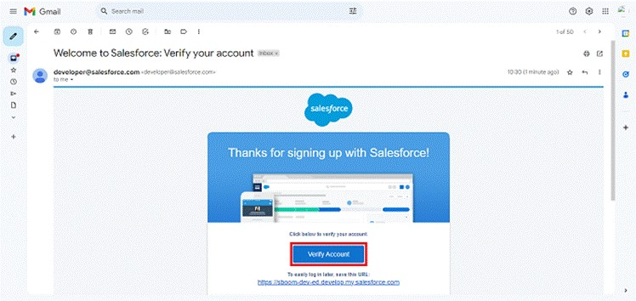
- Open the email inbox associated with your Salesforce registration. Locate the account verification email and select the Verify Account option. The verification email may arrive within 10–30 minutes, although in some cases it can take up to 2 hours.
- Select Verify Account to activate the Salesforce Developer account.
- Create a secure password, provide an answer to the security question, and click Change Password to complete the account setup.
- After successful verification, you will be redirected to the Salesforce Setup page, where the development environment can be configured.

Image

Milestone 2- Objects Creation
To create a custom object in Salesforce:
- From the Setup page, open the Salesforce configuration menu.
- Select Object Manager.
- Click Create, and then choose Custom Object.
- In the Label field, enter Parcel.
- In the Plural Label field, enter Parcels.
- Set the Record Name as Parcel Name.
- Choose Text as the data type and enter Parcel Name.
- Enable the Allow Reports option.
- Enable the Allow Search option.
- Enable Track Field History to maintain changes made to the object records.
- Click Save and New to save the object and continue creating additional objects.
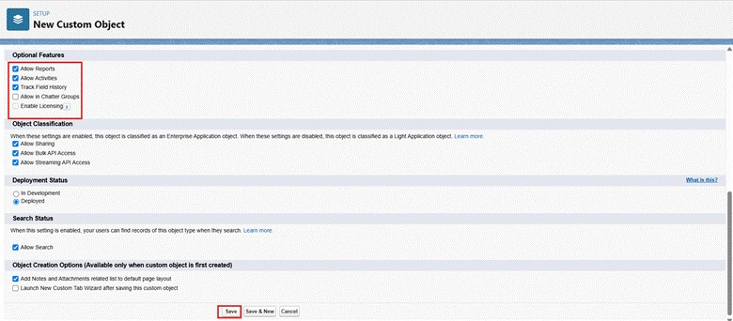
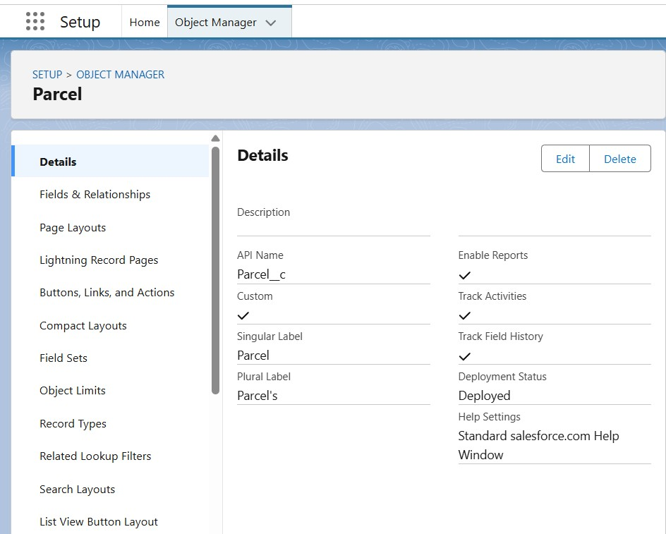

Creating Delivery Object
To configure the Delivery custom object in Salesforce:
- Open the Setup page.
- Navigate to Object Manager.
- Select Create and choose Custom Object.
- Enter Delivery in the Label field.
- Set the Plural Label as Deliveries.
- Enter DeliveryName as the Record Name.
- Select Text as the data type and specify DeliveryName.
- Enable Allow Reports.
- Enable Allow Search.
- Enable Track Field History to record changes made to the object.
- Click Save and New to save the Delivery object and proceed with creating another object.
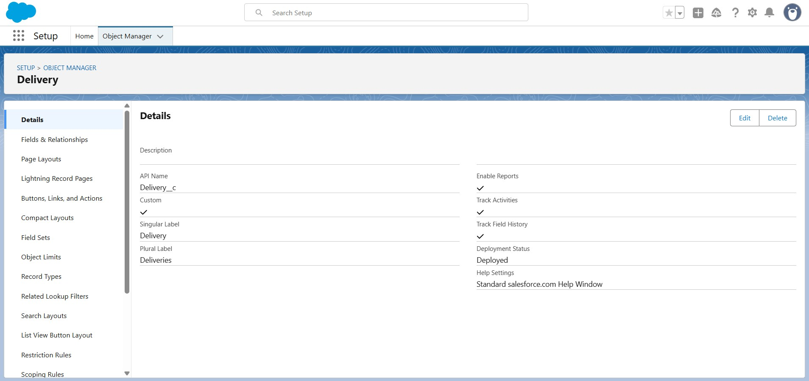

Creating Sender Object

To configure the Sender custom object in Salesforce:
- Open the Setup page.
- Navigate to Object Manager.
- Select Create and choose Custom Object.
- Enter Sender in the Label field.
- Set the Plural Label as Senders.
- Enter SenderName as the Record Name.
- Select Text as the data type and specify SenderName.
- Enable the Allow Reports option.
- Enable the Allow Search option.
- Enable Track Field History to maintain a record of changes made to the object.
- Click Save and New to save the Sender object and continue with the next object.

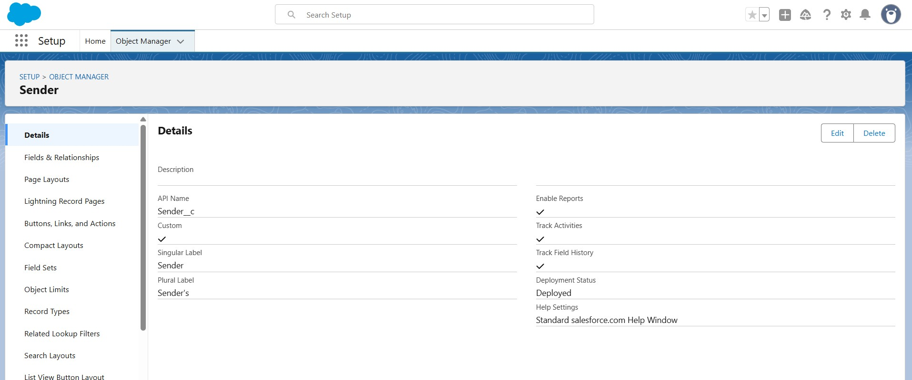

Creating Receiver Object
To configure the Receiver custom object in Salesforce:
- Open the Setup page.
- Go to Object Manager.
- Click Create and select Custom Object.
- Enter Receiver in the Label field.
- Set the Plural Label as Receivers.
- Specify ReceiverName as the Record Name.
- Choose Text as the data type and enter ReceiverName.
- Enable Allow Reports.
- Enable Allow Search.
- Turn on Track Field History to record modifications made to the object.
- Click Save and New to save the Receiver object and proceed with the next configuration.

Milestone 3 - Tabs
Creating a tab for Parcel Object
- Open the Setup page and search for Tabs using the Quick Find bar.
- Select Tabs from the search results.
- Under Custom Object Tabs, click New.
- Choose Parcel as the object and select a suitable Tab Style.
- Click Next. Keep the profile settings as default, then click Next again. Under Add to Custom Apps, clear the Include Tab option.
- Ensure that Append tab to the user's existing personal customizations is enabled.
- Click Save to create the Parcel tab.
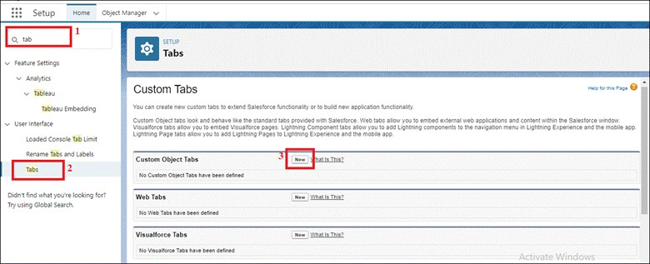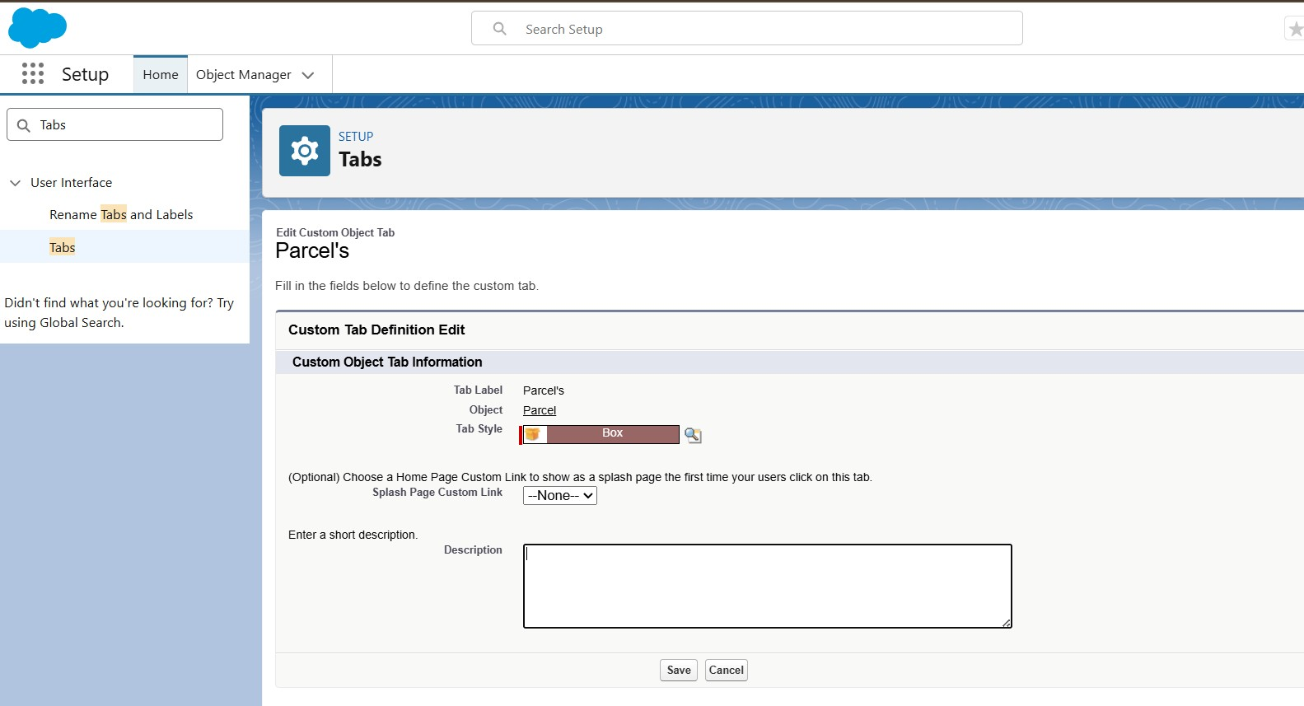

More Tab Creation
- Open Setup and enter Tabs in the Quick Find search box.
- Select Tabs from the User Interface section.
- Under Custom Object Tabs, click New.
- Select the required object (Delivery, Sender, or Receiver) and choose an appropriate Tab Style.
- Click Next, leave the Add to Profiles settings unchanged, and select Next again.
- In the Add to Custom Apps section, clear the Include Tab checkbox.
- Confirm that Append tab to the user’s existing personal customizations remains selected.
- Click Save and follow the same procedure for the remaining objects: Delivery, Sender, and Receiver.
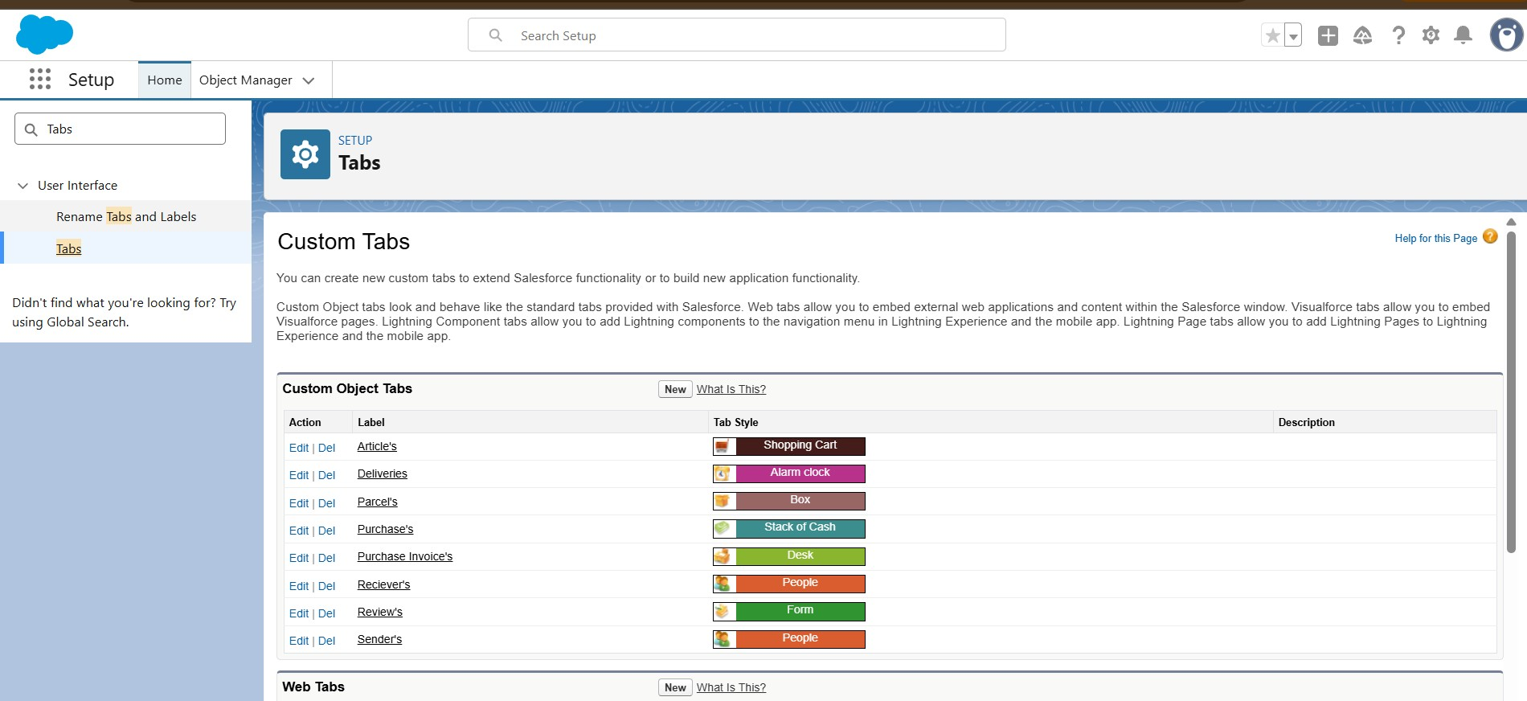

Milestone 4- Fields & Relationships

Create the required fields and establish relationships for the custom objects configured in the previous milestone.
Creating Fields and Relationships for Parcel Object
From Setup, open Object Manager and select the Parcel custom object.
Field 1: Parcel ID
● Navigate to Fields & Relationships and click New.
Enter:
● Data Type: Auto Number → Display Format: P-{000}

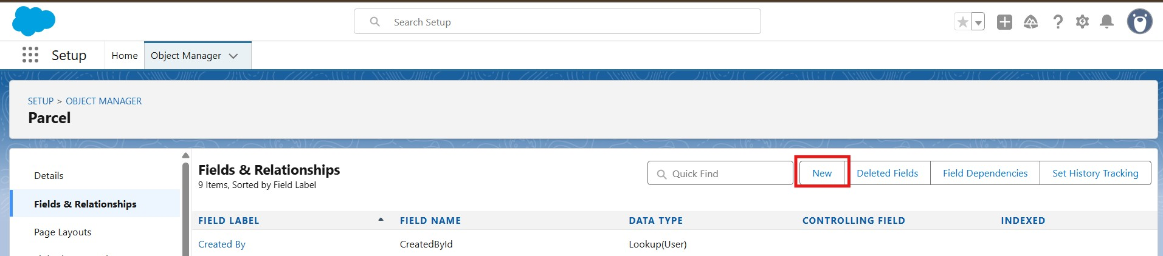
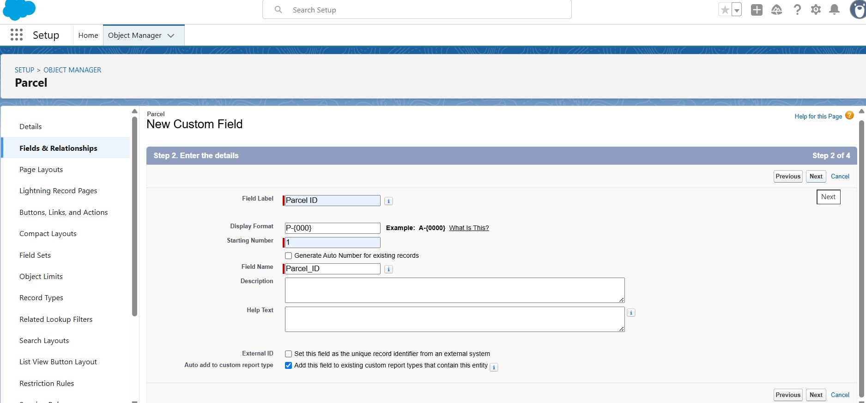
● Click Next → Next → Save & New.
- Repeat the same procedure described in Steps 1 and 2 to add the remaining Parcel object fields, including Status, Weight, Estimated Delivery, and Sender, as specified in the table below.

Creating Fields And Relationships For Delivery Object
From Setup, locate Object Manager using the Quick Find search and open it.
- Search for and select the Delivery object.
Field 1: Current Location
● Navigate to Fields & Relationships and click New.
Image
● Select Geolocation as the Data Type, then click Next.
Field Label: Current Location
● Click Next → Next → Save & New.
Image
- Repeat the procedures given in Steps 1 and 2 to create the remaining fields — Estimated Delivery, Sender, and Parcel — for the Delivery object, as provided in the table below.
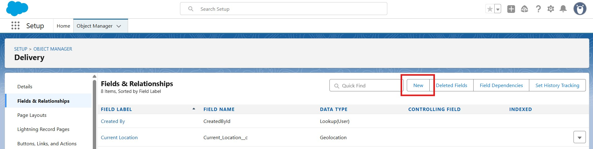

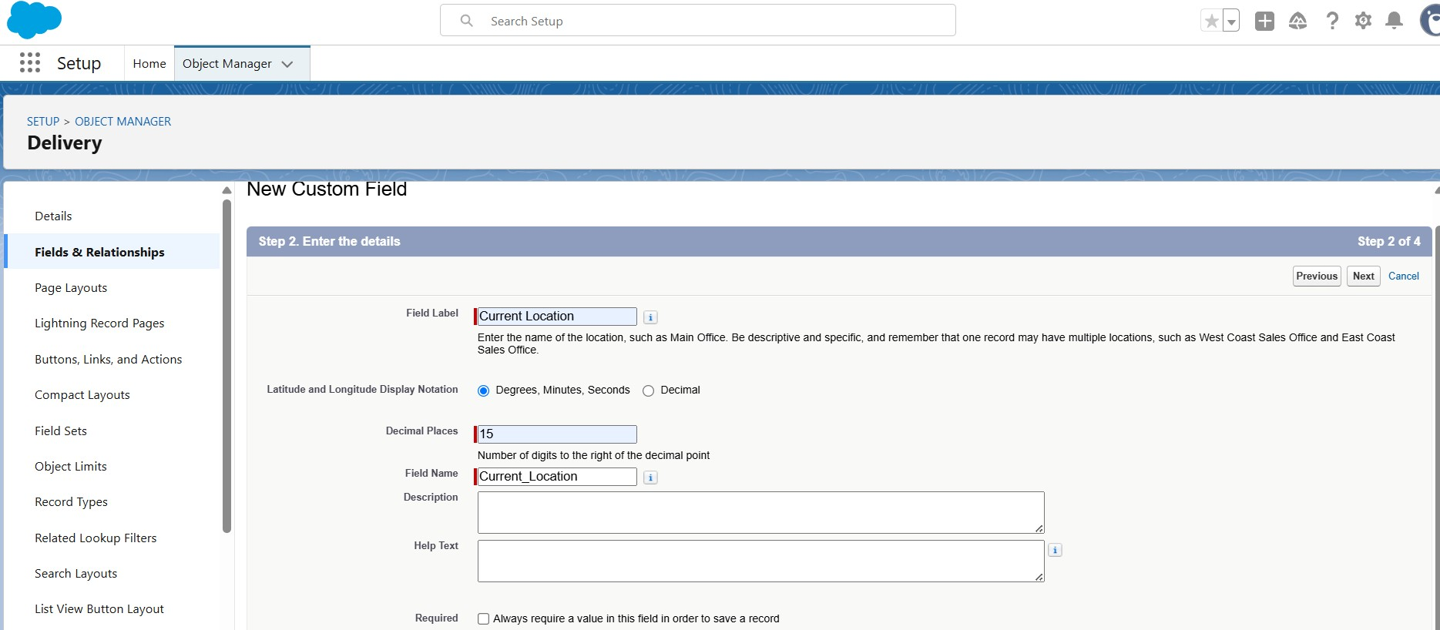

Creating Fields And Relationships For Sender Object
Beside the Quick Find box you have, Object Manager click on it.
1. Search for and select your Sender object. Field 1: Sender Address
- Go to Fields & Relationships → click New
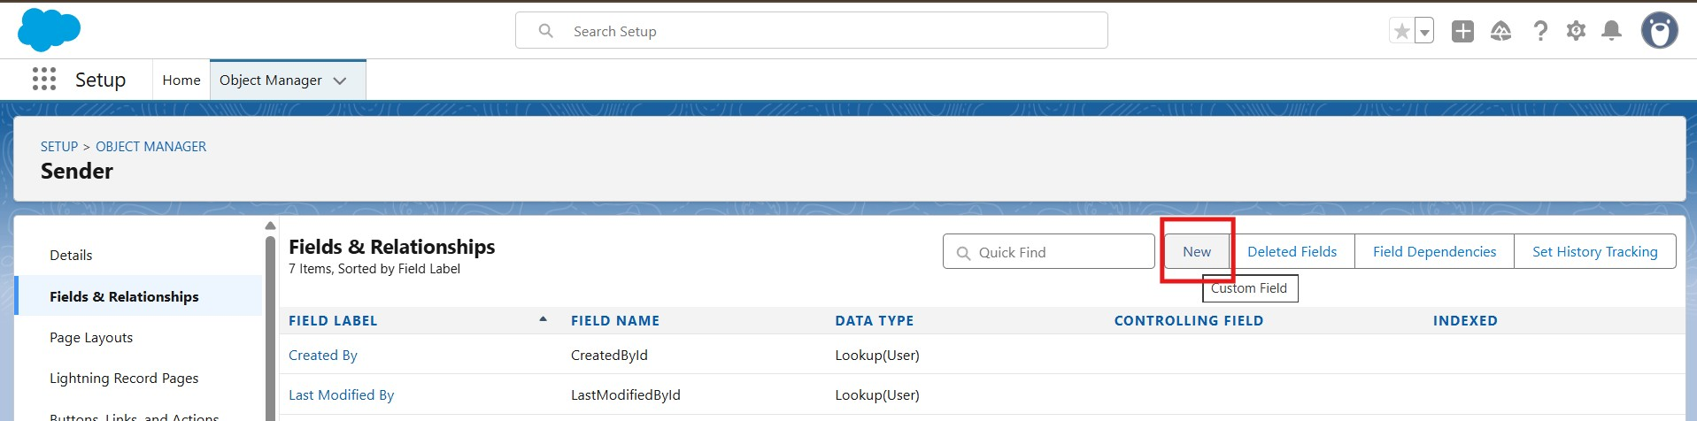
- Choose Data Type: Geolocation → click Next.
Field Label: Sender Address
Click Next → Next → Save & New.
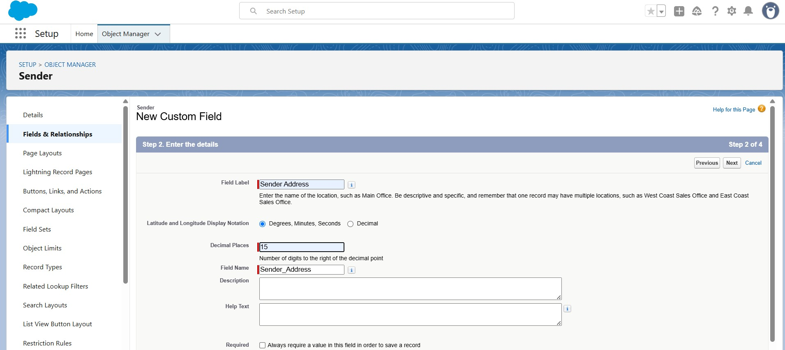
- 3. Follow step 1 and 2 to create the remaining fields (Sender Contact, Sender Email) of the Sender object mentioned in the table below.
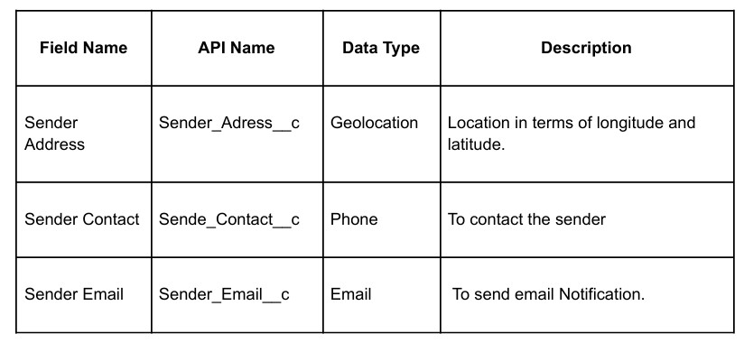

Creating Fields And Relationships For Receiver Object
Beside the Quick Find box you have, Object Manager click on it.
1. Search for and select your Receiver object.
Field 1: Receiver Address
- Go to Fields & Relationships → click New
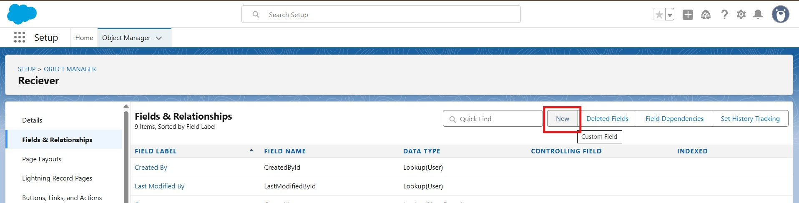
- Choose Data Type: Geolocation → click Next.
Field Label: Receiver's Address
Click Next → Next → Save & New.
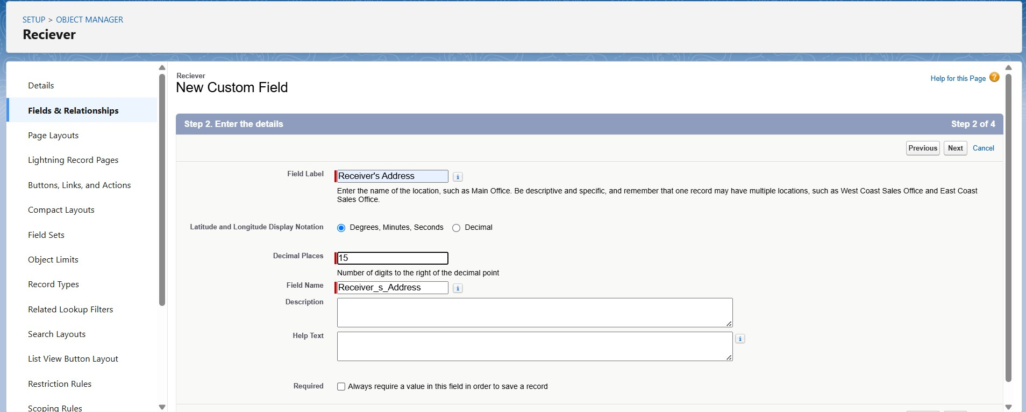
- 3. Follow step 1 and 2 to create the remaining fields (Receiver Contact, Receiver Email, Sender, Parcel) of the Receiver object mentioned in the table below.
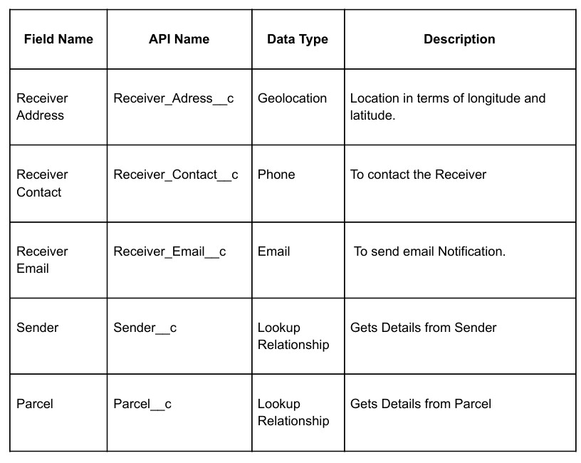

Milestone 5 - Prompt Builder Designing Prompts for Agent Building.
In Salesforce, go to Setup.
- In the Quick Find box, type Prompt Templates (or in Agent Console, go to Agent Builder → Prompt Templates).
- Click New Prompt Template.-- Record summary template
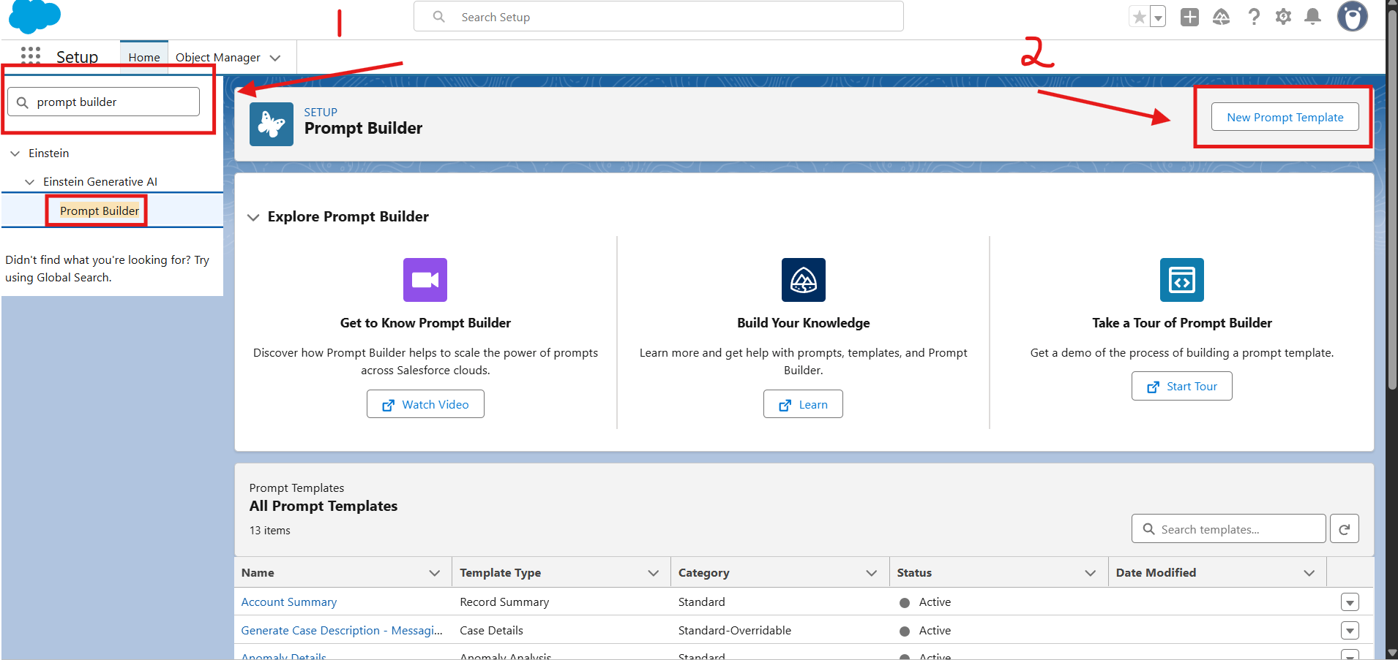
4. Enter the details
- Label: Retrieve Parcel Details
- API Name: Retrieve_Parcel_Details
- Description: Retrieves parcel details where Parcel_ID matches the user input.
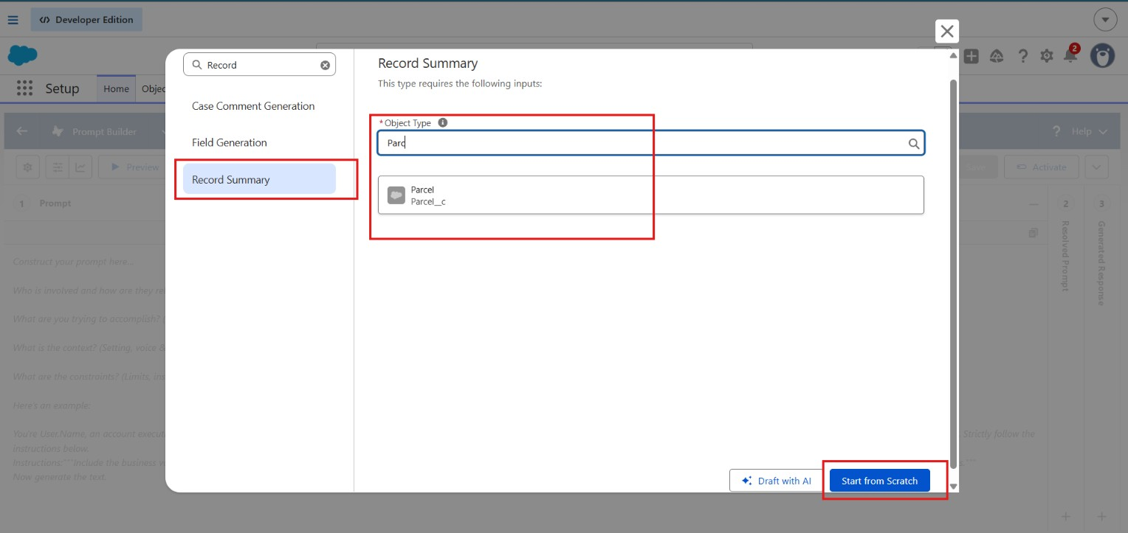
5. Enter the Prompt Template Content
In the Prompt Template Text area, paste the following exactly:
Retrieve details from Parcel c where Parcel_ID__c matches user input. Return response in this format:
Parcel Tracking Update
📦 Parcel Tracking Update
- Parcel Name:{!$Input:Parcel__c.Name}
- Parcel ID:{!$Input:Parcel__c.Parcel_ID__c}
- Status:{!$Input:Parcel__c.Status__c}
- Weight:{!$Input:Parcel__c.Weight__c}
- Estimated Delivery Date:{!$Input:Parcel__c.Estimated_Delivery_Date__c}
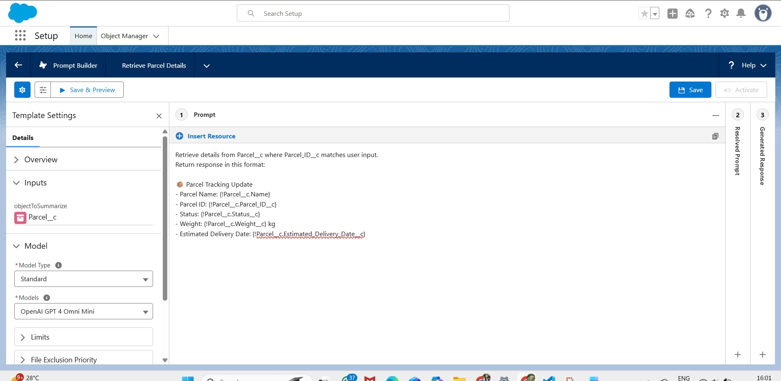
  - Add Resource Mapping
  - Scroll down to the Resources / Insert Resources section.
  - Click Insert Resource → choose Object.
  - Select Parcel__c.
  - Add the following fields:
  - Name
  - Parcel_ID__c
  - Status__c
  - Weight__c
  - Estimated_Delivery_Date__c

Click Insert Resource (or Add) for each one.
- Click Save.
- Then click Activate to make this Prompt Template available for your agent or flow.
Testing the Prompt

Test the Prompt:
- Open your Agent preview.
- Type: “Track parcel P-12345”.
- It should return details from the Parcel record.
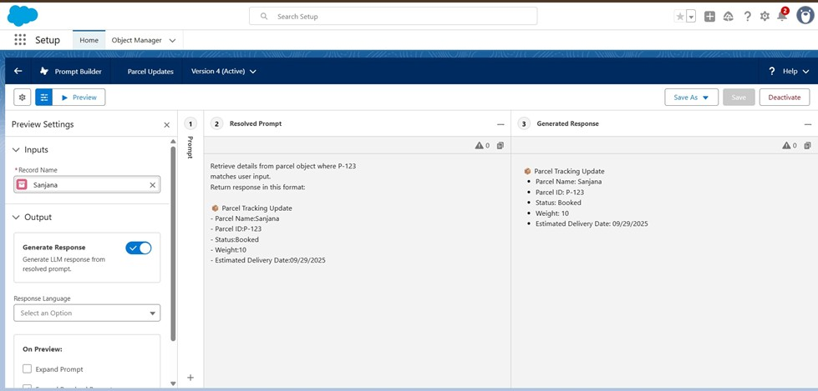

Milestone 6 - Flows
Create flows for capturing the response as shown.

Go to Setup → search Flows → click New Flow.
1. Choose Auto-Launched Flow (No Trigger) → click Create
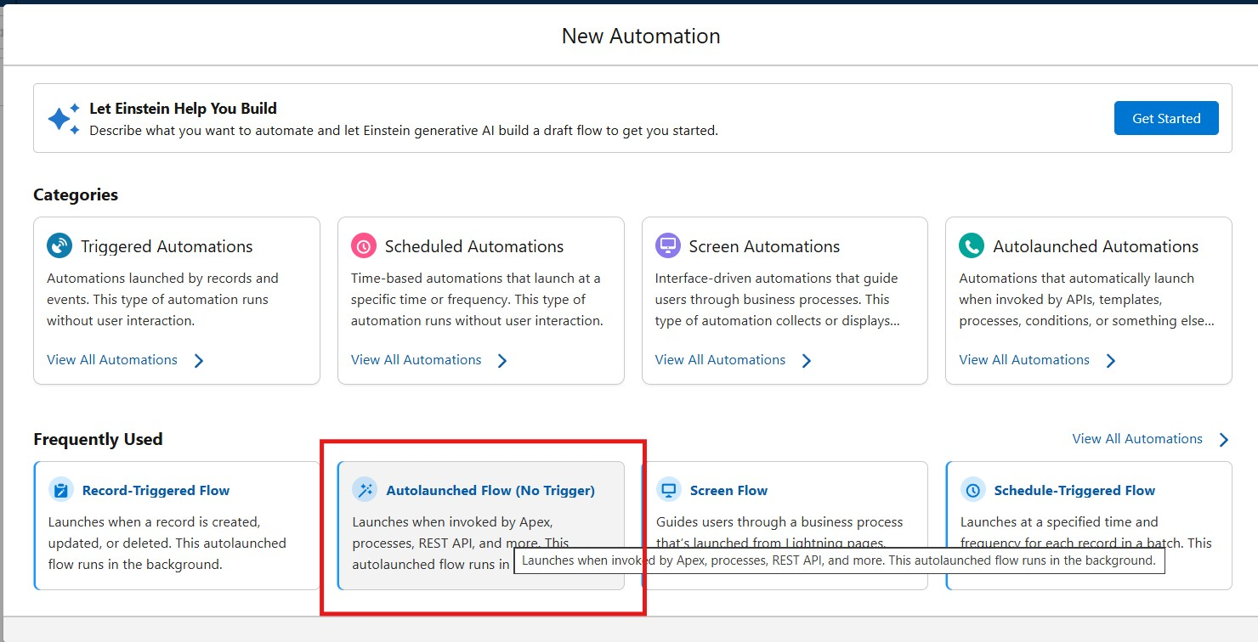

- Add Input Variables (to allow Agent to pass values):
  - Click On New Recourse →Variable → Available for Input.
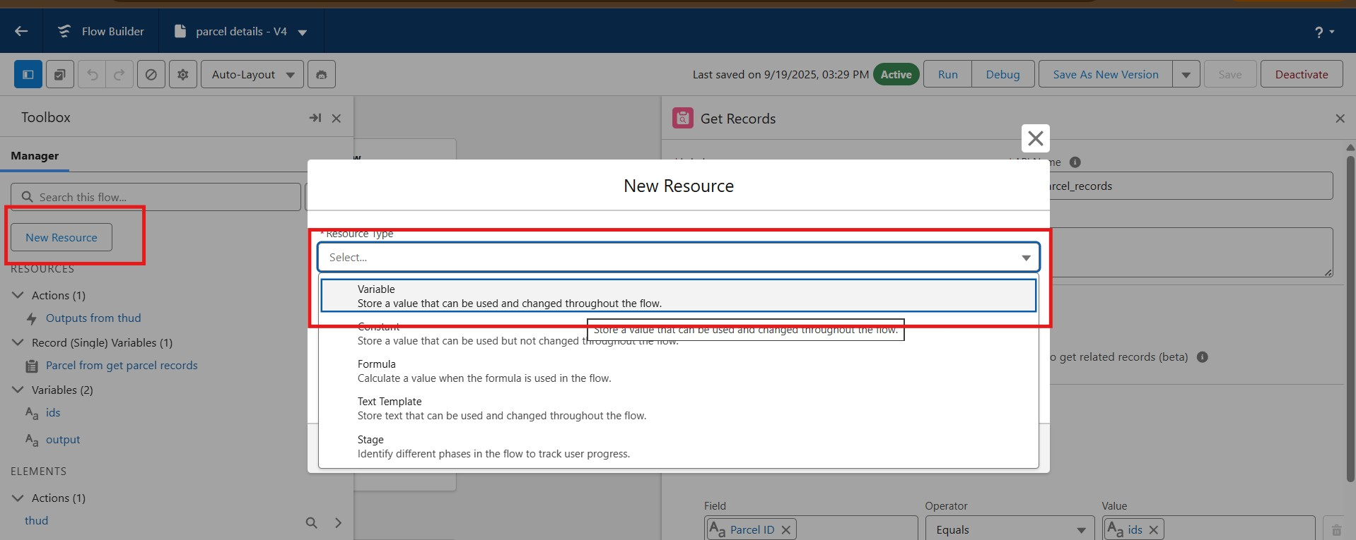
  - Ids → Data Type: Text → Available for Input.
  - Output → Data Type: Text → Available for Output.
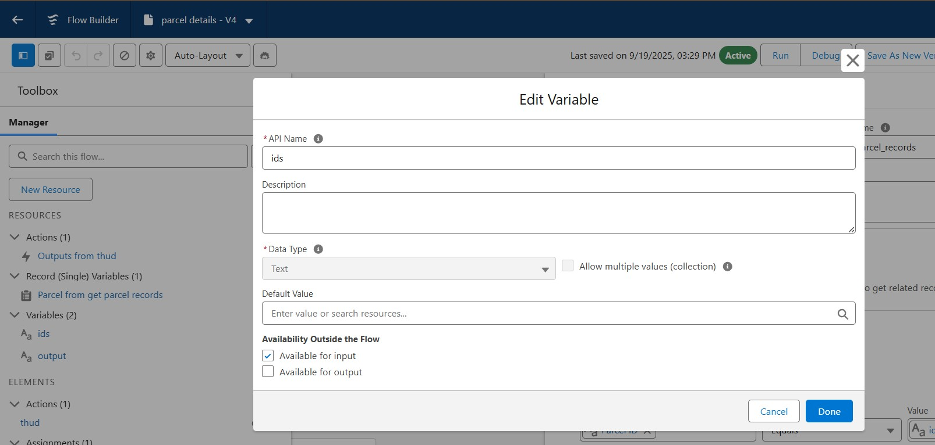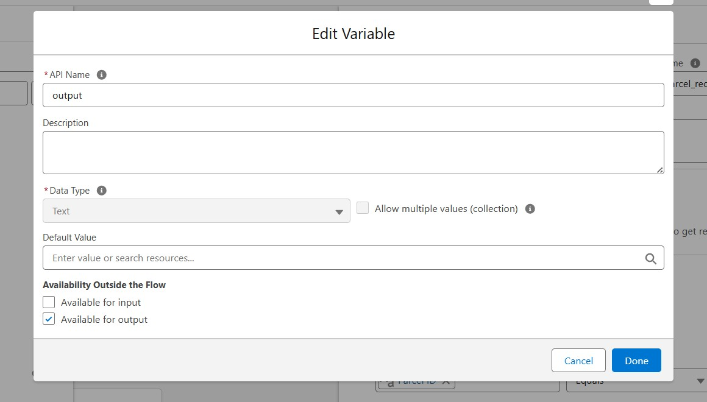
- Click on the Add icon to add Element: Get Records→ Label: Get Parcel Records
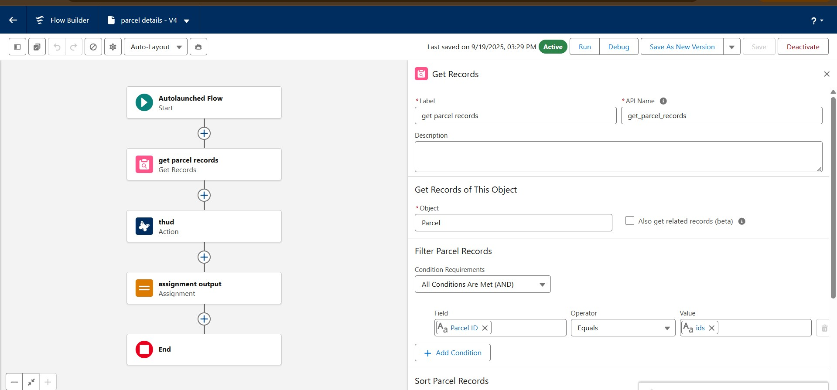
  - Object: Parcel
  - Field = Parcel_ID__c
  - Operator = Equals
  - Value = ids
- Element : Action
1. Find Retrieve parcel details 2. Click Retrieve parcel details ● Label: Parcel Updates.
  - Object To Summarize : Parcel from get Parcel records.
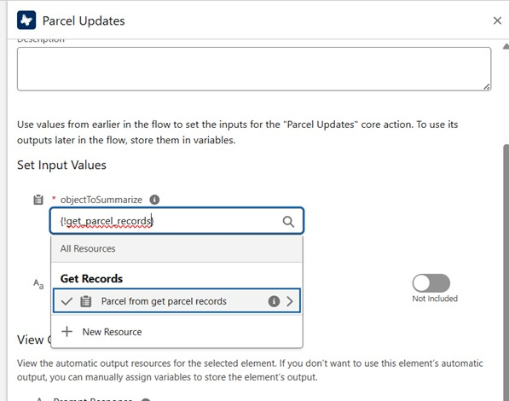
- Element : Assignment
  - Label: Assignment Outputs.
  - Variable= Output
  - Operator = Equals
  - Value = Outputs from Action>Prompt Response
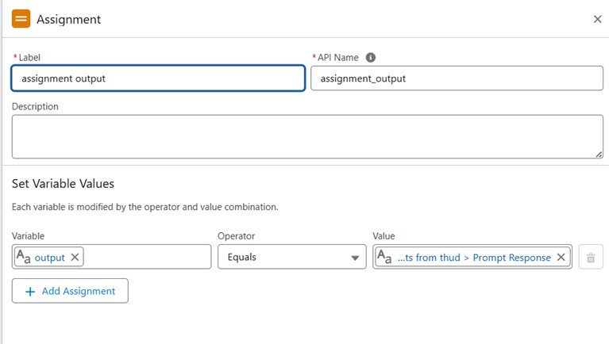
- Connect Start → Get Records → Action → Assignment → End.
- Save Flow → Name: Parcel Details.
- Activate Flow.
- Once the flow is saved go back to the flows, Click on the drop down near the flow that is just created, click on edit access.
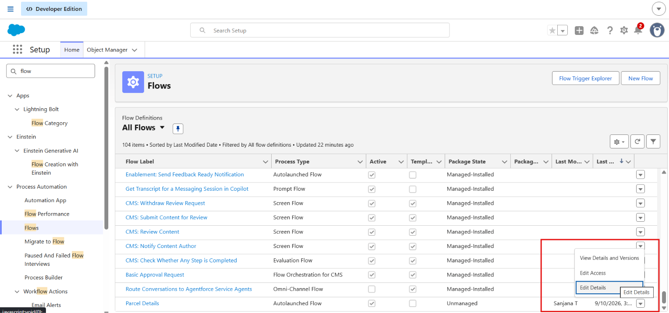

- On the top look for flow user access and then assign these available profiles, and click save.
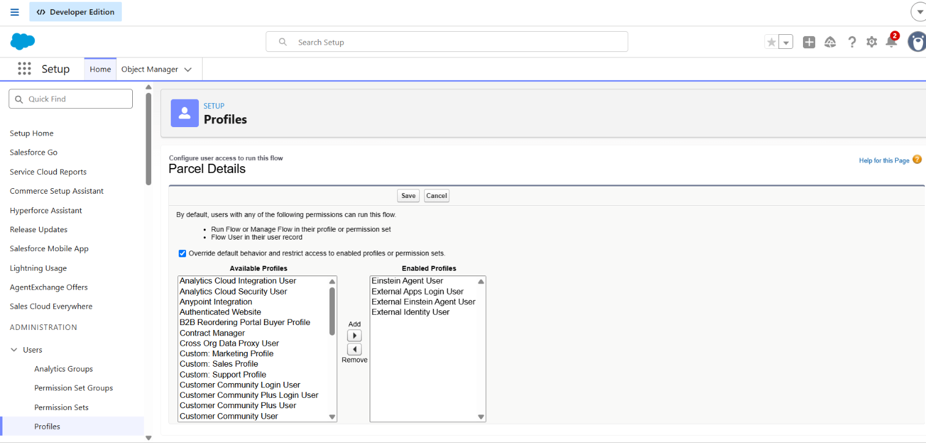

Phase 3: UI/UX Development & Customization

To enable agents to efficiently manage parcel operations and ensure secure access control using permission sets and AI-driven agent experiences built with AgentForce.

Milestone - 1 Creating Permission Sets
In the Quick Find box (left side), type Permission Sets.
1. Click Permission Sets under Users.
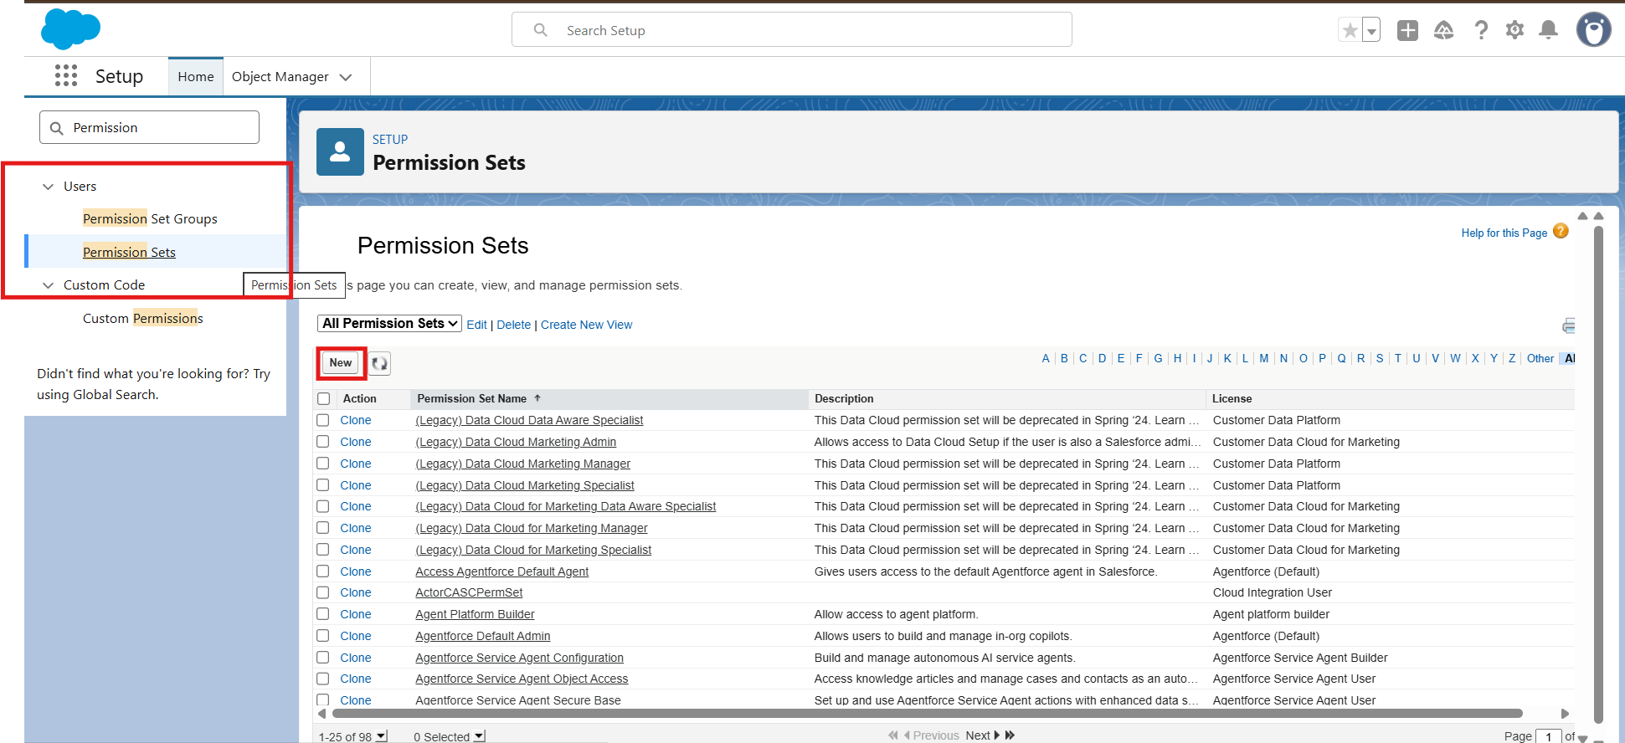
  - Click the New button.
  - Enter the following details:
    - Label: Swift Ship
    - API Name: auto-fills
    - License: Choose Einstein Agent.
3. Click Save.
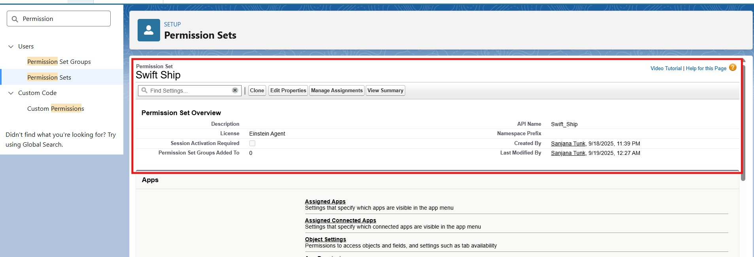

1. Inside the Permission Set page → under Apps → Object Settings, click Object Settings.
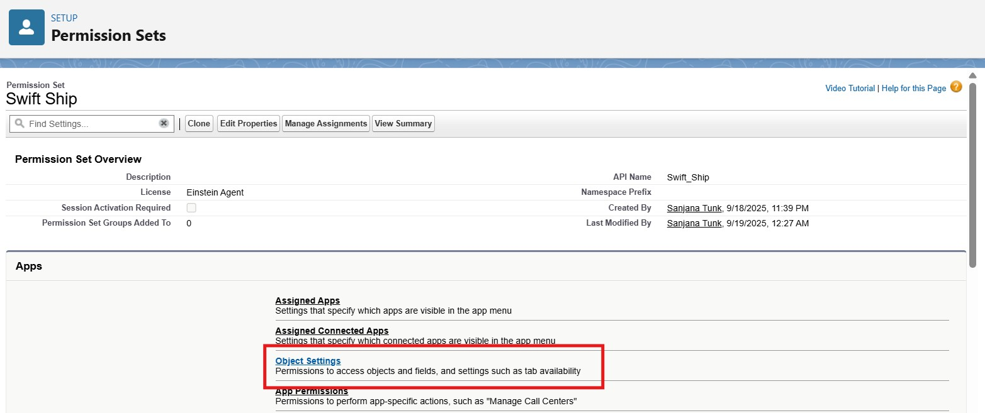
  - Search and click each object one by one
  - Click Edit.
Enable the following:
✅ Read
✅ Create
✅ Edit
(Optional: Delete, if you want agents to remove records)
Under Field Permissions, ensure at least Visible is checked for all key fields.
Click Save after each object.
Parcel__c
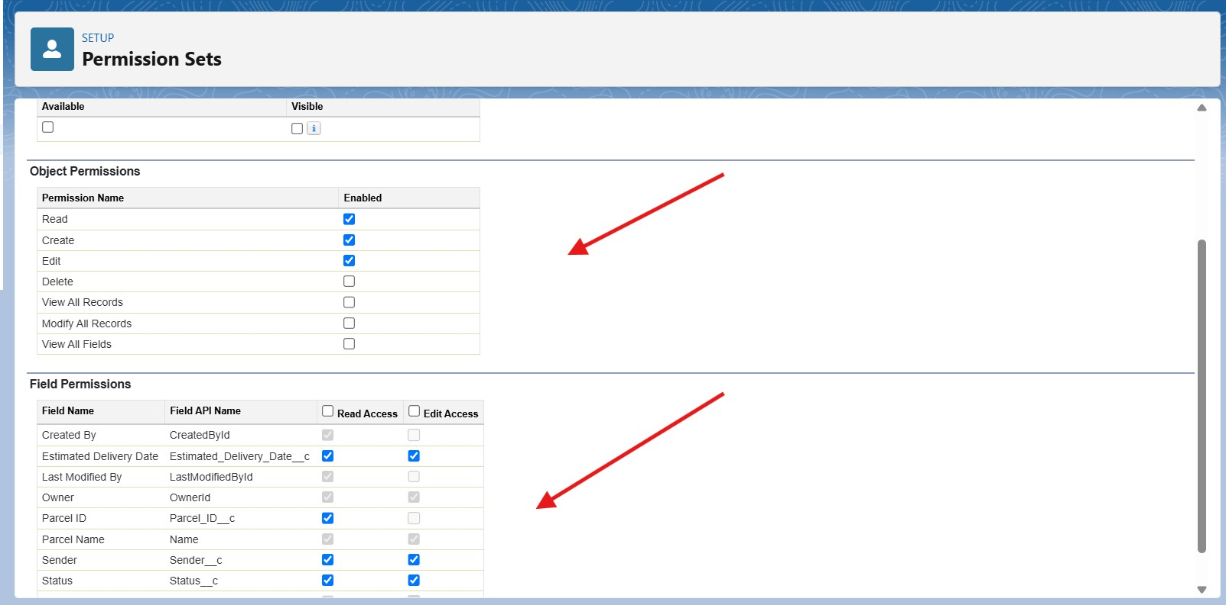
Delivery__c
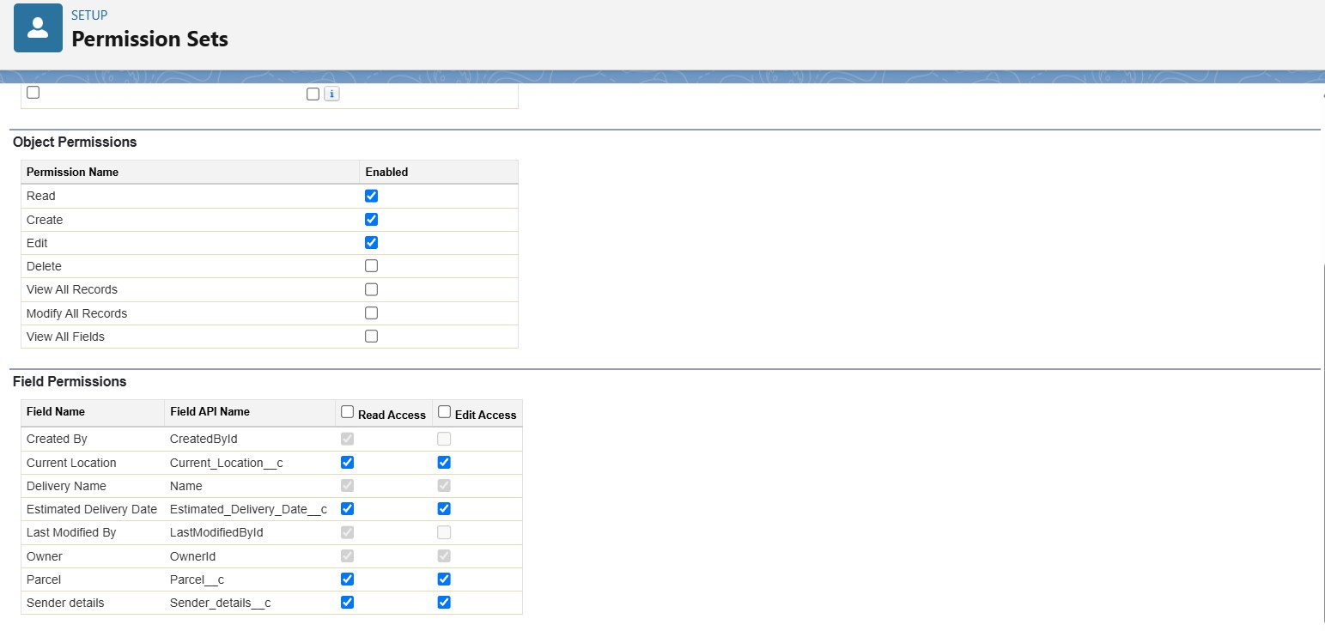
Sender__c
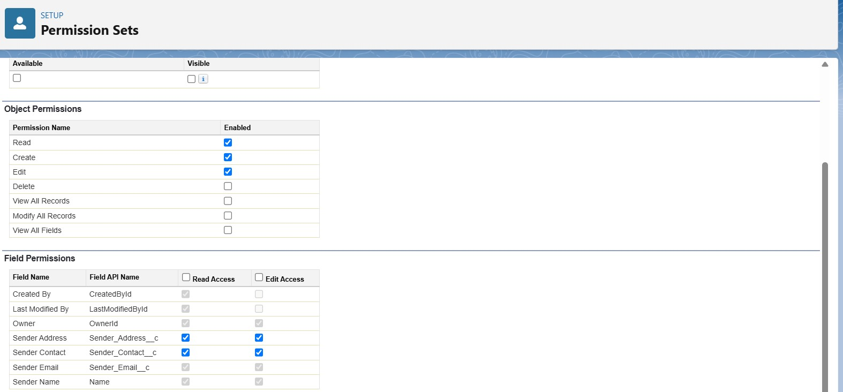
Receiver__c
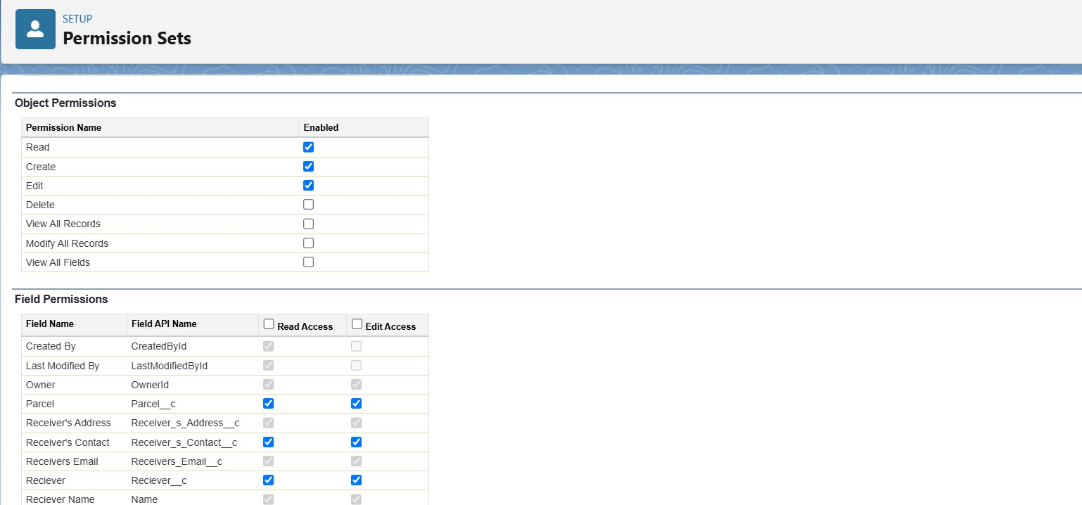

Milestone - 2 Assigning Permissions to your Agent user

In the Quick Find box on the left, type Users.
- Click Users under the Users section.
- Open the Agent User Record

From the list of users, find the Einstein Service Agent user to represent your Agent (e.g., “SwiftShip Agent”).
Click on the Full Name of that user to open the record.

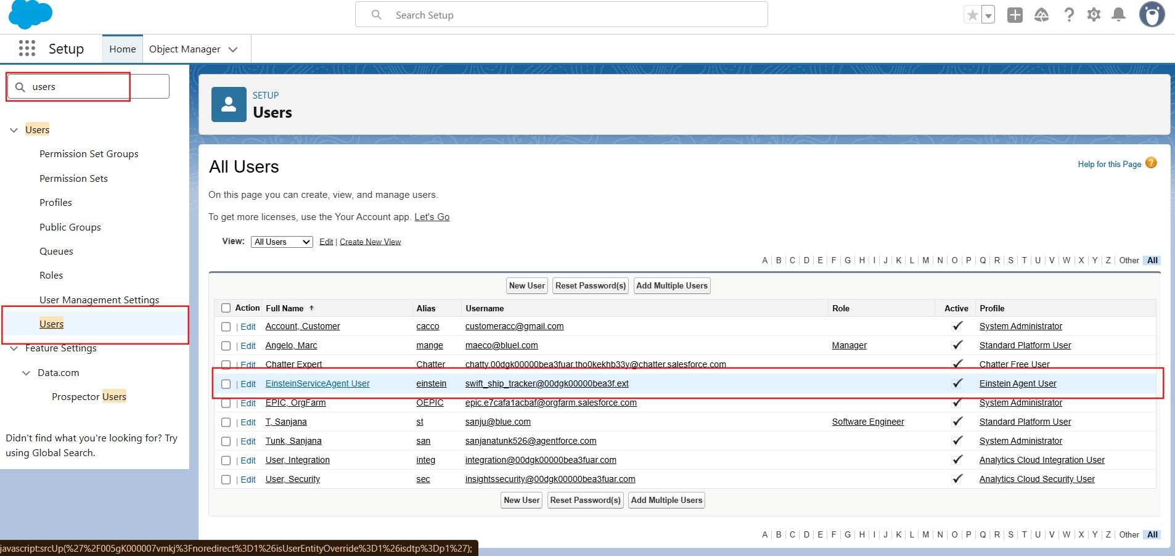
- Scroll down to the section named Permission Set Assignments.
- Click the Edit Assignments button.
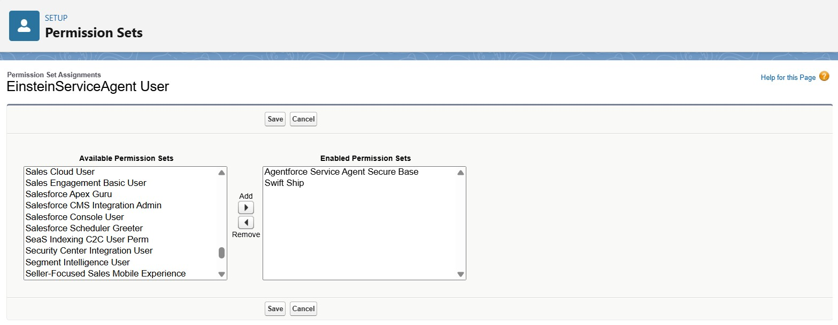
1. On the left side (Available Permission Sets), find and select your permission set: ● SwiftShip
Click the Add → button to move it to the right-side list (Enabled Permission Sets).
Click Save.
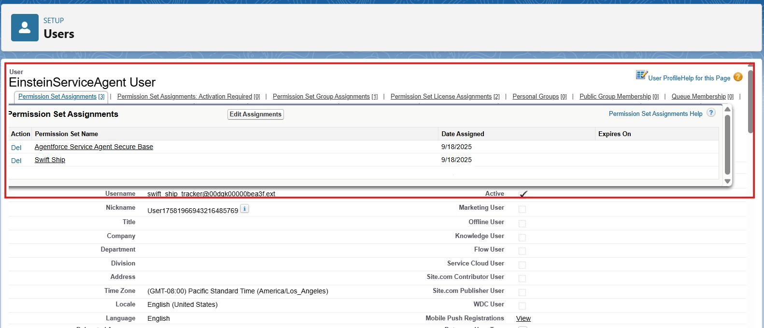

Milestone -3 Org Setup for AgentForce

Enable salesforce Default agent from Salesforce Go
- From Quick find box→ search “Salesforce Go” → Click on it
- Search for Default agent —> click get started→ and turn on
- And refresh the page
Enable Einstein Setup
Go to Setup → Quick Find → Einstein Setup.
1. Open Einstein Setup → click Get Started if prompted.
Toggle On these key services:
- Turn On Einstein
- Global Languages
- Deploy Prompt Template
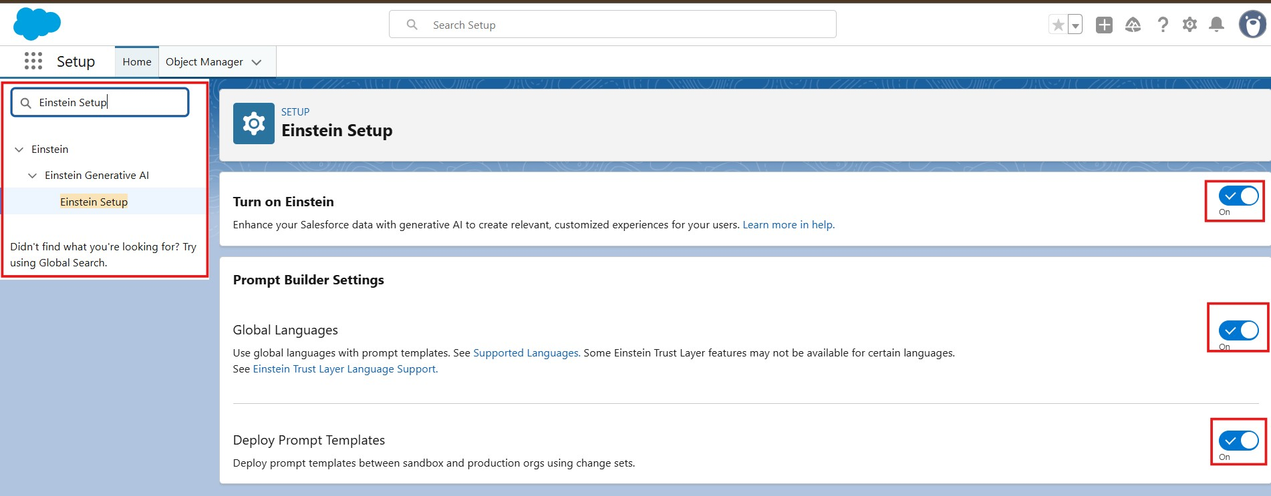
- Refresh your browser page.
- Go to Setup → Quick Find → AgentForce Agents. Toggle On these key services:
  - Agentforce
  - Enable Agentforce Default Agent
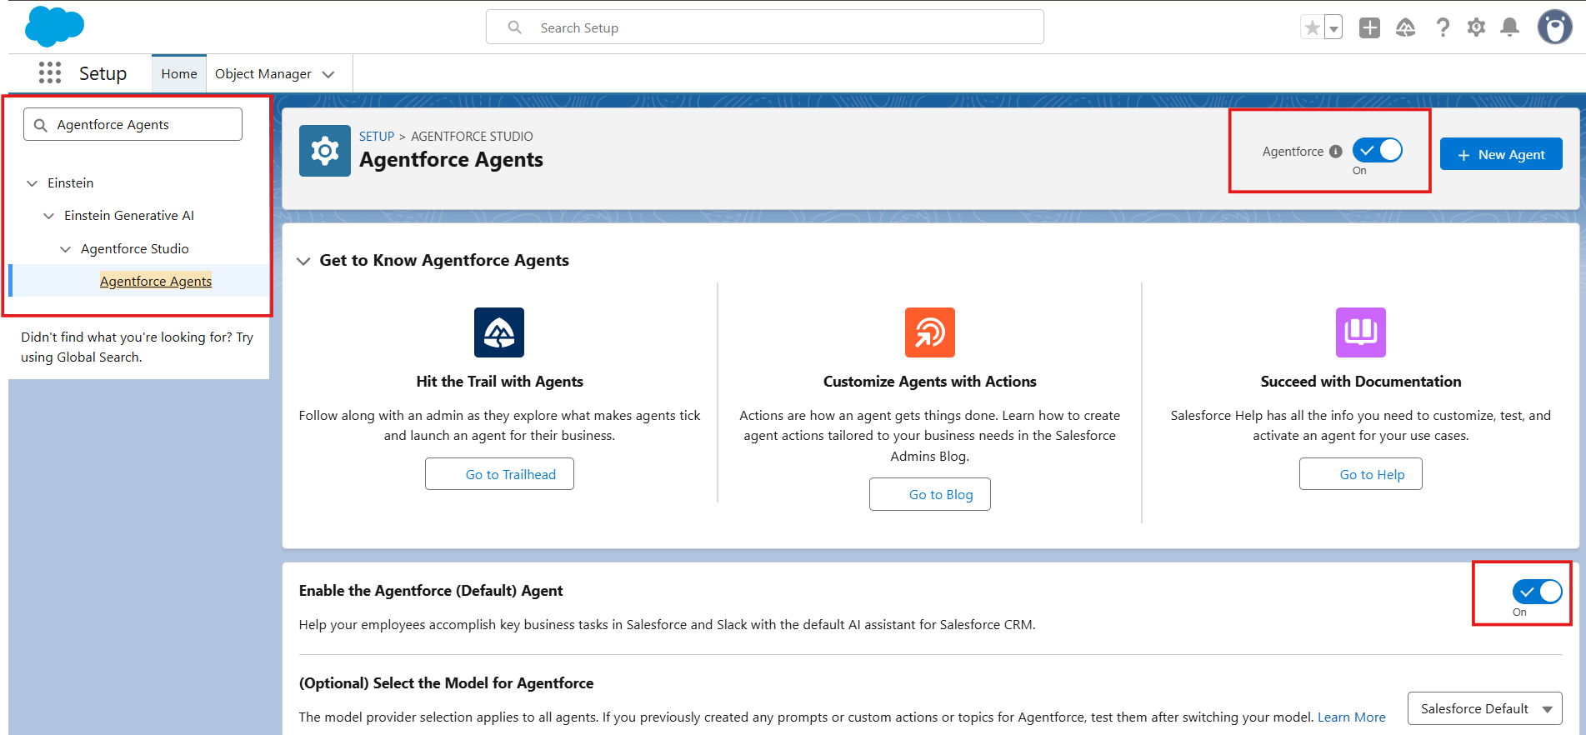

Milestone - 4 Building The Agent
- In Setup, search for Agentforce Agents in Quick Find.
- Click Agentforce Agents, then click on the default Agent, Then click on Open in Builder.
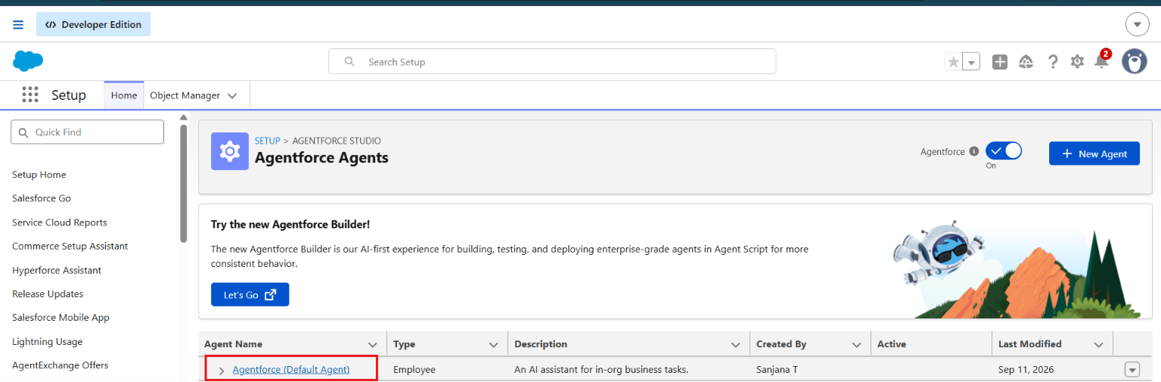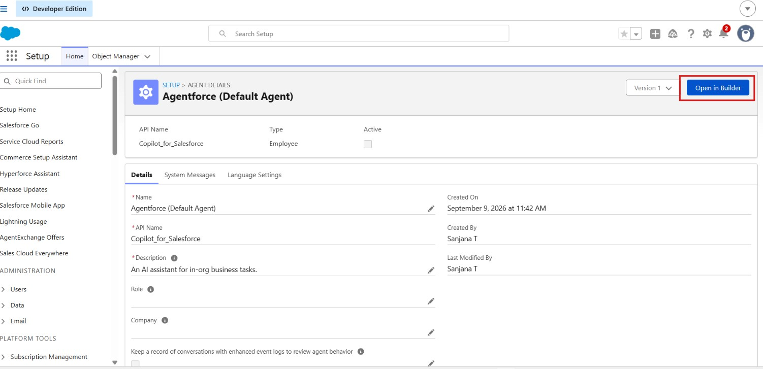

Assign Sub Agents to the Agent On the subagents Click on New.
1. Click New Subagent
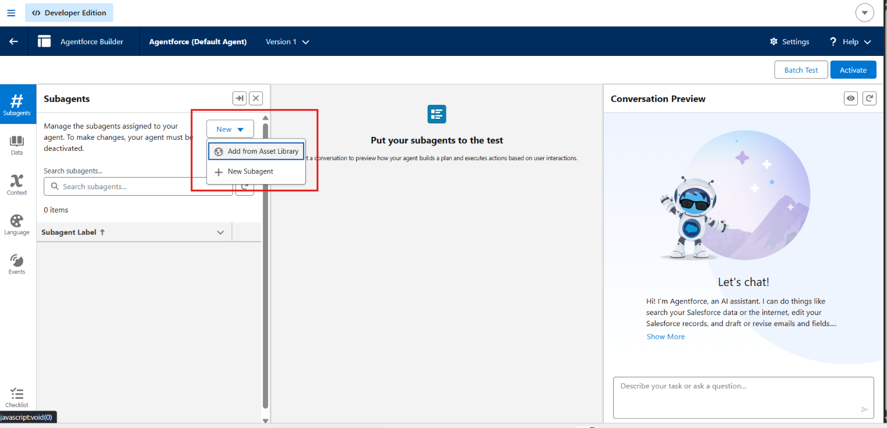
- Create a new subagent.
- Fill in the details as shown.

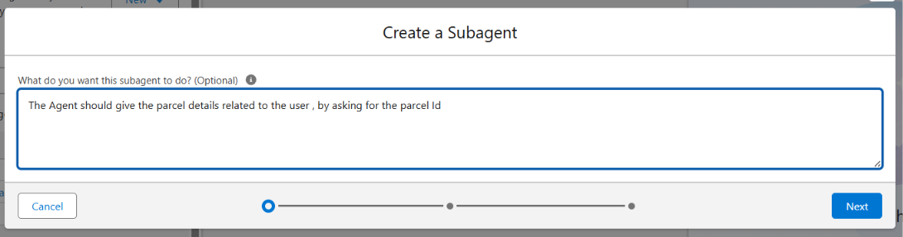

Adding Actions to Agentforce Assets
While still on the Agent Builder in the topics, Click on the Topics Actions
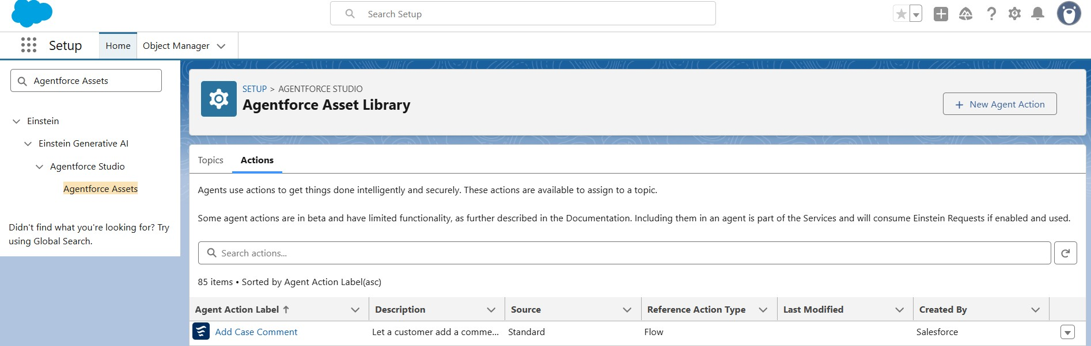
- Click on New Agent Action.
- For Action type, Click on Flow then Next.
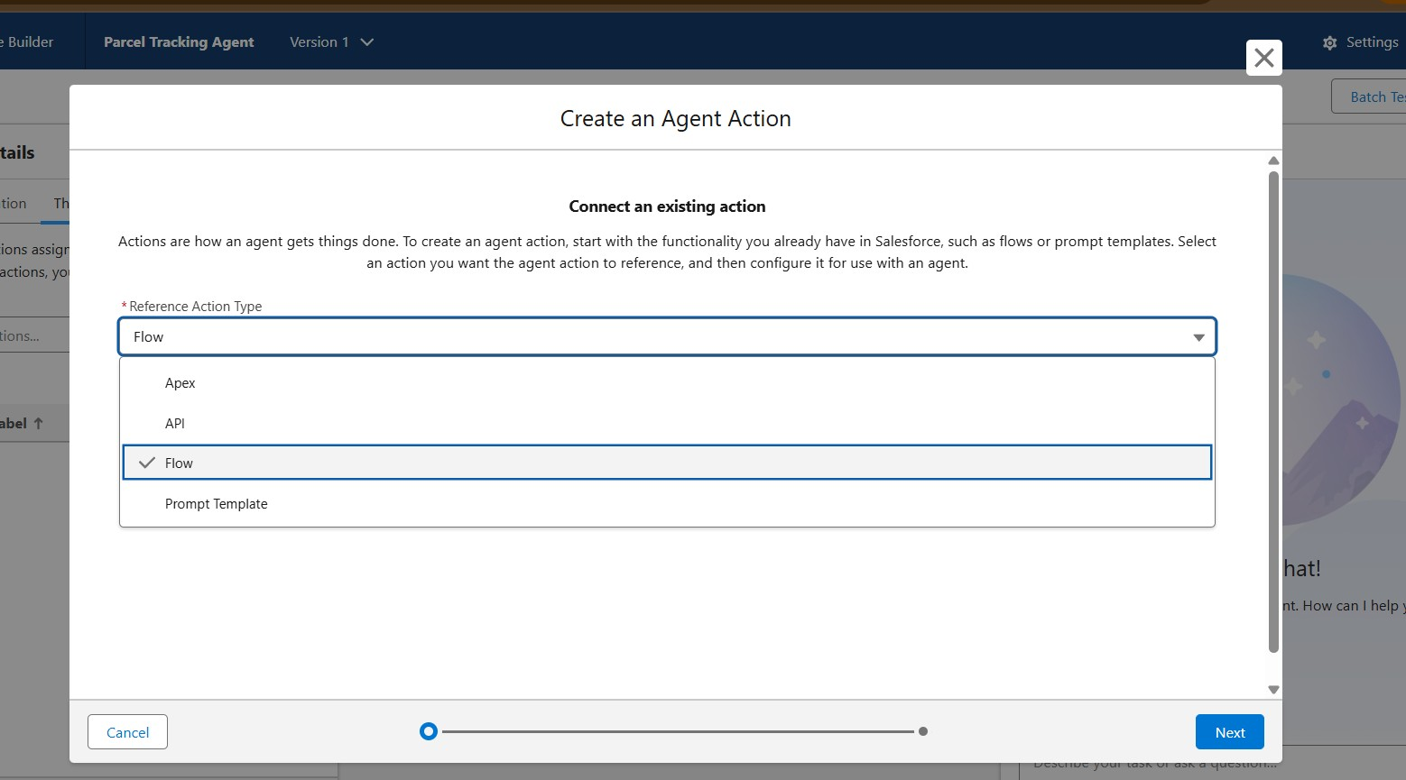
- For Reference Flow use the recently created flow, click Next.
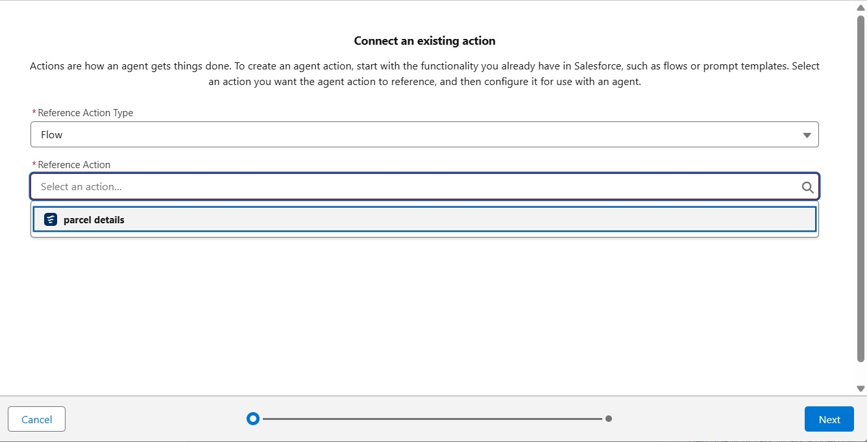
- Fill the details for Agent Configurations.
Assign Subagents Action

While on the Agent Builder in Subagent, Click on the Parcel Updates Subagent
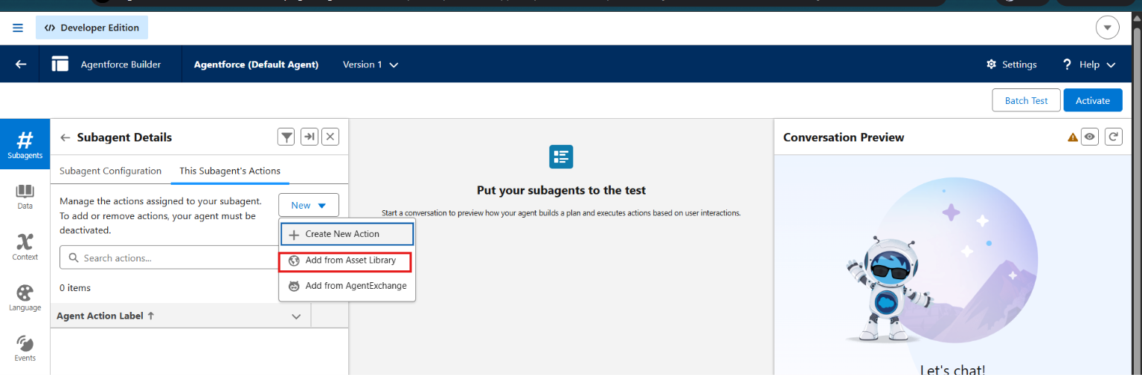
  - Click on the subagents Actions, then select Add from asset library.
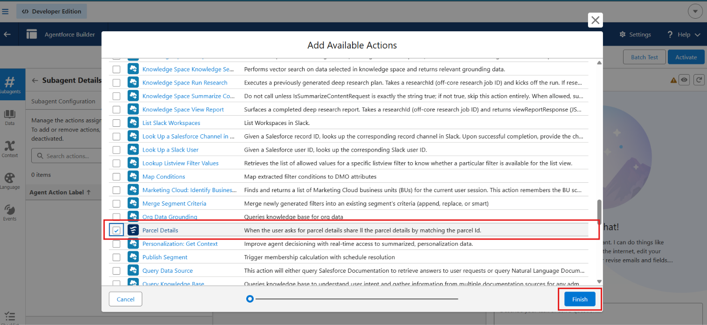
  - Select the flow action that we created and click on finish.
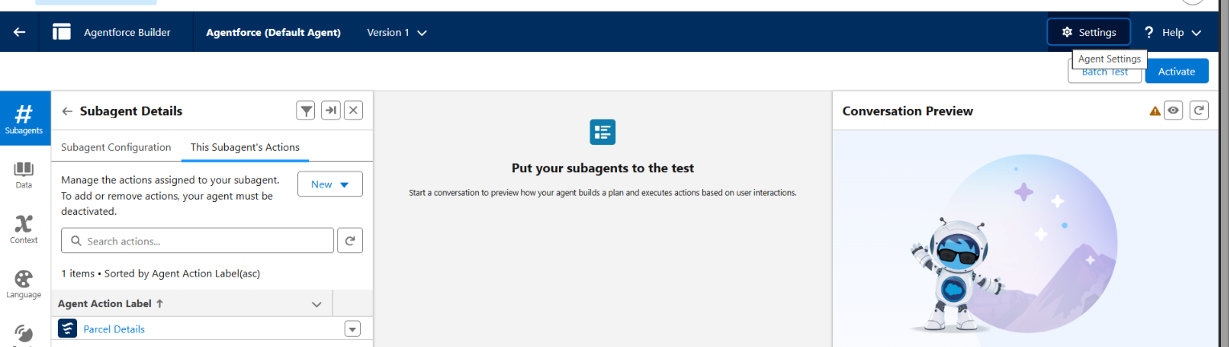
  - Click on settings , and rename your agent to SwiftShip Tracker
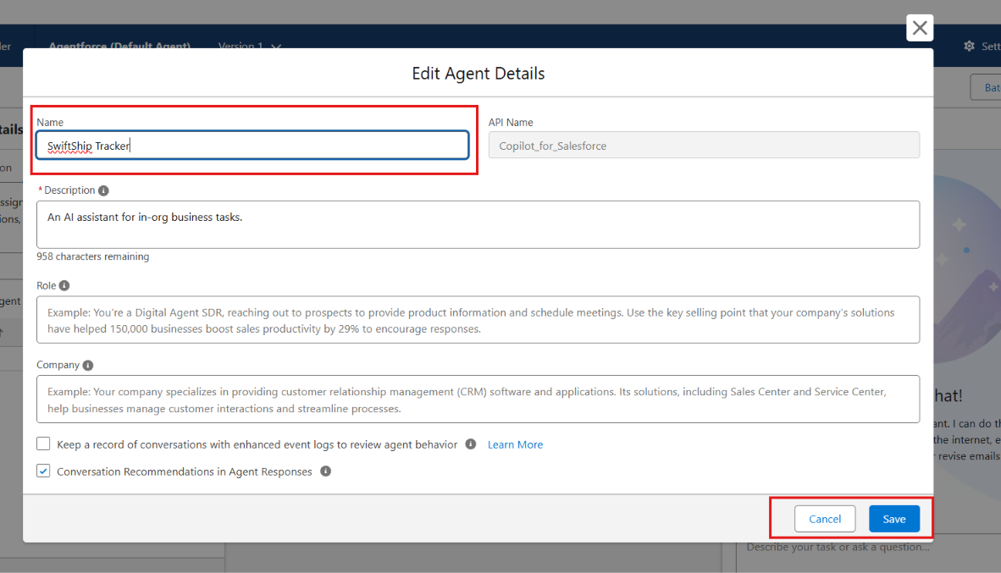
  - Click Save.
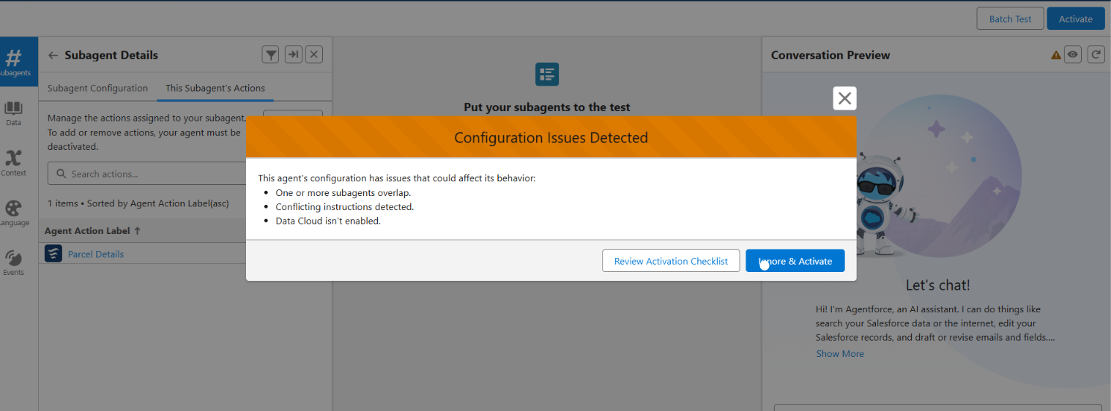
- Click on Ignore and Activate, then Activate.

Phase 4: Data Migration, Testing & Security

To validate the functionality and reliability of the Parcel Tracking Agent created in Agent Builder. This phase ensures that the agent correctly recognizes topics, triggers the assigned Flow (SwiftShip Tracker ), retrieves or updates parcel data, and performs all intended actions without access or permission issues. The goal is to confirm that the AI-driven agent operates seamlessly within Salesforce and provides accurate, real-time responses to parcel management queries.

Verify Agent
Go to Setup → Agentforce Agents.
1. Open the Agents list and confirm that your agent
Name: Parcel Tracking Agent, appears
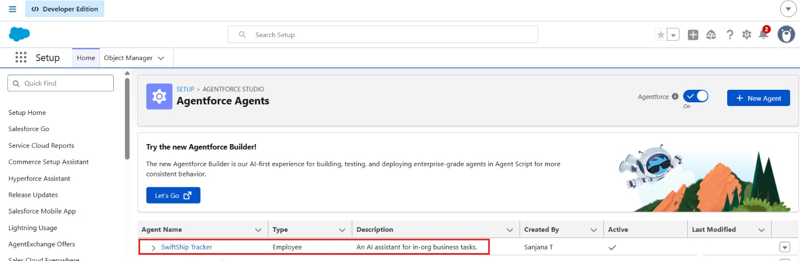

Validate Assigned Topic
In Agent Builder → SubAgent, confirm that the SubAgent you created (e.g., Parcel Tracking or SwiftShip Tracker) is listed.
Open the topic to verify:
  - It contains a prompt or description related to parcel management. ● The Action/Flow (SwiftShip Tracker) is linked to this topic.
2.Click Save and ensure the topic is Active.
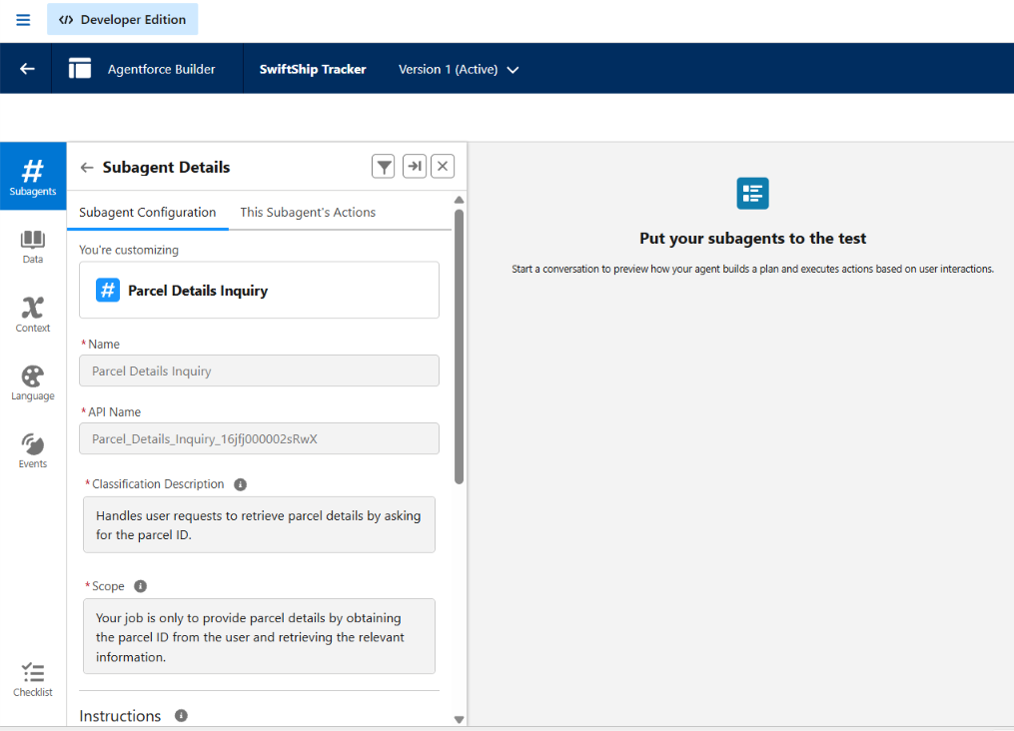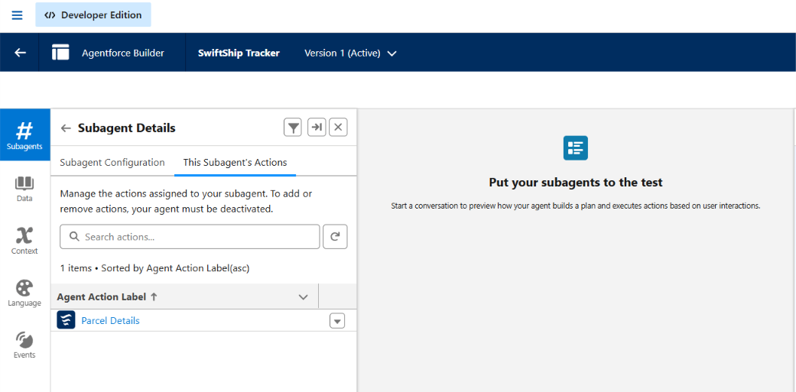

Check the Flow Association Go to Setup → Flows.
  - Locate the Flow named SwiftShip Tracker.
  - Confirm:
    - The Flow is Activated.
    - The Flow includes screens or actions that handle:
    - Parcel ID input
    - Parcel details retrieval
    - Status update or confirmation message
3. Open the Flow’s Advanced Settings → ensure Run in System Context (Without Sharing) if data access is restricted.
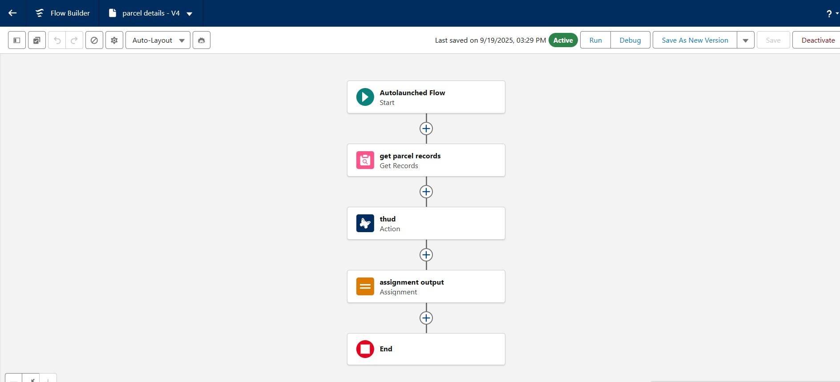

Activate and Test the Agent

  - Return to Setup → Agent Builder → Parcel Tracking Agent.
  - Click Activate (if not already activated).
  - Once active, test using Preview / Try it Out mode:
Type a query such as:
“Track parcel ID P12345” or
“Update delivery status for parcel P67890 to Delivered.”
  - Observe the agent’s response.
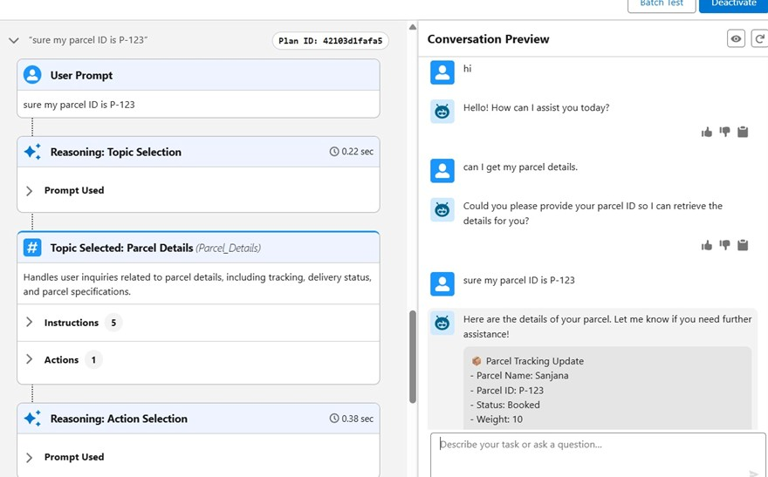

Validate Data in Salesforce

1. After the agent runs the Flow:
  - Go to App Launcher → Parcels (Parcel__c).
Search for the Parcel ID you used during testing.
Verify:
  - The Status or related field is updated.
  - Any Flow-created records (bookings, updates) appear correctly.
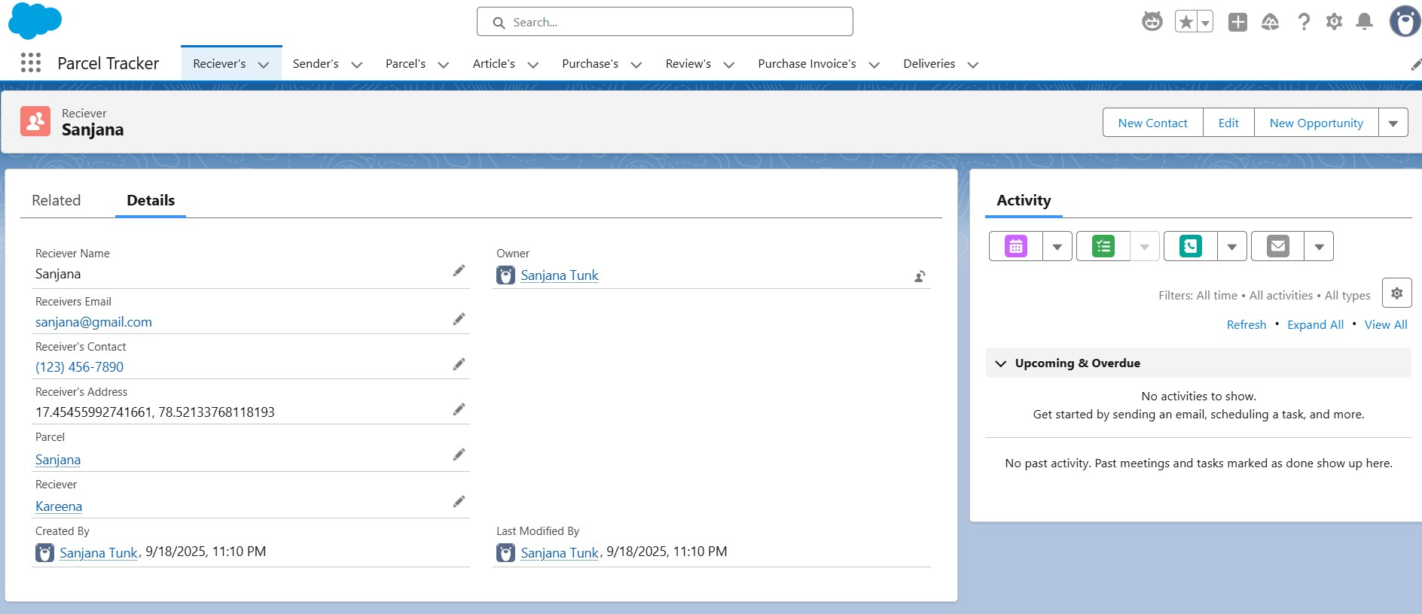

Phase 5: Deployment, Documentation & Maintenance
  - In the scope of our SwiftShip Tracker (AgentForce) project implementation:
  - The purpose of this phase is to validate that the Parcel Tracking Agent, created using Salesforce Agent Builder, works as intended within the Salesforce Developer Org environment.
  - The main goal is to understand how an AI-powered Service Agent can be tested to ensure correct topic recognition, Flow execution, and data retrieval from Salesforce custom objects.
  - Testing is conducted within the Developer Org to simulate how the Agent would perform in a live setup, ensuring that permissions, flows, and interactions function correctly before any deployment stage.
  - Real-world production testing (UAT or sandbox deployment) is not performed in this project because:
  - Developer Edition orgs are standalone environments and do not support production-linked testing environments.
  - Enterprise-level AgentForce deployment involves sandbox testing, staging environments, and CI/CD automation, which are outside the scope of this academic/prototype implementation.
Maintenance, Monitoring & Troubleshooting
In the SwiftShip Tracker (AgentForce) project, ongoing maintenance ensures that Parcel, Customer, and Delivery data remain accurate, synchronized, and up to date. Regular monitoring helps detect issues such as misrouted agent queries, failed Flow executions, or performance delays in AgentForce responses. Troubleshooting activities include resolving configuration errors, updating Flow logic, refining agent topics, and improving prompts to enhance user interactions.
Although this project is implemented within a Salesforce Developer Org for learning purposes, in real-world enterprise deployments, these maintenance and monitoring practices are essential. They ensure that AI-powered service agents remain reliable, scalable, and continuously aligned with evolving customer service operations and business goals.

- FUNCTIONAL & PERFORMANCE TESTING

During testing, screenshots were captured from Salesforce to validate vehicle creation, dealer assignment, stock validation triggers, order status updates, batch processing, scheduled reminders, and dashboard analytics. All features were verified to ensure correct functionality and performance.
- ADVANTAGES & DISADVANTAGES
Advantages
  - Centralized parcel and customer information in Salesforce.
  - Provides better visibility into parcel booking and delivery tracking.
  - Automates key logistics processes using Salesforce Flow.
  - Agentforce enables conversational customer support and parcel-status assistance.
  - Prompt Builder supports AI-powered responses and self-service.
  - Reduces manual effort for customers, support teams, and administrators.
  - Provides timely notifications and updates during the delivery process.
  - Experience Cloud can provide customers with convenient access to tracking information.
  - Supports integration with external logistics systems.
  - Can scale to support multiple locations and growing parcel operations.
Disadvantages
  - Requires accurate and up-to-date parcel and customer data.
  - Dependence on Salesforce configuration and automation.
  - Agentforce responses depend on properly configured prompts and available data. ● External logistics integrations may increase implementation complexity.
  - Flow and automation logic require regular maintenance when business processes change.
  - Users need appropriate Salesforce or Experience Cloud access to use the system.
  - Initial Salesforce implementation and configuration can require significant effort.
  - Expanding the system to additional locations or integrations may require further customization.
- Conclusion:

The SwiftShip Tracker demonstrates how Salesforce can be used to build a centralized parcel management and tracking solution. The project integrates custom objects, relationships, Flows, Apex, Email Alerts, Experience Cloud, AgentForce AI, Prompt Builder, security controls, and reporting to support parcel booking, delivery tracking, status updates, and customer communication.
The integration of AgentForce AI with Prompt Builder and Salesforce Flow provides a conversational approach to parcel tracking, enabling customers to obtain shipment information without depending entirely on manual support. The project therefore provides a practical foundation for a scalable and user-friendly parcel management solution.
- FUTURE SCOPE
  - Extend AgentForce capabilities for more parcel-management queries.
  - Enhance real-time delivery tracking.
  - Expand customer self-service through Experience Cloud.
  - Add more advanced delivery-performance analytics.
  - Integrate additional external logistics systems.
  - Improve AI prompts and conversational experiences.
  - Introduce enterprise-level sandbox and CI/CD deployment.
  - Expand automation for additional parcel operations.
The source identifies enterprise deployment, continuous monitoring, prompt refinement, Flow improvement, and AI-agent scalability as areas for future enhancement.
- APPENDIX
  - A. Custom Objects: Parcel, Delivery, Sender, Receiver
  - B. Standard Objects: Account, Contact, Case, Task, EmailMessage, User
  - C. Automation: Flows, Approval Processes, Email Alerts
  - D. Apex: Apex Classes, Batch Apex
  - E. AI: AgentForce AI, Prompt Builder
  - F. UI: Lightning App, Lightning Record Pages, Experience Cloud
  - G. Security: Profiles, Roles, Permission Sets, Sharing Rules, Field-Level Security
  - H. Analytics: Reports & Dashboards
  - I. Testing: Flow, AgentForce, data retrieval, security and permission validation

Thank You

