AN
INTERNSHIP REPORT
ON
A MULTI-PERSPECTIVE FRAUD DETECTION METHOD FOR MULTI-PARTICIPANT E-COMMERECE TRANSACTIONS
BY
VORKOLU HARSHITHA
HALL TICKET NO : 2129-23-862-058

MASTER OF COMPUTER APPLICATIONS
BY



OSMANIA UNIVERSITY,HYDERABAD-500007


AURORA’S POST GRADUATE COLLEGE (MCA)
NAMPALLY, HYDERABAD
[2023-2025]

AURORA’S PG COLLEGE
(Affiliated to Osmania University, Hyderabad, TS.)
Nampally, Hyderabad
Department of Master of Computer Applications

CERTIFICATE
This is to certify that Ms.VORKOLU HARSHITHA, bearing Hall Ticket NO: 2129-23-862-058 is a bonafide student of the college in Master of Computer applications.The following are the complete details of evaluation of the student’s performance during the project internship, tools training and reviews during the project work .
This internship titled “A MULTI-PERSPECTIVE FRAUD DETECTION METHODFOR MULTI-PARTICIPANT E-COMMERECE TRANSACTIONS” which is being submitted in partial fulfilment of the requirements for the award of MCA program of Department of COMPUTER APPLICATIONS of Osmania University, Hyderabad was carried out under my guidance.This has not been submitted to any other University or Institution for the award of any Degree or Diploma .
Signature of the Guide: Signature of the HOD:
Mrs. VIJAYA SRI Mrs. VIJAYA SRI
Signature of Principal:
Dr. PRADOSH CHANDRA PATNAYAK

ACKNOWLEDGEMENT

I express my gratitude to my institution “AURORA’S POSTGRADUATE COLLEGE, NAMPALLY” and our beloved principal sir- Dr.PRADOSH CHANDRA PATNAYAK and Head of Department – Mrs. VIJAYA SRI. For providing us means of attaining our most cherishful goals.
I would also like to thank “Mrs. VIJAYA SRI”, HOD, for providing me an opportunity to carry out this INTERNSHIP along with her guidance and moral support throughout my INTERNSHIP work.
Finally, yet importantly, I would like to express my heartfelt thanks to my beloved parents for their blessings, my friends/classmates for their help and wishes for the successful completion of this project.

With gratitude,

VORKOLU HARSHITHA (2129-23-862-058)

VORKOLU HARSHITHA

DECLARATION
(ANNEXURE-I)
I hereby declare that this internship Report titled "PROTECTING YOUR MOBILE CLOUD DATA CHAOS BASED ENCRYPTION” submitted by me to the Department of Computer Applications, OU, Hyderabad, is a bonafide work undertaken by me and it is not submitted to any other University or Institution for the award of any degree/diploma certificate or published any time before.

Name : Signature :
VORKOLU HARSHITHA

INDEX
TOPICS Page No’s
➢ Certificates
➢ Acknowledgement
➢ Abstract
➢ Figures/Tables

CHAPTER-1: INTRODUCTION 1-2
CHAPTER-2: LITERATURE SURVEY 3-5
CHAPTER-3: SYSTEM ANALYSIS
3.1 Existing System 6-7
3.2 Proposed System 7-8
CHAPTER-4: SYSTEM REQUIREMENTS
4.1 Functional Requirement 9
4.2 Non-Functional Requirements 9
CHAPTER-5: SYSTEM STUDY
5.1 Feasibility Study 10
5.2 Feasibility Analysis 11
CHAPTER-6: SYSTEM DESIGN
6.1 SYSTEM ARCHITECTURE 12
6.2 UML DIAGRAMS 13-20
6.2.1 Use Case Diagram
6.2.2 Class Diagram
6.2.3 Sequence Diagram

6.2.4 Collabration Diagram
6.2.5 Activity Diagram
6.2.6 Component Diagram
6.2.7 Deployment Diagram
6.2.8 Er Diagram
6.2.9 Data Dictionary
CHAPTER-7: INPUT AND OUTPUT DESIGN
7.1 Input Design 21
7.2 Output Design 22
CHAPTER-8: IMPLEMENTATION
8.1 Modules 23
8.1.1 Module Description 23
CHAPTER-9: SOFTWARE ENVIRONMENT
9.1 Python 24-62
9.2 Source Code 62-83
CHAPTER-10: RESULTS/DISCUSSIONS
10.1 System Testing 84-87
10.1.1 Test Cases 87-89
10.2 Output Screens 90-93
CHAPTER-11: CONCLUSION
11.1 Conclusion 94
11.2 Future Scope 94-96
CHAPTER-12: REFERENCES 97-98

LIST OF FIGURES

S.NO | TABLES/FIGURES | PAGE NO’S
1 | System Architecture | 12
2 | UML Diagrams | 13-20
 | 2.1 Use Case Diagram | 13
 | 2.2 Class Diagram | 14
 | 2.3 Sequence Diagram | 15
 | 2.4 Collaboration Diagram | 15
 | 2.5 Activity Diagram | 16
 | 2.6 Component Diagram | 17
 | 2.7 Deployment Diagram | 17
 | 2.8 ER Diagram | 18
 | 2.9 Data Sets | 18-20
3 | Interpretation and Compilation of Python Source code file | 24-62
4 | Screenshots | 90-93

A MULTI-PERSPECTIVE FRAUD DETECTION
METHOD FOR MULTI-PARTICIPANT E-COMMERCE
TRANSACTIONS

ABSTRACT
Detection and prevention of fraudulent transactions in e-commerce platforms have always been the focus of transaction security systems. However, due to the concealment of e-commerce, it is not easy to capture attackers solely based on the historic order information. Many researches try to develop technologies to prevent the frauds, which have not considered the dynamic behaviors of users from multiple perspectives. This leads to an inefficient detection of fraudulent behaviors. To this end, this paper proposes a novel fraud detection method that integrates machine-learning and process mining models to monitor real-time user behaviors.
First, we establish a process model concerning the B2C e-commerce platform, by incorporating the detection of user behaviors. Second, a method for analyzing abnormalities that can extract important features from event logs is presented. Then, we feed the extracted features to a Support Vector Machine (SVM) based classification model that can detect fraud behaviors. We demonstrate the effectiveness of our method in capturing dynamic fraudulent behaviors in e-commerce systems through the experiments.

CHAPTER-1

INTRODUCTION

WITH the increasing popularity of e-commerce platforms, more and more commercial transactions are now relying on web-based systems than the traditional cash-based approach [1]. Although the entity economy is greatly impacted by the COVID-19 epidemic in recent years, ecommerce remains largely unaffected by the pandemic, whereby aiding a steady market growth [2]. The sales volume of B2C (Business to Customer) e-commerce is expected to reach 6.5 trillion dollars by 2023 [3].
Though the growth of e-commerce and the expansion of modern technologies offer better opportunities for online businesses, new security threats have emerged over the past few years. Reportedly, the significant increase in the number of online fraud cases costs billions of dollars worldwide every year [4]. The dynamic and distributed nature of the Internet has made anti-fraud systems inevitable to ensure the security of online transactions. Existing fraud detection systems focusing on detecting abnormal user behaviors still characterize vulnerabilities when mitigating emerging security threats. An important issue in existing fraud detection systems is their lack of efficient process management during the trading process. The imperfect monitoring function is one of the key issues that need attention [5]. The detection perspective is usually not enough due to the lack of process capture for the existing work. To this end, we propose a process-based method, where user behaviors are recorded and analyzed in real-time, and historical data is transformed into controllable data. In addition, we incorporate a multi-perspective detection of abnormal behaviors.

This paper combines the advantages of process mining and machine learning models by introducing a hybrid method to solve the anomaly detection in data flows, which provides information about each action embedded in a control flow model. By modeling and analyzing the business process of the e-commerce system, this method can dynamically detect changes in user behaviors, transaction processes, and noncompliance situations, and comprehensively analyze and identify fraudulent transactions from multiple perspectives. Important contributions of this paper are listed as follows:
- A conformance checking method based on process mining is applied in the field of e-commerce transactions to capture the abnormalities.
- A user behavior detection method is proposed to perform comprehensive anomaly detection based on Petri nets.
- An SVM model is developed by embedding a multi perspective process mining into machine learning methods to automatically classify fraudulent behaviors. The rest of this paper is organized as follows: Section 2 introduces the related work. Section 3 presents a model analysis and a background study. Section 4 forms the theoretical basis and describes our proposed fraud detection method. Section 5 presents and discusses the results of our experiments and Section 6 validates our proposed fraud detection method. Section 7 concludes our paper along with outlining our future research directions.

CHAPTER-2
LITERATURE SURVEY
TITLE: Fraud Detection with Multi-Modal Attention and Correspondence Learning
AUTHOR: Jongchan Park; Min-Hyun Kim; Seibum Choi; In So Kweon; Dong-Geol Choi ABSTRACT: Deep learning based recognition systems have shown high performances in various tasks. Most of them are single-modality based, using camera inputs only, thus are vulnerable to look-alike fraud inputs. Fraud inputs may frequently be abused when rewards are given to the users, such as in reverse vending machines. Joint use of multi-modal inputs can be a solution to fraud inputs since modalities contain different information about the target task. In this work, we propose a deep neural network that utilizes multi-modal inputs with an attention mechanism and a correspondence learning scheme. With an attention mechanism, the network can learn better feature representation for multiple modalities; with the correspondence learning scheme, the network learns intermodal relationships and thus can detect fraud inputs where modalities do not correspond to each other. We investigate the proposed approach in a reverse vending machine system, where the task is to perform classification among 3 given classes (can, PET bottles, glass bottles), and reject any suspicious input. Three different modalities (image, ultrasound, and weight) are used. As a result, we show that our proposed model can effectively learn to detect fraud inputs while maintaining a high accuracy for the given classification task.

TITLE: A Multiperspective Fraud Detection Method for Multiparticipant E-Commerce Transactions
AUTHOR: Wangyang Yu; Yadi Wang; Lu Liu; Yisheng An; Bo Yuan; John Panneerselvam ABSTRACT: Detection and prevention of fraudulent transactions in e-commerce platforms have always been the focus of transaction security systems. However, due to the concealment of ecommerce, it is not easy to capture attackers solely based on the historic order information. Many works try to develop technologies to prevent frauds, which have not considered the dynamic behaviors of users from multiple perspectives. This leads to an inefficient detection of fraudulent behaviors. To this end, this article proposes a novel fraud detection method that integrates machine learning and process mining models to monitor real-time user behaviors. First, we establish a process model concerning the business-to-customer (B2C) e-commerce platform, by incorporating the detection of user behaviors. Second, a method for analyzing abnormalities that can extract important features from event logs is presented. Then, we feed the extracted features to a support vector machine (SVM)-based classification model that can detect fraud behaviors. We demonstrate the effectiveness of our method in capturing dynamic fraudulent behaviors in e-commerce systems through the experiments.

TITLE: Improved fraud detection in e-commerce transactions
AUTHOR: Jisha Shaji; Dakshata Panchal
ABSTRACT: Online transactions have gained popularity in the recent years with an impact of increasing fraud cases associated with it. Fraud increases as new technologies and weaknesses are found, resulting in tremendous losses each year. Since the transactions associated with ecommerce are large in number, the dataset associated with them is also large; therefore, it requires fast and efficient algorithms to identify fraudulent transactions. Most of the methods used for fraud detection are rule-based or are systems that require re-training when newer patterns of fraud occurs. Detecting fraud as it is happening or within a short time span is not easy and requires advanced techniques. As the demand has arisen for self-learning predictive systems, the main objective is to detect the fraudulent transactions by using Adaptive Neuro-Fuzzy Inference System, which is a hybrid of neural networks along with fuzzy inference, wherein the system can adapt to newer instances of fraud.

TITLE: An Approach for Detecting Frauds in E-Commerce Transactions using Machine Learning
Techniques
AUTHOR: Abhirami K; Alok Kumar Pani; Manohar M; Pankaj Kumar
ABSTRACT: This paper is primarily focused on E-commerce fraud detection using machine learning techniques. There are many different ways to detect E-commerce fraud using machine learning approach. In this work, comparison study is conducted between various available machine learning algorithms to detect the online frauds. During the comparative study, focus is underlined on comparison of all the algorithms to identify the fraud transactions. When compared to other algorithms, such as support vector machine, Decision Tree, K-nearest neighbour and Random Forest, it has been observed that Logistic regression gives better result among all machine learning algorithms.
TITLE: An Optimized Quantitative Argumentation Debate Model for Fraud Detection in ECommerce Transactions
AUTHOR: Haixiao Chi; Yiwei Lu; Beishui Liao; Liaosa Xu; Yaqi Liu
ABSTRACT: Since the existing machine-learning-based approaches for fraud detection are incapable of providing explanations, we propose a fraud detection method based on quantitative argumentation, which is intrinsically interpretable. First, we construct an argumentative tree by combining human-level knowledge and the knowledge learned from data. Second, we extend the existing quantitative argumentation debates (QuAD) frameworks by adding correlation strength between arguments and exploit the particle swarm optimization algorithm (PSO) to identify the correlation strength between arguments. Third, the performance of the new method is investigated by an empirical study, using the data from Ant Financial, the Alibaba Group's financial services provider. The results show that the new method has better performance than the existing DF-QuAD algorithm and is competitive with other machine learning methods, including Xgboost, ANN, SVM, and LR.

CHAPTER-3
SYSTEM ANALYSIS
3.1 EXISTING SYSTEM
The machine-learning-based methods learn from previously obtained historical data to perform classifications or predictions of future observations to identify potential risky offline or online transactions [6]. Xuetong Niu et al. conducted a comparative study on credit card fraud detection methods that rely on machine-learning algorithms. Most of the machine-learning models perform well on the dataset of credit card transactions. Moreover, supervised models perform slightly better than unsupervised models after additional pre-processing, such as removing outliers [7]. Credit card fraud detection is widely deployed at the application layer, which uses the idea of discovering specific abnormal user behaviors to detect fraud. The supervised learning algorithm is the most commonly used learning method in online fraud monitoring transactions, since it has higher accuracy and coverage. Recent research in [8, 9] has proved that the machine learning method can efficiently capture fraudulent transactions in credit card applications.

Fraudsters often change their behavioral pattern dynamically to overcome existing fraud detection methods. In online credit card fraud detection, SVM can classify user behaviors under complex scenarios and deliver reliable results [10]. Many researchers take the advantage of combining multiple detection methods for comprehensive fraud detection. For example, focusing on payment fraud applications, Dahee Choi et al. proposed a method by combining supervised and unsupervised learning [11]. Most of the machine learning based methods use historical data to analyze fraudulent transactions. They have not given enough emphasis to the transactional process flow and dynamic user behaviors. The second type of fraud detection methods uses process mining, focusing on extracting knowledge from existing event logs in information systems for the purpose of monitoring and improving the operational process in business IT infrastructure [12]. Process mining specializes in comparing the event log with an established model to further detect, locate, and interpret the deviation between the established model and the actual event log [13].

Process mining can detect a large number of abnormal transactions, which are not known to be identifiable by traditional methods. M Jans et al. postulated the emerging process mining approach as an appropriate solution to mitigate against fraud incorporating internal affairs [14]. For example, C Rinner et al. applied conformance checks to monitor the process of melanoma patients [15]. Asare et al. applied alignment and replay to check the conformance of the electronic medical record log and the hospital workflow model [16]. Research has focused on monitoring and evaluating the sequence of processes occurring in the historical medical event log by establishing corresponding training and testing models for conformance checking [17]. Tools such as ProM, Disco and Heustic miner are largely used for conformance checking. Process mining can be an efficient approach for fraud detection.

Especially, it is important to be dynamic and multi perspective when detecting fraudulent user behaviors [18]. Process mining helps to compare the actual data against the standard model to identify outliers. Despite existing progress in fraud detection, it is still necessary to develop hybrid learning methods to improve the accuracy of detection [19]. To promote the understanding and development of process mining for anomaly detection, a method of multi-perspective anomaly detection is proposed that goes beyond the perspective of control flow including time and resources [20]. Febriyanti et al. [21] assumed any noticeable changes in business processes as a suspected fraud behavior and proposed a method to detect some suspicious abnormal behaviors using a hybrid method of association rules and process mining. Previous research on using process mining to detect fraudulent transactions showed that process mining is capable of detecting fraudulent transactions, and it can effectively prevent audit fraud at a much earlier stage due to the continuous monitoring nature of event logs [22].

3.1.1 DISADVANTAGES
1) Fraud mode one - an order is tempered by a malicious actor: The malicious actor may deceive the victim merchant by sending a fake formal payment order order F
A to the cashier server. The malicious actor obtained the order items that do not match the payment value by tampering with the order information, such as the total amount.
2) Fraud mode two - subcontract the order: The victim pays the malicious actor’s order instead of his order. To achieve their goals, the malicious actors impersonate the duties of sellers and buyers.
The order information changes before and after the payment.

3.2 PROPOSED SYSTEM
The proposed system combines the advantages of process mining and machine learning models by introducing a hybrid method to solve the anomaly detection in data flows, which provides information about each action embedded in a control flow model. By modeling and analyzing the business process of the e-commerce system, this method can dynamically detect changes in user behaviors, transaction processes, and noncompliance situations, and comprehensively analyze and identify fraudulent transactions from multiple perspectives. Important contributions of this paper are listed as follows:
- A conformance checking method based on process mining is applied in the field of e-commerce transactions to capture the abnormalities.
- A user behavior detection method is proposed to perform comprehensive anomaly detection based on Petri nets.
- An SVM model is developed by embedding a multi perspective process mining into machine learning methods to automatically classify fraudulent behaviors.

3.2.1 ADVANTAGES
- To arrive at a clearer result, the plug-in Multi-Perspective Process Explorer and Conformance Checking are used to match and analyze the event log and the DPN. The result is shown in this system, where each action is represented with different colors. For instance, green represents the move both on model and log, purple means move on the model only, and grey represents invisible actions, that is, skipped actions.
- By clicking on a given action, we can obtain the matching information between the model and the event log in the data flow of each action. The data marked in red indicates a mismatch. We extract these suspicious anomalies and use them as the basis for subsequent training using machine learning models.

CHAPTER-4
SYSTEM REQUIREMENTS
4.1 FUNCTIONAL REQUIREMENTS
- Service agent: In this module, the Service agent has to login by using valid user name and password. After login successful he can do some operations
- Virtual user: In this module, there are n numbers of users are present. User should register before doing any operations. Once user registers, their details will be stored to the database.
4.2 NON-FUNCTIONAL REQUIREMENTS

4.2.1 HARDWARE REQUIREMENTS
- Processor - Pentium –IV
- RAM - 4 GB (min)
- Hard Disk - 20 GB
- Key Board - Standard Windows Keyboard
- Mouse - Two or Three Button Mouse
- Monitor - SVGA

4.2.2 SOFTWARE REQUIREMENTS
➢ Operating system |  | : Windows 7 Ultimate.
➢ Coding Language |  | : Python.
➢ Front-End |  | : Python.
➢ Back-End |  | : Django-ORM
➢ Designing |  | : Html, css, javascript.
➢ Data Base |  | : MySQL (WAMP Server

CHAPTER-5
SYSTEM STUDY
5.1 FEASIBILITY STUDY
The first and foremost strategy for development of a project starts from the thought of designing a mail enabled platform for a small firm in which it is easy and convenient of sending and receiving messages, there is a search engine, address book and also including some entertaining games. When it is approved by the organization and our project guide the first activity, ie. preliminary investigation begins. The activity has three parts:
- Request Clarification
- Feasibility Study
- Request Approval
After the approval of the request to the organization and project guide, with an investigation being considered, the project request must be examined to determine precisely what the system requires.
Here our project is basically meant for users within the company whose systems can be interconnected by the Local Area Network (LAN). In today’s busy schedule man need everything should be provided in a readymade manner. So taking into consideration of the vastly use of the net in day to day life, the corresponding development of the portal came into existence.

5.2 FEASIBILITY ANALYSIS
An important outcome of preliminary investigation is the determination that the system request is feasible. This is possible only if it is feasible within limited resource and time. The different feasibilities that have to be analyzed are
- Operational Feasibility
- Economic Feasibility
- Technical Feasibility

Operational Feasibility
Operational Feasibility deals with the study of prospects of the system to be developed. This system operationally eliminates all the tensions of the Admin and helps him in effectively tracking the project progress. This kind of automation will surely reduce the time and energy, which previously consumed in manual work. Based on the study, the system is proved to be operationally feasible.

Economic Feasibility
Economic Feasibility or Cost-benefit is an assessment of the economic justification for a computer based project. As hardware was installed from the beginning & for lots of purposes thus the cost on project of hardware is low. Since the system is a network based, any number of employees connected to the LAN within that organization can use this tool from at anytime. The Virtual Private Network is to be developed using the existing resources of the organization. So the project is economically feasible.

Technical Feasibility
According to Roger S. Pressman, Technical Feasibility is the assessment of the technical resources of the organization. The organization needs IBM compatible machines with a graphical web browser connected to the Internet and Intranet. The system is developed for platform Independent environment. Java Server Pages, JavaScript, HTML, SQL server and WebLogic Server are used to develop the system. The technical feasibility has been carried out.
CHAPTER-6 SYSTEM DESIGN
6.1 SYSTEM ARCHITECTURE
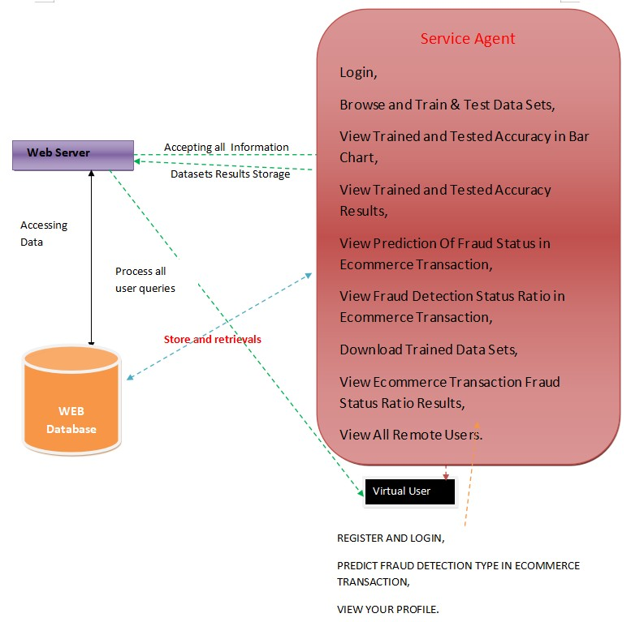
6.2 UML DIAGRAMS
6.2.1 USE CASE DIAGRAM
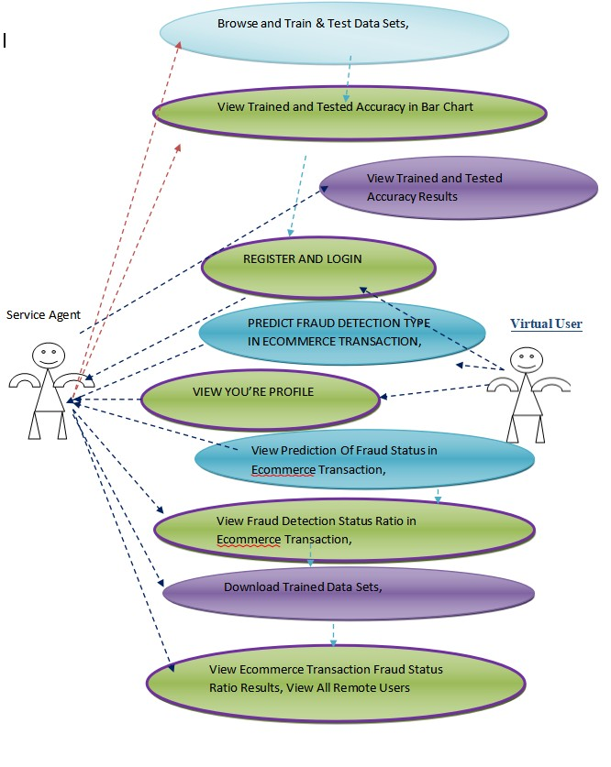

6.2.2 CLASS DIAGRAM
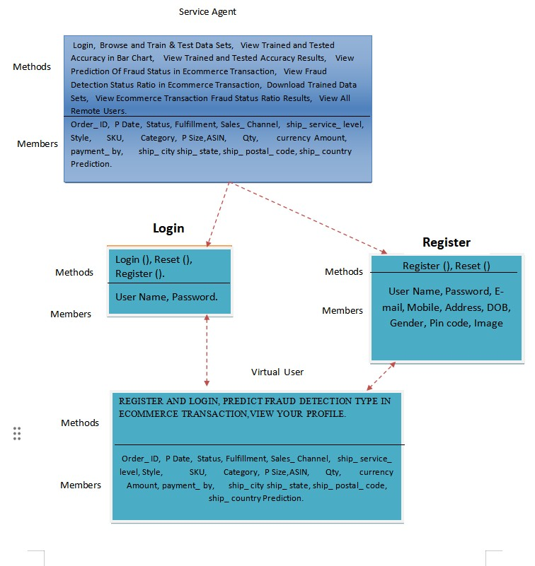

6.2.3 SEQUENCE DIAGRAM

service agent |  | web server |  | virtual user
Login,
Browse and Train & Test Data Sets,
View Trained and Tested Accuracy Results,
View Prediction Of Fraud Status in Ecommerce Transaction,
View Fraud Detection Status Ratio in Ecommerce Transaction,
Download Trained Data Sets
View Ecommerce Transaction Fraud Status Ratio Results
,View All Remote Users
View Trained and Tested Accuracy in Bar Chart,
REGISTER AND LOGIN
PREDICT FRAUD DETECTION TYPE IN ECOMMERCE TRANSACTION,
VIEW YOUR PROFILE

6.2.5 ACTIVITY DIAGRAM
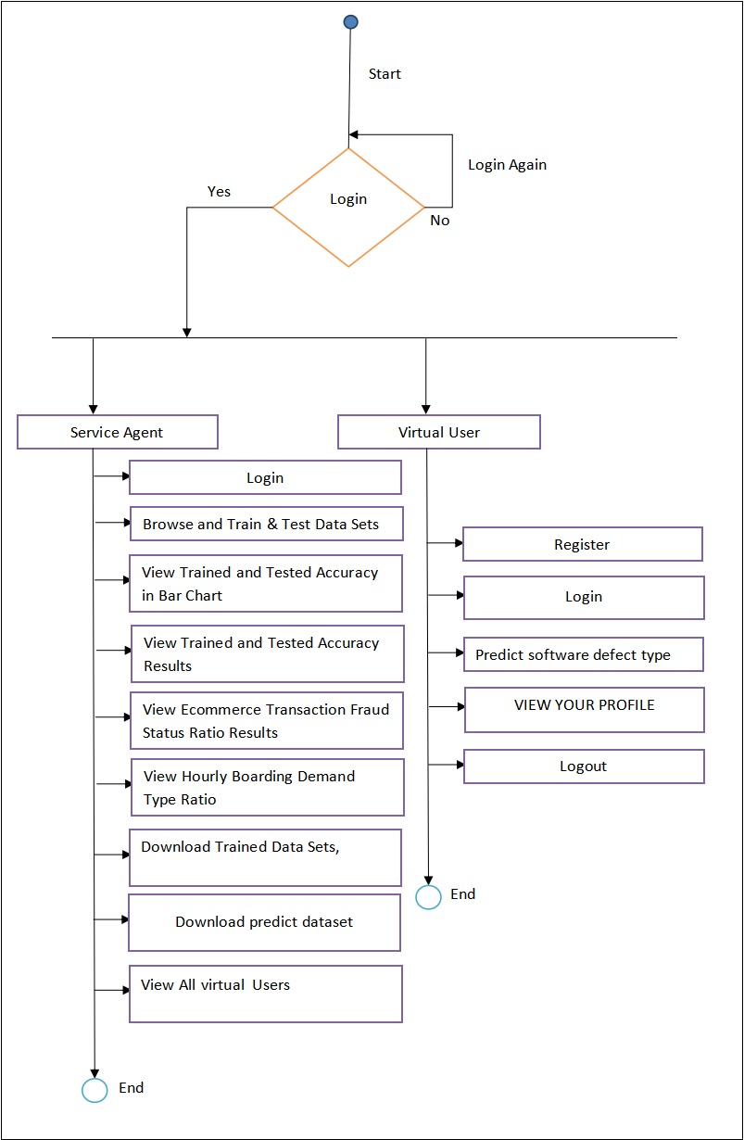

6.2.6 COMPONENT DIAGRAM

Applicatio
n
Service
agent
Virtual user
Login,
Browse and Trai
n & Test Data
View Trained an
d Tested
View Trained an
d Tested
View Prediction
Of Fraud Status
View Fraud
Detection Statu
Download
Trained Data
View
Ecommerce
,View All Remot
e Users
REGISTER AN
D LOGIN
PREDICT
FRAUD
VIEW YOUR
PROFILE
6.2.7 DEPLOYMENT DIAGRAM

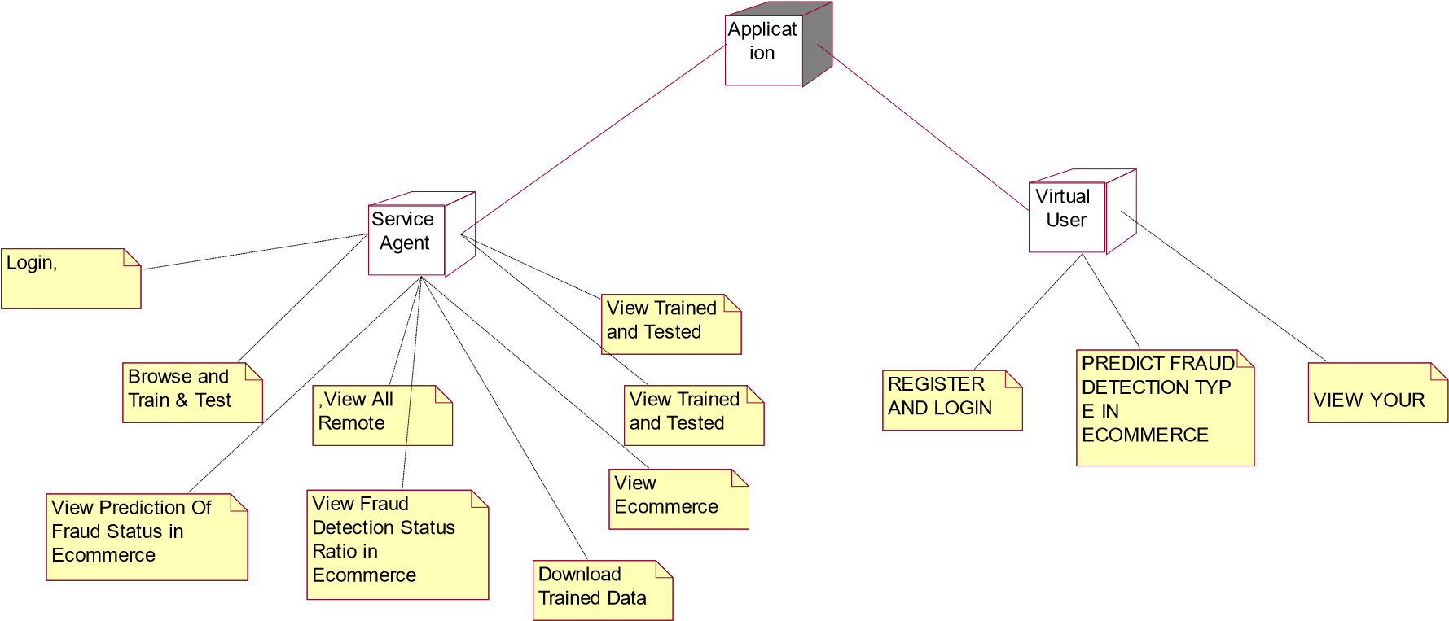

6.2.8 ER DIAGRAM
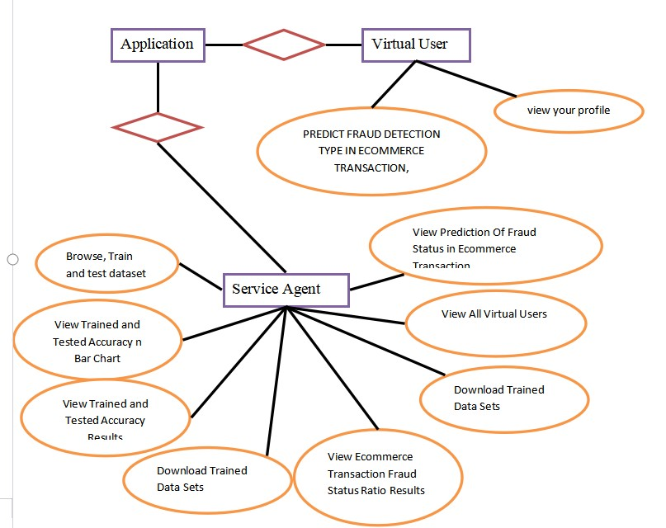

6.2.9 DATA DICTIONARY
Database: a_multi-perspective_fraud_detection_method_for_multi-participant_e-commerce transactions

Table name: auth_group

Column | Data Type | Constraints | Description
id | Int(11) | Primary key | Unique Identifier
name | Varchar(1000) | Not null | name

Table Name: Auth_group_Permission
Column | Data Type | Constraints | Description
id | Int(11) | Primary key | Unique Identifier
Group id | Int(11) | Primary Key | Unique Identifier
Permission_id | Int(11) | Primary Key | Unique Identifier
Table Name: auth_permission
Column | Data Type | Constraints | Description
id | Int(11) | Primary key | Unique Identifier
Name | Int(255) | Not Null | name
Content_type_id | Int(11) | Primary Key | Unique Identifier
Code name | Int(100) | Not Null | name
Table Name: auth_User
Column | Data Type | Constraints | Description
id | Int(11) | Primary key | Unique Identifier
Password | varchar(128) | Not Null | password
Last_Login | Datetime(6) | Not Null | Last login
Is_superuser | tinyint(1) | Not Null | Name
username | Varchar(150) | Not Null | Username
lastname | Varchar(30) | Not Null | Lastname
email | Varchar(150) | Not Null | Email id
Is_staff | Tinyint(1) | Not Null | Staff
Is_active | Tinyint(1) | Not Null | Active
Date_joined | Datetime(6) | Not Null | Date and time

Table Name: auth_user_groups
Column | Data Type | Constraints | Description
id | Int(11) | Primary key | Unique Identifier
User_id | Int(11) | Primary Key | Unique Identifier
Group_id | Int(11) | Primary Key | Unique Identifier

CHAPTER-7
INPUT AND OUTPUT DESIGN

7.1 INPUT DESIGN
The input design is the link between the information system and the user. It comprises the developing specification and procedures for data preparation and those steps are necessary to put transaction data in to a usable form for processing can be achieved by inspecting the computer to read data from a written or printed document or it can occur by having people keying the data directly into the system. The design of input focuses on controlling the amount of input required, controlling the errors, avoiding delay, avoiding extra steps and keeping the process simple. The input is designed in such a way so that it provides security and ease of use with retaining the privacy. Input Design considered the following things:
- What data should be given as input?
- How the data should be arranged or coded?
- The dialog to guide the operating personnel in providing input.
- Methods for preparing input validations and steps to follow when error occur.

7.1.1 OBJECTIVES
1.Input Design is the process of converting a user-oriented description of the input into a computer-based system. This design is important to avoid errors in the data input process and show the correct direction to the management for getting correct information from the computerized system.
2. It is achieved by creating user-friendly screens for the data entry to handle large volume of data. The goal of designing input is to make data entry easier and to be free from errors. The data entry screen is designed in such a way that all the data manipulates can be performed. It also provides record viewing facilities.
3.When the data is entered it will check for its validity. Data can be entered with the help of screens. Appropriate messages are provided as when needed so that the user will not be in maize of instant. Thus the objective of input design is to create an input layout that is easy to follow.

7.2 OUTPUT DESIGN
A quality output is one, which meets the requirements of the end user and presents the information clearly. In any system results of processing are communicated to the users and to other system through outputs. In output design it is determined how the information is to be displaced for immediate need and also the hard copy output. It is the most important and direct source information to the user. Efficient and intelligent output design improves the system’s relationship to help user decision-making.
1. Designing computer output should proceed in an organized, well thought out manner; the right output must be developed while ensuring that each output element is designed so that people will find the system can use easily and effectively. When analysis design computer output, they should Identify the specific output that is needed to meet the requirements.
2.Select methods for presenting information.
3.Create document, report, or other formats that contain information produced by the system.
The output form of an information system should accomplish one or more of the following objectives.
- Convey information about past activities, current status or projections of the
- Future.
- Signal important events, opportunities, problems, or warnings.
- Trigger an action.
- Confirm an action.

CHAPTER-8
IMPLEMENTATION

8.1 MODULES
- Service Agent
- Virtual User

8.1.1 MODULE DESCRIPTION

SERVICE AGENT
In this module, the Service Agent has to login by using valid user name and password. After login successful he can do some operations such as Train & Test Agriculture Crop Data Sets, View Trained and Tested Accuracy in Bar chart View Trained and Tested Accuracy Results, View Prediction Of Agricultural Text Classification Type,View Agricultural Text Classification Type Ratio, Download Predicted Data Sets, View Agricultural Text Classification Type Ratio Results, View All Remote Users.

VIEW AND AUTHORIZE USERS
In this module, the admin can view the list of users who all registered. In this, the admin can view the user’s details such as, user name, email, address and admin authorizes the users.

VIRTUAL USER
In this module, there are n numbers of users are present. User should register before doing any operations. Once user registers, their details will be stored to the database. After registration successful, he has to login by using authorized user name and password. Once Login is successful user will do some operations like REGISTER AND LOGIN, Predict Agricultural _ text _ classification, VIEW YOUR PROFILE.

maintained by a core development team at the institute, although Guido van Rossum still holds a vital role in directing its progress.

Python Features Python's features include:
- Easy-to-learn: Python has few keywords, simple structure, and a clearly defined syntax. This allows the student to pick up the language quickly.
- Easy-to-read: Python code is more clearly defined and visible to the eyes.
- Easy-to-maintain: Python's source code is fairly easy-to-maintain.
- A broad standard library: Python's bulk of the library is very portable and crossplatform compatible on UNIX, Windows, and Macintosh.

- Interactive Mode: Python has support for an interactive mode which allows interactive testing and debugging of snippets of code.
- Portable: Python can run on a wide variety of hardware platforms and has the same interface on all platforms.
- Extendable: You can add low-level modules to the Python interpreter. These modules enable programmers to add to or customize their tools to be more efficient.
- Databases: Python provides interfaces to all major commercial databases.
- GUI Programming: Python supports GUI applications that can be created and ported to many system calls, libraries and windows systems, such as Windows MFC, Macintosh, and the X Window system of Unix.
- Scalable: Python provides a better structure and support for large programs than shell scripting.
Python has a big list of good features:
- It supports functional and structured programming methods as well as OOP.

9.2 SOURCE CODE MANAGE.PY
#!/usr/bin/env python
"""Django's command-line utility for administrative tasks.""" import os import sys def main():
"""Run administrative tasks."""
os.environ.setdefault('DJANGO_SETTINGS_MODULE',
'a_multiperspective_fraud_detection.settings')
try:
from django.core.management import execute_from_command_line except ImportError as exc:
raise ImportError(
"Couldn't import Django. Are you sure it's installed and "
"available on your PYTHONPATH environment variable? Did you "
"forget to activate a virtual environment?"
) from exc
execute_from_command_line(sys.argv) if _name_ == '_main_':
main()

INDEX.HTML
<!DOCTYPE html PUBLIC "-//W3C//DTD XHTML 1.0 Transitional//EN"
"http://www.w3.org/TR/xhtml1/DTD/xhtml1-transitional.dtd">
{% load static %}
<html xmlns="http://www.w3.org/1999/xhtml">
<head>
<title>Home Page</title>
<meta http-equiv="Content-Type" content="text/html; charset=utf-8" />
<link rel="stylesheet" type="text/css" href="{% static 'style.css'%} " />
<link rel="stylesheet" type="text/css" href="{% static 'coin-slider.css'%}" />
<script type="text/javascript" src="{% static 'cufon-yui.js'%} "></script>
<script type="text/javascript" src="{% static 'cufon-aller.js'%}"></script>
<script type="text/javascript" src="{% static 'jquery-1.4.2.min.js'%}"></script>
<script type="text/javascript" src="{% static 'script.js'%}"></script>
<script type="text/javascript" src="{% static 'coin-slider.min.js'%}"></script>
<style type="text/css">
<!--
.style5 {
font-size: 24px; color: #FF0000;
}
.style12 {font-weight: bold}
.style13 {font-size: 24px; color: #FF0000; font-weight: bold; }
.style16 {
color: #FF0000; font-weight: bold;
}
-->
</style>
</head>
<body>
<div class="main">
<div class="header">
<div class="header_resize">
<div class="menu_nav">
<p>&nbsp;</p>
</div>
<div class="mainbar">
<h1 align="center"><a href="index.html"><span class="content style5">A Multi perspective Fraud Detection Method for Multi Participant Ecommerce
Transactions</span></a></h1>
<div class="tab-content tab-space">
<div class="tab-pane active" id="preview-alerts">
<link href="https://fonts.googleapis.com/css?family=Open+Sans:300,400,600,700" rel="stylesheet" />
<script src="https://kit.fontawesome.com/42d5adcbca.js" crossorigin="anonymous"></script><link href="https://unpkg.com/soft-ui-designsystem@1.0.1/assets/css/soft-design-system.min.css" rel="stylesheet" /><div class="container py-5">
<div class="row">
<div class="alert alert-primary text-white font-weight-bold" role="alert">
<p align="center"><span class="active"><span class="style12"><a href="{% url 'index' %}">Home| </a><a href="{% url 'login' %}">Remote User </a>|<a href="{% url
'serviceproviderlogin' %}"> Service Provider </a></span></span></p>
</div>
<div>
</div>
<img src="{% static 'Banner.jpg'%}" width="1297" height="421" alt="" class="fl" /> </div>
<div class="clr"></div>
<div class="slider">
</div>
<div class="clr"></div>
</div>
</div>
<div class="content">
<div class="content_resize">
<div class="mainbar">
<div class="article">
<h2 align="center" class="style13">Fraud detection; Electronic transaction; Petri net; Machine learning..</h2>
<div class="img">
<div align="center"><img src="{% static 'img1.jpg'%}" width="630" height="221" alt="" class="fl" /></div>
</div>
<div class="post_content">
<p align="center" class="style16">Detection and prevention of fraudulent transactions in e-commerce platforms have always been the focus of transaction security systems. However, due to the concealment of e-commerce, it is not easy to capture attackers solely based on the historic order information. Many researches try to develop technologies to prevent the frauds, which have not considered the dynamic behaviors of users from multiple perspectives. This leads to an inefficient detection of fraudulent behaviors. To this end, this paper proposes a novel fraud detection method that integrates machine-learning and process mining models to monitor real-time user behaviors. First, we establish a process model concerning the B2C e-commerce platform, by incorporating the detection of user behaviors. Second, a method for analyzing abnormalities that can extract important features from event logs is presented. Then, we feed the extracted features to a Support Vector Machine (SVM) based classification model that can detect fraud behaviors. We demonstrate the effectiveness of our method in capturing dynamic fraudulent behaviors in e-commerce systems through the experiments...</p>
</div>
<div class="tab-content tab-space">
<div class="tab-pane active" id="preview-alerts">
<link href="https://fonts.googleapis.com/css?family=Open+Sans:300,400,600,700" rel="stylesheet" />
<script src="https://kit.fontawesome.com/42d5adcbca.js" crossorigin="anonymous"></script><link href="https://unpkg.com/soft-ui-designsystem@1.0.1/assets/css/soft-design-system.min.css" rel="stylesheet" /><div class="container py-5">
<div class="row">
<div class="alert alert-primary text-white font-weight-bold" role="alert">
<p align="center"><span class="active"><span class="style12"><a href="{% url 'login' %}">Home| </a><a href="{% url 'login' %}">Remote User </a>|<a href="{% url
'serviceproviderlogin' %}"> Service Provider </a></span></span></p>
</div>
<div>
</div>
<div class="clr"></div>
</div>
</div>
<div class="sidebar">
<div class="searchform"></div>
<div class="clr"></div>
</div>
<div class="clr"></div>
</div>
</div>
<div class="fbg"></div>
<div class="footer"></div>
</div>
<div align=center></div>
</body>
</html>

REGISTER.HTML
<!DOCTYPE html PUBLIC "-//W3C//DTD XHTML 1.0 Transitional//EN"
"http://www.w3.org/TR/xhtml1/DTD/xhtml1-transitional.dtd">
{% load static %}
<html xmlns="http://www.w3.org/1999/xhtml">
<head>
<title>Register</title>
<meta http-equiv="Content-Type" content="text/html; charset=utf-8" />
<style type="text/css">
<!--
.style5 {
font-size: 24px; color: #FF0000;
}
.style12 {font-weight: bold}
.style13 {font-size: 24px; color: #FF0000; font-weight: bold; }
.style19 {color: #FFFF00; font-weight: bold; }
.style22 {color: #FF0000; font-weight: bold; }
.style23 {
color: #FFFFFF; font-weight: bold;
}
-->
</style>
</head>
<body>
<div class="main">
<div class="header">
<div class="header_resize">
<div class="menu_nav">
<p>&nbsp;</p>
</div>
<div class="mainbar">
<h1 align="center"><a href="index.html"><span class="content style5">A Multi perspective Fraud Detection Method for Multi Participant Ecommerce
Transactions</span></a></h1>
<div class="tab-content tab-space">
<div class="tab-pane active" id="preview-alerts">

<link href="https://fonts.googleapis.com/css?family=Open+Sans:300,400,600,700" rel="stylesheet" />
<script src="https://kit.fontawesome.com/42d5adcbca.js" crossorigin="anonymous"></script><link href="https://unpkg.com/soft-ui-designsystem@1.0.1/assets/css/soft-design-system.min.css" rel="stylesheet" /><div class="container py-5">
<div class="row">
<div class="alert alert-primary text-white font-weight-bold" role="alert">
<p align="center"><span class="active"><span class="style12"><a href="{% url 'index' %}">Home| </a><a href="{% url 'login' %}">Remote User </a>|<a href="{% url
'serviceproviderlogin' %}"> Service Provider </a></span></span></p>
</div>
<div>
</div>
<img src="{% static 'Banner.jpg'%}" width="1297" height="327" alt="" class="fl" /> </div>
<div class="clr"></div>
<div class="slider">
</div>
<div class="clr"></div>
</div>
</div>
<div class="content">
<div class="content_resize">
<div class="mainbar">
<div class="article">
<h2 align="center" class="style13">Fraud detection; Electronic transaction; Petri net; Machine learning.</h2>
<div class="img">
<div align="center">
<div class="container-fluid">
<div>
<div class="row">
<div >
<form role="form" method="POST" >
{% csrf_token %}
<fieldset>
<p>{% load static %}
<img src="{% static '/Register.jpg' %}" alt="My image"><br>
<span class="style1 style22">REGISTER YOUR
DETAILS HERE !!!</span> </p>
<table width="719" border="0" align="center">
<tr>
<td width="160" bgcolor="#FF0000"><span class="style19">Enter Username </span></td>
<td width="173"><span class="form-group">
<input type="text" name="username" id="username" placeholder="User Name" required="required" />
</span></td>
<td width="147" bgcolor="#FFFF00"><span class="style22">Enter Password </span></td>
<td width="211"><span class="form-group">
<input type="password" name="password" id="password" placeholder="Password" required="required" />
</span></td>
</tr>
<tr>
<td height="47" bgcolor="#FF0000"><span class="style19">Enter EMail Id </span></td>
<td><span class="form-group">
<input type="email" name="email" id="email" placeholder="Enter Email " required="required" />
</span></td>
<td bgcolor="#FFFF00"><span class="style22">Enter Address </span></td>
<td><span class="form-group">
<textarea name="address" placeholder="Enter Address "></textarea> </span></td>
</tr>
<tr>
<td height="37" bgcolor="#FF0000"><span class="style19">Enter Gender </span></td>
<td><select name="gender">
<option>----Select Gender ----</option>
<option>Male</option>
<option>Female</option>
</select>
</td>
<td bgcolor="#FFFF00"><span class="style22">Enter Mobile Number </span></td>
<td><span class="form-group">
<input type="number" name="phoneno" id="phoneno" placeholder="Enter
Mobile Number" required="required" />
</span></td>
</tr>
<tr>
<td bgcolor="#FF0000"><span class="style19">Enter Country Name </span></td>
<td><span class="form-group">
<input type="text" name="country" id="country" placeholder="Enter
Country Name" required="required" />
</span></td>
<td bgcolor="#FFFF00"><span class="style22">Enter State Name </span></td>
<td><span class="form-group">
<input type="text" name="state" id="state" placeholder="Enter State Name" required="required" />
</span></td>
</tr>
<tr>
<td bgcolor="#FF0000"><span class="style19">Enter City Name </span></td>
<td><span class="form-group">
<input type="text" name="city" id="city" placeholder="Enter City Name" required="required" />
</span></td>
<td bgcolor="#FFFF00">&nbsp;</td>

<td><input type="submit" class="btn btn-lg btn-primary" name="submit" value="Register" /></td>
</tr>
</table>
</fieldset>
<div><br>
<button class="btn btn-lg ">
</form>
</div>

</div>

<table border="0" align="left" >
<tr><td width="246" bgcolor="#FF0000"><div align="center" class="style23"><span class="style6">Registered Status</span> :: {{object}}</div></td>

</table>

<div class="mainbar">
<div class="tab-content tab-space">
<div class="tab-pane active" id="preview-alerts">
<link href="https://fonts.googleapis.com/css?family=Open+Sans:300,400,600,700" rel="stylesheet" />
<script src="https://kit.fontawesome.com/42d5adcbca.js" crossorigin="anonymous"></script><link href="https://unpkg.com/soft-ui-designsystem@1.0.1/assets/css/soft-design-system.min.css" rel="stylesheet" /><div class="container py-5">
<div class="row">
<div class="alert alert-primary text-white font-weight-bold" role="alert">
<p align="center"><span class="active"><span class="style12"><a href="{% url 'login' %}">Home| </a><a href="{% url 'login' %}">Remote User </a>|<a href="{% url
'serviceproviderlogin' %}"> Service Provider </a></span></span></p>
</div>
<div>
</div>
<div class="col-md-2">
<!-------null------>
</div>

<div class="col-md-5">
</div>
</div>
</div>
</div>
</div>
</div>
<div class="clr"></div>
</div>
</div>
<div class="sidebar">
<div class="searchform"></div>
<div class="clr"></div>
</div>
<div class="clr"></div>
</div>
</div>
<div class="fbg"></div>
<div class="footer"></div>
</div>
<div align=center></div>
</body>
</html>

VIEW PROFILE.HTML
{% extends 'RUser/Header.html' %}
{% block userblock %}

<link rel="icon" href="images/icon.png" type="image/x-icon" />

<link href="https://fonts.googleapis.com/css?family=Lobster" rel="stylesheet">
<link href="https://fonts.googleapis.com/css?family=Righteous" rel="stylesheet">
<link href="https://fonts.googleapis.com/css?family=Fredoka+One" rel="stylesheet">
<style>
body {background-color:#000000;}
.container-fluid {padding:50px;}
.container{background-color:white;padding:50px; }
#title{font-family: 'Fredoka One', cursive;
}
.text-uppercase{
font-family: 'Righteous', cursive;

}
.style1 {
color: #FF0000; font-weight: bold;
}
.style4 {color: #FFFFFF; font-weight: bold; }
.style6 {color: #FF0000; font-weight: bold; font-style: italic; } </style>

<body>
<div class="container-fluid">
<div class="container">

<div class="row">
<div class="col-md-5">
<form role="form" method="POST" >
{% csrf_token %}
<fieldset>
<p class="text-uppercase pull-center style1">YOUR PROFILE DETAILS !!! </p>
<hr>
<div class="form-group">
<P>&nbsp;</P>
</div>

<div class="form-group">
<table width="879" border="0" align="center">
<tr>
<td width="148" height="34" bgcolor="#FF0000"><span class="style4">Username</span></td>
<td width="225"><span class="style6">{{object.username}}</span></td>
<td width="157" bgcolor="#FF0000"><span class="style4">Email Id </span></td>
<td width="321"><span class="style6">{{object.email}}</span></td>
</tr>
<tr>
<td height="38" bgcolor="#FF0000"><span class="style4">Mobile Number </span></td>
<td><span class="style6">{{object.phoneno}}</span></td>
<td bgcolor="#FF0000"><span class="style4">Gender</span></td> <td><span class="style6">{{object.gender}}</span></td>
</tr>

<tr>
<td height="34" bgcolor="#FF0000"><span class="style4">Address</span></td>
<td><span class="style6">{{object.address}}</span></td>
<td bgcolor="#FF0000"><span class="style4">Country</span></td> <td><span class="style6">{{object.country}}</span></td>
</tr>
<tr>
<td height="32" bgcolor="#FF0000"><span class="style4">State</span></td>
<td><span class="style6">{{object.state}}</span></td>
<td bgcolor="#FF0000"><span class="style4">City</span></td> <td><span class="style6">{{object.city}}</span></td>
</tr>
<tr>
<td>&nbsp;</td>
<td>&nbsp;</td>
<td>&nbsp;</td> <td>&nbsp;</td>
</tr>
</table>
<p>&nbsp;</p>
<p>&nbsp;</p>
</div>
</fieldset>
</form>
</div>

<div class="col-md-2">
<!-------null------>
</div>
</div>
</div>
</div>
{% endblock %}

CHAPTER-10
RESULTS/DISCUSSION

10.1 SYSTEM TESTING
The purpose of testing is to discover errors. Testing is the process of trying to discover every conceivable fault or weakness in a work product. It provides a way to check the functionality of components, sub-assemblies, assemblies and/or a finished product It is the process of exercising software with the intent of ensuring that the Software system meets its requirements and user expectations and does not fail in an unacceptable manner. There are various types of test. Each test type addresses a specific testing requirement.
TYPES OF TESTS UNIT TESTING
Unit testing involves the design of test cases that validate that the internal program logic is functioning properly, and that program inputs produce valid outputs. All decision branches and internal code flow should be validated. It is the testing of individual software units of the application .it is done after the completion of an individual unit before integration. This is a structural testing, that relies on knowledge of its construction and is invasive. Unit tests perform basic tests at component level and test a specific business process, application, and/or system configuration. Unit tests ensure that each unique path of a business process performs accurately to the documented specifications and contains clearly defined inputs and expected results.
INTEGRATION TESTING
Integration tests are designed to test integrated software components to determine if they actually run as one program. Testing is event driven and is more concerned with the basic outcome of screens or fields. Integration tests demonstrate that although the components were individually satisfaction, as shown by successfully unit testing, the combination of components is correct and consistent. Integration testing is specifically aimed at exposing the problems that arise from the combination of components.

FUNCTIONAL TEST
Functional tests provide systematic demonstrations that functions tested are available as specified by the business and technical requirements, system documentation, and user manuals.
Functional testing is centered on the following items:
Valid Input : identified classes of valid input must be accepted.
Invalid Input : identified classes of invalid input must be rejected.
Functions : identified functions must be exercised.
Output : identified classes of application outputs must be exercised.
Systems/Procedures : interfacing systems or procedures must be invoked.
Organization and preparation of functional tests is focused on requirements, key functions, or special test cases. In addition, systematic coverage pertaining to identify Business process flows; data fields, predefined processes, and successive processes must be considered for testing. Before functional testing is complete, additional tests are identified and the effective value of current tests is determined.
SYSTEM TEST
System testing ensures that the entire integrated software system meets requirements. It tests a configuration to ensure known and predictable results. An example of system testing is the configuration-oriented system integration test. System testing is based on process descriptions and flows, emphasizing pre-driven process links and integration points.

WHITE BOX TESTING
White Box Testing is a testing in which in which the software tester has knowledge of the inner workings, structure and language of the software, or at least its purpose.
It is purpose. It is used to test areas that cannot be reached from a black box level.
BLACK BOX TESTING
Black Box Testing is testing the software without any knowledge of the inner workings, structure or language of the module being tested. Black box tests, as most other kinds of tests, must be written from a definitive source document, such as specification or requirements document, such as specification or requirements document. It is a testing in which the software under test is treated, as a black box you cannot “see” into it. The test provides inputs and responds to outputs without considering how the software works.

UNIT TESTING
Unit testing is usually conducted as part of a combined code and unit test phase of the software lifecycle, although it is not uncommon for coding and unit testing to be conducted as two distinct phases.
TEST STRATEGY AND APPROACH
Field testing will be performed manually and functional tests will be written in detail.

Test objectives
- All field entries must work properly.
- Pages must be activated from the identified link.
- The entry screen, messages and responses must not be delayed.

Features to be tested
- Verify that the entries are of the correct format
- No duplicate entries should be allowed
- All links should take the user to the correct page. Integration Testing
Software integration testing is the incremental integration testing of two or more integrated software components on a single platform to produce failures caused by interface defects.
The task of the integration test is to check that components or software applications, e.g. components in a software system or – one step up – software applications at the company level – interact without error.

Test Results: All the test cases mentioned above passed successfully. No defects encountered.
ACCEPTANCE TESTING
User Acceptance Testing is a critical phase of any project and requires significant participation by the end user. It also ensures that the system meets the functional requirements.
Test Results: All the test cases mentioned above passed successfully. No defects encountered.
10.1.1 TEST CASES Test case1:
Test case for Login form:

FUNCTION: | LOGIN
EXPECTED RESULTS: | Should Validate the user and check his existence in database
ACTUAL RESULTS: | Validate the user and checking the user against the database
LOW PRIORITY | No
HIGH PRIORITY | Yes

Test case2:
Test case for User Registration form:

FUNCTION | VIRTUAL USER REGISTRATION
EXPECTED RESULTS: | Should check if all the fields are filled by the user and saving the user to database.
ACTUAL RESULTS: | Checking whether all the fields are filled by user or not through validations and saving user.
LOW PRIORITY | No
HIGH PRIORITY | Yes

Test case3:

Test case for Change Password:
When the old password does not match with the new password , then this results in displaying an error message as “ OLD PASSWORD DOES NOT MATCH WITH THE NEW
PASSWORD”.

Test case 4:
Test case for Forget Password:
When a user forgets his password he is asked to enter Login name, ZIP code, Mobile number. If these are matched with the already stored ones then user will get his Original password.

Modu le | Functio nality | Test Case | Expected Results | Actual  Results | Res  ult | Priori ty
User | Login  Usecase | - Navigate To  Www.Sample.Co m  - Click On Submit  Button Without Entering  Username and Password | A Validation Should  Be As Below  “Please Enter Valid  Username &  Password” | A  Validation  Has Been  Populated  As Expected | Pass | High
 |  | - aNavigate To  Www.Sample.Co m  - Click On Submit  Button With Out Filling  Password And With Valid  Username | A Validation Should  Be As Below  “Please Enter Valid  Password Or  Password Field Can  Not Be Empty “ | A  Validation Is  Shown As  Expected | Pass | High
 |  | - NNavigate To  Www.Sample.Co m  - Enter Both  Username And Password  Wrong  And Hit Enter | A Validation Shown  As Below “The  Username Entered Is  Wrong” | A  Validation Is  Shown As  Expected | Pass | High
 |  | - Navigate To  Www.Sample.Co m  - Enter Validate Username And Password  And  Click On Submit | Validate Username And Password In  DataBase And Once  If They Correct  Then Show The  Main Page | Main Page/ Home Page  Has Been  Displayed | Pass | High

10.2 SCREENSHOTS

FIG 1: HOME PAGE


FIG 2: VIRTUAL USER LOGIN PAGE

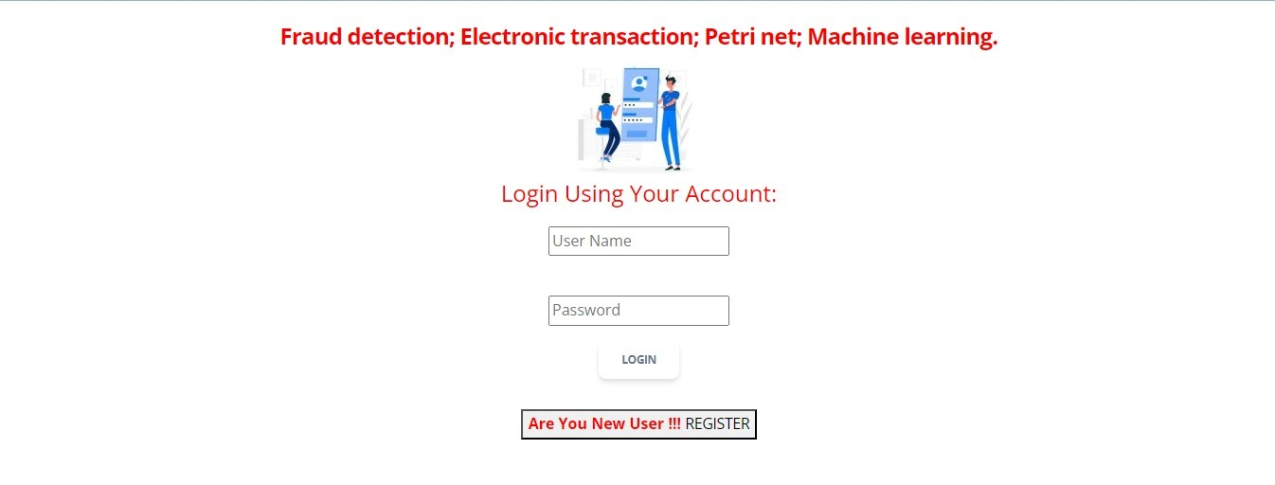

FIG 3: REGISTRATION PAGE

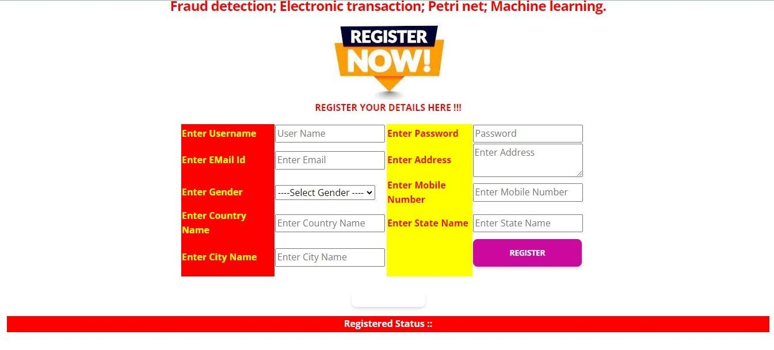

FIG 4: SERVICE AGENT LOGIN PAGE


FIG 5: BROWSE AND TRAIN & TEST DATA SETS

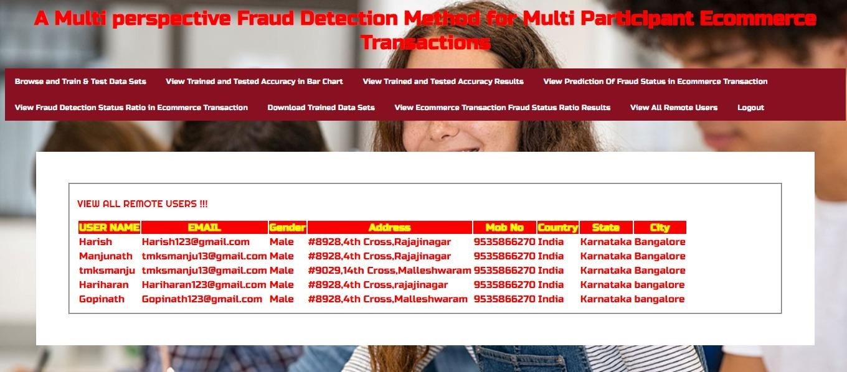

FIG 6: VIEW PREDICTION OF FRAUD STATUS IN ECOMMERCE TRANSACTION

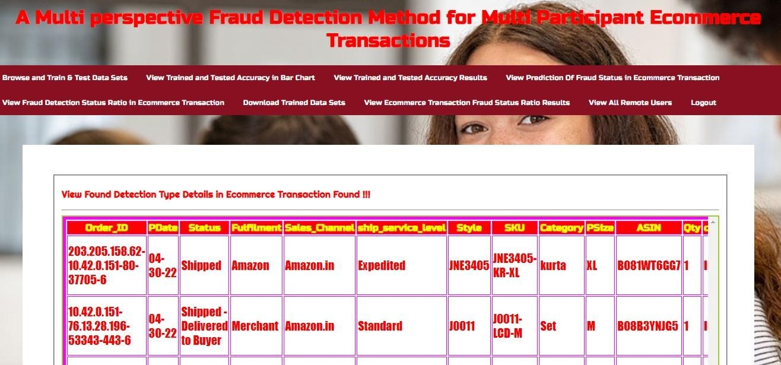

FIG 7:VIEW ECOMMERCE TRANSACTION FRAUD STATUS RATIO RESULT

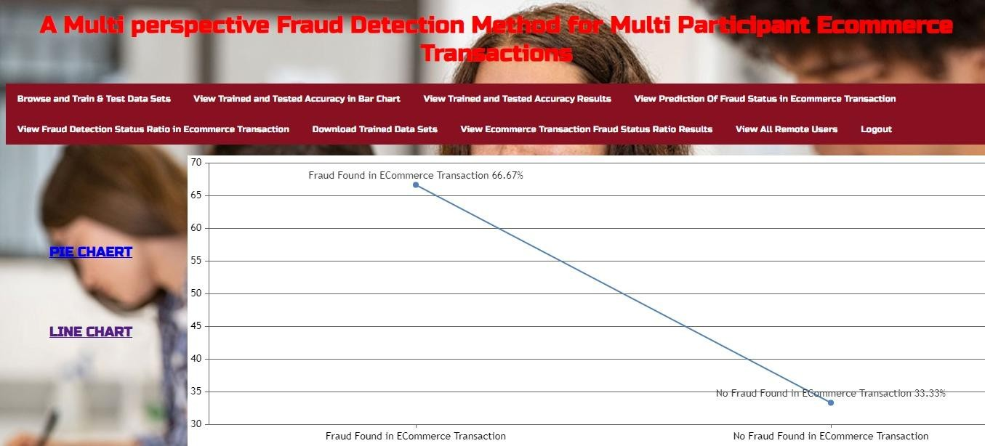

FIG 8: VIEW ALL REMOTE USERS

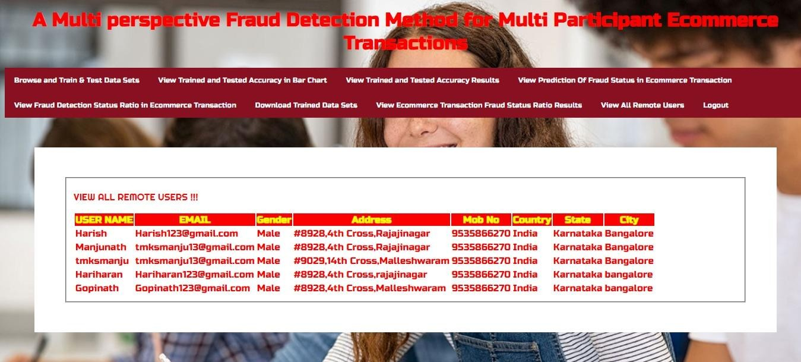

CHAPTER-11
CONCLUSION

11.1 CONCLUSION
This paper proposed a hybrid method to capture fraud transactions by integrating the formal process modeling and the dynamic user behaviors. We analyzed the e-commerce transaction process under five major perspectives: control flow perspective, resource perspective, time perspective, data perspective, and user behavior patterns. This paper utilized high-level Petri nets as the basis of process modeling to model the abnormal user behaviors and created an SVM model to perform fraudulent transaction detection. Our extensive experiments showed that the proposed method can effectively capture fraudulent transactions and behaviors. The overall index of our proposed multi-perspective detection method outperformed the singleperspective detection method. As our future work, related deep learning [38-42] and model checking methods [43-45] would be incorporated in the proposed framework for higher accuracy. Additionally, it’s also a future work to incorporate more time features to the behavior patterns so as to make the risk identification more accurate. Furthermore, we will conduct research on constructing a standard fraud mode library, and apply the proposed methodology to other malicious behavior areas by coordinating the models.

11.2 FUTURE SCOPE
The future scope for a multi-perspective fraud detection method for multi-participant ecommerce transactions encompasses a wide array of advancements and developments aimed at enhancing the efficacy, efficiency, and adaptability of fraud detection systems. Here's a narrative exploration of the potential future directions for this project:

In the evolving landscape of e-commerce, the need for robust fraud detection mechanisms continues to grow in significance. As online transactions become increasingly complex and multi-faceted, traditional methods of fraud detection often fall short in capturing the nuanced behaviors and patterns indicative of fraudulent activity. Looking ahead, the future of fraud detection in e-commerce lies in embracing a multi-perspective approach that leverages diverse sources of data, analytical techniques, and collaborative frameworks to stay ahead of evolving threats.

One avenue of future development lies in the advancement of machine learning algorithms. As the field of artificial intelligence continues to evolve, so too do the capabilities of machine learning models in detecting and preventing fraud. Future iterations of fraud detection systems may harness the power of deep learning, reinforcement learning, and ensemble methods to analyze vast volumes of transactional data in real-time, enabling more accurate and adaptive fraud detection capabilities.

Furthermore, the proliferation of big data analytics presents exciting opportunities for enhancing fraud detection in e-commerce. By leveraging technologies such as Hadoop, Spark, and cloud-based analytics platforms, organizations can process and analyze large-scale data sets to identify subtle patterns and anomalies indicative of fraudulent behavior. This enables proactive intervention and mitigation strategies, ultimately reducing the impact of fraud on ecommerce platforms and consumers alike.

Another promising avenue for future exploration is the integration of behavioral biometrics into fraud detection systems. By analyzing unique behavioral patterns such as keystroke dynamics, mouse movements, and touchscreen interactions, organizations can add an extra layer of security to e-commerce transactions. Future advancements in behavioral biometrics may lead to more seamless and frictionless authentication methods, enhancing the user experience while mitigating the risk of fraud.

Additionally, the adoption of blockchain technology holds significant promise for enhancing the integrity and transparency of e-commerce transactions. By leveraging blockchain's immutable ledger and smart contract capabilities,

CHAPTER-12
REFERENCES
- R. A. Kuscu, Y. Cicekcisoy, and U. Bozoklu, Electronic PaymentSystems in Electronic Commerce. Turkey: IGI Global, 2020, pp. 114–139.
- M. Abdelrhim, and A. Elsayed, “The Effect of COVID-19 Spread onthe e-commerce market: The case of the 5 largest e-commercecompanies in the world.” Available at SSRN 3621166, 2020, doi:10.2139/ssrn.3621166.
- P. Rao et al., “The e-commerce supply chain and environmentalsustainability: An empirical investigation on the online retail sector.”Cogent. Bus. Manag., vol. 8, no. 1, pp. 1938377, 2021.
- S. D. Dhobe, K. K. Tighare, and S. S. Dake, “A review on preventionof fraud in electronic payment gateway using secret code,” Int. J. Res.Eng. Sci. Manag., vol. 3, no. 1, pp. 602-606, Jun. 2020.
- A. Abdallah, M. A. Maarof, and A. Zainal, “Fraud detection system: Asurvey,” J. Netw. Comput. Appl., vol. 68, pp. 90-113, Apr. 2016.
- E. A. Minastireanu, and G. Mesnita, “An Analysis of the Most UsedMachine Learning Algorithms for Online Fraud Detection,” Info.Econ., vol. 23, no. 1, 2019.
- X. Niu, L. Wang, and X. Yang, “A comparison study of credit cardfraud detection: Supervised versus unsupervised,” arXiv preprintarXiv: vol. 1904, no. 10604, 2019, doi:
10.48550/arXiv.1904.10604. [8] L. Zheng et al., “Transaction Fraud Detection Based on Total OrderRelation and Behavior Diversity,” IEEE Trans. Computat. Social Syst.,vol. 5, no. 3, pp.
796-806, 2018.
- Z. Li, G. Liu, and C. Jiang, “Deep Representation Learning With FullCenter Loss for Credit Card Fraud Detection,” IEEE Trans. Computat.Social Syst., vol. 7, no. 2, pp. 569-579, 2020.
- I. M. Mary, and M. Priyadharsini, “Online Transaction FraudDetection System,” in 2021 Int. Conf. Adv. C. Inno. Tech. Engr.(ICACITE), 2021, pp. 14-16.
- D. Choi, and K. Lee, “Machine learning based approach to financialfraud detection process in mobile payment system,” IT Conv. P.(INPRA), vol. 5, no. 4, pp. 12-24, 2017.
- R. Sarno et al., “Hybrid Association Rule Learning and ProcessMining for Fraud Detection,” IAENG Int. J. C. Sci., vol. 42, no. 2,2015.
- J. J. Stoop, “Process mining and fraud detection-A case study on thetheoretical and practical value of using process mining for thedetection of fraudulent behavior in the procurement process,” M.S.thesis, Netherlands, ENS: University of Twente, 2012.
- M. Jans et al., “A business process mining application for internaltransaction fraud mitigation,” Expert Syst. Appl., vol. 38, no. 10, pp.13351-13359, 2011.
- C. Rinner et al., “Process mining and conformance checking of long running processes in the context of melanoma surveillance,” Int. J.Env. Res. Pub. He., vol. 15, no. 12, pp. 2809, 2018.
- E. Asare, L. Wang, and X. Fang, “Conformance Checking: Workflow of Hospitals and Workflow of Open-Source EMRs,” IEEE Access, vol. 8, pp. 139546-139566, 2020.
- W. Chomyat and W. Premchaiswadi, “Process mining on medicaltreatment history using conformance checking,” in 2016 14th Int. Conf. ICT K. Eng. (ICT&KE), 2016, pp. 77-83.
- M. D. Leoni, W. M. Van Der Aalst, and B. F. V. Dongen, “Data-and resource-aware conformance checking of business processes,” in Int.Conf. Bus. Info. Sys., Springer, Berlin, Heidelberg, 2012. pp. 48-59.
- S. M. Najem, and S. M. Kadeem, “A survey on fraud detection techniques in ecommerce,” Tech-Knowledge, vol. 1, no. 1, pp. 33-47,2021.
- K. Böhmer, and S. Rinderle-Ma, “Anomaly detection in businessprocess runtime behavior--challenges and limitations,” arXiv preprint arXiv, 2017, doi:
10.48550/arXiv.1705.06659.
- K. D. Febriyanti, R. Sarno and Y. Effendi, “Fraud detection on eventlogs using fuzzy association rule learning,” in 2017 11th Int. Conf.Info. Comm. Tech. Sys., Surabaya, Indonesia, 2017, pp. 149-154.
- T. Chiu, Y. Wang and M. Vasarhelyi, “A framework of applyingprocess mining for fraud scheme detection,” SSRN Electronic Journal,2017, doi:10.2139/ssrn.2995286.
- W. Yang et al., “Show Me the Money! Finding FlawedImplementations of Third-party Inapp Payment in Android Apps,” inProc. NDSS, Shanghai, China, 2017.
- W. Rui, S. Chen, X. Wang and S.Qadeer, “How to Shop for FreeOnline--Security Analysis of Cashier-as-a-Service Based Web Stores,”in Proc. SSP, Oakland, CA, USA, 2011, pp. 465480.
- E. Ramezani, D. Fahland and W. Aalst, “Where did I misbehave?Diagnostic information in compliance checking,” in BPM., Berlin，Germany, Springer, 2012, pp. 262-278.

