ATM SYSTEM

NAMES&SECTIONS:

1-Haidy khaled (21).

2-Yasmen elmkdad (21).

3-Doha adel fathy (9).

4-Ahmed Mohamed henawy (3).

5-Eslam ismail abdelnaby (3).

# *Information to deal with our project:

# =Client file= :

|  |  |  |  |  |
| --- | --- | --- | --- | --- |
| ID | USERNAME | | PASSWORD | BALANCE |
| 1 | AHMED | 1234 | | 5000 |
| 2 | DOHA | 1111 | | 8500 |
| 3 | ESLAM | 0000 | | 4000 |
| 4 | HAIDY | 1010 | | 7500 |
| 5 | YASMEN | 4321 | | 9000 |

# =Employee file =:

|  |  |  |
| --- | --- | --- |
| ID | USERNAME | PASSWORD |
| 10 | KHALED | 9876 |
| 20 | mohamad | 5678 |
| 30 | SALWA | 1000 |
| 40 | ALI | 6070 |
| 50 | MANAL | 5050 |

Libraries used:

* #include <iostream> => standard stream objects
* #include <Windows.h> => for titles and colors
* #include <fstream> => for file input & output
* #include <conio.h> => for getch()
* #include <ctime> => to display date and time now.

About ATM :

[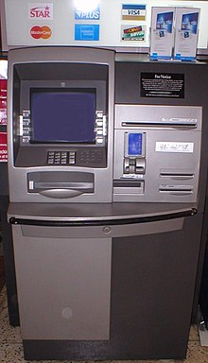](https://en.wikipedia.org/wiki/File:ATM_750x1300.jpg)

An **automated teller machine** (**ATM**) is an electronic telecommunications device that enables customers of [financial institutions](https://en.wikipedia.org/wiki/Financial_institution) to perform [financial transactions](https://en.wikipedia.org/wiki/Financial_transaction), such as cash withdrawals, deposits, transfer funds, or obtaining account information, at any time and without the need for direct interaction with bank staff.